FOURTH GRADE

Where the (Did the) - Did the victory of the colonists at Saratoga create hope that the Americans could win the war against England?

Student Name: _______________________
Date______________________________

Part III: This part consists of a document-based question. On this part, you will be provided with one version of the test based on your readiness to handle critical thinking challenges. (You may opt for a more difficult version than your teacher provides, but you will be graded on the version that you complete.
Document Based Question

Directions: The task below is based on documents 1 through 5-6. The task is designed to test your ability to work with documents. Examine each document and answer all questions beneath the document. Use the answers to the questions to help write your essay.

Background:

This essay will discuss the Battle of Saratoga and the idea of hope. Some people have called the Battle of Saratoga the turning point in the American Revolution. Many people believe that the Battle of Saratoga created hope in the colonists that they could win the war.

Task: Use the information from the documents and your knowledge of social studies, write an essay in which you:
Use the information from the documents and your knowledge of social studies, write an essay in which you:

- Discuss two factors that caused the colonists to have hope.
- Discuss two factors in the Battle of Saratoga that were important for the American colonists.
- Evaluate whether the Battle of Saratoga created hope in the colonists that they could win the war.

In your essay remember to
- Write an opinion essay, arguing whether the Native Americans were a more advanced society than the Europeans who colonized America.
- Include an introduction, a body, and a conclusion
- Use information from at least three documents in your answer
- Include historical facts, relevant details, and reason in developing your ideas

Document #1:
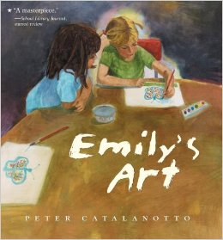
The Creation of Hope
“When her teacher announces an art contest, Emily uncertainly wonders, "Does the judge know which is better?" When the judge rejects Emily's picture of a dog because she hates dogs, Emily stops painting.
Emily’s friend Kelly, restored her hope when she asked her to draw her a new picture, that she could keep.
1. According to Peter Catalanotto, in Emily’s Art, what did the judge do to Emily’s art?
_________________________________________________________ [2]

2. Referring to the text,
- How did Emily feel after the situation between her and the judge?
- Who helped Emily get through this?
A.________________________________________________________ [1]
B.________________________________________________________ [1]

Document #2
“Oliver Boardman had a vivid recollection, “It was a glorious sight to see the [arrogant] British March out and surrender their arms to an army which but a little before they despised and called [cowards].”

-R.M. Ketchum

1. According to the document, what were the British required to do after they lost the Battle of Saratoga? [1]
_______________________________________________________________________________________________________________________
2. Based on the document, how do you think the Americans felt after their victory at the Battle of Saratoga?
______________________________________________________________________________________________________________________[2]
Document #3:

“When Ms. Esteves taught the fourth grade a new math lesson the students began to get frustrated and gave up, however, Ms. Esteves said “if you believe you can achieve it, you can succeed!”
- Based on the scenario above, state whether or not Ms. Esteves is displaying characteristics of a hope crusher or hope creator.
__________________________________________________________________ [1]
2. How do you think Ms. Esteves’ fourth grade class quote might be related to the Americans at the battle of saratoga.
_________________________________________________________________________________________________________________________________________________________ [2]

Document #4
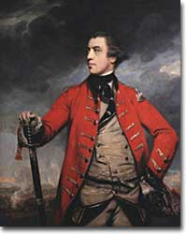

“The Battle of Saratoga was the turning point of the Revolutionary War.
The scope of the victory is made clear by a few key facts: On October 17, 1777, 5,895 British and Hessian troops surrendered their arms. The British General, John Burgoyne, had lost 86 percent of his expeditionary force that had triumphantly marched into New York from Canada in the early summer of 1777.This was the first major face to face battle for the American troops in the American Revolution.”

General John Burgoyne

- Based on the document, what was the reason why the British and Hessian troops surrendered? [1]

____________________________________________________________________[1]
2. How was hope apparent for the American Colonist to win the American Revolution?

_____________________________________________________________________[2]

3. Why did you think people thought of the Battle of Saratoga is the turning point of the war? _____________________________________________________________________[2]

Document #5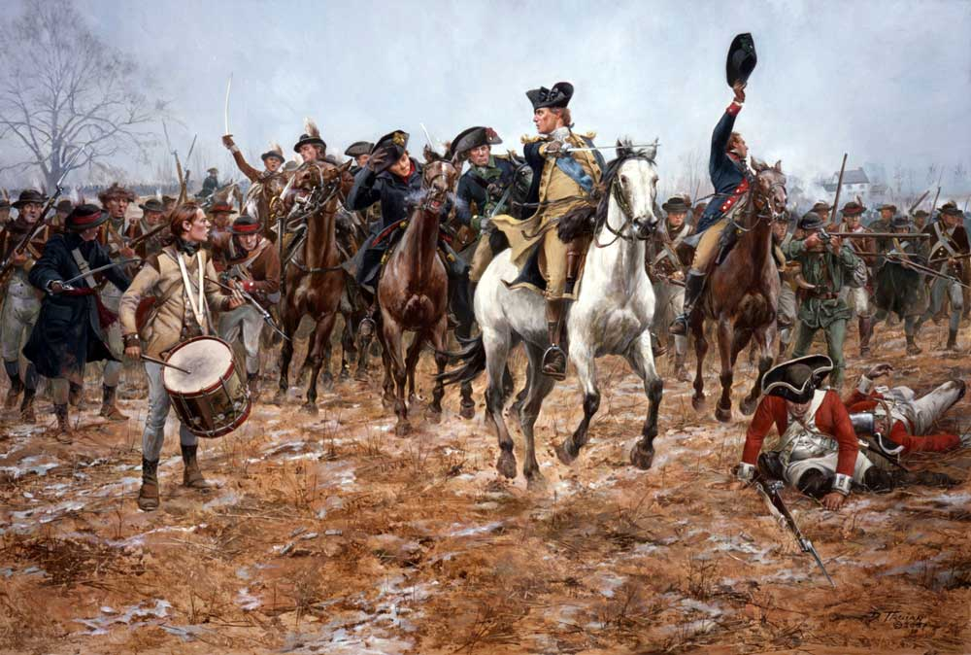
Key: Red Coat= British; Men on the horses =American Colonist
- According to the picture above, what do you think the feelings of the British soldiers were? [1]
_________________________________________________________________________________________________________________________________________________________[1]
2. According to the picture above, what do you think the feelings of the American Colonist were? [1]
_________________________________________________________________________________________________________________________________________________________[1]
Document #6
“The Battle of Saratoga and the surrender of the British army under General Burgoyne was one of the major turning points of the Revolutionary War. The Americans morale was boosted and the country now felt it could win the war. Just as important to the war, the French decided to support the Americans with military aid. The French gave the Americans general Marquis de Lafayette, a full navy.”
- According to the document, what did the French do after the Battle of Saratoga?

- ____________________________________________________________________ [1]

2. Why might the French entering the war, have been the turning point of the war?

B. ____________________________________________________________________ [1]

Task: Use the information from the documents:

Directions: The task below is based on documents 1 through 5. The task is designed to test your ability to work with documents. Examine each document and answer all questions beneath the document. Use the answers to the questions to help write your essay.

Background

The

Task: Use the information from the documents and your knowledge of social studies, write an essay in which you:
Use the information from the documents and your knowledge of social studies, write an essay in which you:

- Discuss
- Discuss
- Evaluate

In your essay remember to
- Write an opinion essay, arguing whether the Native Americans were a more advanced society than the Europeans who colonized America.
- Include an introduction, a body, and a conclusion
- Use information from at least three documents in your answer
- Include historical facts, relevant details, and reason in developing your ideas

