8th Grade
Hope or Economics
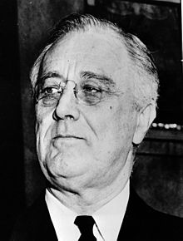

FDR, Hope, and Economics

The unit focuses on the presidency of Franklin Roosevelt and how he provided relief to the American people during the Great Depression. The central concept of the unit is to determine how he accomplished this feat, was it through creating hope or sound economic policy. In lesson one… In lesson two, students experience a photographic bus tour of the Great Depression throughout the United States. They will be exposed to 5 different “stops”, including The Stock Market Crash, Hoovervilles, Bread/Soup Lines, The Hoover Dam and lastly, Dust bowls in California. During the Bus tour, there will be a simulation of what it was like waiting for bread. In lesson three, students will work hands on with primary and secondary source documents. They will analyze the documents and corroborate evidence they found about the time period. In lesson four, students will work cooperatively to complete a history mystery. This activity will have them determine which documents support economic theory and which support creating hope.The unit concludes in a summative performance, in which students will complete a DBQ essay. They will then take informed action and work on a community wide project about the concept of hope.

Compelling Question: Did Franklin Roosevelt Get Us Out of The Depression by Creating Hope or Sound Economic Policy?

Staging Question: What is hope?

Standards and Practices:
8.5 GREAT DEPRESSION: Economic and environmental disasters in the 1930s created hardships for many Americans. Amidst much debate about the appropriate role of the government, President Franklin D. Roosevelt helped to create intensive government interventions in the United States economy and society. (Standards: 1, 3, 5; Themes: TCC, SOC, GOV, ECO).

Key Concepts:
8.5c President Roosevelt issued the New Deal in an attempt to revive the economy and help Americans deal with the hardships of the Great Depression. These New Deal reforms had a long-lasting effect on the role of government in American society and its economic life, but did not resolve all of the hardships Americans faced.

National Social Studies Standards and Themes
VI. Power, Authority, & Governance: Social studies programs should include experiences that provide for the study of how people create and change structures of power, authority, and governance

Social Studies Practices: Habits of Mind
E. Economics and Economic Systems
.

1. Supporting Question:  What is hope? Does hope have more than one meaning? | Formative Task:  Students will explore multiple avenues of hope through various activities. Students will analyze the book Rosie Revere, Engineer, a clip from the movie Superman, and will engage in an activity with a lotto ticket. Students will be introduced to Keynesian Economics and parts of the New Deal and determine if hope or sound economic policy got America out of the Great Depression. | Sources:  Bateman, B. W. (2015). An Encyclopedia of Keynesian Economics. 2nd ed. History of  Political Economy, 47(3), pp. 535-536. doi:10.1215/00182702-3153176  Beaty, A., & Roberts, D. (2013). Rosie Revere, Engineer. Abrams Books for Young  Readers, New York.  Black, J, Hashimzade, N, Myles, G. (2017, January 12). Keynesian economics A  Dictionary of Economics. Oxford University Press.  Harari, Yuval N. (2015). Sapiens: A brief history of humankind. New York :Harper,  Chapter 16.  Martinelli, D. K. (2007). New deal public relations: A glimpse into FDR press secretary  Stephen Early's work. Public Relations Review, 33(1), pp. 49-57.  Roosevelt, F. (1933). Inaugural Fireside Chat. National Archives; March 12, 1933.  Sheehan, K, Ryan, J. (2017). Growing a Growth Mindset: Unlocking Character Strengths through Children's Literature. Lanham: Rowman & Littlefield Publishers.

2. Supporting Question:  How were living conditions during the Great Depression? How did living conditions change throughout your journey? | Formative Task:  Students will take a virtual bus tour starting in New York City, ending in California. Throughout this task, students will see how it was to live during the Great Depression as well as how life changed within in each state. | Sources:  The Teacher’s Passport (n.d.) Travel Bundle (Passports, Boarding Passes, Travel Journals).Teachers Pay Teachers. Retrieved from https://www.teacherspayteachers.com/Product/Travel-Bundle-Passports-Boarding-Passes-Travel-Journals-1997983  Great Depression Simulation & Lecture (n.d.) (PowerPoint Presentations, Simulations)  Teachers Pay Teachers. Retrieved from  https://www.teacherspayteachers.com/Product/Great-Depression-Simulation-Lecture-FUN-1666219

3. Supporting Question:  What can we learn about FDR’s presidency and the Great Depression from primary and secondary source documents, using the SSMS method? | Formative Task:  Students will analyze primary and secondary source documents and then share what they learned with other students, in order to fill out graphic organizer. | Sources:  - http://rooseveltinstitute.org/great-depression-great-recession/  - http://www.presidency.ucsb.edu/ws/index.php?pid=14540  - http://www.presidency.ucsb.edu/ws/index.php?pid=14473

4. Supporting Question:  Did FDR get us out of the depression by sound economic theory or by creating hope?  (History Mystery) | Formative Task:  Students will analyze documents that either support their claim for economic theory or hope. Students will work together in groups to complete a history mystery activity. Students will then create a claim statement using the documents provided as evidence. | Sources:  Carroll, C. (2009, January 15). New Data, Same Result: New Deal Never Solved Unemployment. Retrieved from https://www.dailysignal.com/2009/01/15/new-data-same-result-new-deal-never-solved-unemployment/  G. (n.d.). F.d.r. Cartoon, 1930s by Granger. Retrieved from https://fineartamerica.com/featured/fdr-cartoon-1930s-granger.html  National Brotherhood Week: Gone and Forgotten. (n.d.). Retrieved from http://www.chicagonow.com/not-for-jews-only/2013/02/national-brotherhood-week-123/

Summative Performance Task

Students will complete a Document Based Question Essay in class as a culminating project for the unit. Students will analyze the documents provided, answer scaffolding questions based on the documents and then based on the documents each student will write an essay responding to the question, “Did Franklin Roosevelt Get Us Out of The Depression by Creating Hope or Sound Economic Policy?”

Taking Informed Action

Students will go out into the school or larger community and interview people. The interview will consist of asking people about a time they may have hopeless and if/how the situation turned around. They can also ask about a time they were very hopeful about something. Students will then type up the stories they heard and use them to decorate a hallway board. This way any students, teachers, or visitors will pass it in the hallway and can maybe find some inspiration or a turn a feeling of hopelessness around. Students will have to work together to make up specific interview questions and also create a consent form to be signed by each interviewee.

GRADE 8 DBQ

Did Franklin Roosevelt Get America Out of The Depression by Creating Hope or Sound Economic Policy?

Student Name________________________
Date___________________________

Part III: This part consists of a document-based question. On this part, you will be provided with one version of the test based on your readiness to handle critical thinking challenges. (You may opt for a more difficult version than your teacher provides, but you will be graded on the version that you complete)

Document Based Question

Directions: The task below is based on documents one through six. The task is designed to test your ability to work with documents. Examine each document and answer all of the questions beneath each document. Use the answers to the questions to help write your essay.

Background
President Franklin Roosevelt is credited with getting the United States out of the Depression, one of the worst economic periods in our history. He was able to turn around the economy but it is questionable whether he accomplished this by eliciting hope that things will get better or by implementing sound economic theory that helped create jobs and resurrect the economy.
Task: Use the information from the documents and your knowledge of social studies; write an essay in which you:

- Discuss two conditions that people faced in the Great Depression
- Discuss two instances in which FDR created by hope during the depression through his actions
- Evaluate whether FDR ended the depression by creating hope or because of economic policy

In your essay remember to
● Write an opinion essay, arguing whether FDR got us out of the depression by
creating hope OR by using sound economic theory, using evidence from the
documents.
● Include an introduction, a body, and a conclusion.
● Use information from at least four documents in your answer.
● Include facts, relevant details, and reason in developing your ideas.

Document 1:

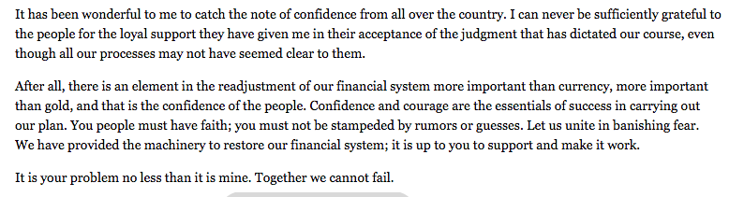
[Excerpt from President Roosevelt’s Fireside Chat on Banking, March 12, 1933]

- What does President Roosevelt claim is more important than currency?

[2]

2. According to the document what does faith have to do with banking?

[2]
Document 2:

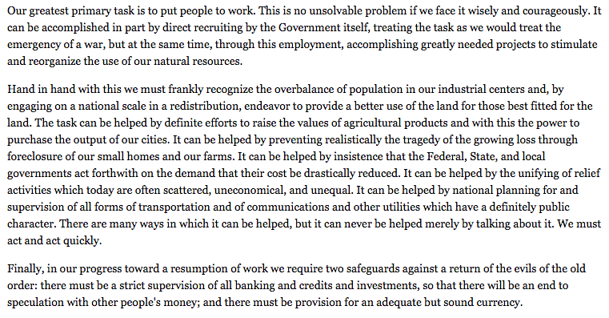
[Excerpt from President Roosevelt’s First Inaugural Address, March 4, 1933]

- What are the three ways President Roosevelt describes what he is going to do?

[2]

2. According to the document, what is President Roosevelt’s ultimate goal for the suffering economy?

[2]
Document 3:

Many “kitchens” similar to this one in Chicago in 1931 were opened by various individuals or groups.

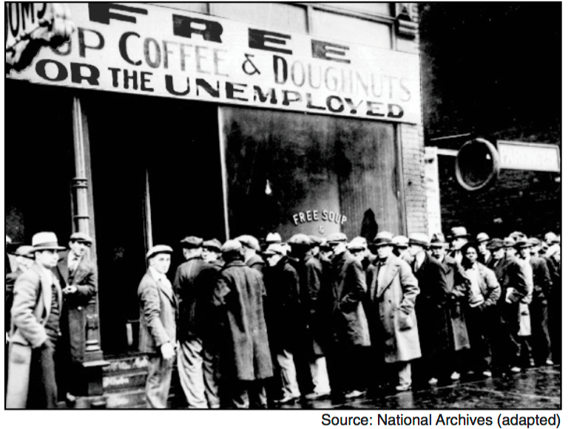

- Based on this photograph, what assistance is being offered to the people standing in line?

Document 4:

Hoovervilles start to become more popular throughout Washington D.C.
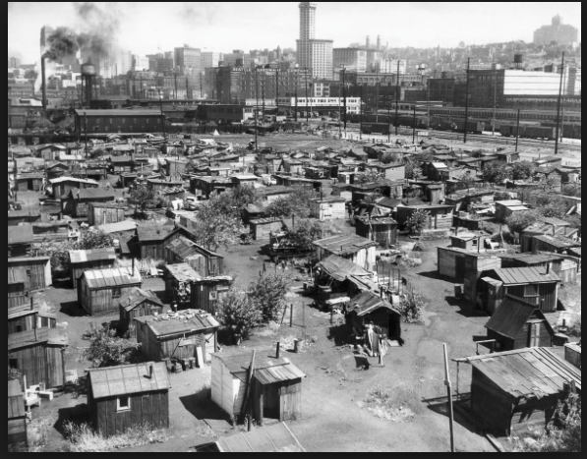

- Based on this photograph, what were most Hooverville homes made out of?

- What does this reveal about the quality of people’s lives and the state of their hope during the Great Depression?

Document 5:

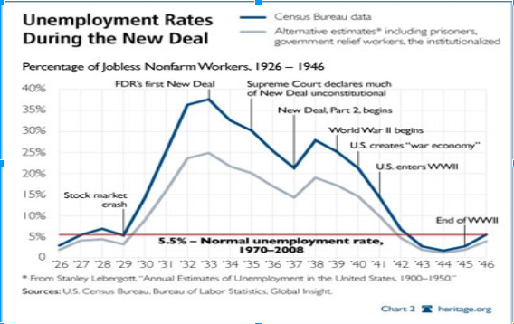

- What happens to unemployment after the stock market crash?

[2]

2. What happens to unemployment after FDR’s first new deal?

[2]

Document 6:
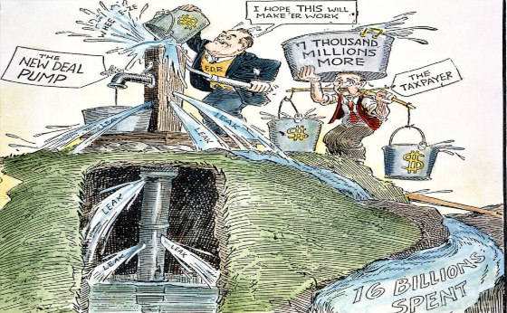
“FDR primed the pump by spending money to create jobs, many people believed this would be an answer to the Great Depression but others believed this would destroy the country”

- Who is priming the pump of the political cartoon?

[2]

2. What is the taxpayer doing in the cartoon?

