GRADE: 6

Are people happier living in Uganda or in America?

Student Name_____________________
Date______________________________

Part III: This part consists of a document-based question. On this part, you will be provided with one version of the test based on your readiness to handle critical thinking challenges.

Document Based Question

Directions: The task below is based on documents 1 through 5-6. The task is designed to test your ability to work with documents. Examine each document and answer all questions beneath the document. Use the answers to the questions to help write your essay.

Background: This question asks you to form an opinion based on the evidence in the documents that follow. Although you may have your own opinion, based your answer on proving your position with the documents. You can add outside information

Task: Use the information from the documents and your knowledge of social studies, write an essay in which you:
Use the information from the documents and your knowledge of social studies, write an essay in which you:

● Evaluate whether Ugandans or Americans are happier?

In your essay remember to
● Write an opinion essay, arguing whether people live a happier life in Mexico or America
● Include an introduction, a body, and a conclusion
● Use information from at least four documents in your answer
● Include historical facts, relevant details, and reason in developing your ideas

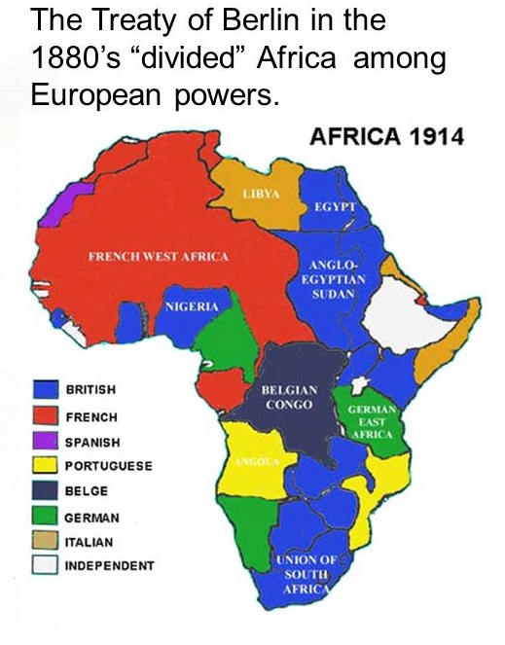
Document #1a
:

Document #1a

General Act of the Berlin Conference is seen as the formalization of the Scramble for Africa. This conference (made official) European colonization, and eliminated or overrode existing forms of African autonomy and self-governance.]
Article II

“All flags, without distinction of nationality, shall have free access to the whole of the coastline of the territories above enumerated, to the rivers there running into the sea, to all the waters of the Congo and its effluents, including the lakes, and to all the ports situated on the banks of these waters, as well as to all canals which may in future be constructed with intent to unite the watercourses or lakes within the entire area of the territories described in Article I. - quote from the Berlin Conference.

Document 1b

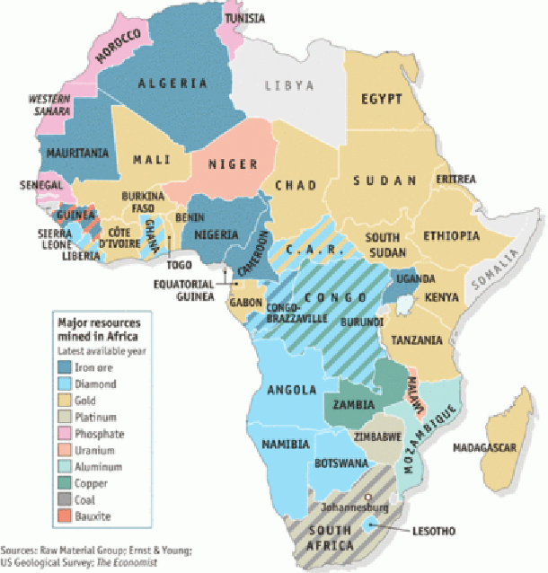
1. Based the map above (1a), identify the two European nation(s) that had the most involvement in the partitioning of the African continent.
_________________________________________________________________________________________________________________________________________ [2]

2. Based on the words in italics, what did the Berlin Conference do to the rights of African nations _____________________________________________________________(1)

1.

3. Based the two maps above (1a), identify the European nation(s) that contriollege Uganda and what resource they had that the nation wanted.
_________________________________________________________________________________________________________________________________________ [2]
Document 2: 5 Reasons Why Uganda’s Youth Are Unhappy
Link:https://serveugandainitiative.org/2018/01/22/5-reasons-why-ugandas-youth-are-unhappy/
Six of the key variables used to explain happiness differences among countries and through time affect their level of happiness. These six variables include income, healthy life expectancy, having someone to count on in times of trouble, generosity, freedom, and trust, with the latter measured by the absence of corruption in business and government.

Poor Education System
Young people are unhappy with the current schooling system, which they say; it leaves a lot of information to be stuffed into their brains in very little time. The system sheepishly embraces the elitist education system that the colonialists bequeathed to Uganda 60 years back. With such a massively wide variety of subjects that students need to study, it is nearly impossible to focus on one thing long enough to actually stick with it.

Unemployment
Unemployment causes a major fall in happiness, and even for those in work, the quality of work can cause major variations in happiness.

Lack of opportunities amid high expectations
Youths have always been promised a bright future, unlimited opportunities, and the ability to follow their dreams and do whatever truly makes them happy. They are now unhappy because the growth, equality, and sustainable development that the current government promised have not materialized. Many young people feel hopeless about securing a productive future for themselves and sharing in the elusive-sounding “prosperity” and Vision 2040 that politicians say Uganda will achieve..

Increasing Divide Between Rich and Poor
Frustration with a continually widening gap between the rich and the poor is a big factor undermining young people’s potential for happiness and satisfaction with life….When the youths are asked about one major factor that would make the greatest difference in uniting Ugandans and making them happier, most point to economic equality, for example, by focusing on increasing household incomes, especially of the people residing in rural areas.

Government and Corruption
Bad governance and corruption have led to the upswing in unhappiness among Uganda’s young people… According to the World Happiness Report 2017, there is a strong link between good governance and well-being. meet citizens’ basic needs for food and health.

1. Identify the three reasons for Ugandan unhappiness in youth.
___________________________________________________________________ [1}
___________________________________________________________________ [2}
___________________________________________________________________ [3}
2. Explain one of the reasons above and how affects happiness in Uganda.
_______________________________________________________________________________________________________________________________________________________________________________________________________________ [2]

Document # 3 What Is Happiness? Can Countries Like Uganda Really Be Happy?
Despite all of their misfortune, however, these people from Uganda were the happiest people she has ever met. Carrie states that “it was strange to [her] that people who have so little could be so invested and happy in everything they do; whether it was playing soccer in the dirt with an old soccer ball, or even just singing and dancing with their friends. These people are truly happy because of the way that they all view life, giving raw evidence to the statement “the best things in life are free.”
- Emily Parrish, “Bear Market Review”.
Parrish is describing her friend’s mission trip to Uganda.

Link: https://bearmarketreview.wordpress.com/2014/06/28/is-uganda-really-happy/

1. How Emily Parrish describe the Ugandans.
___________________________________________________________________ [1]

2. What are two reasons that Emily Parrish provides to support why Ugandas are so happy?
_______________________________________________________________________________________________________________________________________________________________________________________________________________[2]

Document 4: Happiness in America
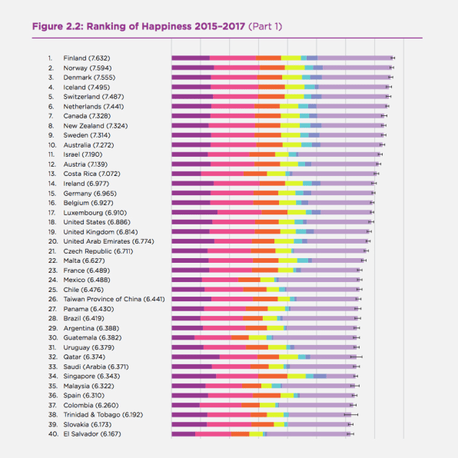
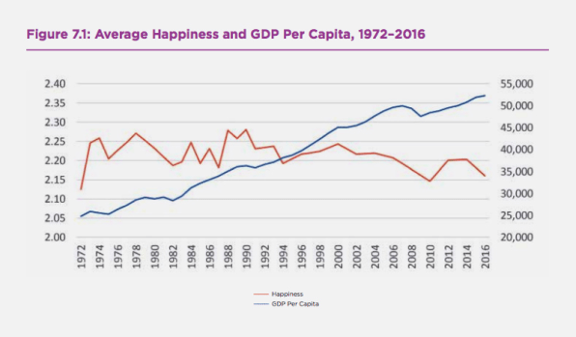

The United Nations latest World Happiness Report shows this once again. Finland, Norway, Denmark, Iceland, and Switzerland occupy the top five places, as they have in previous years (though in slightly different orders). The U.S. is in 18th place, and our happiness levels may, in fact, be falling.
“For a country that prides itself on pursuing happiness (it’s in the Declaration of Independence, even), America isn’t particularly happy in international terms. European nations regularly top the U.S in surveys of happiness, showing how well-being isn’t necessarily linked with economic growth.

Link:https://www.fastcompany.com/40544341/america-desperate-for-happiness-is-getting-less-and-less-happy

1. Identify the ranking of the United States in regards to World Happiness.

___________________________________________________________________ [1]

2. What is the relationship between GDP over 40K and happiness (What happens to happiness as GDP increases)?
________________________________________________________________________________________________________________________________________________________________________________________________________________[2]

3. What is the source of this report? Do you find it credible?

________________________________________________________________________________________________________________________________________________________________________________________________________________[2]

Document #5

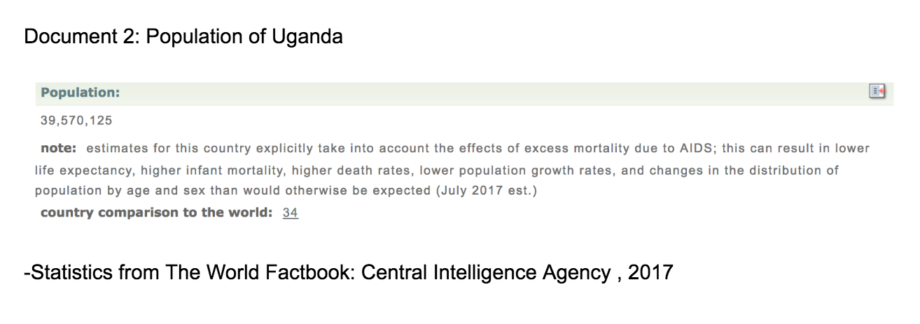

1. Based on the document, give two reasons why Ugandan life expectancy is so low?
_____________________________________________________________________________________________

__________________________________________________________________________[2]

Document 6 A Document 6 B

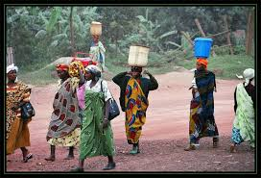
1. Based on these two pictures 6a and 6b, can you identify which picture was taken in Uganda and which one was taken in The United States?

_________________________________________________________________________[1]

2. Based on this document, can you conclude which people are ?

__________________________________________________________________________________[1]

3. Based on these pictures, can you conclude which country is happier?

__________________________________________________________________________[1]

Task: Use the information from the documents:

Directions: The task below is based on documents 1 through 5. The task is designed to test your ability to work with documents. Examine each document and answer all questions beneath the document. Use the answers to the questions to help write your essay.

Background: This question asks you to form an opinion based on the evidence in the documents that follow. Although you may have your own opinion, based your answer on proving your position with the documents. You can add outside information

Task: Use the information from the documents and your knowledge of social studies, write an essay in which you:
Use the information from the documents and your knowledge of social studies, write an essay in which you:

● Evaluate whether Mexicans or Americans are happier?

In your essay remember to
● Write an opinion essay, arguing whether people live a happier life in Mexico or America
● Include an introduction, a body, and a conclusion
● Use information from at least four documents in your answer
● Include historical facts, relevant details, and reason in developing your ideas

DBQ Scoring Rubric
(From the Revised Generic Scoring Rubric for Regents Examinations.)

Score of 5 | *Thoroughly develops all aspects of the task evenly & in depth | *Is more analytical than descriptive (applies, analyzes, evaluates, & creates information) | *Incorporates relevant information from at least the requested number of documents | *Incorporates substantial relevant outside information | *Richly supports the theme with many relevant facts, examples, & details | *Demonstrates a logical & clear plan of organization; includes and introduction & conclusion that are beyond a restatement of the theme
Score of 4 | *Develops all aspects of the task but may do so somewhat unevenly | *Is both descriptive & analytical (applies, analyzes, evaluates, and/or creates information) | *Incorporates relevant information for at least the requested number of documents | *Incorporates relevant outside information | *Supports the theme with relevant facts, examples, & details | *Demonstrates a satisfactory plan of organization; includes an introduction & a conclusion that are beyond a restatement of the theme
Score of 3 | *Develops all aspects of the task with little depth or develops most aspects of the task in some depth | *Is more descriptive than analytical (applies, may analyze and/or evaluate information) | *Incorporates relevant information from some documents | *Incorporates limited relevant outside information | *Includes some relevant facts, examples, & details; may include some minor inaccuracies | *Demonstrates a satisfactory plan of organization; includes an introduction & a conclusion that may be a restatement of the theme
Score of 2 | *Minimally develops all aspects of the task or develops some aspects of the task in depth | *Is primarily descriptive; may include faulty, weak, or isolated application or analysis | *Incorporates limited relevant information from the documents or consists primarily of relevant information copied from the documents | *Presents little or no relevant outside information | *Includes few relevant facts, examples, & details; may include some inaccuracies | *Demonstrates a general plan of organization; may lack focus; may contain digressions; may not clearly identify which aspect of the task is being addressed; may lack an introduction an/or an conclusion
Score of 1 | *Minimally develops some aspects of the task | *Is descriptive; may lack understanding, application, or analysis | *Makes vague, unclear references to the documents or consists primarily of relevant & irrelevant information copied from the documents | *Presents no relevant outside information | *Includes few relevant facts, examples, or details; may include inaccuracies | *May demonstrate a weakness in organization; may lack focus; may contain digressions; may not clearly identify which aspect of the task is being addressed; may lack an introduction and/or a conclusion
Score of 0 | *Fails to develop the task or may only refer to the theme in a general way; OR includes no relevant facts, examples or details; OR includes only the historical context and/or task as copied from the test booklet; OR includes only entire documents copied from the test booklet; OR is illegible: OR is a blank paper

