Student(s): Teresa Vitucci Professor: Dr. Sheehan
Course EDU: EDU 3510 01 Date: December 4, 2019
Grade: 1 Topic: History Mystery Content Area: Social Studies

INSTRUCTIONAL OBJECTIVES (s)
After the students perform the “History Mystery,” students will participate in collaborative conversations with diverse peers to determine if a source is credible or not by completing an “exit ticket” correctly answer at least 3 out of 4 questions.
NYS-CCLS / +NYS STANDARDS AND INDICATORS
New York State Social Studies Standard
Key Idea: 1.2 There are significant individuals, historical events, and symbols that are important to American cultural identity.
Key Concept: 1.2a The study of historical events, historical figures, and folklore enables Americans with diverse cultural backgrounds to feel connected to a common national heritage.
- - Students will listen to stories about historical events, folklore, and popular historical figures and identify the significance of the event or person.
- - Students will explain when and why celebrate national holidays such as Labor Day, Constitution Day, Columbus Day, Thanksgiving, Martin Luther King Jr. Day, Presidents’ Day, Law Day, and Independence Day are celebrated.
- Indicator: This will be evident when the students discuss if a source about Thanksgiving is credible or not.
New York State Next Generation English Language Arts Learning Standards Grade 1 Comprehension and Collaboration
1SL1: Participate in collaborative conversations with diverse peers and adults
Indicator: This will be evident the students participate in collaborative discussions to decide if a source is credible or not credible.
SOCIAL STUDIES PRACTICE: HABITS OF MINDS SKILL
A.Gathering, Interpreting and Using Evidence
F. Civic Participation
1. Demonstrate respect for the rights of others in discussions and classroom debates, regardless of whether one agrees with the other viewpoint. Consider alternate views in discussion, with teacher support.
Indicator: This will be evident when students have a discussion on whether the source is a fact or opinion during the “history mystery”
NCSS C3 SOCIAL STUDIES INQUIRY ARC
Dimension 4: Students will draw on knowledge and skills to work individually and collaboratively to conclude their investigations into societal issues, trends, and events and will present their information, portions and findings
Indicator: This will be evident when students work collaboratively to conclude if a source is a fact or opinion.

INSTRUCTIONAL RESOURCES
- Youtube video
- Powerpoint
- Sources from twitter, facebook, and online
- Poster paper
- 4 History Mystery envelopes
- “Exit Ticket” worksheet
- “Thanksgiving; Fact or Opinion” worksheet
- Tape
DEVELOPMENTAL PROCEDURES
- Motivation: Students will begin by watching the video, “Thanksgiving Story for Kids - The First Thanksgiving Cartoon for Children”
(What did you learn from the video that you have not read about? (METACOGNITIVE)
- Students will review what it means to be credible vs. non-credible from yesterday’s lesson.
(Can one source be more credible than another? (LITERAL) How can we tell if a source is credible?(INFERENTIAL)
- Students will participate in a slide show that reviews facts and opinions.
(What are facts (LITERAL)? What are opinions?(LITERAL)
- The teacher will split the class into equal groups and discuss some rules.
(Why do you think rules are important?(METACOGNITIVE)
- Students will engage in a history mystery where they work in groups to determine if a statement is a fact or an opinion about Thanksgiving.
(What type of documents are in your envelope?(LITERAL)
- Students will make two lists of facts and opinions and decide if the sources are credible or non-credible.
(How do you determine if the statement is a fact or opinion?(INFERENTIAL)
- The teacher will ask each group to share their findings.
(Which statements are facts?(LITERAL) Which statements are opinions?(LITERAL) How do you know this?(INFERENTIAL)
- As a closure, students will do a stop and jot, writing down one thing they learned from the lesson.
INSTRUCTIONAL STRATEGIES
Discussion
Indicator: This will be evident when the students work in groups and discuss whether the statement is a fact or opinion.
Cooperative Learning:
Indicator: This will be evident during the history mystery exercise where students will work in small groups
ASSESSMENT
Formal:
Students will participate in collaborative conversations with diverse peers to determine if a source is credible or not by completing an “exit ticket” correctly answer at least 3 out of 4 questions.
Informal:
Students will be informally assessed when the teacher walks around the room and observes the students work.
INDEPENDENT PRACTICE
As for homework, students will complete “Thanksgiving; Fact or Opinion” worksheet. Students must cut out various phases and determine is the phrase is a fact or an opinion about Thanksgiving.

Sources for History Mystery:
Opinions

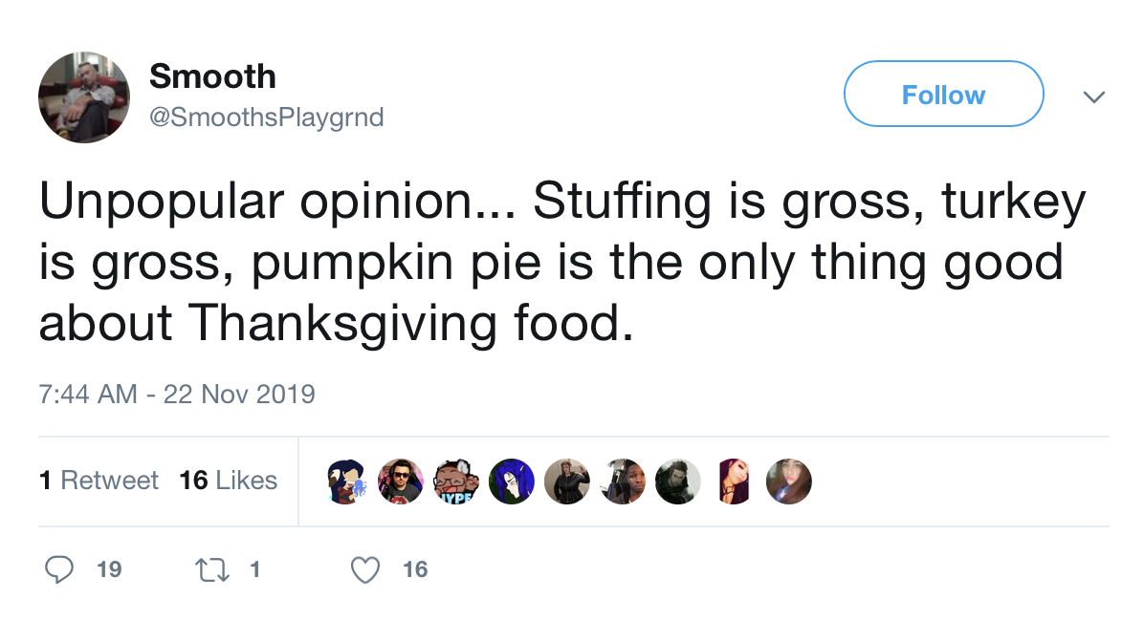

1. Twitter

2. Thanksgiving is the best holiday- Morgan, 4th grade student
3. My favorite dessert is pumpkin pie- Ms. Vitucci
Facts
1. Thanksgiving Day is celebrated on the fourth Thursday of November in the United States- kidskonnect.com
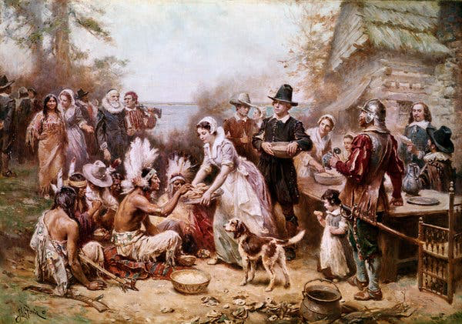
2. The Pilgrims sailed to America from Great Britain on a ship called the Mayflower.- ducksters.com
3. New York Times

References

Kids Academy. (2019, November 23). Thanksgiving Story for Kids - The First Thanksgiving Cartoon for Children. Retrieved from https://www.youtube.com/watch?v=VvzMp5WUjls
Nelson, Ken. (2019). Holidays for Kids: Thanksgiving Day. Ducksters. Retrieved from https://www.ducksters.com/holidays/thanksgiving_day.php
New York State Education Department. (2017). New York State P-12 ELA Learning Standards.http://www.nysed.gov/common/nysed/files/programs/curriculum-instruction/nys-next-generation-ela-standards.pdf
New York State K-12 Social Studies Framework. (n.d.). Retrieved from https://www.engageny.org/resource/new-york-state-k-12-social-studies-framework.
Silverman, D. J. (2019, November 27). The Vicious Reality Behind the Thanksgiving Myth. Retrieved from https://www.nytimes.com/2019/11/27/opinion/thanksgiving-history-racism.html.
Thanksgiving Day Facts, Worksheets & Origin For Kids. (2019, December 3). Retrieved from https://kidskonnect.com/holidays-seasons/thanksgiving/.

Name: ______________________________ Date:_____________
Directions: Cut out each box then place each box in the fact or opinion column.
Thanksgiving; Fact or Opinion
Fact | Opinion
Turkey tastes amazing! | The first Thanksgiving was celebrated in 1621. | Pumpkin pie is gross!
The pilgrims had a ship called the Mayflower. | Thanksgiving is my favorite holiday! | Thanksgiving is the fourth Thursday in November.
Name:________________________________________ Date:_____________
Exit Ticket
Directions: Identify if each sentence is a fact or opinion and explain why.
- In my opinion, Christmas is way better than Thanksgiving- Danielle, 1st grade student [1]

Explain why this sentence is a fact or opinion. [1]

- Thanksgiving is the fourth Thursday in November.- npr.org [1]

Explain why this sentence is a fact or opinion. [1]

