Student: Kaitlin Batik Professor: Dr. Sheehan
Course EDU 351 01 Date: 11/20/2017
Grade: 6 Topic: Ibn Battuta and Marco Polo Content Area: Social Studies

INSTRUCTIONAL OBJECTIVE

After completing a History Mystery the day before, students will participate in a “Meeting of the Minds” activity to engage in collaborative discussions about whether or not Marco Polo and Ibn Batutta lied about their travels and what character strengths the explorers used to either complete their journey or to convince others that they completed their journeys, gathering information that will be used to write a paragraph earning at least six out of eight points on a teacher-created rubric.

NYS-CCLS / +NYS STANDARDS AND INDICATORS

New York State Social Studies Standard
6.7a The Silk Roads, the Indian Ocean, and the Trans-Saharan routes formed the major Afro-Eurasian trade networks connecting the East and the West. Ideas, people, technologies, products, and diseases moved along these routes
- Students will study interregional travelers such as Marco Polo, Ibn Battuta, Mansa Musa, and Zheng He and examine why they traveled, the places visited, what was learned, and what was exchanged as a result of their travel
Indicator: This will be evident when students incorporate the information they have learned about Marco Polo and Ibn Battuta into their discussions.

NCSS Themes
IX--Global connections
- explore ways that language, art, music, belief systems, and other cultural elements may facilitate global understanding or lead to misunderstanding
Indicator: This will be evident when students discuss the impact of the travels of Marco Polo and Ibn Battuta.

Social Studies Habit of Mind
- Gathering, Interpreting, and Using Evidence
Indicator: This will be evident when students use documents from throughout the week to to create their arguments in the Meeting of the Minds.

National Social Studies C3 Inquiry Arc
Dimension 4: Students will draw on knowledge and skills to work individually and collaboratively to conclude their investigations into societal issues, trends, and events and will present their information, portions and findings.
Indicator: This will be evident when students use information from throughout the unit as evidence in their Meeting of the Minds discussions.

ELA Standard--New York State Next Generation
Speaking and Listening
Comprehension and Collaboration
6SL1: Engage effectively in a range of collaborative discussions with diverse partners; express ideas clearly and persuasively, and build on those of others.
Indicator: This will be evident when students participate in the Meeting of the Minds discussion.

ELA Standard--New York State Next Generation
Writing
Text Types and Purposes
6W1: Write arguments to support claims with clear reasons and relevant evidence
Indicator: This will be evident when students write a paragraph at the end of the lesson.

INSTRUCTIONAL RESOURCES

- Historian Reading--“Historians getting Suspicious”
- Historian question sheet
- Ibn Batuta question sheet
- Marco Polo question sheet
- Meeting of the Minds graphic organizer
- Rubric

MOTIVATION

Students will play a game of two truths and lie. 5 volunteers will come to the front of the class and share two things about themselves that are true and one thing that is false. They can choose to share orally or by writing on the whiteboard. The class will then guess which item is false. this will get students thinking about how to spot lies or exaggerations when looking at historical documents when participating in the activity to discuss if Ibn Batuta and Marco Polo made up the stories about their travels

DEVELOPMENTAL PROCEDURES

- Students will be broken into groups and assigned one of three perspectives--Ibn Battuta, Marco Polo, or historians who think they made up their journeys. In these groups students will prepare for a “meeting of the minds” discussion to decide whether or not the explorers made up the stories about their travels, and depending on the answer to the first question, which character strengths helped them on their journeys or which character strengths helped them to make up their stories and have their stories be believed. During preparation, students will focus on the questions that pertain to their assigned perspective--Marco Polo, Ibn Battuta, or a historian who believes the travels were fabricated. (Literal: Which perspective is your group arguing for? Inferential: Based on the evidence your group is using. which character strengths would Marco Polo/Ibn Battuta demonstrate? Metacognitive: Do you personally agree with the position you were assigned? Why or why not? Could that influence your performance in a debate?)
- The preparation groups will break up and form groups with at least one representative from each perspective (exact number will depend on how many students are in the class) and debate whether Marco Polo and Ibn Battuta actually traveled or fabricated their travels and which character strengths they demonstrated by traveling or fabricating. (Literal: What position did each of your group members argue for? Inferential: Do you think historians often disagree with each other? Why or why not? Metacognitive:
- Students will write a paragraph describing their own opinion about the travels Marco Polo and Ibn Batuta. Their opinions must be backed up with evidence from the documents used throughout the lesson and must reference what character strengths were demonstrated by traveling or by convincing people that the travels happened. (Literal: What position did you take in your paragraph? Inferential: Do you think others in your group chose the same position? Metacognitive: Which document’s evidence did you find most convincing? Why? Which document’s evidence did you find least convincing? Why?)

INSTRUCTIONAL STRATEGIES

Strategy
Discussion
Indicator: This will be evident when students participate in the ‘Meeting of the Minds” activity and discuss their assigned point of view.

ADAPTATIONS

- Groups will have flexible seating during discussions and students will move around to get to groups. This will allow the student with ADHD to move around during the lesson. Some of the seating options are designed so students can fidget/move in their seats without disrupting the lesson, allowing the student with ADHD to focus on the information and not on whether or not they are sitting still.
- The student with autism who fidgets/stims will be provided with objects that are safe and non-distracting to fidget with.

DIFFERENTIATION OF INSTRUCTION

- Students with social strengths will benefit from discussions in different groups
- Students with linguistic strengths will benefit from reading and filling out their preparation packets.
- Students who are visual learners will benefit from the graphic organizer.

ASSESSMENT

Formal: Students will write a paragraph where they state their own opinion about Marco Polo and Ibn Battuta and back it up with evidence. The paragraph will be graded on a teacher-created rubric.
Informal: The teacher will float from group to group to listen in on conversations and offer help where needed.

INDEPENDENT PRACTICE
Students will find a song that they think relates to either the explorers or the historians and use a classroom social media account (Edmodo, Twiducate, class Twitter hashtag, etc.) to share a YouTube video of the song with the class. Students who do not have parental permission to use these websites can email the teacher a link to the video. If a student does not have internet access at home, the teacher will meet with them individually to discuss the course of action/alternate assignment that will work best for the student’s situation.

FOLLOW-UP ACTIVITIES: DIRECT TEACHER INTERVENTION AND ACADEMIC ENRICHMENT

Direct Teacher Intervention
The teacher will sit with a group of students and do a guided reading with documents the students had trouble understanding and therefore incorporating into their discussions and paragraphs.

Academic Enrichment
Students will write a pretend journal entry from the perspective of someone traveling with Marco Polo or Ibn Battuta. The journal entry should include images of the places and things seen on the journey. Pictures can be drawn or found online.

REFERENCES

Edwards, M. (2008, July 01). Wonders and whoppers. Retrieved November 19, 2017, from https://www.smithsonianmag.com/travel/wonders-and-whoppers-27166/
History With Mr. E--A Social Studies Professional. (Last updated July 2017). Marco Polo CSI investigation: was Marco Polo a fraud? Investigate Polo’s story! Teacherspay teachers.com
THE VIEW FROM FEZ. (2010, December 22). Was Ibn Battuta a fake? Retrieved November 19, 2017, from http://riadzany.blogspot.com/2010/12/was-ibn-battuta-fake.html

Historians Getting Suspicious

Some historians believe that Marco Polo and Ibn Battuta may have faked, or at least exaggerated about, their travels. They noticed that some of the writings by/about the explorers didn’t match up with with other information about the time period.
One thing that historians noticed was what Marco Polo left out of his writings. Many aspects of Chinese culture, such as calligraphy, foot binding, chopsticks, and the Great wall of China. Because these would be unfamiliar to Marco Polo, some historians find it odd that he didn’t record them. In addition to leaving details out of his records, Marco Polo’s name was not found in the records of many of the people and places he claimed to have visited. For example, there is no record of him being at the royal court even though the Chinese and the Mongols kept thorough records. His name is also excluded from any official documentation of the years he claimed to have served as the governor of the trade city of Chiang-su.
In addition to leaving information out, Polo also exaggerated in the parts he did include. Some of the animals he described do not really exist. for example, some of his writings mention unicorns. While it is possible that he saw a rhino and described it as a unicorn, some historians find it suspicious. He also exaggerated the number of animals he had with him. For example, while nobles would keep stables of elephants as a show of power, 5,000 is excessive and unlikely. according to an article in Smithsonian Magazine, many Italians consider Polo’s writings to be tall tales.
As for Ibn Battuta, some historians suspect plagiarism may have been involved in his writings. historian and author Ralph Elger wrote a book that suggests there are similarities between Ibn Battuta’s writings and the accounts of other explorers. some details about the geography are different as well, and there are descriptions of leaders who were in power either before or after Ibn Battuta’s lifetime.
Even if the travels of either explorer were fabricated, the writings they created can still be worth reading, and can still be valued as historical documents.

Meeting of the Minds: Historian Questions
Use the information on the “Historians Getting Suspicious” reading

- List three examples of reasons that historians think Marco Polo and/or Ibn Battuta faked their travels. _______________________________________________________________________________________________________________________________________________________________________________________________________________________________________________________________________________________________________________________________________________________________________________________________________________
- What character strengths would Marco Polo and/or Ibn Battuta demonstrate by faking their travels? _______________________________________________________________________________________________________________________________________________________________________________________________________________________________________________________________________________________________________________________________________________________________________________________________________________

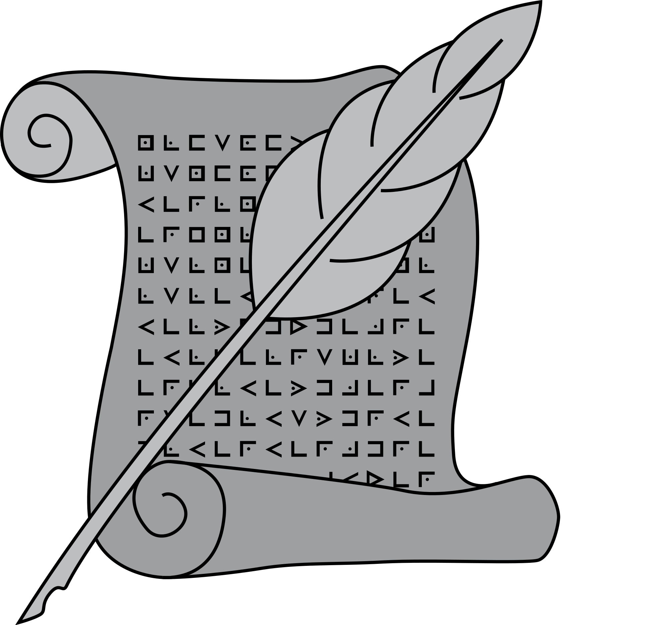

meeting of the Minds--Marco Polo Questions
Use your documents from throughout the past week

- What impact did Marco Polo have on the world by traveling and recording his travels? ____________________________________________________________________________________________________________________________________________________________________________________________________________________________________________________________________________________________________________________________________________________________________________
- What character Strengths did Marco Polo demonstrate by traveling and recording his travels? ____________________________________________________________________________________________________________________________________________________________________________________________________________________________________________________________________________________________________________________________________________________________________________

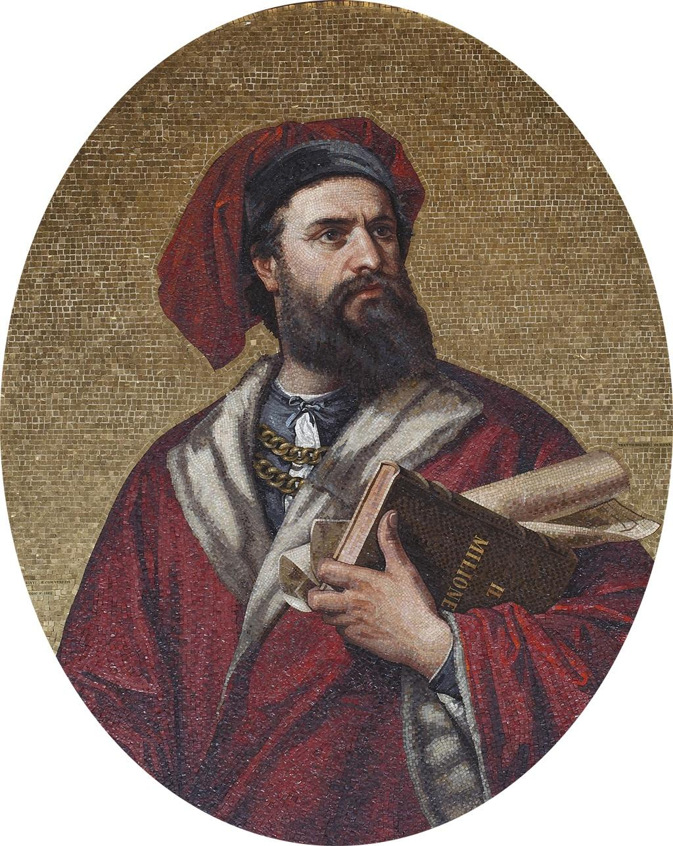

Meeting of the Minds--Ibn Battuta Questions
Use your documents from throughout the past week

- What impact did Ibn Battuta have on the world by traveling and recording his travels? ____________________________________________________________________________________________________________________________________________________________________________________________________________________________________________________________________________________________________________________________________________________________________________
- What character Strengths did Ibn Battuta demonstrate by traveling and recording his travels? ____________________________________________________________________________________________________________________________________________________________________________________________________________________________________________________________________________________________________________________________________________________________________________

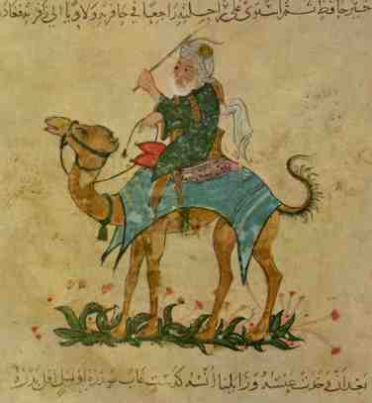

Meeting of the Minds--Graphic Organizer
Fill out the column with your topic before the discussion. Use the information discussed when you meet with people from other topics to fill out the other columns.

Marco Polo | Ibn Battuta | Historians
Rubric--Meeting of the Minds/Paragraph

Score one point for each of the following:
- Answered questions for individual topic ___
- Filled out Meeting of the Minds graphic organizer ___
- Clearly stated opinion in paragraph ___
- Backed up opinion with evidence ____
- Referenced at least one document____
- Stated at least one character strength demonstrated ___
- Explained how that character strength was demonstrated ____
- Paragraph used proper grammar ____
Total: ___/8

