Molloy College
Division of Education

Student: Scott Stiene Dr. Sheehan
Course: EDU 509 Date: April 3, 2018
Grade: 3 Topic: Melbourne, Australia
Content Area: Social Studies

INSTRUCTIONAL OBJECTIVES

After listening to Voki time travel expert Doc Brown’s instructions and participating in a visual discovery activity (I see, I think, I feel), students will perform a mini read and retell statement strategy and write a journal entry based on the historical documents given, from the perspectives of the people who have experienced these events. Students will score at least an 8/10 based on the ‘Read and Retell’ rubric and include three details on the ‘Journal Entry.’

STANDARDS AND INDICATORS

New York State Social Studies Standards

Key Idea: 3.3 Geographic factors often influence where people settle and form communities. People adapt to and modify their environment in different ways to meet their needs.
Key Concept: 3.3a Geographic factors influence where people settle and their lifestyle. Some geographic factors make a location more suitable for settlement, while others act as deterrents.
Indicator: This will be evident when students observe the given documents and participate in a visual discovery exercise and statement strategy amongst their classmates.

Key Idea: 3.4 Each community or culture has a unique history, including heroic figures, traditions, and holidays.
Key Concept: 3.4a People in world communities use legends, folktales, oral histories, biographies, and historical narratives to transmit cultural histories from one generation to the next.
Indicator: This will be evident when students observe the given documents and participate in a visual discovery activity and read and retell statement strategy amongst their classmates.

Key Idea: 3.5 Communities share cultural similarities and differences across the world.
Key Concept: 3.5a The structure and activities of families and schools share similarities and differences across world communities.
Indicator: This will be evident when students observe the given documents and participate in a statement strategy and visual discovery exercise amongst their classmates.

National Social Studies Standards and Themes
Culture: Social studies programs should include experiences that provide for the study of culture and cultural diversity.
- Human beings create, learn, share, and adapt to culture.
- Cultures are dynamic and change over time.
- Through experience, observation, and reflection, students will identify elements of culture as well as similarities and differences among cultural groups across time and place.
- In schools, this theme typically appears in units and courses dealing with geography, history, sociology, and anthropology, as well as multicultural topics across the curriculum.

Indicator: This will be evident when students analyze the documents and perform a read and retell representing the history of Melbourne throughout time and describe the historical events that shaped the country.

Individual Development & Identity: Social studies programs should include experiences that provide for the study of individual development and identity.
- Personal identity is shaped by an individual’s culture, by groups, by institutional influences, and by lived experiences shared with people inside and outside the individual’s own culture throughout her or his development.
- Questions related to identity and development, which are important in psychology, sociology, and anthropology, are central to the understanding of who we are.
- The study of individual development and identity will help students to describe factors important to the development of personal identity.

Indicator: This will be evident when students write their journal entries and act as a person from Melbourne of a specific time period and historical event they studied. This will help students to identify the factors that shape people on individual levels as well as the nation as a whole.

NCSS C3 Inquiry Arc

Dimension 2: Students will analyze societal issues, trends, and events by applying
concepts and tools from civics, economics, geography, and history. Look
with lens and skills of the discipline.
Indicator: This will be evident when students perform the mini read and retell activity about how Australia was founded and how it was established as a penal colony by England.

Dimension 3: Students will work toward conclusions about societal issues, trends, and events by collecting evidence and evaluating its usefulness in developing causal explanations.
Indicator: This will be evident when students analyze the given documents to make a stance in agreement or in disagreement with a given statement.

Dimension 4: Students will draw on knowledge and skills to work individually and collaboratively to conclude their investigations into societal issues, trends, and events and will present their information, portions and findings.
Indicator: This will be evident when students work collaboratively and individually to perform a read and retell, describing the historical events of the given time periods. They will then reflect on history and how it shaped Melbourne today.

Common Core Anchor Standards for Social Studies

3rd Grade Reading Standard: Key Ideas and Details
3R3: Analyze how and why individuals, events, or ideas develop and interact over
the course of a text.
Indicator: This will be evident when students analyze pictures and documents to determine how history has shaped Melbourne today.
3rd Grade Writing Standard: Text types and Purposes
3W1: Write arguments to support claims in an analysis of substantive topics or
texts, using valid reasoning and relevant and sufficient evidence.
Indicator: This will be evident when students agree or disagree to the statement asking whether or not Australia should have forced the Aboriginals to move based on document-based evidence.

3rd Grade Speaking and Listening Standard: Comprehension and Collaboration
3SL1: Prepare for and participate effectively in a range of conversations and collaborations with diverse partners, building on others’ ideas and expressing their own clearly and persuasively.
Indicator: This will be evident when students take the information given and perform a read and retell activity while applying visual, auditory, and speaking skills.

Social Studies Practice: Habits of Minds Skills

A. Gathering, Interpreting, and using Evidence
2. Recognize and effectively select different forms of evidence used to make meaning in social studies (including primary and secondary sources such as art and photographs, artifacts, oral histories, maps, and graphs).
Indicator: This will be evident when students utilize information, quotes, maps, and pictures to analyze the sentiment of the time to develop a position and perform a scene regarding their findings.

INSTRUCTIONAL RESOURCES
Voki Time Travel Character
“Founding of Australia by Aborigines” Passage
“Establishing a Penal Colony by England” Passage
“Made Part of British Empire” Passage
Read and Retell sheet
Read and Retell Rubric
SMART Board
Google Slides Presentation
Embedded Prezi Link for picture zoom in
Journal Entry
Document based pictures
Time Machine YouTube video

MOTIVATION
Students will be told that they are traveling in a time machine. The operator of the time machine is Doc Brown and he will take us back in time to three historical events that happened that helped shape Australia to what it is today. A quick segment of a YouTube video will also be shown depicting a time machine in operation.

DEVELOPMENTAL PROCEDURES
- Students will watch an instructional video presented by Voki Character, Doc Brown. After reviewing the CHAMPS rules the students will be divided into groups of three, each group will be assigned a specific event and time period throughout Australian history and answer what do I see, what do I think, and what do I feel (Why are these rules important? How would you describe this experience if you were an Australian during this time? What if you were Australian, an Aborigine, a Brit, and so on? Can you explain what is happening in the documents? What would happen if this event didn’t take place? Can you assess the value/ importance of these events from the documents provided?).
Assessment:
Teacher will record anecdotal notes regarding the students’ understanding of the documents and historical events presented.
Differentiation:
In order to adapt to the auditory learners, students will be able to listen to the class discussion, as well as Doc Brown’s time travel instructions. Visual learners will be able to view instructions written out on paper. Kinesthetic learners will be able to walk around the room and share their ideas with other group members.

2. The students will participate in a group read and retell literacy strategy in which they will read a short paragraph twice to each other and then record five words or phrases they feel have a large significance on the subject matter (Can you make use of these facts to determine how this history shaped Melbourne today? What examples can you provide to support your stance?).

Assessment:
Teacher will assess students understanding of the historical events based on their stance they present during the literacy strategy.
Instructional Strategy:
Collaboration/ Cooperative Groups: This will be evident when students work together to analyze the documents in order to make their individual stance
Statement Strategy: This will be evident when students use the documents to decide how history shaped Australia today.
Students will share their group findings and individual stances as a class (What words or phrases did you write down? Do you agree or disagree with your classmates and why? Did you all come up with the same words/phrases for each paragraph? Why do you think this is? How can you rationalize why someone picked a different word than you?)
Instructional Strategy:
Discussion: This will be evident when students discuss the evidence presented in the documents with each other and how the people of that time must have felt based on where they live.
The students will then participate in individual practice with a journal entry for homework (Express from the standpoint of a character from your assigned event, how it must have felt during that time period. Do you think it was fair? Do you think Australia became stronger because of these events? In your own words, which historical events do you believe helped shape Australia most and why?).
Instructional Strategy:
Independent Work: This will be evident when students write their journal entry and when they agree or disagree with the provided statement.
Adaptation:
The student who struggles with writing will be pulled aside to orally state their claims regarding the statement strategy and will be provided the option to create a recorded flip grid instead of a journal entry.

Academic Enrichment:
The students who excelled with ease throughout the lesson will be challenged to find two additional outside sources to support their claims, in agreement or disagreement, to the statements and to explain how these sources support their claims based on sound evidence. Enrichment students will be asked to utilize a description of these additional sources in their journal entries.
Direct Teacher Intervention:
The students will be given a highlighter to highlight key
reasons for determining their stance on a topic. The highlighting strategy will help the students collect data to analyze the topic and make their claims based on evidentiary support. The students will then be able to read and analyze the evidence in order to answer the compelling questions.
Assessment:
Teacher will assess the Journal Entries based on a teacher created ‘Journal Entry Checklist”.

After performance and class discussion, students will be encouraged to share their journal entries. (How did your participating classmate show their understanding of the event? How would you apply what you learned to develop your perspective on failure, hard work, and determination?)
To close the lesson, students will review the compelling question: (How did Australia come to be Australia? What historical events have shaped the country?).
Assessment:
Teacher will assess the students understanding through how the students interact and perform during the visual discovery, statement strategy, journal entry, and throughout the class discussions.

INSTRUCTIONAL STRATEGIES
Collaboration/Cooperative Groups
Indicator: This will be evident when students work together to analyze the documents in order to make their individual stance and when they write their journal entry.
Discussion
Indicator: This will be evident when students discuss the evidence presented in the documents with each other and how the people of that time must have felt based on where they live.
Independent Work
Indicator: This will be evident when students write their journal entry and when they agree or disagree with the provided statement.
Statement Strategy
Indicator: This will be evident when students use the documents to decide whether or not they agree with the provided statement.

ADAPTATIONS
-The student that struggles to stay focused will be seated near the teacher in the front of the room and be given non-verbal refocusing cues (i.e. a double tap on the desk) when needed.
-The student who struggles socially will be pulled aside to discuss their stances and will be provided the option to write out a dialogue depicting their assigned scene instead of discussing it with their classmates.
-The student who struggles with writing will be pulled aside to orally state their claims regarding the statement strategy and will be provided the option to create a recorded flip grid instead of a journal entry.

DIFFERENTIATION OF INSTRUCTION
Auditory Learners:
In order to adapt for the auditory learners, they will be able to listen to the class discussion, as well as Doc Brown’s time travel instructions. They will also be able to listen to their peers when working together during the statement strategy and the journal entry.

Visual Learners:
The visual learners will be able to visualize these historical events through the provided pictures and documents as well as through the Powerpoint presentation. The read and retell exercise will activate students’ episodic memory.

Kinesthetic Learners:
The kinesthetic learners will be able to move around the classroom when working with their groups on their visual discovery exercise.

ASSESSMENT

-Teacher will assess students’ homework from the night before.
-Teacher will assess students understanding of historical thinking strategies through discussion.
-Teacher will assess how the students interact during the visual discovery and statement strategy (read and retell)
-Teacher will record anecdotal notes regarding the students’ understanding of the documents and historical events presented.
-Teacher will assess students understanding of the historical events based on their stance they present during the statement strategy.
-Teacher will assess the Journal Entry based on the teacher created “Journal Entry Checklist”

INDEPENDENT PRACTICE

Students will participate in a statement strategy. As a group, they will read and discuss the events during the assigned period, and individually, they will either agree or disagree with the provided statement. As homework, students will create a journal entry from the perspective of a person from the time period and historical event they were assigned regarding the way they must have felt and why based on the documents.

FOLLOW-UP ACTIVITIES: DIRECT TEACHER INTERVENTION AND ACADEMIC ENRICHMENT

Direct Teacher Intervention
For the students who struggled during the lesson, the teacher will work with them on determining their stance, whether they disagree or agree with the statement based on the documents. The students will be given multiple opportunities to practice determining their stance. The students will be given a highlighter to highlight key details and reasons for determining their stance on a topic. The highlighting strategy will help the students collect data to analyze the topic and make their claims based on evidentiary support. The students will then be able to read and analyze the evidence in order to answer the compelling questions.

Academic Enrichment
The students who excelled with ease throughout the lesson will be challenged to read three paragraphs that provide in depth information pertaining to the lesson. These will be used to enhance their position on whether they agree or disagree to a proposed statement and then cite document based evidence to support their opinion. Enrichment students will be asked to utilize information in each of these three paragraphs as additional sources in their journal entries.

See, Think, and Feel
Directions: Write how you see, think, and feel based on each of the three pictures.

Picture 1: Australian Aborigines
Picture 2: Establishing a Penal Colony by England
Picture 3: Australia Made Part of British Empire

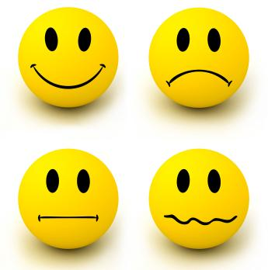
Australia is Shaped
Read and Retell (Read Twice)

Directions: Write down 5 key words or phrases you hear while listening to the story that will help you in retelling the story.

Please do one paragraph at a time
Aborigines are a race of people who were 1.__________________
the first to settle in Australia. Aborigines migrated
from South-East Asia around 40,000 BC from places
like Papua New Guinea and Indonesia. The Aborigines 2. __________________
are similar to the Native Americans of the United States.
They are an indigenous (original, native). The Aborigines
dispersed across the Australian continent over time and 3. __________________
expanded and differentiated into distinct groups, each
with its own language and culture. The Aborigines suffer
from higher rates of obesity, diabetes, and kidney disease 4. __________________
as compared to non-Aboriginal Australians. A large number
of them use tobacco and alcohol. The Aborigines popularized
the returning boomerang and the didgeridoo. The Aborigines 5. __________________
slowly had their land taken from them as white colonization
spread across the continent.

In 1788, the first Australian penal colony was established. 1. __________________
Penal means to punish offenders under the legal system.
The first 736 convicts banished from England to Australia
landed in Botany Bay. With the American victory in the 2. _________________
Revolutionary War, criminals could no longer be shipped off
across the Atlantic. Convicts were chained beneath the deck
during the entire six-month voyage. The first voyage claimed the3. _________________
lives of nearly 10 percent of the prisoners and was very stressful.
Only a small amount were transported for violent offenses. 4. _________________
Among the first group was a 70-year-old woman who had
stolen cheese to eat. 5. _________________

Australia was originally named New South Wales 1. ________________
when Captain James Cook sailed along 2,000 miles
of the east coast in 1770, landing at Botany Bay
(as named by him). He claimed the coastline for the
British crown. 2. ________________
Australia was an untouched, empty continent that the British
could occupy without opposition.Transportation of convicts to
Australia ended in 1840, by which time the colony was 3. ________________
well established as the home of free people.
The various British colonies became “Australia” in 1901.
4. _________________

5. __________________

Founding of Australia by Aborigines

Document 1: The Founding of Australia by the Aborigines

Aborigines are a race of people who were the first to settle in Australia. Aborigines migrated from South-East Asia around 40,000 BC from places like Papua New Guinea and Indonesia. The Aborigines are similar to the Native Americans of the United States. They are an indigenous (original, native). The Aborigines dispersed across the Australian continent over time and expanded and differentiated into distinct groups, each with its own language and culture. The Aborigines suffer from higher rates of obesity, diabetes, and kidney disease as compared to non-Aboriginal Australians. A large number of them use tobacco and alcohol. The Aborigines popularized the returning boomerang and the didgeridoo. The Aborigines slowly had their land taken from them as white colonization spread across the continent.

Statement: The Aborigines of Australia are very different from Native Americans in the United States and kept their land when the white colonists came.

Agree _______ Disagree _______

Document-Based Evidence:
____________________________________________________________________________________________________________________________________________________________________________________________________________________________________________________________________________________

http://www.aboriginalculture.com.au/introduction3.html
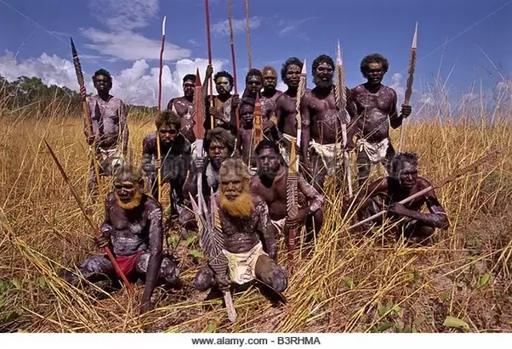

Document 2: Establishing a Penal Colony by England

In 1788, the first Australian penal colony was established. Penal means to punish offenders under the legal system. The first 736 convicts banished from England to Australia landed in Botany Bay. With the American victory in the Revolutionary War, criminals could no longer be shipped off across the Atlantic. Convicts were chained beneath the deck during the entire six-month voyage. The first voyage claimed the lives of nearly 10 percent of the prisoners and was very stressful. Only a small amount were transported for violent offenses. Among the first group was a 70-year-old woman who had stolen cheese to eat.

Statement: England established a colony in Australia as a vacation spot. They liked Australia for its warm climate and nice beaches.
Agree ___________ Disagree _____________
Document-Based Evidence:
____________________________________________________________________________________________________________________________________________________________________________________________________________________________________________________________________________________
Source: https://www.history.com/this-day-in-history/first-australian-penal-colony-established
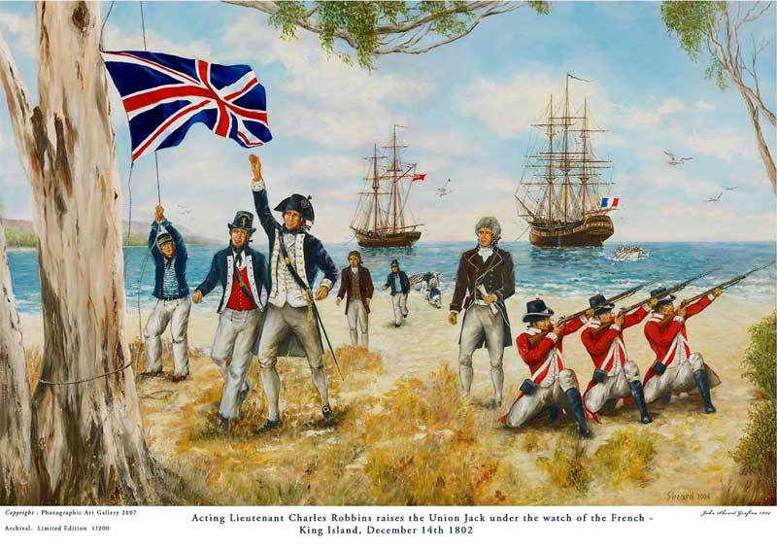
Document 3: Australia Was Made Part of the British Empire

Australia was originally named New South Wales when Captain James Cook sailed along 2,000 miles of the east coast in 1770, landing at Botany Bay (as named by him). He claimed the coastline for the British crown. Australia was an untouched, empty continent that the British could occupy without opposition.Transportation of convicts to Australia ended in 1840, by which time the colony was well established as the home of free people. The various British colonies became “Australia” in 1901.

Reference: https://owlcation.com/humanities/Why-Great-Britain-Colonized-Australia

Statement: The British faced intense opposition when they landed at Australia. The Dutch, Spanish, and French explorers all claimed ownership of the land.

Agree ________________ Disagree _________________

Document-Based Evidence

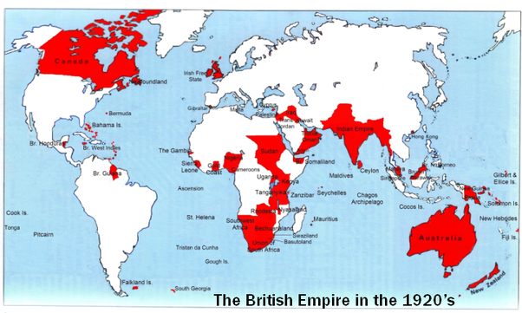
_______________________________________________________________________________________________________________________________________________________________________________________________________________

Historical Events that helped shape Melbourne Today
Journal Entry

Directions: In your own words, how did each historical event shape Australia today? Which historical event do you feel most shaped Australia to be what it is today and why? Be sure to include 3 key details. Use information discussed in class during visual discovery and read and retell!

Historical  Accuracy  (6 points) | Contains five accurate facts from the reading. | Contains three to four accurate facts from the reading. | Contains no accurate facts from the reading.
Relevance  (2 points) | The words or phrases recorded are relevant to the reading and aid in deciphering the main idea of the passage. | Some of the words or phrases are relevant to the reading. | None of the words or phrases are relevant to the reading.
Attention to Detail  ( 2 points) | The words or phrases that are recorded accurately depict what the passage is saying and originate directly from reading the passage. | The words or phrases are partly from the reading or recreated using synonyms. | The words or phrases written down do not help in deriving meaning from the passage.
Rubric for Read and Retell
Name_________________________ Points (10) ______ Course Points______

Time Travel Voki: http://tinyurl.com/ycr9u7ug

Additional Documents for Enrichment Students

First Stop On Our Time Machine: 40,000 BC The Founding of Australia by Aborigines
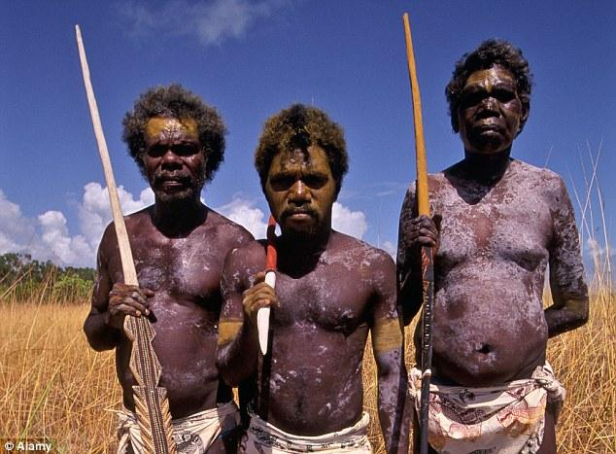

40,000 BC The first Aborigines arrive from south-east Asia. By 20,000 BC they have spread throughout the mainland and Tasmania. Aborigines are indigenous to Australia. The artistic, musical and spiritual traditions they established are among the longest surviving such traditions in human history. They are similar to the Native Americans of the United States.

Second Stop: Establishing a Penal Colony by England in 1788

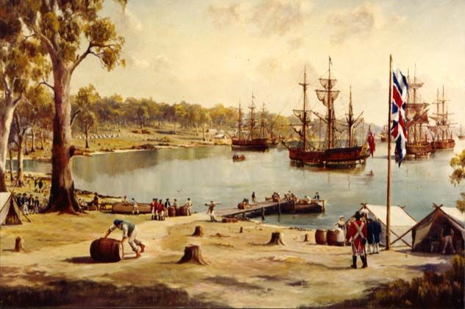

British Navy captain Arthur Phillip founds a penal settlement at Sydney. He had arrived through Botany Bay with a fleet of 11 vessels, carrying nearly 800 convicts. The Aboriginal population at the time is thought to number several hundred thousand.

Third Stop: Australia Made Part of British Empire

The transportation of convicts to Australia ended in 1840. Australia was made part of the British empire in 1901. Australia is a federation, a constitutional monarchy, and a parliamentary democracy. This means that Australia has a Queen, who resides in the United Kingdom and is represented in Australia by a Governor-General.
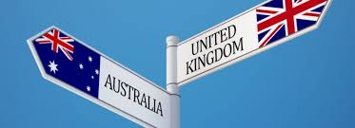

References

First Australian Penal Colony Established. (n.d.). Retrieved from https://www.history.com/this-day-in-history/first-australian-penal-colony-established

Welch, D. M. (2017, February 24). Introduction to Australia's Aboriginal Culture. Retrieved April 25, 2018, from http://www.aboriginalculture.com.au/introduction3.html

Welford, J. (2017, March 26). Why Great Britain Colonized Australia. Retrieved from https://owlcation.com/humanities/Why-Great-Britain-Colonized-Australia

