Molloy College
Division of Education

Lesson Plan Template

Michelle Grant Dr. Sheehan
EDU 351.01 April 5, 2018
Grade 5 Puerto Rico Social Studies

INSTRUCTIONAL OBJECTIVES

After being taught the SCIM-C Method, students will observe four different documents while participating in a group discussion based on Puerto Rico’s history, and will use the SCIM-C method to determine if what they learned about Puerto Rico is valid. Students will then complete an exit ticket answering the question “Was the information taught about Puerto Rico valid, why or why not? Include two examples from the document to support your answer.”

NYS-CCLS / +NYS STANDARDS AND INDICATORS
New York State Social Studies Standard
Key Idea: 5.4 GEOGRAPHY IN THE WESTERN HEMISPHERE: The diverse geography of the Western Hemisphere has influenced human culture and settlement in distinct ways. Human communities in the Western Hemisphere have modified the physical environment.
Key Concepts: 5.4c The physical environment influences human population distribution, land use, and other forms of economic activity.
Indicator: This will be evident when students answer SCIM-C questions on documents about the Spanish American War, hurricanes and their effects, founding with Columbus and river of Gold, and the movement to make Puerto Rico a state.
Key Idea: 5.5 COMPARATIVE CULTURES: The countries of the Western Hemisphere are diverse, and the cultures of these countries are rich and valid. Due to their proximity to each other, the countries of the Western Hemisphere share some of the same concerns and issues.
Key Concepts: 5.5b Counties in the Western Hemisphere face a variety of concerns and issues specific to the region.
Indicator: This will be evident when students answer SCIM-C questions on documents about the Spanish American War, hurricanes and their effects, founding with Columbus and river of Gold, and the movement to make Puerto Rico a state.
National Social Studies Standards and Themes
Culture: Social studies programs should include experiences that provide for the study of culture and cultural diversity.
- Human beings create, learn, share, and adapt to culture.
- Cultures are dynamic and change over time.
- Through experience, observation, and reflection, students will identify elements of culture as well as similarities and differences among cultural groups across time and place.
- In schools, this theme typically appears in units and courses dealing with geography, history, sociology, and anthropology, as well as multicultural topics across the curriculum.

Indicator: This will be evident when students analyze documents and answer SCIM-C questions based on how the information depicted in the documents effected Puerto Rican culture.

Individual Development & Identity: Social studies programs should include experiences that provide for the study of individual development and identity.
- Personal identity is shaped by an individual’s culture, by groups, by institutional influences, and by lived experiences shared with people inside and outside the individual’s own culture throughout her or his development.
- Questions related to identity and development, which are important in psychology, sociology, and anthropology, are central to the understanding of who we are.
- The study of individual development and identity will help students to describe factors important to the development of personal identity.

Indicator: This will be evident when students answer a specific set of questions, which will all be differentiated with different color markers. Everyone will answer different types of questions, which allows them to focus on their own thinking, rather than their peers.

NCSS C3 Inquiry Arc
Dimension 3: Students will work toward conclusions about societal issues, trends, and events by collecting evidence and evaluating its usefulness in developing causal explanations.
Indicator: This will be evident when students answer SCIM-C questions based on documents provided about Puerto Rico.
Dimension 4: Students will draw on knowledge and skills to work individually and collaboratively to conclude their investigations into societal issues, trends, and events and will present their information, portions, and findings.
Indicator: This will be evident when students work collaboratively and individually to research a document while all answering specific sets of questions based on the SCIM-C method.

Next Generation ELA Standards
5th grade reading standard: Craft and Structure
5R4: Determine the meaning of words, phrases, figurative language, academic, and content-specific words and analyze their effect on meaning, tone, or mood.
Indicator: This will be evident when students analyze pictures and documents to answer SCIM-C method-based questions.
5th grade writing standard: Text Types and Purposes
5W1b: Provide logically ordered reasons that are supported by facts and details from various sources.
Indicator: This will be evident when students answer questions based on a document.
5th grade speaking and listening standard:
5SL1: Engage effectively in a range of collaborative discussions with diverse partners; express ideas clearly and persuasively and build on those of others.
Indicator: This will be evident when students discuss their answers to SCIM-C questions in their groups.

Social Studies Practices: Habits of Mind
A. Gathering, Interpreting, and using Evidence
2. Recognize and effectively select different forms of evidence used to make meaning in social studies (including primary and secondary sources such as art and photographs, artifacts, oral histories, maps, and graphs).
Indicator: This will be evident when students analyze primary and secondary sources.

INSTRUCTIONAL RESOURCES

- CHAMPS rules
- Different color markers (4 of each color)
- Documents (4)
- Power Point
- SMARTboard
- Exit tickets
- SCIM-C sheet
- Tape
- Big paper
- Homework

MOTIVATION

The teacher will discuss with students that the Civil War is called the War of Northern Aggression in the South, which implies a bias. The teacher will then connect this to convey the message that not all sources are accurate; it is our job as historians to do research on our sources and the SCIM-C method can help us do that.

DEVELOPMENTAL PROCEDURES

1: Students will go over the homework from last night (Are there any questions?)
2: Students will review CHAMPS classroom rules.
The teacher will show a power-point introducing the SCIM-C Method. And briefly explaining what each letter stands for. (SCIM-C stands for Summarizing, Contextualizing, Inferring, Monitoring, and Corroborating)
3: Students will be divided into 4 groups, each group receiving a different document.
4: Students will have a group discuss while using the SCIM-C method to answer the key question: “Was the information about Puerto Rico that you learned yesterday valid?” while all having different colored markers to represent their task.
5: Students will switch with members of different groups and discuss what they learned.
6: Students will complete an exit ticket answering the question: “Was the information taught about Puerto Rico valid, why or why not? Include two examples from the document to support your answer.”
7: Students will receive their homework for the night that will be reviewed in class the following morning.

INSTRUCTIONAL STRATEGIES
1. Discussion
This will be evident when the students discuss their documents with their group members.
2. Scaffolding
This will be evident when the teacher briefly explains the meaning of the SCIM-C method before having students answer questions independently.
3. Collaboration
This will be evident when students work in groups to determine if the information provided to them is valid.
ADAPTATIONS

Students: John McDermott, Casey Smith, Nick Olson, Kelsey Johnson.

John McDermott: Struggling learner (ADD diagnosed- has trouble focusing).
John struggles to focus and attention will be re-focused and re-directed through use of specific non-verbal cues. During class discussion, the teacher looks at John and points to his/her eye as an indicator for John to focus.

Casey Smith: Grapho-motor challenges.
Casey profiles with grapho-motor challenges and will be provided with pencil grips during small writing assignments, such as answering SCIM-C questions.

Nick Olson: English Language Learner.
Nick is an English learner and will be provided with a peer buddy throughout all activities in the lesson.

Kelsey Johnson: Kelsey is advanced in her academics and will be required to write a short response (4-5 sentences) answering the question: What aspect of the SCIM-C method is her favorite and why?

DIFFERENTIATION OF INSTRUCTION

Struggling
Struggling students will be provided with example question and answers of the SCIM-C method.
Average
Average students will have example questions, but no answers of the SCIM-C method.
Advanced
Advanced students will be asked to answer two types of questions instead of one of the SCIM-C method.
Visual learners
Visual learners will benefit from the documents being displayed on the power point and on a big paper in front of them.
Auditory learners
Auditory learners will benefit from the group discussions during the analysis of their document.
ASSESSMENT

Students will use the SCIM-C method to answer specific questions based on a document provided to determine if the information they learned is valid, then they will complete an exit ticket.

INDEPENDENT PRACTICE

Homework: Students will be asked to compare two of the documents discussed in class and determine their similarities and differences.

FOLLOW-UP ACTIVITIES
Direct Teacher Intervention
The student, under direction instruction with the teacher will explain the SCIM-C method.
Academic Enrichment
The student will write a journal entry answering the question: “Do you feel the SCIM-C method is helpful to you while analyzing the validity of documents, why or why not?

REFERENCES

Puerto Rico electricity service slow to return after Hurricane Maria. (2017, October 24). Retrieved April 05, 2018, from https://theamericanenergynews.com/usa/puerto-rico-electricity-hurricane-maria
Statehood likely to win overwhelming majority in Puerto Rico status vote. (2017, June 08). Retrieved April 05, 2018, from https://pasquines.us/2017/06/08/statehood-likely-win-overwhelming-majority-puerto-rico-status-vote/
TOP 25 QUOTES BY CHRISTOPHER COLUMBUS (of 56). (n.d.). Retrieved April 05, 2018, from http://www.azquotes.com/author/3151-Christopher_Columbus
USS Maine Sinks In Havana Harbor February 15, 1898. (n.d.). Retrieved April 05, 2018, from http://www.vfwpost7916.org/archives/uss-maine-sunk-in-havana-harbor-february-15-1889/

SCIM-C

Summarizing
What type of historical document is the source?
What specific information, details, and/or perspectives does the source provide?
What is the subject, audience, and/or purpose of the source?
Who was the author and/or audience of the source?

Contextualizing
When and where was the source produced?
Why was the source produced?
What was happening within the immediate and broader context at the time this source was produced?
What summarizing information can place the sources in time, space, and place?

Inferring
What is suggested by the source?
What interpretations may be drawn from the source?
What perspectives are indicated in the source?
What inferences may be drawn from absences or omissions in the source?

Monitoring
What additional evidence beyond the source is necessary?
What ideas, images, or terms need further defining from the source?
How useful or significant is the source for its intended purpose in answering the historical question?
What questions from the previous stages need revisiting to analyze the source successfully?

Corroborating
What similarities and differences between the sources exist?
What factors could account for the similarities and differences?
What conclusions can be drawn from the accumulated interpretations?
What additional information or sources are necessary to answer more fully the guiding historical question?

"Gold is a treasure, and he who possesses it does all he wishes to in this world and succeeds in helping souls into paradise." ~ Christopher Columbus

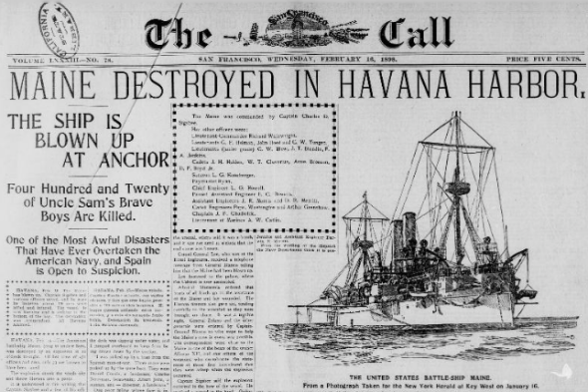

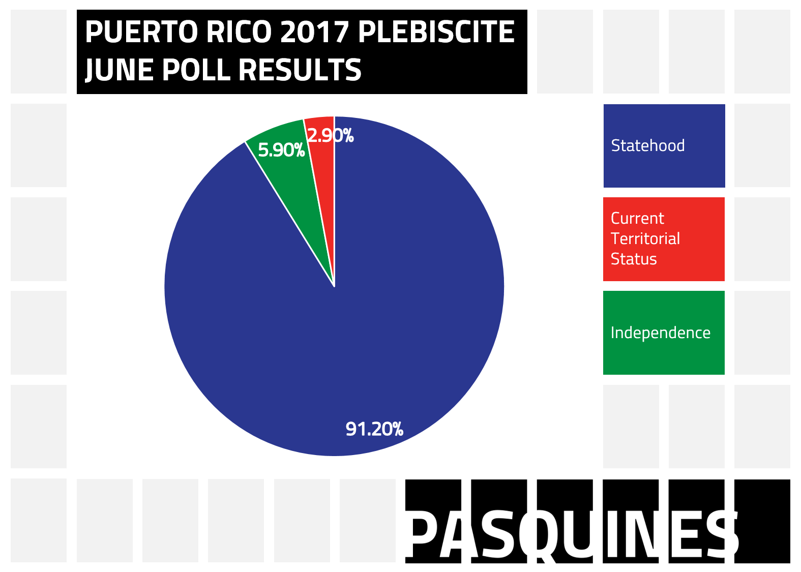
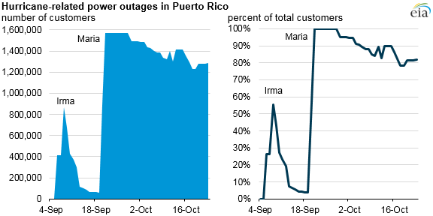
Homework
Directions: Compare two documents of your choice discussed in class today and determine the similarities and differences.
"Gold is a treasure, and he who possesses it does all he wishes to in this world and succeeds in helping souls into paradise." ~ Christopher Columbus

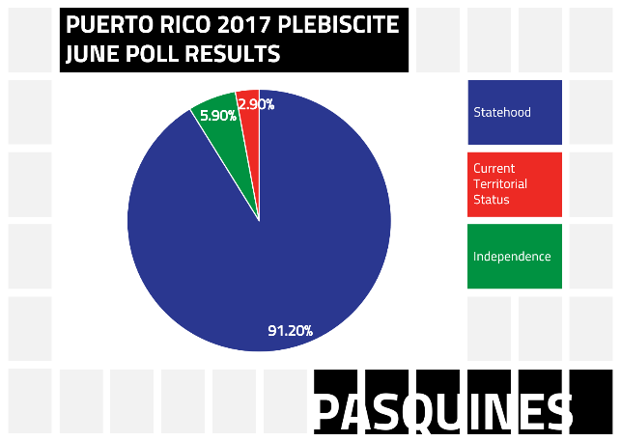

.
Exit Ticket

Was the information taught about Puerto Rico valid, why, or why not? Include two examples from the document to support your answer.

.

