Molloy College
Division of Education
Student: Sarah Grzybowski Dr. Sheehan
Course: EDU 5090 Date: November 29, 2018
Grade: 2 Topic: Urban Communities Content Area: Social Studies

INSTRUCTIONAL OBJECTIVES
After taking a bus tour of an urban community, students will integrate and evaluate information presented in diverse media formats, including visually, quantitatively, and orally by creating a poster of two advantages and one disadvantage of living in an urban community. Students will score a 3 out of 4 on a teacher created rubric.

STANDARDS AND INDICATORS
New York State Social Studies Standards
Key Idea:
2.1 A community is a population of various individuals in a common location. It can be characterized as urban, suburban, or rural. Population density and use of the land are some characteristics that define and distinguish types of communities.
Key Concepts:
2.1a An urban community, or city, is characterized by dense population and land occupied primarily by buildings and structures that are used for residential and business purposes.

Indicator: This will be evident when the students create a poster depicting two advantages and one disadvantage of living in an urban community with relevant facts.

National Social Studies Standards and Themes
III. People, Places and Environments: Social studies programs should include experiences that provide for the study of people, places, and environments so that the learner can:
- describe how people create places that reflect ideas, personality, culture, and wants and needs as they design homes, playgrounds, classrooms, and the like;
- examine the interaction of human beings and their physical environment, the use of land, building of cities, and ecosystem changes in selected locales and regions;
Indicator: This will be evident when students examine the interaction of human beings and the physical environment of an urban community to create a poster depicting two advantages and one disadvantage of living in an urban community.

NCSS C3 Inquiry Arc
-Dimension 3: Students will work toward conclusions about societal issues, trends, and events by collecting evidence and evaluating its usefulness in developing casual explanations.
Indicator: This will be evident when students collect evidence to determine two advantages and one disadvantage of living in an urban community.
-Dimension 4: Students will draw on knowledge and skills to work individually and collaboratively to conclude their investigations into societal issues, trends, and events and will present their information, portions and findings.
Indicator: This will be evident when students work individually and collaboratively to conclude two advantages and one disadvantage of living in an urban community and present their findings.

Common Core ELA Standards
CCSS.ELA-LITERACY.SL.2.1
Prepare for and participate effectively in a range of conversations and collaborations with diverse partners, building on others’ ideas and expressing their own clearly and persuasively.
Indicator: This will be evident when students work collaboratively sharing their own ideas and listening to the ideas of peers during the bus tour.
CCSS.ELA-LITERACY.SL.2.2
Integrate and evaluate information presented in diverse media formats, including visually, quantitatively, and orally.
Indicator: This will be evident when students integrate and evaluate information from the bus tour to create their posters and then share their findings.

Social Studies Practices: Habits of Mind
C. Comparison and Contextualization
1. Identify a region in the Western Hemisphere by describing a characteristic that places within it have in common, and then compare it to other regions. Understand how regions can be defined as sharing common characteristics in contrast with other regions.
Indicator: This will be evident when students are able to compare their feelings towards life in urban communities versus other communities on a Venn diagram to determine two advantages and one disadvantage.
INSTRUCTIONAL RESOURCES
- SMART Board
- White board
- Google Docs Presentation
- Virtual Bus Tour Presentation
- Metro Card
- Venn Diagram worksheet
- Poster Boards
- Markers, Pencils, Crayons
- Teacher created rubric
- Exit ticket
MOTIVATION
Students will receive a Metro Card that they will use to board the subway bus of their virtual field trip. By traveling in a subway, students will discover important attractions and elements of urban communities. A quick video of a subway station will start off the virtual field trip.

DEVELOPMENTAL PROCEDURES
- Students will board the virtual subway with their Metro Card tickets. Once swiping their card, they will be divided into 5 pre-determined groups based on their “destination”.
- Students will participate in the bus tour of an urban community. During the bus tour, each destination group will recite observations and facts presented in each picture slide. The teacher will scribe the students’ findings on the white board.
- Students will reach their “destination” to conclude the bus tour. Students will be given a Venn diagram worksheet to individually assess and reflect on the scribed facts, categorizing them into advantages and disadvantages of living in an urban community.
- Students will respond to the question: “If you moved to the city, what are two advantages and one disadvantage of living in that urban community?” by creating a poster with 4 relevant facts.
- Students will present their posters to the class, explaining two pros and one con they would feel if they lived in an urban community.
- The completed posters will be hung up in the classroom for students to reflect on each other’s opinions and conclusions.

INSTRUCTIONAL STRATEGIES
Demonstration: This will be evident when then teacher guides the students on the bus tour and students complete the Venn diagram worksheet.
Cooperative Learning: This will be evident when students work in groups to develop and recite elements of an urban community during the bus tour.

ADAPTATIONS
-Impulsive students will be monitored through a Behavior Intervention Plan.
-Students with autism will be able to take breaks when they feel overwhelmed.
-Students who struggle to attend will be provided with manipulatives to help then focus.
-Visually impaired students will be given a front row seat on the bus tour to view the slideshow.
DIFFERENTIATION OF INSTRUCTION
-The students with technological strengths will have the opportunity to create a PowerPoint instead of a poster.
-Students with writing strengths will have the opportunity to write a short paragraph answering the question “If you moved to the city, what are two advantages and one disadvantage of living in that urban community?”
ASSESSMENT
Students will complete an exit ticket identifying if they would be happy living in an urban community and explain why or why not.

INDEPENDENT PRACTICE
After participating in the bus tour lesson, students will research 5 major urban communities in the world and write a paragraph of which one they like best, citing 3 reasons why.

FOLLOW-UP ACTIVITIES: DIRECT TEACHER INTERVENTION AND ACADEMIC ENRICHMENT
Direct Teacher Intervention: The teacher and students will, together, work on identifying elements of urban communities through a video presentation, stopping during important features. Students will complete the Venn diagram during the stopped breaks of the presentation.
Academic Enrichment: Students will create a bus tour of their hometown, showcasing four pros and two cons.
REFERENCES
New York State K-8 Social Studies Framework. (n.d.). Retrieved from https://www.engageny.org/resource/new-york-state-k-12-social-studies-framework
New York State P-12 Common Core Learning Standards for English Language Arts & Literacy . (n.d.). Retrieved from https://www.engageny.org/resource/new-york-state-p-12- common-core-learning-standards-for-english-language-arts-and-literacy

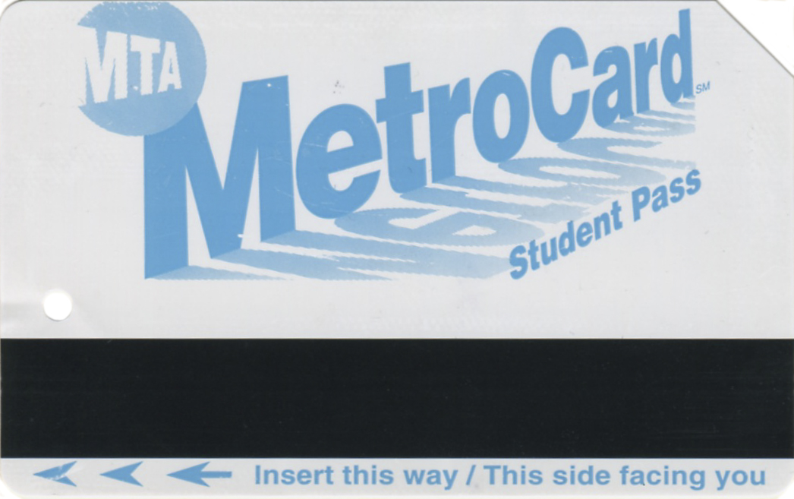

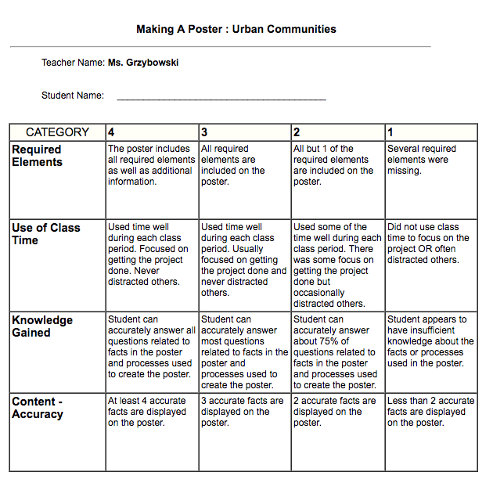

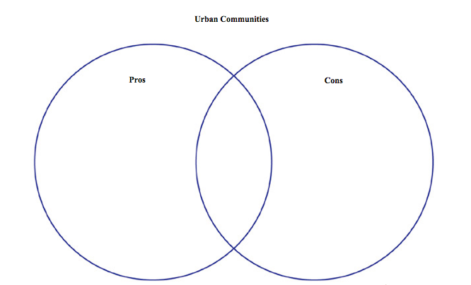

Exit Ticket
_______________________________________________________________________________
_____________________________________________________________________________________________________________________________________________________________________________________________________________________________________________

Would you be happy living in an urban community? Explain why or why not with two relevant facts.
Name: _______________________________

