Name: _________________________________ Date: __________________
GRADE: 7

Part III: This part consists of a document-based question. On this part, you will be provided with one version of the test based on your readiness to handle critical thinking challenges.

Document Based Question

Directions: The task below is based on documents 1 through 5-6. The task is designed to test your ability to work with documents. Examine each document and answer all questions beneath the document. Use the answers to the questions to help write your essay.

Background: This question asks you to form an opinion based on the evidence in the documents that follow. Although you may have your own opinion, based your answer on proving your position with the documents. You can add outside information

Task: Use the information from the documents and your knowledge of social studies, write an essay in which you answer:

● Discuss the role of hope in Americans after the Battle of Saratoga ?
● Discuss grit as the reason Americans could deal with harsh conditions at Valley Forge
● Evaluate whether success in the American Revolution was a product of the hope and and grit of the American people?

In your essay remember to
● Write an opinion essay, arguing whether people live a happier life in Mexico or America
● Include an introduction, a body, and a conclusion
● Use information from at least four documents in your answer

Document 1

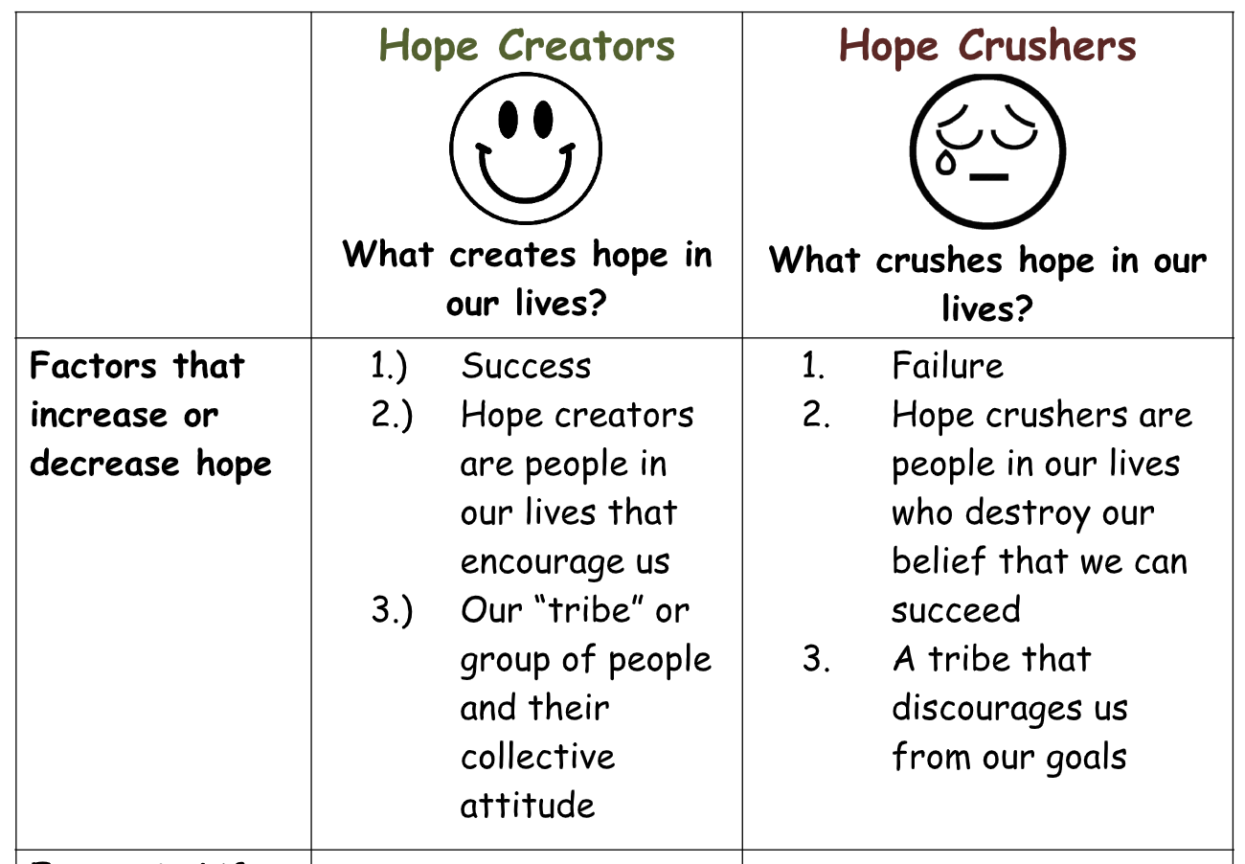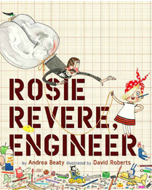

“...But Fred slapped his knee and he chuckled out loud. He laughed till he wheezed and his eyes filled with tears, all to the horror of Rosie Revere, who stood embarrassed, perplexed and dismayed.”

1. Based on the quote above, what are two ways that Rosie feel about her invention based on the actions of Fred?
A.________________________________________________[1]
B.________________________________________________[1]
2. Based on the chart and quote from the book, what happened to Rosie’s hope and why?
_________________________________________________________________________________________________________________________________________________________[2]

3.What are three ways that hope can be created?
______________________________________________________________________________________________________________________________________________________________________________________________________________________________________[3]

Document 2
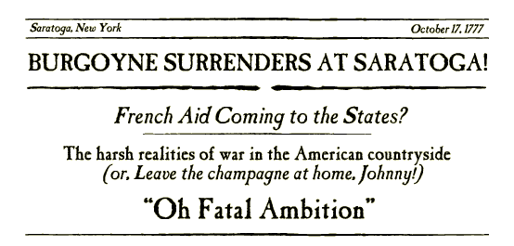
ment #2: Newspaper Headline: Burgoyne Surrenders!

Background:
British General John Burgoyne and his army of 7000 men surrender on October 17th 1777 to the American forces in Saratoga. (b)This victory is much more than it appears as this
will be the victory that shows the French that the American-cause is to be taken seriously.

Date: October 17th 1777

- How many British troops surrendered at the Battle of Saratoga according to the document above?
___________________________________________________________________________ [1]
- What effect does the American success at Saratoga have on the French?
___________________________________________________________________________________________________________________________________________________ [2]
3. Based on the document above and chart in document 1, how might the actions of the French after the Battle of Saratoga affected Americans hope for success in the war? Why?
_______________________________________________________________________________________________________________________________________________________ [2]

Document 3: THE DECLARATION OF INDEPENDENCE

We hold these truths to be self-evident, that all men are created equal, that they are endowed [given] by their Creator with certain unalienable [not to be altered or changed] Rights, that among these are Life, Liberty and the pursuit of Happiness.

Source: Library of Congress
Date: July 4th 1776

1. Based on the document above, what three unchangeable rights does the Declaration suggest everyone should have?
____________________________________________________________________________________________________________________________________________________________
___________________________________________________________________________ [3]

- Based on the quote above, do you think the the English motivation for victory in the war was as great as the American motivation? Why? Who had the greater motivation?
____________________________________________________________________
__________________________________________________________________ [2]

3. ?How might the above document affect the colonist’s hope Why? (2)
______________________________________________________________________
___________________________________________________________________ [2]

Document #4: Salt in His Shoes
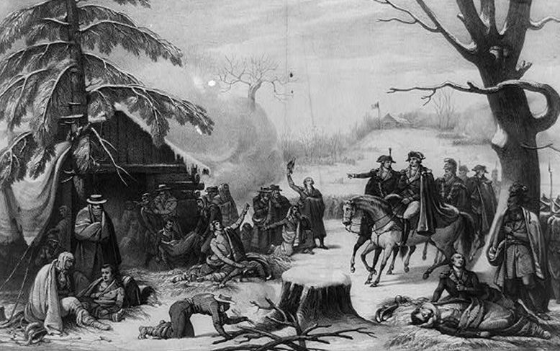

“But you are a great player, son. And you already have everything it takes to be a winner, right in here.” Daddy tapped Michael on his chest. “Being taller may help you play a little better, but not as much as practice, determination, and giving your best will. Those are the things that make you a real winner.”
Salt in his Shoes
-Deloris Jordan

Grit = Passion for a Long Term Goal + Perseverance for a Long Term Goal
Angela Duckworth
1. According to this excerpt from the book, what is Michael Jordan’s father trying to tell him about what it takes to be successful in basketball?
_________________________________________________________________________________________________________________________________________________________[2]
2. According to the quote above by Angela Duckworth, what inspired Michael Jordan’s perseverence and work ethic?
______________________________________________________________________________
__________________________________________________________________________ [2]
3. Based on the above documents, how might the grit Americans displayed during the Valley Forge relate to the grit of Michael Jordan?
__________________________________________________________________________________________________________________________________________________________[2]

Document #5: Soldiers standing in snow-covered military camp [possibly] at Valley Forge

Background: Men at Valley Forge continue to soldier on despite intense weather conditions. Some soldiers are seen working in the back while others surround a fire for a brief moment of warmth. In the bottom image, men seem to be severely injured or worn out.

Source: Library of Congress Date: (1920)

1. According to the document, what are two hardships the Americans faced at Valley Forge?
______________________________________________________________________________
___________________________________________________________________________[2]

3. What role might the passion for independence have played in helping the colonists tolerate the conditions at Valley Forge?
______________________________________________________________________________
___________________________________________________________________________[2]

Document #6: The Americans Pushing Back the British from Saratoga.

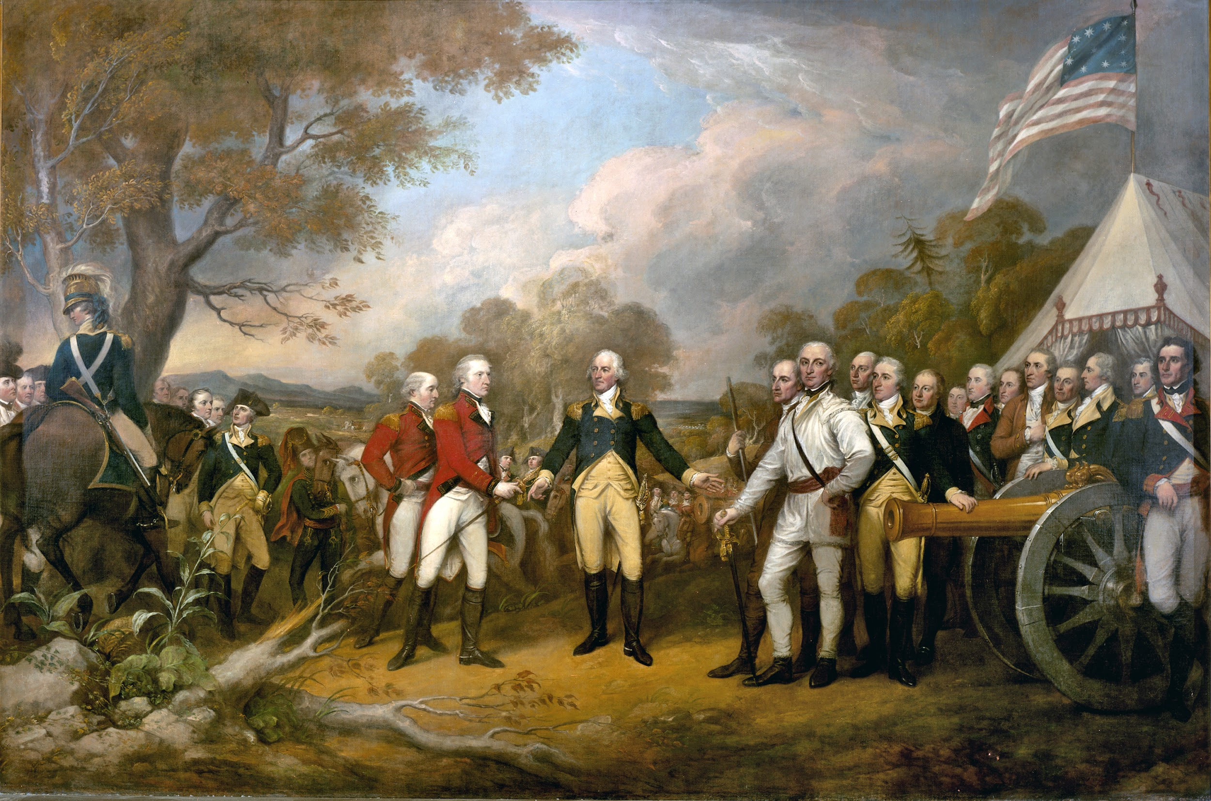
The line it broke, the British ran,
the minutemen gave chase.
Past their camp, they took the plunder, seizing those lost in haste.
Redcoats ran to Old Saratoga,
a frightful, desperate race.
They settled in to lick their wounds,
hoping hard to hold that place,
but the minutemen gave chase

Background: The Battle of Saratoga started with the British trying to split the Americans, but they were unable to divide their forces. The Americans were able to push back the British, and continued to put pressure on their troops. The Revolutionaries eventually forced the British into a surrender at Saratoga.

1. What lines in the poem above about the British soldiers in the Battle of Saratoga might have incereased the hope of the colonists for victory?
______________________________________________________________________________
______________________________________________________________________________
___________________________________________________________________________[2]
2. How might the lines in this poem affected the American belief that they could win the war?
_____________________________________________________________________________
______________________________________________________________________________
___________________________________________________________________________[2]

Document #7: Conditions at Valley Forge
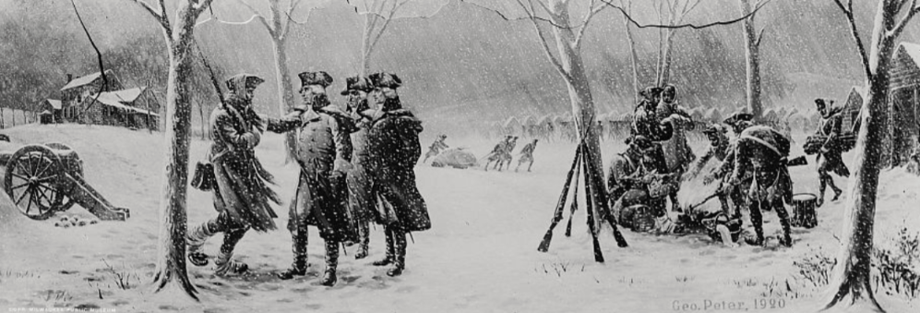
"Let it be told to the future world, that in the depth of winter, when nothing but hope and virtue could survive, that the city and the country, alarmed at one common danger, came forth to meet and to repulse it."
- The Crisis, Thomas Paine (1780)

1. According to The Crisis, what are the only two things Thomas Paine says can survive at Valley Forge?
______________________________________________________________________________
___________________________________________________________________________ [2]

2. According to The Crisis, , what was the city and country alarmed at and what did the city and country do about it?
______________________________________________________________________________
______________________________________________________________________________
___________________________________________________________________________[2]

3. How might the lines in this poem affected the American hope that they could win the war?
_____________________________________________________________________________
___________________________________________________________________________[2]
Task: Use the information from the documents:

Directions: The task below is based on documents 1 through 5. The task is designed to test your ability to work with documents. Examine each document and answer all questions beneath the document. Use the answers to the questions to help write your essay.

Background: This question asks you to form an opinion based on the evidence in the documents that follow. Although you may have your own opinion, based your answer on proving your position with the documents. You can add outside information

Task: Use the information from the documents and your knowledge of social studies, write an essay in which you:

● Discuss the role of hope in after the Battle of Saratoga ?
● Discuss grit as the reason Americans could deal with harsh conditions at Valley Forge
● Evaluate whether success in the American Revolution was a product of the hope and and grit of the American people?

In your essay remember to
- Write an opinion essay, arguing whether people live a happier life in Mexico or America
- Include an introduction, a body, and a conclusion
- Use information from at least four documents in your answer
- Include historical facts, relevant details, and reason in developing your ideas

DBQ Scoring Rubric
(From the Revised Generic Scoring Rubric for Regents Examinations.)

Score of 5 | *Thoroughly develops all aspects of the task evenly & in depth | *Is more analytical than descriptive (applies, analyzes, evaluates, & creates information) | *Incorporates relevant information from at least the requested number of documents | *Incorporates substantial relevant outside information | *Richly supports the theme with many relevant facts, examples, & details | *Demonstrates a logical & clear plan of organization; includes and introduction & conclusion that are beyond a restatement of the theme
Score of 4 | *Develops all aspects of the task but may do so somewhat unevenly | *Is both descriptive & analytical (applies, analyzes, evaluates, and/or creates information) | *Incorporates relevant information for at least the requested number of documents | *Incorporates relevant outside information | *Supports the theme with relevant facts, examples, & details | *Demonstrates a satisfactory plan of organization; includes an introduction & a conclusion that are beyond a restatement of the theme
Score of 3 | *Develops all aspects of the task with little depth or develops most aspects of the task in some depth | *Is more descriptive than analytical (applies, may analyze and/or evaluate information) | *Incorporates relevant information from some documents | *Incorporates limited relevant outside information | *Includes some relevant facts, examples, & details; may include some minor inaccuracies | *Demonstrates a satisfactory plan of organization; includes an introduction & a conclusion that may be a restatement of the theme
Score of 2 | *Minimally develops all aspects of the task or develops some aspects of the task in depth | *Is primarily descriptive; may include faulty, weak, or isolated application or analysis | *Incorporates limited relevant information from the documents or consists primarily of relevant information copied from the documents | *Presents little or no relevant outside information | *Includes few relevant facts, examples, & details; may include some inaccuracies | *Demonstrates a general plan of organization; may lack focus; may contain digressions; may not clearly identify which aspect of the task is being addressed; may lack an introduction an/or an conclusion
Score of 1 | *Minimally develops some aspects of the task | *Is descriptive; may lack understanding, application, or analysis | *Makes vague, unclear references to the documents or consists primarily of relevant & irrelevant information copied from the documents | *Presents no relevant outside information | *Includes few relevant facts, examples, or details; may include inaccuracies | *May demonstrate a weakness in organization; may lack focus; may contain digressions; may not clearly identify which aspect of the task is being addressed; may lack an introduction and/or a conclusion
Score of 0 | *Fails to develop the task or may only refer to the theme in a general way; OR includes no relevant facts, examples or details; OR includes only the historical context and/or task as copied from the test booklet; OR includes only entire documents copied from the test booklet; OR is illegible: OR is a blank paper

