How Can Citizens Demonstrate Proactive, Civic Engagement?

What Can We Do as Informed Citizens to Impact the Problem of Climate Change?

(Compelling Questions)

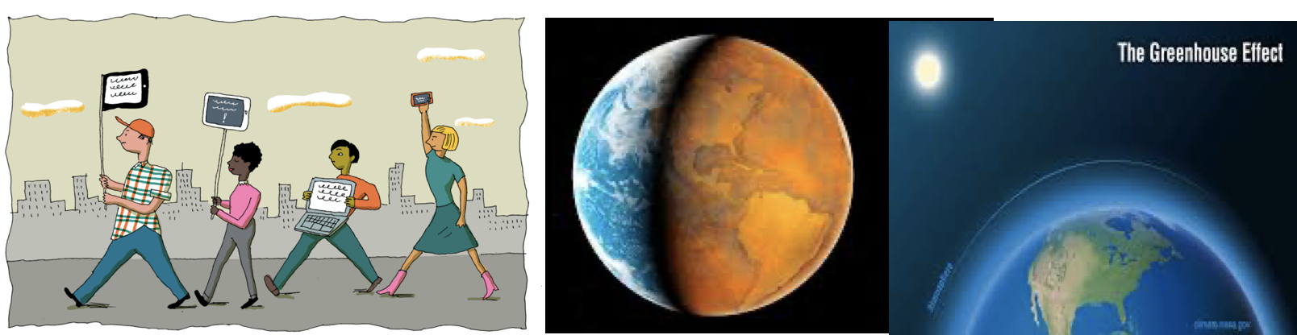

Compelling Question:

How Can Citizens Demonstrate Proactive, Civic Engagement?
What Can We Do as Informed Citizens to Impact the Problem of Climate Change?

Staging the Question:

Guiding Questions:
- Who is the most important one?
- What is the right thing to do?
- When is the best time to do things?

Materials:

- The Three Questions by Jon J. Muth
- Say Something by Peggy Moss
- Carl the Complainer by Michelle Knudsen -
- Just a Dream by Chris Van Allsburg -

Standards and Practices:
Civic Literacy: 2017 Standards for Preparing Social Studies Teachers
Standard 5: Professional Responsibility
Candidates will expand on their knowledge, inquiry skills, and civic dispositions to advance social justice and promote human rights through informed action in schools and/or communities.

Next Generation Science Standards:

HS-ESS3-4. Evaluate or refine a technological solution that reduces impacts of human activities on natural systems. (NCA-related content: Mitigation, Adaptation)

Global climate models used to predict changes continue to be improved, although discoveries about the global climate system are ongoing and continually needed.

- Supporting Question:  WHAT IS THE DIFFERENCE BETWEEN WEATHER AND CLIMATE? | Formative Tasks:  Your Lesson Objective  After watching the video, What’s the  Difference Between Weather and  Climate? and participating in class  discussions on weather and climate,  students, in small groups, will create a  Venn diagram differentiating between  weather and climate. Mastery will be determined by achieving ⅘ on a teacher-designed  checklist. | Sources:  (2018, September 28). What’s the Difference Between Weather and Climate?[Video File]. Retrieved From.  https://www.youtube.com/watch?v=vH298zSCQzY  What is the Difference Between Weather and Climate? What is Climate?  From.  https://www.eo.ucar.edu/kids/green/what1.htm.  Teacher Created Checklist
2. Supporting Question:  WHAT IS CLIMATE CHANGE? | Formative Tasks:  Your Lesson Objective  After watching a teacher demonstration, a video titled What is Climate Change?, participating in a class discussion, and an interactive Smart Board activity, students will apply their knowledge on the Causes and Effects of Climate Change Worksheet to explain the possible causes of climate change on three out of four different climate change pictures with relevant, accurate justification. | Sources:  What is Climate Change? Video: (https://www.youtube.com/watch?v=ko6GNA58YOA)

3. Supporting Question:  WHAT ARE GREENHOUSE GASES? WHAT IS THE EFFECT ON OUR PLANET AND GLOBAL WARMING? | Formative Tasks:  Your Lesson Objective  After discussing images from  Just A Dream and watching a video on greenhouse gasses, students will identify the impact of greenhouse gasses on the environment by scorning no less than an 8/10 on a teacher-designed Kahoot. | Sources:  Learning junction. (2018).Greenhouse Effect video for Kids | The Greenhouse Effect. On YouTube. Retrieved from https://www.youtube.com/watch?v=DYHAZaasdxI  Van Allsburg, C., n.d. Just A Dream.

4. Supporting Question:  WHAT ARE THE IMPACTS OF GLOBAL WARMING? | Formative Tasks:  Your Lesson Objective  After watching Climate Change Animation Shows Devastating Effects, participating in a Think-Pair-Share, actively engaging in class discussions and small group activities, students will analyze and explain the effects of global warming on our planet by correctly connecting 8 out of 10 images to relevant vocabulary/terms listed on the Impacts of Climate Change Worksheet. | Sources:  Climate Change Animation Shows Devastating Effects:  https://www.youtube.com/watch?time_continue=109&v=S7jpMG5DS4Q&feature=emb_title  https://www.thinglink.com/scene/1291101848379326466  Teacher Made Charts

5. Supporting Question:  WHAT ARE SOME CIVIC ACTIONS THAT STUDENTS ARE TAKING TO ATTACK THE PROBLEM OF CLIMATE CHANGE? | Formative Tasks:  After watching and discussing the video, “Nature Now” and participating in a class discussion on Earth Day 2020 (Climate Action), students will participate in small group activities to develop Action Plans to attack the problem of global warming. Mastery will be determined by a score ⅘ on a teacher designed Action Plan Checklist. | Sources:  Nature Now Video:  https://www.youtube.com/watch?v=-S14SjemfAg

6. Supporting Question:  WHAT ARE THE WAYS WE CAN MAKE A DIFFERENCE IN CLIMATE CHANGE AS  PROACTIVE CITIZENS? | Formative Tasks:  Your Lesson Objective  Based on a teacher directed exploration of Time, Talent, Treasure, and Teaching, participation in group activities, and a group vote, students, as a team, will apply their time, talent, treasure to select and refine their project action plan. | Sources:  Global Change Handbook: http://cdn.worldslargestlesson  Time, Talent and Treasure Worksheets  .globalgoals.org/2016/09/Blue-Capes-Global-Game-Changers-Global-Goals-Lesson-FINAL.pdf

7. Supporting Question:  WHAT ARE THE STEPS THAT WE NEED TO TAKE AS A GROUP TO BRING OUR ACTION PLAN TO LIFE? | Formative Tasks:  Your Lesson Objective  After watching “10 Things I Can Do to Help My World” by Melanie Walsh and participating in a group discussion, playing the Heart Power Card game, brainstorming topics for their team trifold boards, and participating in small group activities, students will analyze, plan and complete the “Steps to My Project” Worksheet with 90% accuracy based on a teacher-designed checklist to assess the key points of the activity. | Sources:  Calling All Heroes! Blue Capes: Global Game Changers. (n.d.). Retrieved March 28,2020, from  http://cdn.worldslargestlesson.globalgoals.org/2016/09/Blue-Capes-Global-  Game-Changers-Global-Goals-Lesson-FINAL.pdf  Roberts, Abby. [Youtube]. (2017, July 26). 10 Things I Can Do to Help My World by Mel  Walsh. Retrieved from https://www.youtube.com/watch?v=xTN6T74W4L8

8. Supporting Question:  WHAT ARE WHAT ARE THE WAYS THAT WE CAN SHARE THIS PROJECT WITH THE WORLD? | Formative Tasks:  Your Lesson Objective  After viewing a brief video, engaging in a class discussion about Earth Day and brainstorming ideas on how students can share their information on climate change with others, students will create their “Civic Action Project Plan” inclusive of specific steps to be completed, materials needed, and detailed roles and responsibilities of participating members. Mastery will be assessed on the completion of the Civic Action Project Plan worksheet with no less than eight steps addressed. | Sources:  - Video: Ten Things I Can Do to Help the World  https://www.youtube.com/watch?v=6WA8FpGI5Sw  - Worksheet: Steps To My Project http://cdn.worldslargestlesson.globalgoals.org/2016/09/Blue-Capes-Global-Game-Changers-Global-Goals-Lesson-FINAL.pdf  - Teacher made charts

Summative Performance Task:

The students will present their civic action plans to attack climate change in their assigned unit groups. One of these presentations will be directed at the Molloy Education and Human Services Division and a second presentation will be delivered to a cohort of seventh and eighth grade students from the De La Salle School in Freeport.
Extension:

This unit plan has been adapted to meet the needs of diverse students through a set of Include Strategy Sheets that are not attached to this unit plan to protect the privacy of the students involved. These sheets provide the basis for the designed differentiation that shapes each lesson, based on Universal Design for Learning. The strategy sheets also provide the framework for the personal adaptations that have extended the ability of this plan to meet the needs of all learners.
.
Taking Informed Action:

Dr. Mubina Schroeder will make a presentation on the efforts that the Molloy Campus is making in terms of sustainability and invite students to be a part of those efforts. Students will be given the opportunity to join the Molloy Sustainability Institute.

