GRADE: 5: Question 1

Is What We Have Learned About Mexican History True?

Student Name_____________________
Date______________________________

Part I: This part consists of a short answer question based on the new Regents Format. On this part, you will be provided with one version of the test based on your readiness to handle critical thinking challenges.

Document Based Question

Directions: The task below is based on documents 1 through 5-6. The task is designed to test your ability to work with documents. Examine each document and answer all questions beneath the document. Use the answers to the questions to help write your essay.

Background: The country of Mexico has had to struggle for its Independence over the years. This struggle involved conflicts in which many Mexicans gave their lives for the Independence of Mexico. Below you will be introduced to Mexicans who fought for Mexican Independence and freedom. Use your historical skills to connect these stories to Mexican Independence and to determine the credibility of the history that you have learned in this unit

This Short Answer Essay question is based on the accompanying documents and is designed to test your ability to work with historical documents. Each Short Answer Essay Question set will consist of two documents. These documents have been edited for the purposes of the question. Keep in mind that the languages and images used in the document may have been edited for the purposes of the question.

Task: Read and analyze the following documents, applying your knowledge of social studies and skills to write an essay of two or three paragraphs in which you:

- Describe the historical context surrounding the documents by explaining how the two documents are related. (Cause and Effect or Similarity or Difference)
- Analyze Document 1 and explain how the source, audience, and purpose relate this document to Document 2. Based on your analysis, is this document credible?

Describe means to” illustrate something in words or tell about it.”

Cause means “something that gives rise to something else, the rise of an idea, or brings about a development”

Effect refers to “what happens as a consequence (result, impact, outcome) of an event, an idea, or a development”

Similarity tells how “something is alike or the same as something else”

Difference tells “something is not alike or not the same as something else”

Historical Context refers to the historical circumstances surrounding or connecting the events, ideas, or developments in the documents

Analyze means to “examine a document and determine its elements and relationships”

Document 1

Mexican War of Independence
Cry of Dolores—Father Hidalgo 1816
Napoleon’s invasion and occupation of Spain from 1808 to 1813 heightened the revolutionary fervor in Mexico and other Spanish colonies. On September 16, 1810, Miguel Hidalgo y Costilla, a respected
Catholic priest, issued a passionate rallying cry known as the “Grito de Dolores” (“Cry of Dolores”) that amounted to a declaration of war against the colonial government. So named because it was publicly read in the town of Dolores, the Grito called for the end of Spanish rule in Mexico, the redistribution of land and a concept that the criollos’ earlier plans had deliberately omitted: racial equality.
“My Children, a new dispensation comes to us today…Will you free yourselves? Will you recover the lands stolen 300 years ago from your forefathers by the hated Spaniards? We must act at once.
Come march with us for country and religion…”
”The Grito de Dolores ("Cry of/from Dolores") was the battle cry of the Mexican War of Independence, uttered on September 16, 1810, by Miguel Hidalgo y Costilla, a Roman Catholic priest from the small town of Dolores, near Guanajuato, Mexico.

Document 2
Mexico's Plan of Iguala, 1821
On the eve of declaring independence from Spain, Mexican elites intended the Plan of Iguala to act as a compromise between Mexico's divided classes.

Article 1. The Mexican nation is independent of the Spanish nation, and of every other, even on its own Continent.
Article 2. Its religion shall be the Catholic, which all its inhabitants profess.
Article 3. They shall be all united, without any distinction between Americans and Europeans.

1821, Agustín de Iturbide, the leader of the Royalist forces, negotiated the Plan of Iguala with Vicente Guerrero. Under the plan,

Mexico would be established as an independent constitutional monarchy, the privileged position of the Catholic Church would be maintained, and Mexicans of Spanish descent would be regarded as equals to pure Spaniards. Mexicans of mixed or pure Indian blood would have lesser rights.
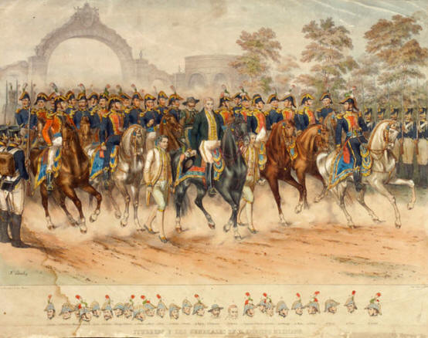

Parade of Impendence 1821

