Molloy College
Division of Education

Student Stefanie Amendoeira Dr. Sheehan
Course EDU 351 Date April 5th, 2018
Grade 5 Topic History of Puerto Rico Content Area Social Studies

INSTRUCTIONAL OBJECTIVES (s) (Lesson Objective(s)*)

After reading a passage about three historical events in Puerto Rico and participating in a read and retell literacy strategy, students will analyze how and why individuals, events, or idea develop and interact over the course of a text by partaking in a History Alive Act it Out based on the passage to determine how these events have shaped Puerto Rico today, and completing an exit slip about which event they feel mostly shaped Puerto Rico today scoring a three out of four on the teacher created History Alive rubric and including three details on the exit ticket.

NYS-CCLS / +NYS STANDARDS AND INDICATORS

NEW YORK STATE SOCIAL STUDIES STANDARDS
Key Idea:
5.4 GEOGRAPHY IN THE WESTERN HEMISPHERE: The diverse geography of the Western Hemisphere has influenced human culture and settlement in distinct ways Human communities in the Western Hemisphere have modified the physical environment.

Key Concepts:
5.4c The physical environment influences human population distribution, land use, and other forms of economic activity.

Indicator: This will be evident when students determine if where you live in the western hemisphere determines your happiness.

Key Ideas:
COMPARATIVE CULTURES: The countries of the Western Hemisphere are diverse and the cultures of these countries are rich and varied. Due to their proximity to each other, the countries of the western Hemisphere share some of the same concerns and issues.

Key Concepts:
5.5a The countries of the Western Hemisphere have varied characteristics and contributions that distinguish them from other countries.
5.5b Countries in the Western Hemisphere face a variety of concern and issues specific to the region.
Indicator: This will be evident when students evaluate how historical events that happened in Puerto Rico have shaped them today.

NATIONAL SOCIAL STUDIES STANDARDS AND THEMES
III. People, Places, & Environments: Social studies programs should include experiences that provide for the study of people, places, and environments, so that the learner can examine the interaction of human beings and their physical environment, the use of land, building of cities, and ecosystem changes in selected locales and regions;

Indicator: This will be evident when students learn of historical events and determine if they have shaped Puerto Rico today.

NCSS C3 Inquiry Arc
Dimension 2: Students will analyze societal issues, trends, and events by applying concepts and tools from civics, economics, geography, and history. Look with Lens and skills of the discipline.

Indicator: This will be evident when students learn about historical events in Puerto Rico and determine if the events have shaped Puerto Rico today discussing why and how.

NEW YORK STATE ENGLISH LANGUAGE ARTS STANDARDS

Key Ideas and Details

1. Read closely to determine what the text says explicitly and to make logical inferences from it, and cite specific textual evidence when writing or speaking to support conclusions drawn from the text.

Indicator: This will be evident when students retell and discuss the passages they read about historical events in Puerto Rico to determine which event helped shaped Puerto Rico the most in their opinion, and why.

3. Analyze how and why individuals, events, or ideas develop and interact over the course of a text

Indicator: This will be evident when students participate in an Act it Out of a historical event that happened in Puerto Rico.

Text Types and Purposes

3. Write narratives to develop real or imagined experiences or events, using effective technique, well-chosen details, and well-structured event sequences.

Indicator: This will be evident when students write a journal entry about the three historical events that occurred in Puerto Rico including three key details for each event and which event most helped shape Puerto Rico today.

SOCIAL STUDIES PRACTICES: HABITS OF MIND
A. Gathering, Interpreting, and using Evidence
2. Recognize and effectively select different forms of evidence used to make meaning in social studies (including primary and secondary sources such as art and photographs, artifacts, oral histories, maps, and graphs).

Indicator: This will be evident when students use historical information and pictures to make meaning and understanding of what occurred in a past event to determine if it helped shape Puerto Rico today.

INSTRUCTIONAL RESOURCES

- “Founding with Columbus and the rover of gold” Passage
- “Spanish American War” passage
- Movement of Puerto Rico to a state” passage
- Listen and Retell sheet
- History Alive; Act it Out rubric
- SMART board
- Power Point presentation
- Exit ticket
- Journal Entry
- https://www.youtube.com/watch?v=BUTiwhTuaN0

MOTIVATION (Engaging the learner(s)*)

Students will be told that they are going in a time machine. The time machine will take them back in time to three historical events that happened that helped shape Puerto Rico to what it is today.

DEVELOPMENTAL PROCEDURES
(Including Key Questions)

- Motivation: Students will be told that they are going in a time machine. The time machine will take them back in time to three historical events that helped shape Puerto Rico to what it is today. (What three events do you think we will be going back in time to? Why do you think these events are important in regards to Puerto Rico? What can you Infer happened during these events?)

- Teacher will go over rules of the lesson. (CHAMPS)

- Students and teacher will have a class discussion about the bus tour they took yesterday and what they remember seeing during their trip in Puerto Rico. (Where did you go on your bus tour through Puerto Rico? What do you remember seeing? What did the cities look like? What were the people like? Do you think there are events in history that made Puerto be like that today?)

- Students will be broken up into three groups. Each group will receive a different passage about a historical event that helped shape Puerto Rico today. The three historical events will be, The founding of Columbus and the River of Gold, The Spanish American War, and the movement to make Puerto Rico a state.

- Within each group students will participate in the literacy strategy listen and retell. Working with a partner, one student will read the passage while the other listens. The student listening will write down five key details on their read and retell sheet. Once they complete the reading, the student listening will retell the story to their partner using the five key words they wrote down to help them. The pairs will then switch roles and complete the activity again. (What words stood out to you? What do you think was important about this event? Has this had any effect on Puerto Rico today? What evidence tells you so?)

- Groups will then share their findings about each of these events with the class. They will discuss the main points of what occurred in the event, why, and how they think it shaped Puerto Rico today. (What were the five key words that you wrote down when listening to the passage? Is there an event that any group finds greater shaped Puerto Rico today more than another? Why?)

- Students will independently complete an Exit ticket on which historical events helped shape Puerto Rico the most and why including three key details.

- On day two of the lesson students will go through a time machine back in time to each of the three historical events that helped shape Puerto Rico. Each group will participate in a History Alive; Act it out. They will perform the scene from the document they recieve, incorporating quotes, captions, and information learned from the listen and retell. (What is happening in this scene of the founding of Columbus and the river of gold? How do you think the Native inhabitants feel? Was it right of the Spanish to do that? How did the Caribbean Islands view the war? How did they feel? Was it good that America entered the war? How is Puerto Rico perceived to the United States? Are they viewed the same as those living in the US? What emotions are they expressing in the pictures?)

INSTRUCTIONAL STRATEGIES (Learning Strategies*)

Group Discussion (Build background on specific topic, engage, and letting students express and explore new ideas and information)
Indicator: This will be evident when students participate in a listen and retell discussing their passages about historical events in Puerto Rico with their groups.

Listen and Retell

Indicator: This will be evident when students work with a partner in their listen and retell group. One person will read the passage aloud and the other will retell what the passage was about after listening and writing down five key words.

Cooperative Learning (Engage pairs/teams of students in working together on assigned activity)
Indicator: This will be evident when students work together in performing their act it out and listen and retell activity based on their historical event.

Act it Out (Taking on a role of a character in a different point in history based on historical evidence)

Indicator: This will be evident when students go back in time and participate in an Act it Out based on their historical event passages.

ADAPTATIONS (Exceptionality*)

- The student with Attention Deficit disorder will have assigned seating near the teacher in the front of the room as well as be given non-verbal cues such as a tap on he shoulder when needed to stay on task.
- The student with hearing impairment will be provided with a voice amplifier

DIFFERENTIATION OF INSTRUCTION

- For the student with auditory strengths, the listen and retell will capitalize on this strength.
- For the linguistic learner completing the exit ticket and journal entry will capitalize this strength.
- The kinesthetic learner will benefit from participating in the Act it out by being able to move around to plan their performance.
- For the visual learner analyzing pictures, watching, and performing an Act it out of each historical event will create a more visual image for the student.
- For the student with interpersonal strengths, the listen and retell team interaction will capitalize this strength.

ASSESSMENT (artifacts* and assessment [formal & informal]*)

Students will be assessed on their History Alive Act it Out based on the passage to determine how these events have shaped Puerto Rico today, and completing an exit slip about which event they feel mostly shaped Puerto Rico today scoring a three out of four on the teacher created History Alive rubric and including three key details on the exit slip.

INDEPENDENT PRACTICE

Students will write a Journal Entry on which historical event they feel most helped shaped Puerto Rico today based on the three events they learned about in class.

FOLLOW-UP ACTIVITIES: DIRECT TEACHER INTERVENTION AND ACADEMIC ENRICHMENT

Direct Teacher Intervention
The student who did not understand what occurred in each historical event will be given a graphic organizer with notes from each event and will draw their own picture of each event.

Academic Enrichment
Student will write a letter that they would put in a time capsule in Puerto Rico for people to open in the future, present day 2018. The letter will three include details about what occurred in each of the historical events. The letter will serve as primary source document for future historians to discover.

REFERENCES

A Rich Gold Mining History in Puerto Rico. (2015, July 28). Retrieved April 05, 2018, from xxxhttp://raregoldnuggets.com/?p=1542

History.com Staff. (2010). Spanish-American War. Retrieved April 05, 2018, from xxxhttps://www.history.com/topics/spanish-american-war

Webber, T. (2017, October 13). What Does Being A U.S. Territory Mean For Puerto Rico? xxxRetrieved April 05, 2018, from https://www.npr.org/2017/10/13/557500279/what-does-xxxbeing-a-u-s-territory-mean-for-puerto-rico

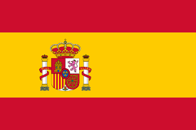
Spanish-American War

Directions: Read the passage below to your partner aloud.

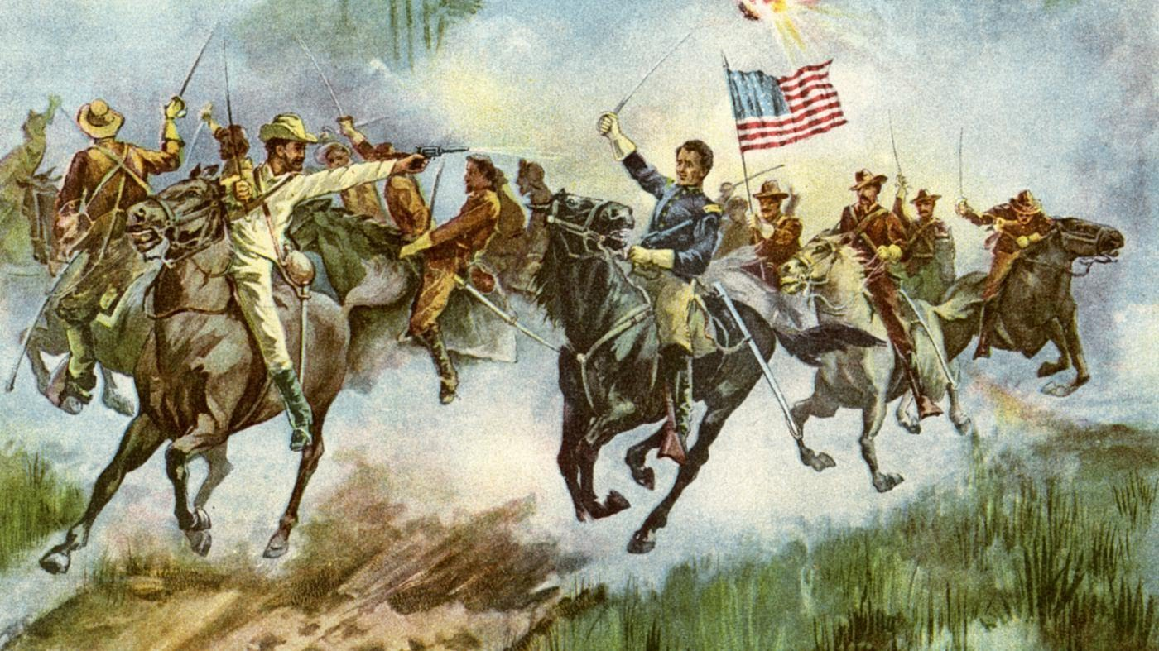
The Spanish-American War was an 1898 conflict between the United States and Spain that ended Spanish rule in the Americas and resulted in U.S. possession of territories in the western Pacific and Latin America. The war originated in the Cuban Struggle for independence from Spain. On April 21, 1898, the United States declared war against Spain. It would be the first overseas conflict fought by the U.S. The reasons for war were many, but there were two immediate ones: America's support for the ongoing struggle by Cubans and Filipinos against Spanish rule, and the mysterious explosion of the battleship U.S.S. Maine in Havana Harbor. The war ended with the signing of the Treaty of Paris when Spain surrendered over their colonies left in the western Pacific. Cuba, Puerto Rico, Guam, and the Philippines were all given to the possession of the United States.

Founding with Columbus and The River of Gold
Directions: Read the passage below to your partner aloud.

On November 19, 1493 Christopher Columbus discovered the island of Puerto Rico in his second voyage to the New World. He found the island populated by as many as 50,000 Taíno or Arawak Indians. The Taíno Indians who greeted Columbus made a big mistake when they showed him gold nuggets in the river and told him to take all he wanted.

The Island gained its name Puerto Rico ("rich port") for its abundance of natural resources, especially gold and its excellent location. During this time, the Spanish explorers were all throughout the Caribbean and Latin America in search of gold, and they were finding that gold was being used by nearly all of the civilizations that they encountered. After several years of mining so much gold sources said there was no more gold to be found.

Today In Puerto Rico there is most certainly still gold that can be found here today. Using modern mining methods that the early miners did not have could help a modern day gold prospector to recover gold in areas that have been mined in the past.
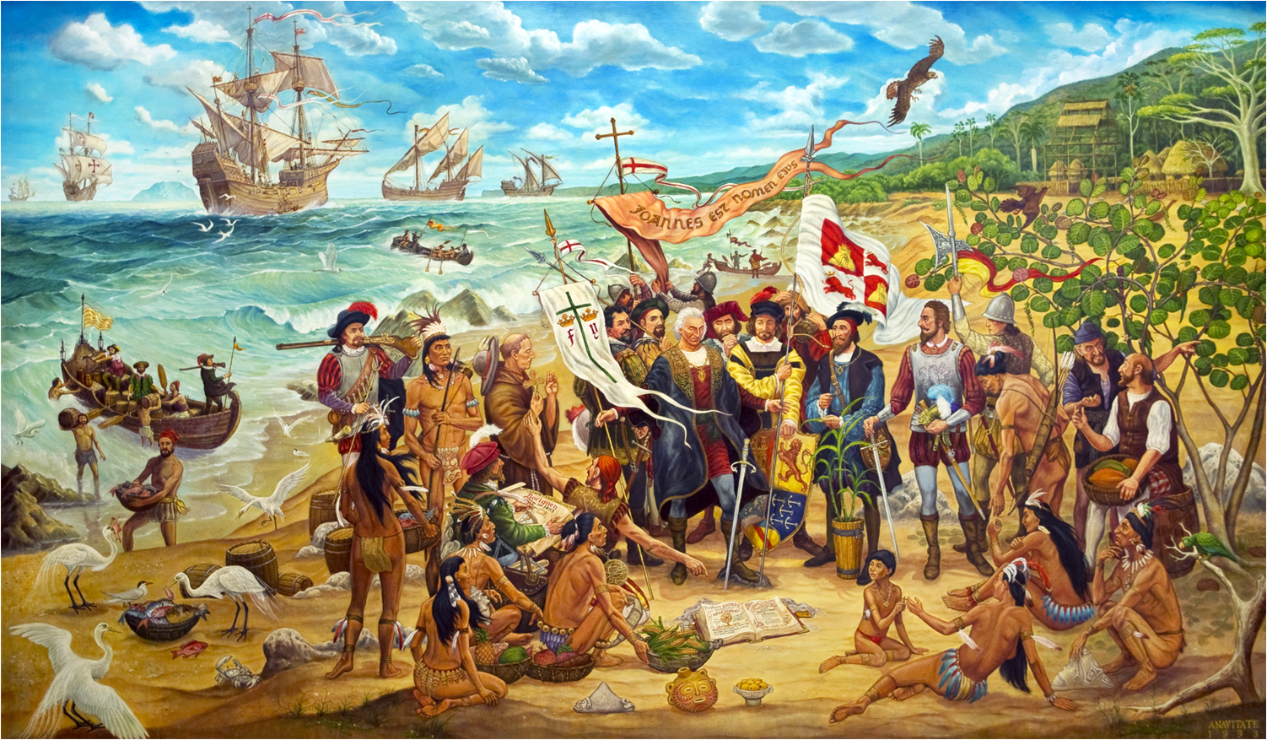

Movement to make Puerto Rico a state

Directions: Read the passage below to your partner aloud.

The United States won control of Puerto Rico in 1898 following the Spanish-American War. In the first three decades of its rule, the U.S. government made efforts to Americanize their new territory. In 1917 they announced that all people born in Puerto Rico would be U.S. Citizens.
The United States wanted to make Puerto Rico just like America, but a popular democratic party lead a movement that opposed that. In 1952 the U.S. Congress approved a new Puerto Rican constitution that made the island a U.S. commonwealth. Puerto Rico has their own government and governor but do not have a vote in congress.
Through out the year’s people in Puerto Rico have taken votes on the question of statehood and have rejected it. In June 2017, 97% of the people voted for statehood but the decision is up to congress.
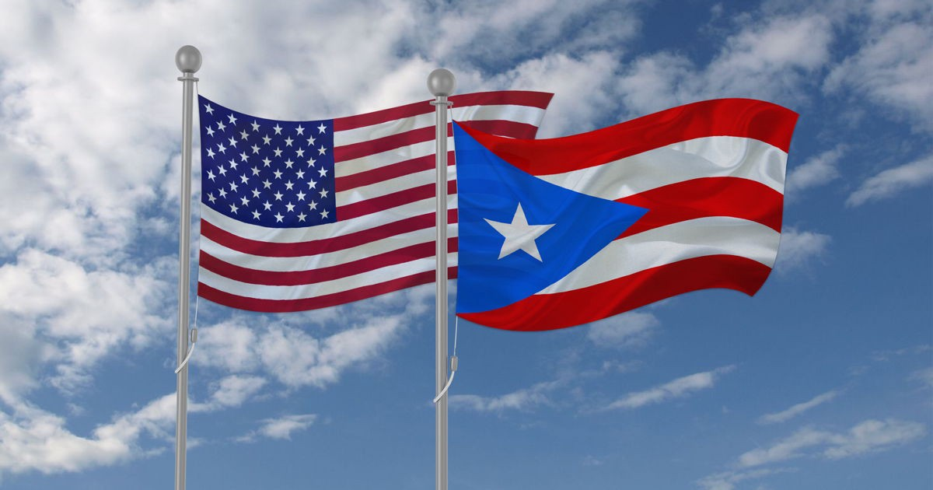

Name: _________________

Listen and Retell

Directions: Write down 5 key words or phrases you hear while listening to the story that will help you in retelling the story.

Historical Event : _____________________________________________________

- _____________________________________

- _____________________________________

- _____________________________________

- _____________________________________

- _____________________________________
Historical Events that helped shape Puerto Rico Today

Directions: Write about how your historical event helps shape Puerto Rico today and why. Be sure to include 3 key details

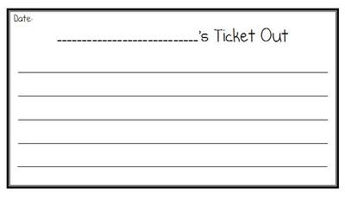

Historical  Accuracy  (6 points) | Contains three accurate facts from the reading. | Contains one to two accurate facts from the reading. | Contains no accurate facts from the reading.
Performance  Quality  (2 points) | The actors wait for each other to present lines and can be clearly heard. The actors do not need to read lines but actually speak the parts. All students involved. | The actors wait for each other to present lines and can be clearly heard. The actors may need to read lines but these lines can be clearly understood. All students involved but some only minimally. | The actors speak at the same time and/or the actors cannot be heard. Not all students are a part of the presentation.
Creativity and Passion for the  Performance  ( 2 points)  (2 points) | The performance is especially creative and captures the imagination of the audience and brings to life the concept in a unique way.  Or  Actors dramatically and creatively use props and/or quote. | The performance is creative and entertains the class but does not bring to life the concept.  Or  Actors use props or and/or quote. | The performance lacks creativity and the actors lack passion.  Or  Actors do not use props and/or quote.
Rubric for History Alive
Act It Out

Name_________________________ Points (10) ______ Course Points_______

First Stop on our Time machine....1493 Puerto Rico

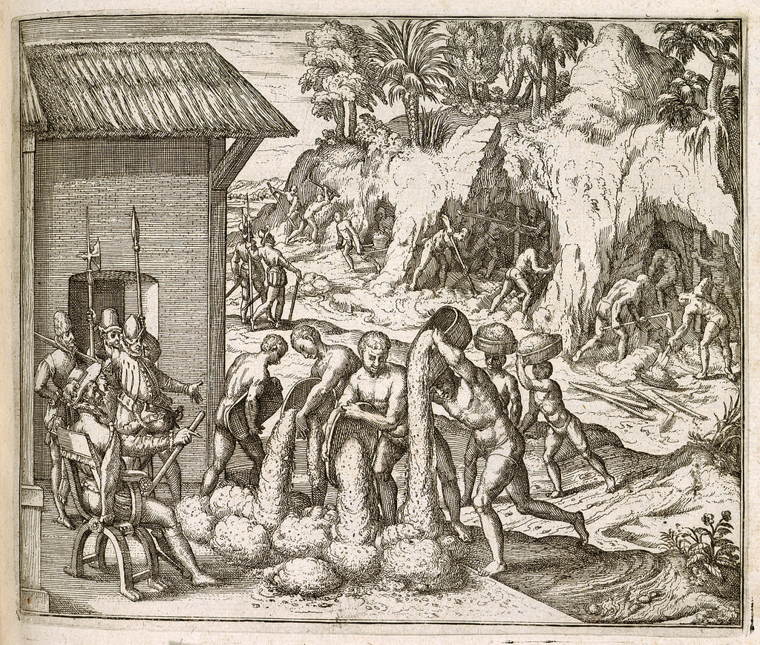

Voyager Christopher Columbus discovers the island of Puerto Rico and claims it as a colony for Spain. The island of Puerto Rico had an abundance of gold in its rivers which native inhabitants were forced to mine and to give to the spanish.

Second Stop.…..1898 The Spanish American War

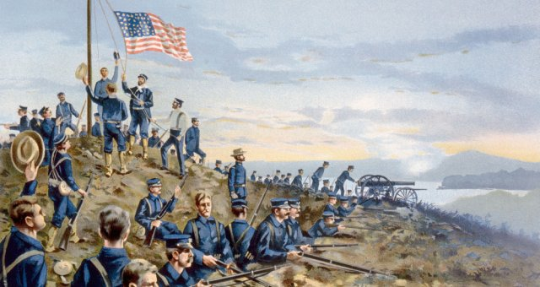

The Spanish-American War was an important turning point in history as the United States emerged as a world power. Spain surrendered over their colonies left in the western Pacific. Cuba, Puerto Rico, and the Philippines were all given to the possession of the United States.

Third Stop......The Movement to make Puerto Rico a State
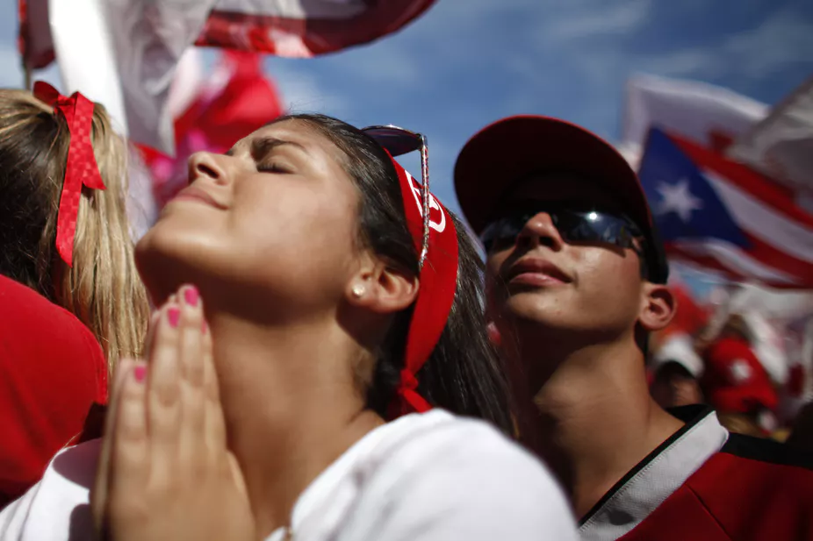

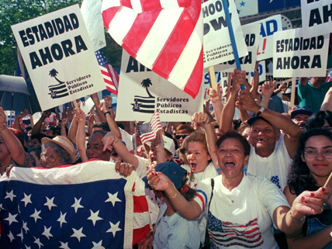

“There’s this perception that we are our own nation,” “And yet, there is this reality that we’re not really a part of the United States, but we don’t own ourselves either. We’ve always been in-between.” - Vagabond Beaumont

Name: _____________
Homework Journal Entry
In your own words, how did each historical event help shape Puerto Rico today? Which historical event do you feel most helped shape Puerto Rico to be what it is today and why? Be sure to include 3 key details. Use information discussed in class during listen and retell as well as our Act it Out Time machine!
________________________________________________________________________________________________________________________________________________________________________________________________
________________________________________________________________________________________________________________________________________________
________________________________________________________________________________________________________________________________________________________________________________________________
________________________________________________________________________________________________________________________________________________

