GRADE: 3

Are people happier living in communities in Rockville Center or Melbourne?

Student Name_____________________
Date______________________________

Part III: This part consists of a document-based question. On this part, you will be provided with one version of the test based on your readiness to handle critical thinking challenges.

Document Based Question

Directions: The task below is based on documents 1 through 5-6. The task is designed to test your ability to work with documents. Examine each document and answer all questions beneath the document. Use the answers to the questions to help write your essay.

Background: All of us in Rockville Centre live in a community and there are parts of life in our community that make us happy. On the other side of the world in Melbourne, Australia, people also live in communities. There are parts of life in the community of Melbourne that make people happy. In the paragraph you write, you are to make a judgement on who is happier based on the documents in this packet.

Task: Use the information from the documents and your knowledge of social studies, write an essay in which you:
Use the information from the documents and your knowledge of social studies, write an essay in which you:
- Discuss one part of life in the community of Rockville Centre, New York that makes you happy.
- Discuss one part of life in the community of Melbourne, Australia that makes people happy.
- In which community do you think people are happier, and why?

In your essay remember to
● Write an opinion essay, arguing whether people live a happier life in Mexico or America.
● Include an introduction, a body, and a conclusion.
● Use information from at least four documents in your answer.
● Include historical facts, relevant details, and reason in developing your ideas.

Document One
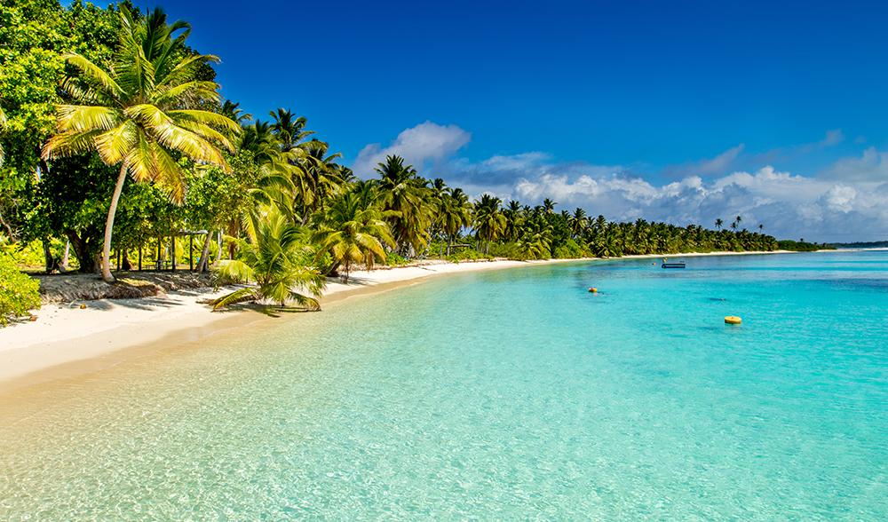
The sun shines about 185 days a year in Melbourne.
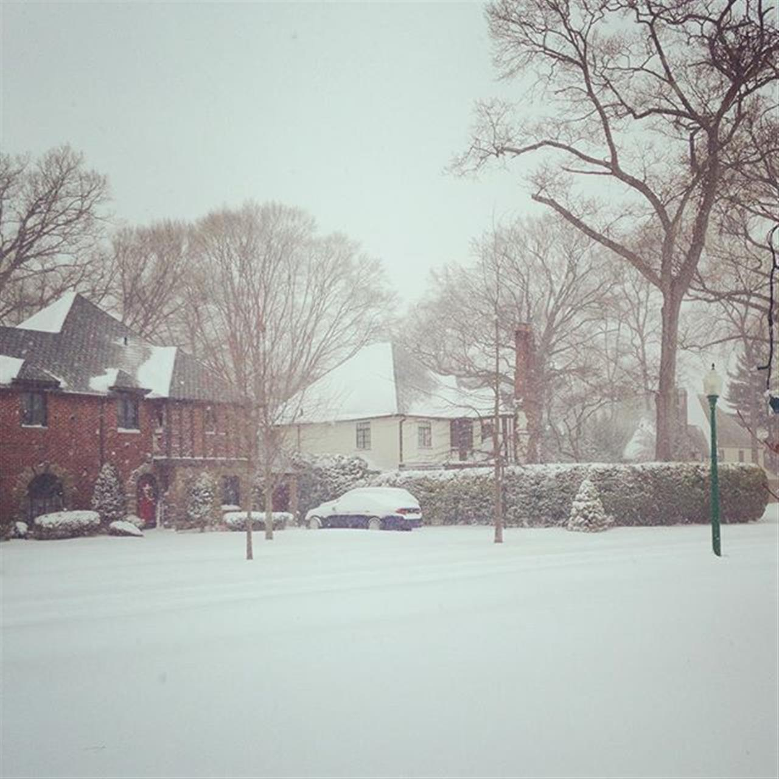
The sun shines about 170 days a year in Rockville Centre.
Questions:
- Do things like the weather change our happiness?
_______________________________________________________________________________________________________________________________________________
- Are the amount of sunny days similar?
_______________________________________________________________________________________________________________________________________________

Document Two

In a yearly letter sent out to the community of Rockville Centre, the town’s mayor said:
“Rockville Centre remains one of the most desirable communities
to live in and raise a family on Long Island.”
Questions:
- Is this a credible source? Why or why not?
________________________________________________________________________________________________________________________________________________
- What does the mayor think of his town?
________________________________________________________________________________________________________________________________________________
Document Three
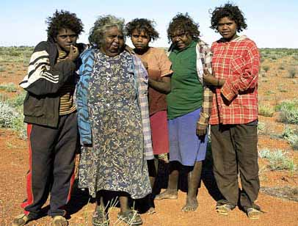

The Aborigines slowly had their land taken from them as the British settled. In Present day, Aborigines suffer from high rates of obesity and alcoholism.
Questions:

- How has the history of Melbourne shaped their happiness today?
________________________________________________________________________________________________________________________________________________

2. Were the Aborigines happier before the British settled or after?
________________________________________________________________________________________________________________________________________________
Document Four
Statement from United States and Australian government census:
- In 2016 there were 24,571 people living in Rockville Centre.
- In 2016 there were 4,353,514 people living in Melbourne.
Questions:
- Which community has more people?
________________________________________________________________________________________________________________________________________________

- Would you like living in a community with a lot of people?
________________________________________________________________________________________________________________________________________________
Document Five

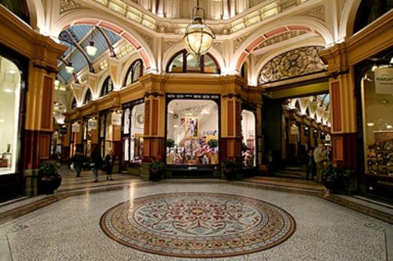
The Block Arcade is a popular area in Melbourne, Australia where people shop and hangout.
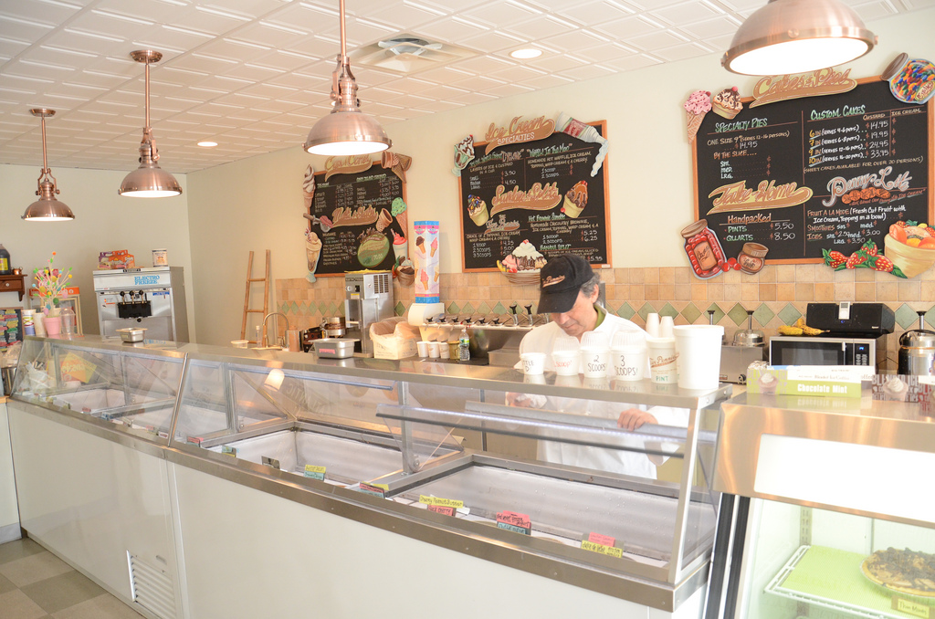
Five Pennies Creamery is an ice cream parlour in Rockville Centre, New York where community members enjoy many delicious flavors.
Questions:
- Between the two, which place would you rather spend your time? Explain why.
____________________________________________________________________________________________________________________________________________________________
2. Which community provides a town location that makes their residents happier?
____________________________________________________________________________________________________________________________________________________________

