3rd Grade
Melbourne Unit

By: Elaine Henriquez, Danielle Valente, Alexis Correa, Scott Stiene, Alexa Lerman,
Nicole Amato, Billy Bushell, Jessica Trinidad

This third grade Inquiry Design (IDM) curriculum allows students to explore the meaning of happiness and its relation to a person’s location in the world. Students will undertake the compelling question, “Are communities in Rockville Centre happier than communities in Melbourne?”

Compelling Question:
Are communities in Rockville centre happier than communities in Melbourne?

Standards and Practices:
3.3 Geographic factors often influence where people settle and form communities. People adapt to and modify their environment in different ways to meet their needs.

3.3a Geographic factors influence where people settle and their lifestyle. Some geographic factors make a location more suitable for settlement, while others act as deterrents.

3.5 Communities share cultural similarities and differences across the world.

3.5a The structure and activities of families and schools share similarities and differences across world communities.

Staging the Question:

Students will read a story, It’s Okay to Make Mistakes by, Todd Parr and develop an understanding of happiness is more result of how you react to things and the things themselves.

1. Supporting Question:  Is happiness shaped by our thoughts? | Formative Task:  The teacher will frame the question: Does where you live in the hemisphere determine your happiness? Teacher and students will engage in a discussion about our happiness depending on our thoughts. Teacher will then read aloud “It’s Ok to Make Mistakes” and point out the different mistakes the characters made and their optimistic views. Students and teacher will also engage in a discussion if optimism plays a role in our happiness. Finally, students will participate in book, head, and heart activity and post their answers on white poster paper being able to explain the questions provided for them on a post-it. | Sources:  Source A: “It’s Ok to Make Mistakes” by Todd Parr.  Source B: Happiness Presentation  Source C: Post on white poster paper with book, head, heart questions and answer.

2. Supporting Question:  How does the geography of life in Melbourne affect life there? | Formative Task:  Students will be taken on a bus tour through Melbourne to view what life is like through a variety of stops throughout the city. Students will natural landmarks, different attractions, and what the community is like. After the tour, students will fill out a graphic organizer of the three stops they liked the best, what they noticed and one fact about it. Students will then fill out a postcard to a friend or family member back in New York for homework, and will write at least three sentences about a place they saw or visited and what they learned. | Sources:  Source A: Google Slides bus tour presentation  Source B: Travel journal to take notes  Source C: Postcard to send to family or friend

3. Supporting Question:  How did Melbourne come to be Melbourne? What historical events have shaped the country? | Formative Task  Students will complete a read and retell activity with a partner on one of three historical events which shaped Melbourne today. After, each of the three groups will use the information provided in the documents to go into a “Time Machine” and complete an Act It Out skit with at least three relevant facts from the document. | Sources:  Source A: Time Machine Powerpoint Presentation  Source B: Read and Retell Documents on the Melbourne Aborigines, and the British Penal Colony.

4. Supporting Question:  How do we know what we have learned about Melbourne is true? | Formative Task:  After examining six documents and engaging in historical thinking using the SCIM-C method, students will discuss and make a claim about if the sources presented that depict life in Melbourne are valid. Students will conclude by writing a response on an exit ticket worksheet that encompasses an overview of how thinking like a historian has shaped their view on life in Melbourne including at least three references to documents analyzed in class. | Sources:  Source A:  Thinking Like a Historian PowerPoint Presentation  Source B:  Six Primary Source Documents to complete SCIM-C  Source C:  Exit Ticket- IS THIS VALID?

5. Supporting Question:  Are people in Melbourne happier than Americans?  Evaluate the credibility of the sources | Formative Task:  After completing a history mystery, students will create a claim on which country they think is happier, America or Australia (Rockville Centre and Melbourne). Students will evaluate the credibility of the sources provided. | Sources:  Source A: History Mystery packets with included articles  Source B: Powerpoint Presentation  Source C: Supporting Claim Handout

6. Supporting Question:  What does informed action mean?  How can we be assistant to our school and community environment? | Formative Tasks:  After a video on how we can help our school and community, students will work in small collaborative teams to develop plans of informed action that will create real, positive change for the people in our school and community.  Students will work in groups to do one of the following: 1) brainstorm ideas for taking informed action in our school and community in small collaborative teams and share them with the class, 2) as a team pick one informed action idea, 3) plan and organize how your team will take informed action and write your plans in your journal, 4) students will work with their teams for 3 weeks, 30 minutes a day taking informed action in their school and community. | Sources:  Source A: The Global Goals  Source B: Change The World In 5 Minutes YouTube video  Source C: Informed - Definition retrieved from www.dictionary.com  Source D: Action - Definition retrieved from www.dictionary.com

7. Supporting Question:  Are the people of Melbourne Australia happier than the people of your own community (Rockville Centre and America)? | Formative Task:  Students will participate in a collective essay in the air by engaging in a fishbowl activity. Students will be assigned roles as the leader, timekeeper, note-taker, and the fact checker. Students will engage in a fishbowl with assigned roles and see how many documents are used. Students who are outside of the fishbowl will be given evaluation rubrics to fill out on their performance and students within the fishbowl will be given self-evaluation rubrics to fill out on their personal performance in the activity. | Sources:  Source 1: DBQ PowerPoint  Source 2: Self Evaluation Resources

Summative Performance Task

Argument: Student will write a DBQ essay answering the question: Are communities in Rockville Centre happier than communities in Melbourne?

Extension: Students will create a flipgrid interaction with their classmates on who they think is happier: people in Melbourne, Australia or people in Rockville Centre, New York.

Taking Informed Action: What can we do to connect with Melbourne to improve our understanding?
- Students will skype with a third grade class from Melbourne, discussing and sharing how their lives are similar and different.
- Students will create signs with informative information on Melbourne regarding how to recycle and the impact it has on the environment.
- Students will organize and set up recycle bins to promote recycling within the community
- Students will create an informative video to educate the rest of their school about life in Melbourne.

GRADE: 3

Are people happier living in communities in Rockville Center or Melbourne?

Student Name_____________________
Date______________________________

Part III: This part consists of a document-based question. On this part, you will be provided with one version of the test based on your readiness to handle critical thinking challenges.

Document Based Question

Directions: The task below is based on documents 1 through 5-6. The task is designed to test your ability to work with documents. Examine each document and answer all questions beneath the document. Use the answers to the questions to help write your essay.

Background: All of us in Rockville Centre live in a community and there are parts of life in our community that make us happy. On the other side of the world in Melbourne, Australia, people also live in communities. There are parts of life in the community of Melbourne that make people happy. In the paragraph you write, you are to make a judgement on who is happier based on the documents in this packet.

Task: Use the information from the documents and your knowledge of social studies, write an essay in which you:
Use the information from the documents and your knowledge of social studies, write an essay in which you:
- Discuss one part of life in the community of Rockville Centre, New York that makes you happy.
- Discuss one part of life in the community of Melbourne, Australia that makes people happy.
- In which community do you think people are happier, and why?

In your essay remember to
● Write an opinion essay, arguing whether people live a happier life in Mexico or America.
● Include an introduction, a body, and a conclusion.
● Use information from at least four documents in your answer.
● Include historical facts, relevant details, and reason in developing your ideas.

Document One
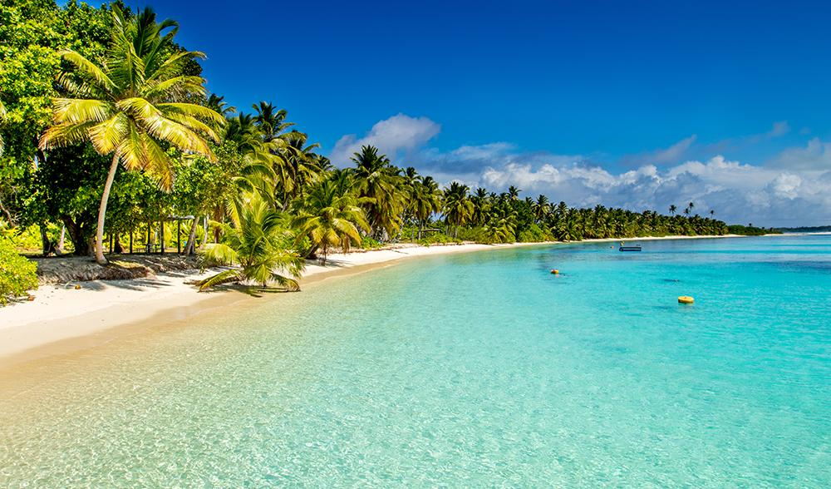
The sun shines about 185 days a year in Melbourne.
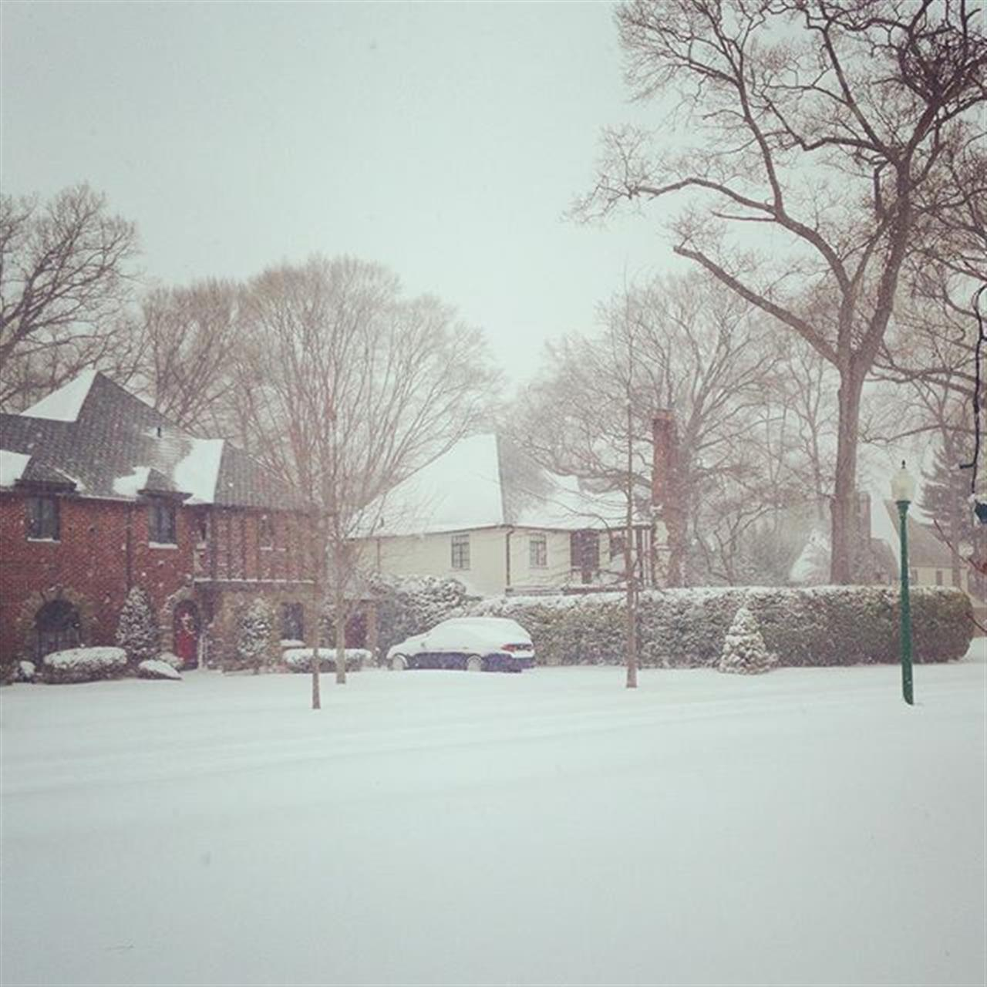
The sun shines about 170 days a year in Rockville Centre.
Questions:
- Do things like the weather change our happiness?
_______________________________________________________________________________________________________________________________________________
- Are the amount of sunny days similar?
_______________________________________________________________________________________________________________________________________________

Document Two

In a yearly letter sent out to the community of Rockville Centre, the town’s mayor said:
“Rockville Centre remains one of the most desirable communities
to live in and raise a family on Long Island.”
Questions:
- Is this a credible source? Why or why not?
________________________________________________________________________________________________________________________________________________
- What does the mayor think of his town?
________________________________________________________________________________________________________________________________________________
Document Three
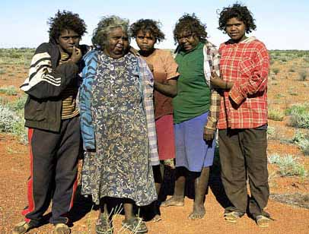

The Aborigines slowly had their land taken from them as the British settled. In Present day, Aborigines suffer from high rates of obesity and alcoholism.
Questions:

- How has the history of Melbourne shaped their happiness today?
________________________________________________________________________________________________________________________________________________

2. Were the Aborigines happier before the British settled or after?
________________________________________________________________________________________________________________________________________________
Document Four
Statement from United States and Australian government census:
- In 2016 there were 24,571 people living in Rockville Centre.
- In 2016 there were 4,353,514 people living in Melbourne.
Questions:
- Which community has more people?
________________________________________________________________________________________________________________________________________________

- Would you like living in a community with a lot of people?
________________________________________________________________________________________________________________________________________________
Document Five

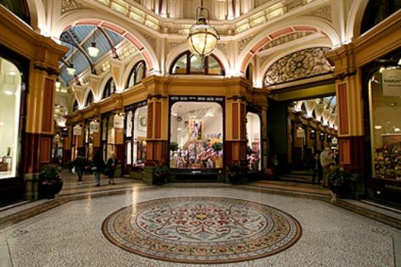
The Block Arcade is a popular area in Melbourne, Australia where people shop and hangout.
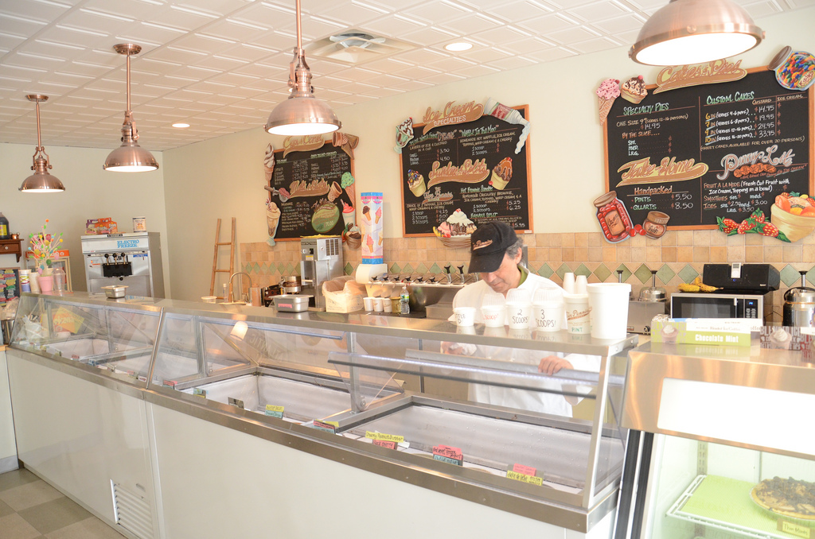
Five Pennies Creamery is an ice cream parlour in Rockville Centre, New York where community members enjoy many delicious flavors.
Questions:
- Between the two, which place would you rather spend your time? Explain why.
____________________________________________________________________________________________________________________________________________________________
2. Which community provides a town location that makes their residents happier?
____________________________________________________________________________________________________________________________________________________________

