GRADE: 5

Are people happier living in America or in Mexico?

Student Name_____________________
Date______________________________

Part III: This part consists of a document-based question. On this part, you will be provided with one version of the test based on your readiness to handle critical thinking challenges.

Document Based Question

Directions: The task below is based on documents 1 through 5-6. The task is designed to test your ability to work with documents. Examine each document and answer all questions beneath the document. Use the answers to the questions to help write your essay.

Background: This question asks you to form an opinion based on the evidence in the documents that follow. Although you may have your own opinion, based your answer on proving your position with the documents. You can add outside information

Task: Use the information from the documents and your knowledge of social studies, write an essay in which you:
Use the information from the documents and your knowledge of social studies, write an essay in which you:

● Evaluate whether Mexicans or Americans are happier?

In your essay remember to
● Write an opinion essay, arguing whether people live a happier life in Mexico or America
● Include an introduction, a body, and a conclusion
● Use information from at least four documents in your answer
● Include historical facts, relevant details, and reason in developing your ideas
Document #1:
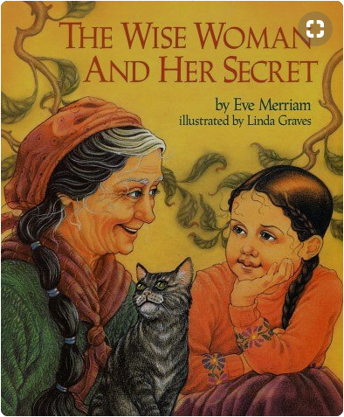

Renowned for her wisdom, an old woman is sought out by people who come from far and wide, eager to discover the secret source of her insights. "You will have to discover it for yourself", she tells them, and so their search begins. But one little girl, who likes to wander and wonder, lag and linger, has already found the secret that eludes her elders".

1. Based on the document above, what does the wise woman say about finding happiness?
_________________________________________________________________________________________________________________________________________ [1]

2. According the above document, what two things does the wise woman say have led to Jenny’s happiness?
________________________________________________________________________________________________________________________________________ [1]

3. Based on this definition of happiness, would having more money automatically make you a happier person? What would make you happier?
_________________________________________________________________________________________________________________________________________ [2]
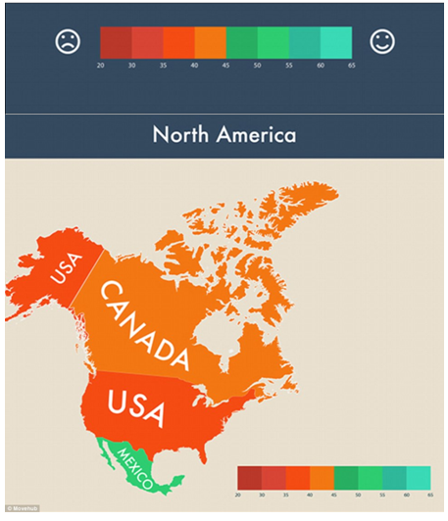
Document #3:

- Based on the document above, which country is happiest on the chart?
___________________________________________________________________ [1]
2. Do you think one test can determine the happiness of an entire country?
_______________________________________________________________________________________________________________________________________________________________________________________________________________ [2]
3.. Who made this chart? Do you think they are credible?
_______________________________________________________________________________________________________________________________________________________________________________________________________________ [2]

Document #4

“Violent crimes have been declining in the U.S. for over three decades, and have been increasing in Mexico during the same period. More Mexicans have been killed in drug wars than Americans killed in the Iraq and Afghanistan wars combined.”
-Glen Olives (2015) from the Mexican News

- According to the document, which country has higher crime rates, America or Mexico?
___________________________________________________________________ [1]

2. How does this document compare to the information in document #2?
_______________________________________________________________________________________________________________________________________________________________________________________________________________[2]

3. How do you think the crime rate affects the happiness of citizens in a region?
______________________________________________________________________________________________________________________________________________________________________________________________________________________________________________________________________________________[2]

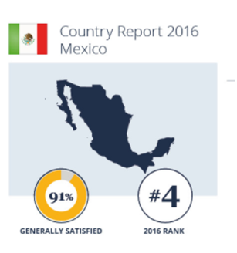

Document #5

- What percentage of people are generally satisfied with their life in Mexico?
___________________________________________________________________ [1]

2. Is this conclusive evidence that people in Mexico are happier than people in America?
________________________________________________________________________________________________________________________________________________________________________________________________________________[2]

#. Where did this information come from? Do you think it is credible?

________________________________________________________________________________________________________________________________________________________________________________________________________________[2]

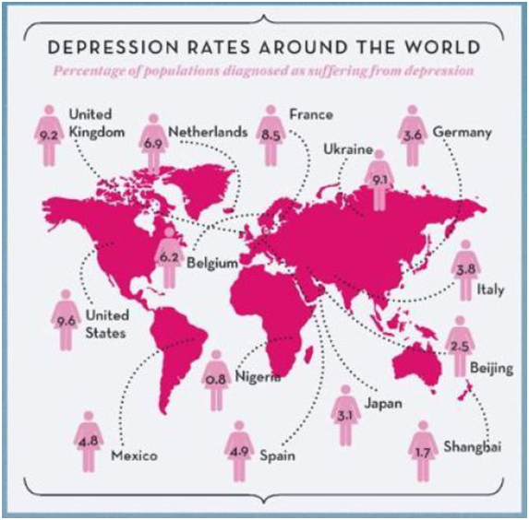
Document #6

Depression is when people are sad all the time and can’t seem to feel happier no matter what they do.

- According to the document, how does the percentage of people suffering from depression (sad all the time) in Mexico compare to those in the United States?
_______________________________________________________________________________________________________________________________________________________________________________________________________________[1]

- Why do you think more people in the United States, one of the richest countries in the world, has such a high rate of depression? (refer to document #1)
_______________________________________________________________________________________________________________________________________________________________________________________________________________[2]

Task: Use the information from the documents:

Directions: The task below is based on documents 1 through 5. The task is designed to test your ability to work with documents. Examine each document and answer all questions beneath the document. Use the answers to the questions to help write your essay.

Background: This question asks you to form an opinion based on the evidence in the documents that follow. Although you may have your own opinion, based your answer on proving your position with the documents. You can add outside information

Task: Use the information from the documents and your knowledge of social studies, write an essay in which you:
Use the information from the documents and your knowledge of social studies, write an essay in which you:

● Evaluate whether Mexicans or Americans are happier?

In your essay remember to
● Write an opinion essay, arguing whether people live a happier life in Mexico or America
● Include an introduction, a body, and a conclusion
● Use information from at least four documents in your answer
● Include historical facts, relevant details, and reason in developing your ideas

DBQ Scoring Rubric
(From the Revised Generic Scoring Rubric for Regents Examinations.)

Score of 5 | *Thoroughly develops all aspects of the task evenly & in depth | *Is more analytical than descriptive (applies, analyzes, evaluates, & creates information) | *Incorporates relevant information from at least the requested number of documents | *Incorporates substantial relevant outside information | *Richly supports the theme with many relevant facts, examples, & details | *Demonstrates a logical & clear plan of organization; includes and introduction & conclusion that are beyond a restatement of the theme
Score of 4 | *Develops all aspects of the task but may do so somewhat unevenly | *Is both descriptive & analytical (applies, analyzes, evaluates, and/or creates information) | *Incorporates relevant information for at least the requested number of documents | *Incorporates relevant outside information | *Supports the theme with relevant facts, examples, & details | *Demonstrates a satisfactory plan of organization; includes an introduction & a conclusion that are beyond a restatement of the theme
Score of 3 | *Develops all aspects of the task with little depth or develops most aspects of the task in some depth | *Is more descriptive than analytical (applies, may analyze and/or evaluate information) | *Incorporates relevant information from some documents | *Incorporates limited relevant outside information | *Includes some relevant facts, examples, & details; may include some minor inaccuracies | *Demonstrates a satisfactory plan of organization; includes an introduction & a conclusion that may be a restatement of the theme
Score of 2 | *Minimally develops all aspects of the task or develops some aspects of the task in depth | *Is primarily descriptive; may include faulty, weak, or isolated application or analysis | *Incorporates limited relevant information from the documents or consists primarily of relevant information copied from the documents | *Presents little or no relevant outside information | *Includes few relevant facts, examples, & details; may include some inaccuracies | *Demonstrates a general plan of organization; may lack focus; may contain digressions; may not clearly identify which aspect of the task is being addressed; may lack an introduction an/or an conclusion
Score of 1 | *Minimally develops some aspects of the task | *Is descriptive; may lack understanding, application, or analysis | *Makes vague, unclear references to the documents or consists primarily of relevant & irrelevant information copied from the documents | *Presents no relevant outside information | *Includes few relevant facts, examples, or details; may include inaccuracies | *May demonstrate a weakness in organization; may lack focus; may contain digressions; may not clearly identify which aspect of the task is being addressed; may lack an introduction and/or a conclusion
Score of 0 | *Fails to develop the task or may only refer to the theme in a general way; OR includes no relevant facts, examples or details; OR includes only the historical context and/or task as copied from the test booklet; OR includes only entire documents copied from the test booklet; OR is illegible: OR is a blank paper

