Maria Spaulding Professor Sheehan
EDU 3510 December 4, 2019
Grade 2 Topic Civic Ideals and Practices Social Studies

INSTRUCTIONAL OBJECTIVE
After a class discussion about credibility, students will listen to a read aloud of Mr. Peabody’s Apples by Madonna. Students will be able to identify how credible sources are based on the book and a discussion of examples, students will correctly answer three out of the four questions on the questionnaire.
STANDARDS AND INDICATORS
Social Studies Standard
Civic Ideals and Practices
Key Idea:
2.3 The United States is founded on the principles of democracy, and these principles are reflected in all types of communities.
Key Concepts:
2.3c The process of holding elections and voting is an example of democracy in action in schools, communities, New York State, and the nation.
- Students will learn about the process of voting and what opportunities adults in the community have for participation.
- Students will participate in voting within the classroom and in school, as appropriate.
Indicator: This will be evident when students discuss the importance of the credibility of a source.
New York State Next Generation English Language Arts Learning Standards
Research to Build and Present Knowledge
2W7: Recall and represent relevant information from experiences or gather information from provided sources to answer a question.
Indicator: This will be evident when students explore the teacher created sources and decide whether it is credible using evidence.

INQUIRY STANDARDS
Questions
Indicator: This will be evident when students are questioned throughout the read aloud.
SKILLS
Gathering information
Indicator: This will be evident when students gather information from sources to decide whether a source is credible or incredible.

DEVELOPMENTAL PROCEDURES
- Motivation: Students will participate in a game of telephone. The teacher will begin the game of telephone and the last student to receive the message will say what they heard out loud. Students will discuss why this method of communication is not reliable. (Is the original message the same as what the last person heard? Why or why not? Can we always believe what we hear?)[5 minutes]
- The teacher will transition this discussion to introduce new vocabulary words and their definitions. (What does it mean when something is credible? What is a source? How can we trust a source? What is evidence? What is a rumor? Who is a better source for getting at the truth, a best friend or a person who saw the whole thing happen?)[10 minutes]
- The teacher will then read aloud Mr. Peabody’s Apples by Madonna to the students. (What do you think this book is about? Do you think this will relate to our game of telephone we played before? Why or why not?)[10 minutes]
- After the read aloud students complete a questionnaire and discuss the events and the characters in the book. (Why did the other characters think Mr. Peabody was stealing? What was Mr. Peabody really doing? What evidence did they have that the rumor was not true? Should they have all believed the rumor? How can this story help us when we hear a rumor about one of our friends?)[8 minutes]
- Students will be shown teacher created sources and decide whether the source is credible enough, using evidence, to support their answers.( Is this a credible source? Why or why not? What does or does not make this credible?) [10 minutes]
- Closure: The teacher will close the lesson with a quick stop and jot so students are able to communicate what they have learned and a question they still might have, during this time the teacher will have the opportunity to reteach and enforce the vocabulary taught in the lesson. (How can we decide if something is credible?) [8 minutes]

INSTRUCTIONAL STRATEGIES
Discussion (engaging in meaningful discussions about the content)
Indicator: This will be evident when students are discussing whether a source is
credible or not.
Direct Instruction (explicit presentation of information)
Indicator: This will be evident when the teacher is going over vocabulary words and students are taking notes.

ASSESSMENT
Informal Assessment:
Students will be informally assessed through questioning from the discussions to identify students’ understanding of credibility.

Formal Assessment:
Students will be formally assessed through the questionnaire,correctly answering three out of the four questions.

INDEPENDENT PRACTICE
Following the lesson, at home students will find at least two credible sources and write about what evidence is provided that makes it a credible source.

REFERENCES
English Language Arts Learning Standards. (n.d.). Retrieved from
http://www.nysed.gov/curriculum-instruction/new-york-state-next-generation-english-language-arts-learning-standards.
New York State K-12 Social Studies Framework. (n.d.). Retrieved from https://www.engageny.org/resource/new-york-state-k-12-social-studies-framework.

Name: ___________________________
Vocabulary Words
Credible
________________________________________________________________________________________________________________
Source
________________________________________________________________________________________________________________
Evidence
________________________________________________________________________________________________________________
Rumor
________________________________________________________________________________________________________________
Name: ____________________________
Mr. Peabody’s Apples
Why did the other characters think Mr. Peabody was stealing?
____________________________________________________________________________________________________________________________

What was Mr. Peabody really doing?
____________________________________________________________________________________________________________________________

What evidence did they have that the rumor was not true?
____________________________________________________________________________________________________________________________

Should they have all believed the rumor?
____________________________________________________________________________________________________________________________

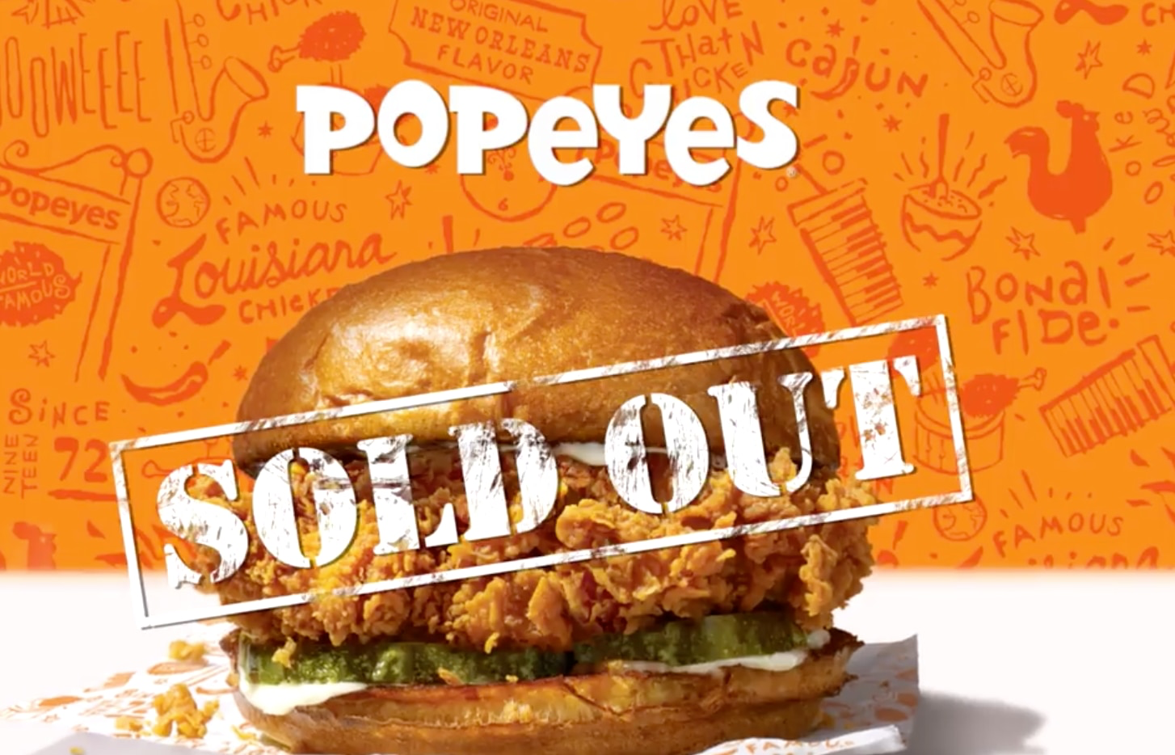
“Just two weeks went by and we were out of the Chicken Sandwich nationally.” - New York Times interview with Popeyes President.
“Dunkin Donuts is better than Starbucks.” - Ms. Spaulding
“A black rhino is critically endangered” - World WildLife
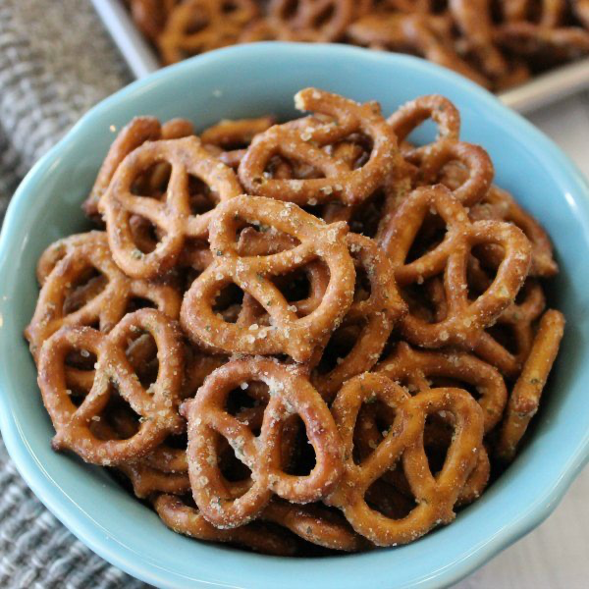
“Potato Chips are better than Pretzels” - Ms. Festa

