Grade : 2nd Election Unit
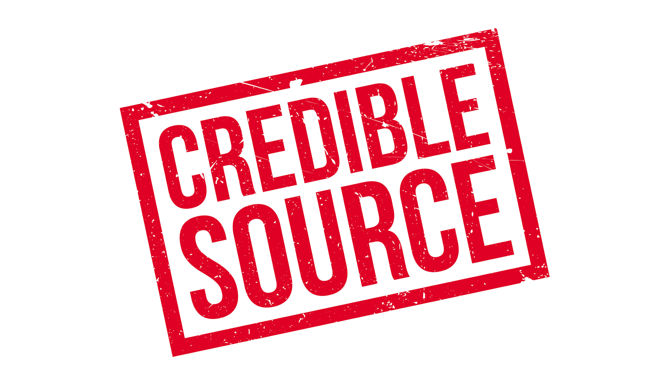

How Can We Elect A Good President?

Narrative Background

In this unit, students will learn how to apply credibility and corroboration in sources to decide which ice cream flavor is best, which will lead to the eventual Presidential election. This unit covers the basic skills students will use in their everyday lives to find credible sources to create informed citizens that will one day vote in an election. The materials needed in this unit are, Mr. Peabody’s Apples by Madonna, I Wanna Iguana by Karen Kaufman Orloff, 6 Insane Iguana Facts on Youtube, as well as the teacher created sources and worksheets.

Compelling question:
How Can We Elect A Good President?

Staging the Question (Brain Framing):

Have you ever heard a rumor about someone that wasn’t true? In this unit we will find out how to find credible sources and corroborate them to elect a good President.
Standards and Practices:
Civic Ideals and Practices
2.3c :
The process of holding elections and voting is an example of democracy in action in schools, communities, New York State, and the nation.
- Students will learn about the process of voting and what opportunities adults in the community have for participation.
- Students will participate in voting within the classroom and in school, as appropriate.

- Supporting Question:  Maria  How can we tell if a source is credible? | Formative Task:  After a class discussion about credibility, students will listen to a read aloud of Mr. Peabody’s Apples by Madonna. Students will be able to identify how credible sources are based on the book and a discussion of examples, students will correctly answer three out of the four questions on the questionnaire. | Sources:  Mr. Peabody’s Apples by Madonna  Teacher made worksheets  Teacher made sources
Supporting Question:  - Lauren  Why is it important to have sources that corroborate? | Formative Task:  After a class discussion about Iguana’s being good pets, students will listen to a read aloud and Youtube video constructing their own opinion based on corroboration used through their sources through an exit ticket attaining a score of at least 2 out of 3 on a teacher constructed rubric. | Sources:  I Wanna Iguana by Karen Kaufman Orloff  6 Insane Iguana Facts on Youtube
- Supporting Question:  How could we use corroboration and credibility to choose a great ice cream topping? | Formative Task:  After reviewing what makes sources credible and corroborate, students will participate in collaborative discussions with diverse peers during the WHAC and then vote on their choice topping, citing why they are credible with at least one piece of accurate evidence. | Sources:  Teacher made worksheets  Teacher made sources

Summative Performance Task:
How Can We Elect A Good President?
Objective: After reviewing corroboration, credibility, and elections, students will read information about current presidential candidates and sort out sources to credible/ not credible while voting at the end and completing a teacher created worksheet.
Supporting Question: Why is it important to know a source’s credibility and to have corroboration before making a decision, such as electing a president?
Sources: Teacher made sources
Formative Task: After discussing what makes a good president and why it is important to know if sources are credible or not, students will receive a sheet of sources with their origins and deem whether they are credible or not.

Extension:
If the student does not understand the unit, they will go over the important vocabulary for credibility, corroboration, and election. They will then go over what makes a source credible and why it is important to find credible sources when voting for anything. They will then have a DTI to go over the information taught in a different approach such as using videos and other books.

Taking Informed Action:
Students will be using these lessons taught in the real world. They will one day be a part of voting for a presidential candidate which will then shape the generations to come. This creates informed citizens who make decisions based off of sound/credible evidence to celebrate diversity.

Maria Spaulding Professor Sheehan
EDU 3510 December 4, 2019
Grade 2 Topic Civic Ideals and Practices Social Studies

INSTRUCTIONAL OBJECTIVE
After a class discussion about credibility, students will listen to a read aloud of Mr. Peabody’s Apples by Madonna. Students will be able to identify how credible sources are based on the book and a discussion of examples, students will correctly answer three out of the four questions on the questionnaire.
STANDARDS AND INDICATORS
Social Studies Standard
Civic Ideals and Practices
Key Idea:
2.3 The United States is founded on the principles of democracy, and these principles are reflected in all types of communities.
Key Concepts:
2.3c The process of holding elections and voting is an example of democracy in action in schools, communities, New York State, and the nation.
- Students will learn about the process of voting and what opportunities adults in the community have for participation.
- Students will participate in voting within the classroom and in school, as appropriate.
Indicator: This will be evident when students discuss the importance of the credibility of a source.
New York State Next Generation English Language Arts Learning Standards
Research to Build and Present Knowledge
2W7: Recall and represent relevant information from experiences or gather information from provided sources to answer a question.
Indicator: This will be evident when students explore the teacher created sources and decide whether it is credible using evidence.

INQUIRY STANDARDS
Questions
Indicator: This will be evident when students are questioned throughout the read aloud.
SKILLS
Gathering information
Indicator: This will be evident when students gather information from sources to decide whether a source is credible or incredible.

DEVELOPMENTAL PROCEDURES
- Motivation: Students will participate in a game of telephone. The teacher will begin the game of telephone and the last student to receive the message will say what they heard out loud. Students will discuss why this method of communication is not reliable. (Is the original message the same as what the last person heard? Why or why not? Can we always believe what we hear?)[5 minutes]
- The teacher will transition this discussion to introduce new vocabulary words and their definitions. (What does it mean when something is credible? What is a source? How can we trust a source? What is evidence? What is a rumor? Who is a better source for getting at the truth, a best friend or a person who saw the whole thing happen?)[10 minutes]
- The teacher will then read aloud Mr. Peabody’s Apples by Madonna to the students. (What do you think this book is about? Do you think this will relate to our game of telephone we played before? Why or why not?)[10 minutes]
- After the read aloud students complete a questionnaire and discuss the events and the characters in the book. (Why did the other characters think Mr. Peabody was stealing? What was Mr. Peabody really doing? What evidence did they have that the rumor was not true? Should they have all believed the rumor? How can this story help us when we hear a rumor about one of our friends?)[8 minutes]
- Students will be shown teacher created sources and decide whether the source is credible enough, using evidence, to support their answers.( Is this a credible source? Why or why not? What does or does not make this credible?) [10 minutes]
- Closure: The teacher will close the lesson with a quick stop and jot so students are able to communicate what they have learned and a question they still might have, during this time the teacher will have the opportunity to reteach and enforce the vocabulary taught in the lesson. (How can we decide if something is credible?) [8 minutes]

INSTRUCTIONAL STRATEGIES
Discussion (engaging in meaningful discussions about the content)
Indicator: This will be evident when students are discussing whether a source is
credible or not.
Direct Instruction (explicit presentation of information)
Indicator: This will be evident when the teacher is going over vocabulary words and students are taking notes.

ASSESSMENT
Informal Assessment:
Students will be informally assessed through questioning from the discussions to identify students’ understanding of credibility.

Formal Assessment:
Students will be formally assessed through the questionnaire,correctly answering three out of the four questions.

INDEPENDENT PRACTICE
Following the lesson, at home students will find at least two credible sources and write about what evidence is provided that makes it a credible source.

REFERENCES
English Language Arts Learning Standards. (n.d.). Retrieved from
http://www.nysed.gov/curriculum-instruction/new-york-state-next-generation-english-language-arts-learning-standards.
New York State K-12 Social Studies Framework. (n.d.). Retrieved from https://www.engageny.org/resource/new-york-state-k-12-social-studies-framework.

Name: ___________________________
Vocabulary Words
Credible
________________________________________________________________________________________________________________
Source
________________________________________________________________________________________________________________
Evidence
________________________________________________________________________________________________________________
Rumor
________________________________________________________________________________________________________________
Name: ____________________________
Mr. Peabody’s Apples
Why did the other characters think Mr. Peabody was stealing?
____________________________________________________________________________________________________________________________

What was Mr. Peabody really doing?
____________________________________________________________________________________________________________________________

What evidence did they have that the rumor was not true?
____________________________________________________________________________________________________________________________

Should they have all believed the rumor?
____________________________________________________________________________________________________________________________

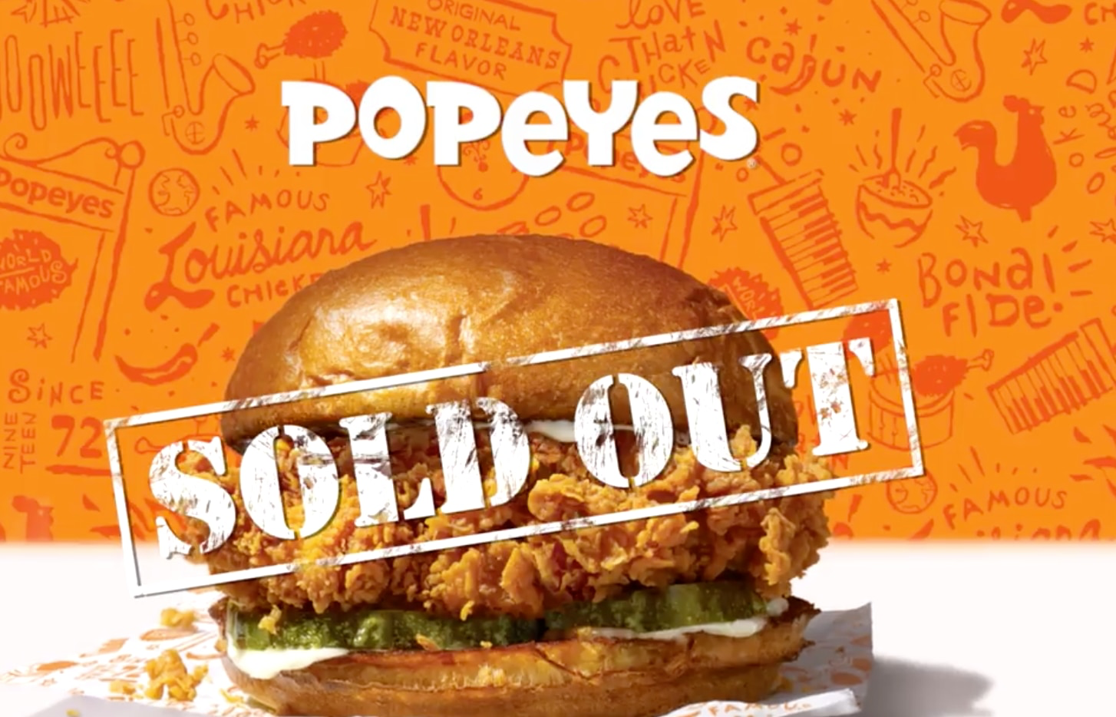
“Just two weeks went by and we were out of the Chicken Sandwich nationally.” - New York Times interview with Popeyes President.
“Dunkin Donuts is better than Starbucks.” - Ms. Spaulding
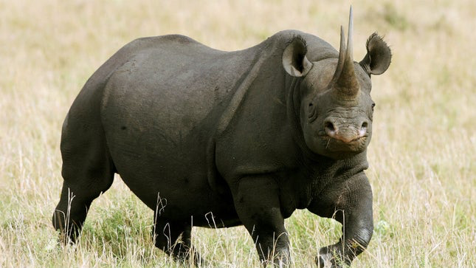
“A black rhino is critically endangered” - World WildLife
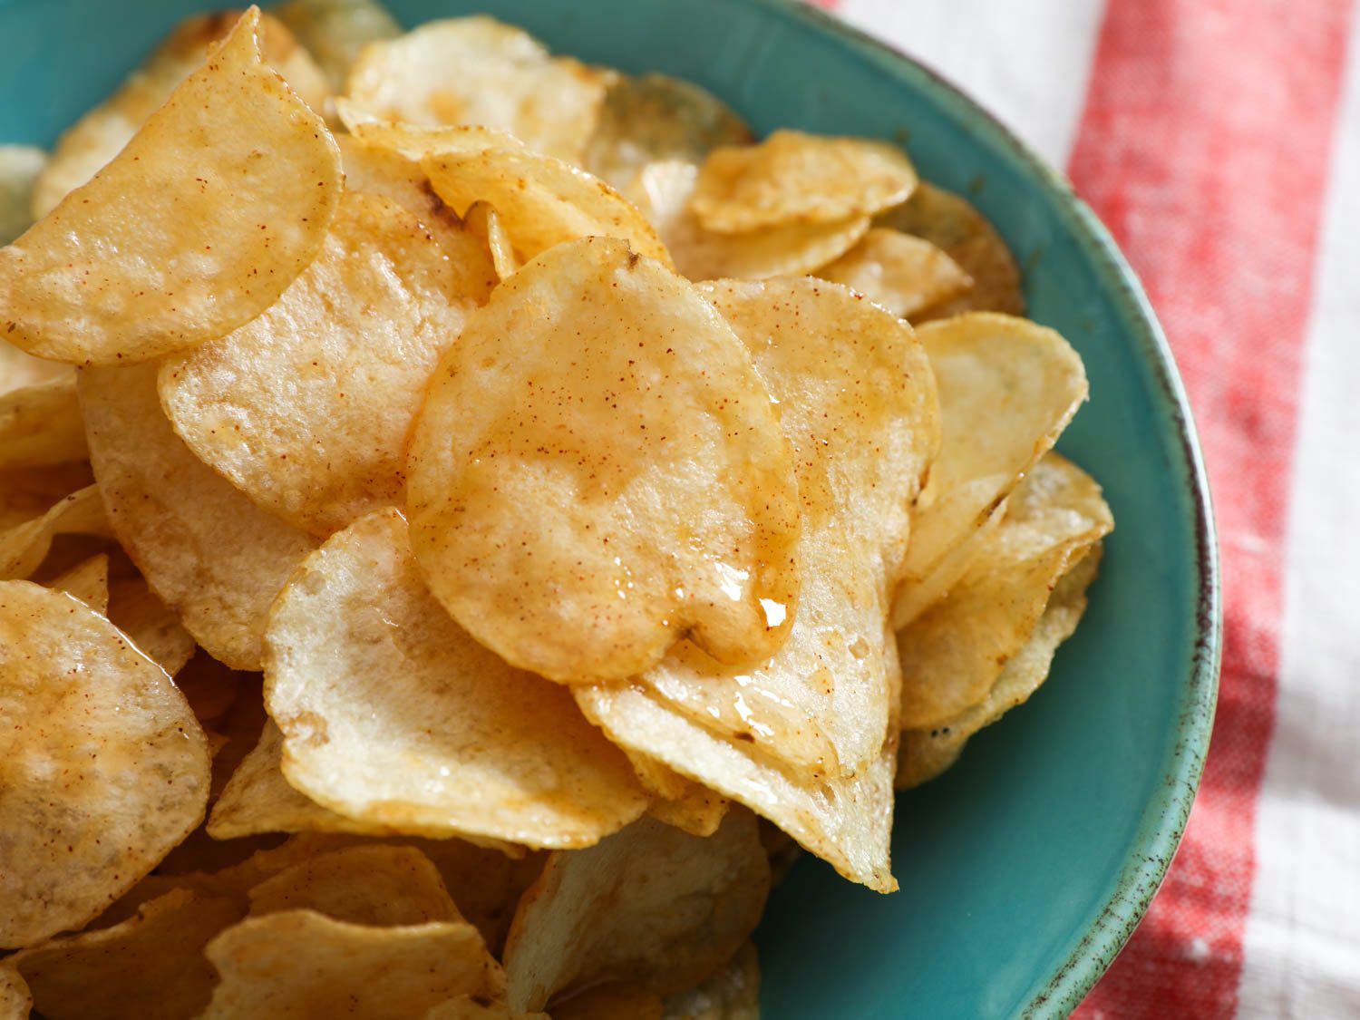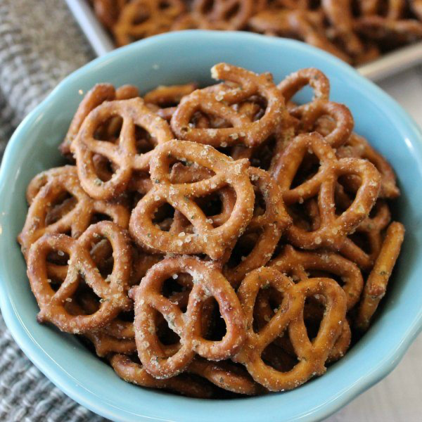
“Potato Chips are better than Pretzels” - Ms. Festa
Lauren Radburn Professor Sheehan
EDU 3510 12/2/19
Grade 2 Topic Civic Ideals and practices Social Studies

INSTRUCTIONAL OBJECTIVE

After a class discussion about Iguana’s being good pets, students will listen to a read aloud and Youtube video constructing their own opinion based on corroboration used through their sources through an exit ticket attaining a score of at least 2 out of 3 on a teacher constructed rubric.

STANDARDS AND INDICATORS
Civic Ideals and Practices
2.3c :
The process of holding elections and voting is an example of democracy in action in schools, communities, New York State, and the nation.
- Students will learn about the process of voting and what opportunities adults in the community have for participation.
- Students will participate in voting within the classroom and in school, as appropriate.
Indicator: This will be evident when students discuss the importance of finding corroboration.

English Language Arts New York State Standard
Research to Build and Present Knowledge
2W7: Recall and represent relevant information from experiences or gather information from provided sources to answer a question.
Indicator: This will be evident when students use evidence to back up their agreement or disagreement.

INQUIRY STANDARDS
Present information
Indicator: This will be evident when students do a turn and talk and discuss their corroboration.

SKILLS
Gathering information
Indicator: This will be evident when students gather and review videos and books to show corroboration.

DEVELOPMENTAL PROCEDURES
- Motivation: Students will be asked to do a turn and talk to discuss if they believe Iguanas are good pets. Students will be asked to vote on the SMART board their opinion. (Would an Iguana be a good pet? How do you know if an Iguana would be a good pet? Do you have any pets?) [5 minutes]
- The teacher will then transition into an introduction of the new vocabulary words and their definitions. (What does it mean to agree/disagree? Where could you use the word corroboration? Where would you see a source? How is evidence used? If you prove something what does it mean you’re doing?) [8 minutes]
- The teacher will then read aloud “I Wanna Iguana” by Karen Kaufman Orloff to the students. (Did the mom agree or disagree with Alex? What was Alex trying to prove to his mom?Is Alex using corroboration with his mom? Is there evidence shown by Alex that he deserves a pet?) [20 minutes]
- After the read aloud, the teacher will then show the students 6 Insane Iguana Facts on YouTube. (Should iguanas be pets? Are there any similarities between the book and video? What kind of evidence did this video show?) [5 minutes]
- The teacher will ask students to have a class discussion on what they saw through the read aloud and video and discuss the importance of corroboration. (Did the video have any evidence to corroborate or agree with or prove, either Alex or his mom’s ideas? Is it important to make up information to help give an opinion? Should you find evidence when you are proving a point?) [ 5 minutes]
- Closure: The teacher will close the lesson by handing out an exit ticket on their opinion. (Is an Iguana a good pet? How do you show evidence from today’s lesson using corroboration?) [2 minutes]

INSTRUCTIONAL STRATEGIES
Scaffolding (providing support and moving students toward greater independence)
Indicator: This will be evident when the teacher helps students understand the vocabulary to help students show their own corroboration when they are giving their opinion.

Discussion (engaging in meaningful discussions about the content)
Indicator: This will be evident when students are discussing what important information can be used in helping prove their opinion.

ASSESSMENT
Informal Assessment
Students will be informally assessed through their turn and talks and questions from the discussion to identify students' understanding of the concept.

Formal Assessment
Students will be formally assessed through an exit ticket attaining a score of at least 3 out of 4 on a teacher constructed rubric.

INDEPENDENT PRACTICE
Following the lesson on corroboration, students will create a newspaper ad to alert all parents if children should be allowed to have iguanas using their corroboration that they learned in class and will need to find one more video and or article.

REFERENCES

English Language Arts Learning Standards. (n.d.). Retrieved from
http://www.nysed.gov/curriculum-instruction/new-york-state-next-generation-english-language-arts-learning-standards.
New York State K-12 Social Studies Framework. (n.d.). Retrieved from https://www.engageny.org/resource/new-york-state-k-12-social-studies-framework

Name:_____________________________
Vocabulary Words
Agree: ____________________________________________________________

Disagree: ____________________________________________________________

Prove:
____________________________________________________________

Source:
____________________________________________________________

Evidence:
____________________________________________________________

Corroboration:
____________________________________________________________

Name:________________________
Exit Ticket
- Did Alex give enough evidence for his mom to receive the Iguana? Why or why not?
__________________________________________________________

__________________________________________________________
- Is an Iguana a good pet? Use the evidence from the book and video to help back you up.
__________________________________________________________

__________________________________________________________
- Why is it important to have corroboration when you are giving an opinion?
__________________________________________________________

__________________________________________________________

__________________________________________________________
_________________________________________________________
Molloy College
Division of Education

Student: KellyAnn Turton Professor Sheehan
Course EDU 3510 Date: December 4, 2019
Grade: 2nd Topic Elections Content Area: Social Studies

INSTRUCTIONAL OBJECTIVE(S)

After reviewing what makes sources credible/ incredible and if they corroborate, students will participate in collaborative conversations with diverse peers during the WHAC and then vote on their choice topping, citing why they are credible with at least one piece of accurate evidence.

STANDARDS AND INDICATORS

Social Studies Standard
Key Idea:
2.3 The United States is founded on the principles of democracy, and these principles are reflected in all types of communities.
Key Concepts:
2.3c The process of holding elections and voting is an example of democracy in action in schools, communities, New York State, and the nation. Students will learn about the process of voting and what opportunities adults in the community have for participation. Students will participate in voting within the classroom and in school, as appropriate.
Indicator: This will be evident when students vote for their choice of ice cream topping.

New York State Next Generation English Language Learning Standard
Speaking and Listening
Comprehension and Collaboration
2SL1:
Participate in collaborative conversations with diverse peers and adults in small and large groups and during play.
Indicator: This will be evident when students “participate in collaborative conversations” about the credibility and corroboration of different ice cream toppings candidates during the WHAC.

Inquiry Standards
Questions
Indicator: This will be evident when students answer questions throughout the lesson.

Skills
Gathering info
Indicator: This will be evident when students gather information to vote for the best
topping.

DEVELOPMENTAL PROCEDURES (*Engaging the learner)
(Based on a lesson about participating in an election; 60 minutes)

- MOTIVATION
After being introduced to what the word “election” means, students will then sign up to be able to vote in a class election about ice cream toppings. (Have you ever heard of the word election before? [LITERAL] Where have you heard it? [INFERENTIAL] What do we think the word vote means? [METACOGNITIVE] Could we use it in our class?[LITERAL]) [7 minutes]
- Students will be introduced to a new vocabulary word “register”, as well as the word “election” will be added to the unit word wall. Teacher will then discuss with students the importance of researching before voting in an election. (By signing up to vote, you all have actually registered, based off that information, what inferences can we make about what register might mean?[INFERENTIAL] What kind of sources do we look for when we research a topic? [METACOGNITIVE] Do the sources matter? [LITERAL]) [5 minutes]
- Teacher will review with students what it means to have non- credible or credible sources. Students will also review what corroboration means. (What makes a source credible?[INFERENTIAL] How would you know? [METACOGNITIVE] What does it mean when sources corroborate?[INFERENTIAL]) [5 minutes]
- Teacher will introduce to students the 4 contenders in the running for the best ice cream topping. Students will participate in a WHAC with their table groups and move around the room to decipher if the documents are credible and if they corroborate. The toppings and their statements will be hung on the walls around the room. Each group will be given pieces of paper with each ice cream topping contender’s number and with the W (What is the source?), H (How credible is it?), A (What is the Author’s purpose?), C (Which sources corroborate?). Students will rotate from group to group analyzing the statements. Teacher will monitor groups. ( Have you ever eaten sand before? [LITERAL] What makes that source credible? [INFERENTIAL] How did you tell?[METACOGNITIVE] ) [20 minutes]
- The class will then come back together to talk about whether or not each contender is credible and why and which would corroborate. (Let’s have a discussion, and see if we agree which candidates are credible. Why would sprinkles be considered credible? [METACOGNITIVE] Why would sand not be considered credible? [METACOGNITIVE] Did all the statements corroborate? [LITERAL] Which topping’s statements didn’t corroborate? Why?[INFERENTIAL]) [7 minutes]
- The class will pick the top two contenders and rule out the ones who did not have credible sources. Students will then vote for their choice of topping based on the two left on the “VOTE” worksheet. Teacher will count the votes and display the winner on the board. (Which toppings can we rule out based on our sources? [LITERAL] Why did you choose that topping? [INFERENTIAL] How did you know it was credible? [METACOGNITIVE]) [5 minutes]
- Closure: Students will be able to take part in an ice cream party with their choice of toppings! Students will discuss the big picture they learned today. (While enjoying our tasty treat, could we have a few volunteers say what the big takeaway was today?[METACOGNITIVE]) [5 minutes]

ASSESSMENT (formal & informal)

Informal assessment

Questions throughout the lesson
WHAC

Formal assessment

Students will vote on their choice topping by citing at least one accurate and credible source.

INSTRUCTIONAL STRATEGIES

- Cooperative Learning
Indicator: This will be evident when students participate in the WHAC.
- Discussion
Indictor: This will be evident when students participate in the WHAC.
- Independent work
Indicator: This will be evident when students place their vote for ice cream topping and
cite why the candidate is credible.
- Direct Instruction
Indicator: This will be evident when the teacher is going over the new vocabulary
words.

INDEPENDENT PRACTICE

After a lesson on using corroboration and credibility to vote, for homework, students will identify another good choice they believe would be a good ice cream topping and a credible source to share the next day at the morning meeting.

REFERENCES

New York State Department of Education. (2019). New York State Next Generation English Learning
Standards. Retrieved from
http://www.nysed.gov/curriculum-instruction/new-york-state-next-generation-english-language
arts-learning-standards

New York State K-12 Social Studies Framework. (n.d.). Retrieved from https://www.engageny.org/resource/new-york-state-k-12-social-studies-framework.

SIGN UP TO VOTE!

My name is

________________________.

---------------------------------

SIGN UP TO VOTE!

My name is

________________________.

WHAC #1

“Sprinkles add color to your ice cream”- John Smith, Ice Cream Specialist

“Sprinkles can also be used on brownies and other dessert treats!” - Gordon Ramsey, Celebrity Chef

WHAC #2
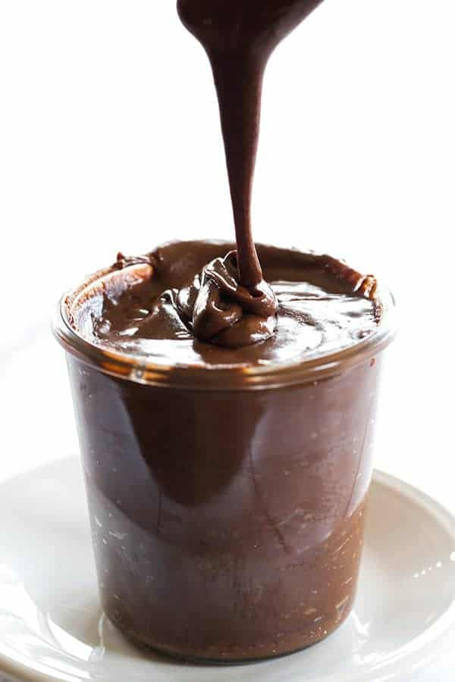
“Hot fudge is a delicious, chocolate ice cream topping”
- Ben & Jerry’s

“Hot fudge comes in different chocolate flavors”
-Mark T. Smuckers, CEO of Smucker’s

WHAC #3

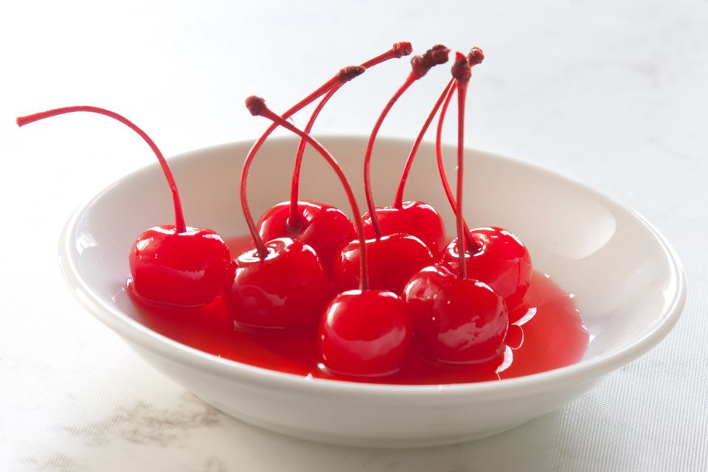
“Cherries are the best on ice cream!”
- Miss Turton’s mom

“Cherries are actually vegetables” - Timmy Jones, Kindergartener

WHAC #4

“Sand makes me you smarter when you put it on ice cream!”
- Spongebob Squarepants, cartoon character

“Sand is not a dessert topping”
- The Food and Drug Administration

WHAC (Picture #1)

What is the source?
- __________________________________________________
- __________________________________________________

How credible is it?
- __________________________________________________
- __________________________________________________

What is the Author’s purpose?
- _________________________________________________
- _________________________________________________

Do the sources Corroborate?
_______________________________________

WHAC (Picture #2)
What is the source?
- __________________________________________________
- __________________________________________________

How credible is it?
- __________________________________________________
- __________________________________________________

What is the Author’s purpose?
- _________________________________________________
- _________________________________________________

Do the sources Corroborate?
________________________________________

WHAC (Picture #3)
What is the source?
- __________________________________________________
- __________________________________________________

How credible is it?
- __________________________________________________
- __________________________________________________

What is the Author’s purpose?
- _________________________________________________
- _________________________________________________

Do the sources Corroborate?
________________________________________

WHAC (Picture #4)
What is the source?
- __________________________________________________
- __________________________________________________

How credible is it?
- __________________________________________________
- __________________________________________________

What is the Author’s purpose?
- _________________________________________________
- _________________________________________________

Do the sources Corroborate?
________________________________________

VOTE:
Name:____________________________
Directions: Check the box to cast your vote! Write why your choice was credible on the lines below!
Hot Fudge Sprinkles

_______________________________________________________________________________________________________________________________________________________________________.

Emily Festa Professor Sheehan
Course EDU December 4, 2019
Grade: 2 Topic: Elections Content Area: Social Studies
Objective
After reviewing corroboration, credibility, and elections, students will read information about current presidential candidates and sort out sources to credible/ not credible while voting at the end and completing a teacher created worksheet.

Standard
Civil Ideals and Practices
2.3 The United States is founded on the principles of democracy, and these principles are reflected in all types of communities
2.3c The process of holding elections and voting is an example of democracy in action in schools, communities, New York State, and the nation.
- Students will learn about the process of voting and what opportunities adults in the community have for participation.
- Students will participate in voting within the classroom and in school, as appropriate.
Indicator: This will be evident when students gather information to vote for a president.

English Language Arts New York State Standard
Research to Build and Present Knowledge
2W7: Recall and represent relevant information from experiences or gather information from provided sources to answer a question.
Indicator: This will be evident when students use evidence to back up their agreement or
disagreement.

Inquiry Standard
Questions
Indicator: This will be evident when students are asked questions about whether a
source is credible or if it is not.

Skills
Gathering Information
Indicator: This will be evident when students gather and review information based on
documents shown to determine who would be a better presidential candidate.

DEVELOPMENTAL PROCEDURES
- Motivation: Students will gather at the meeting rug and asked to do a turn and talk to review what an election means and why we use them. (Why do we need elections? (INFERENTAL) What purpose do they serve? (METACOGNITIVE) What election is coming up? What will your parents be voting for? (LITERAL) ) [5 minutes]
- Students will then discuss why it is important to understand the facts about each person before making an informed decision on who they want to vote for. (Why is it important to know all of the information about something or someone before voting for it?(METACOGNITIVE) When you’re at a restaurant, would you not look at the menu, point to a random thing and say “I want that”?(LITERAL) What is the importance of research? (INFERENTAL) ) [5 minutes]
- Teacher will explain that students will learn facts about two candidates for the “presidential election”. (Who is the current President of the United States? (LITERAL) Who are two of the candidates for the upcoming presidential election? (INFERENTAL) What do you know about the presidential election?(METACOGNITIVE) ) [2 minutes]
- Teacher will show a sheet of information about two of the candidates, Joe Biden and Donald Trump, and ask the students to look for similarities and differences about each candidate. (What are some differences you can spot? (LITERAL) What do you think the donkey means? What do you think the elephant means? (INFERENTAL) Why do you think we have political parties? (METACOGNITIVE) ) [3 minutes]
- Teacher will send students back to their seats and give them a worksheet which they must cut out a “fact” and paste it under a column that states whether it is a credible source or not. (Why is this source credible? Why is it not credible? (INFERENTAL) Why do we have to know if a source is credible? (LITERAL) Why do you think this is important? (METACOGNITIVE) ) [15 minutes]
- Students will then go over their answers for the credible/not credible sources and then be asked to explain why they chose them for those sections. (Why did you say ‘Joe Biden is the best candidate for president because he likes dogs -by Ms. Festa’s mom’ is not a credible source? (INFERENTAL) What does it mean to be credible? (LITERAL) What can you tell about Donald Trump from the credible information presented? (METACOGNITIVE) )
- The students will then examine the strengths and weaknesses of each candidate and say who they would vote for as president with the information they have been given. (Who will you vote for? (LITERAL) Why did you vote for them? (INFERENTAL) Why do you think they would be a good president? (METACOGNITIVE) ) [5 minutes]
- Closure: Students will be asked to independently answer the question “What kind of a person they would want for president?” and make a list to explain important facts about what would make a good president. [10 minutes]

INSTRUCTIONAL STRATEGIES
Scaffolding (providing support and moving students toward greater independence)
Indicator: This will be evident when the teacher helps students
examine the importance of corroboration, understanding, credibility,
and asking questions to determine what makes a good president.

Discussion (engaging in meaningful discussions about the content)
Indicator: This will be evident when students are discussing what
makes a good president.

ASSESSMENT
Informal Assessment
Students will be informally assessed through the use of questions (literal, inferental, and metacognitive)

Formal Assessment
Students will complete a teacher created worksheet on what kind of person would they want for president by making a list, writing a short speech if they were running for president, and they will be graded with a 3 out of 4 on a teacher created rubric.

Independent Practice
Following the lesson on presidential elections, students will create a speech about why they would be a good president to present to the class and they will need to find a speech online to compare theirs too.

REFERENCES

English Language Arts Learning Standards. (n.d.). Retrieved from
http://www.nysed.gov/curriculum-instruction/new-york-state-next-generation-english-language-arts-learning-standards.
New York State K-12 Social Studies Framework. (n.d.). Retrieved from https://www.engageny.org/resource/new-york-state-k-12-social-studies-framework.

Name _________________________ Date _____________

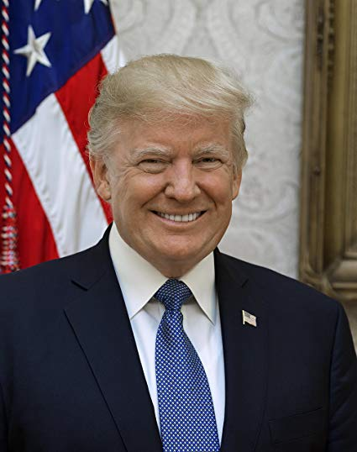
Credible Not Credible

Name ___________________________ Date _____________
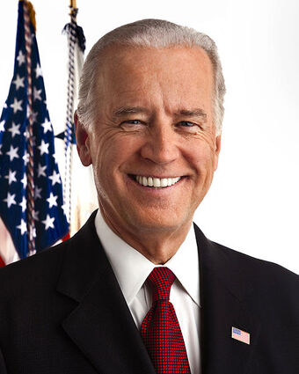

Credible Not Credible

Directions: Take these sources and cut them out. On the worksheets above, please paste in the correct columns if a source is credible or not credible.

Donald Trump Sources

”Donald Trump is the best president ever!” -Donald Trump’s Mom | Donald Trump was elected for president in 2016 - The White House
Donald Trump is the current President of the United States of America. - The White House | Donald Trump does not like chocolate chip cookies. - Donald Trump Fan Club
Donald Trump owns businesses. - Donald Trump INC. | Donald Trump is allergic to shellfish - Anti Donald Trump Fan Club
Donald Trump is the 50th President of the United States. -The White House | Donald Trump is Donald Duck - Not the Real Mickey Mouse
Donald Trump is a businessman runs a company. -Donald Trump INC | Donald Trump has purple hair - Not a real source.com

Joe Biden Sources

Joe Biden was the Vice President to former President Barack Obama- The White House | Joe Biden has one toe on his right foot- Barack Obama’s left foot
Joe Biden is an American politician. - The White House | Joe Biden invented donuts! -The Fake News
Joe Biden invented the first airplane. - Ms. Festa’s Aunt | Joe Biden was in the United States Senate from 1973 to 2009. - White House Records
Joe Biden knows the Tooth Fairy - the turtle from the petting zoo | Joe Biden was re-elected six times to be a senator- Joe Biden Biography
Joe Biden is in the Democratic Party - United States of America files | Joe Biden can do 100 jumping jacks in a row! - Mr. Sheehan’s Uncle

EXIT TICKET

Name ___________________________ Date _____________

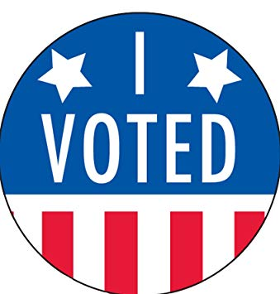
Directions: After you have sorted out your sources, now place your vote with who you would vote for president in the upcoming election

WRITE CANDIDATES NAME HERE

Formal Assessment

Name _________________________ Date _____________

Directions: Please write in the box below a couple things that would make a good president.

Now that you wrote what makes a good president, write a speech of your own with why you would be a good president.

