Amanda Esteves Dr. Sheehan
EDU 351 01 November 7th, 2016
Grade: 4 Topic: Hope Crushers Content Area: Social Studies and Hope Creators

INSTRUCTIONAL OBJECTIVE (Lesson Objectives)*

After watching Emily’s Art and a discussion/turn and talk on hope, students form an opinion on hope based on Emily’s Art and successfully complete an exit ticket with 100% accuracy.

CCLS/+NYS STANDARDS AND INDICATORS

New York State Social Studies Standards
Key Idea:
4.3 COLONIAL AND REVOLUTIONARY PERIOD IN NEW YORK: European exploration led to the colonization of the region that became New York State. Beginning in the early 1600s, colonial New York was home to people from many different countries. Colonial New York was important during the Revolutionary Period. (Standards: 1, 3, 4; Themes:MOV, TCC, GEO, SOC, GOV)
Key Concepts:
4.3d Growing conflicts between England and the 13 colonies over issues of political and economic rights led to the American Revolution. New York played a significant role during the Revolution, in part due to its geographic location.
Indicator:
This will be evident when students answer the question Did the Declaration of Independence create hope in Americans?
National Social Studies Standards and Themes
VI. Power, Authority, & Governance
Social studies programs should include experiences that provide for the study of how people create and change structures of power, authority, and governance.
IV. Individual Development & Identity
Social studies programs should include experiences that provide for the study of individual development and identity.
NCSS C3 Inquiry Arc
Dimension 1:
Dimension 1 of the arc features the developing of questions and the planning of investigations. With a robust question in mind, teachers and students determine the kind of content (Dimension 2) they need to create a plan to address their questions.
Indicator: This will be evident when the students turn and talk after watching the story book “Emily’s Art.”
Common Core ELA Standards
College and Career Readiness Anchor Standards for Speaking and Listening:
Comprehension and Collaboration
2. Integrate and evaluate information presented in diverse media and formats, including visually, quantitatively, and orally.
Indicator: This will be evident when students view “Emily’s Art” on the Smartboard and discuss what who they believe the hope crusher and hope creator.
College and Career Readiness Anchor Standards for Writing:
Text Types and Purposes
2. Write informative/explanatory texts to examine and convey complex ideas and information clearly and accurately through the effective selection,organization, and analysis of content.
Indicator: This will be evident when students complete an exit ticket at the end of the lesson.
Social Studies Practices: Habits of Mind
A.Gathering, Interpreting, and Using Evidence
5. Identify implicit ideas to draw inference, with support
B. Chronological Reasoning
4. Identify and classify the relationship between multiple causes and multiple effects
Indicator: This will be evident when students compare a hope crusher to a hope creator in their life.

MOTIVATION: (Engaging the learners*) (Engagement)

The teacher will play a video of the story book known as, Emily’s Art for the class. The students will then discuss the hope crushers and creators from the book.

MATERIALS
- SMART Board
- Powerpoint
- Exit Slips
- Emily’s Art Video (Computer)
- Writing utensils
- Two emojis
- Six scenarios

STRATEGIES (Learning Strategies)*

Group Discussion: The teacher will facilitate a discussion on what the students believe hope is.

Cooperative Learning: The students will turn and talk with their partner to identify the hope crusher and hope creator from the story, Emily’s Art.

Independent Study: Students will independently complete the front and back side of the exit slip.

ADAPTATIONS (Exceptionality*)

- The student in which English in not their first language will be able to interview their parents on video and bring it in.
- The hearing impaired student will have subtitles for the video on Emily’s Art.
- The student in which has poor spelling skills will be provided with a dictionary for the exit slip.
- The student in which has poor reading skills will be provided with picture directions in addition to the written assignment for homework.

DIFFERENTIATION OF INSTRUCTION

Tier one students will have extended time with their exit slips and finish them for homework.

Tier two students will successfully complete their exit slips with 100% accuracy.

Tier three students will be required to complete their exit slips with 100% accuracy and create two additional scenarios for a hope crusher and a hope creator.

DEVELOPMENTAL PROCEDURES

- Motivation: The teacher will Emily’s Art storybook. Throughout the video clip the teacher will pause to ask frequent questions. (Literal) Who is the how crusher? (Inferential) Is there something else she could have said? (Metacognitive) How do you think Emily feels when the judge turns down her picture?

- The students will identify the true meaning of hope.

- Students will then participate in a turn and talk to identify a hope crusher and hope creator, relating it back to the storybook.

- The students will each receive two emoji faces, one happy and one sad. They will hold up the related emotion when they listen to 6 scenarios. The sad face symbolizes a hope crusher whereas the happy face symbolizes a hope creator.

- The students will complete both the front and back of an exit slip. on the front and on the back the students will write an acrostic poem for hope.

- Lastly, the students will record their homework assignment, due the following day.

ASSESSMENT (artifacts and assessment [formal & informal]*) (Evaluation)

- The teacher will assess the students understanding while answering questions throughout the lesson.

- The teacher will assess the students’ completed exit slips for 100% accuracy.

INDEPENDENT PRACTICE

Following the lesson on hope, students will interview their parents or grandparents to seek who their hope creator is in their life.

FOLLOW-UP DIRECT TEACHER INTERVENTION AND ACADEMIC ENRICHMENT

Direct Teacher Intervention: The student who did not easily meet the lesson objective will meet with the teacher who will evaluate the students work together. The teacher will then review the errors or misunderstandings the student had. The student will then watch a different story known as Rosie Revere by Andrea Beaty. The teacher will then review the same concepts based on hope.

Academic Enrichment: The student who easily met the lesson objective will have the opportunity to share their work with the class as a model.

TEACHER REFERENCES

Emily's Art "Read Aloud" (2013, February 06). Retrieved November 06, 2016, from
http://www.youtube.com/

Hope. (2016). Retrieved November 06, 2016, from http://www.merriam-webster.com/

New York State K-8 Social Studies Framework. (n.d.). Retrieved from
https://www.engageny.org/resource/new-york-state-k-12-social-studies-framework

New York State P-12 Common Core Learning Standards for English Language Arts &
Literacy. (n.d.). Retrieved from
https://www.engageny.org/resource/new-york-state-p-12-
common-core-learning-standards-for-english-language-arts-and-literacy

Pinterest. Twitter Exit Slip (n.d.). Retrieved November 06, 2016, from
https;//www.pinterest.com/

EXIT SLIP
Front:
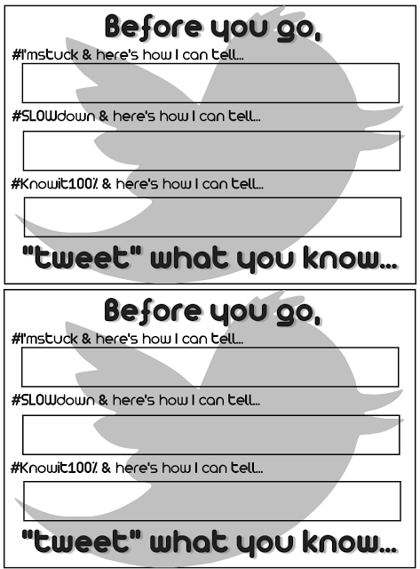

Back: Write an acrostic poem for HOPE

Scenarios for Hope Crushers and Hope Creators: How would you feel?

- When you tried out for the soccer team in the Spring, your coach took one look at you and told you; “You don’t look like a soccer player!” (HOPE CRUSHER)

- You failed your Science exam even though you stayed up late to study, when you informed your mom about the bad grade she said: “That’s okay I know you tried and I know you’ll do better next time.” (HOPE CREATOR)

- You informed your dad that when you grow up you want to be a doctor, your dad replied “you’ll be in school for thousands of years, plus your not smart enough to become a doctor.” (HOPE CRUSHER)

- When Ms. Esteves taught you a new math lesson you began to get frustrated and give up, but Ms. Esteves said “if at first you don’t succeed, you must try, try and try again!” (HOPE CREATOR)

- You and your big brother are fighting because you believe he took something of yours, he then tells your parents that you are too stupid to even remember you had it in the first place. (HOPE CRUSHER)

- You finally completed a difficult puzzle you had been working on for the last week, your mom sees and says “Wow! Good work, I couldn’t even do that myself!” (HOPE CREATOR)

