Lesson Three
Molloy College
Division of Education
Student Allison Fleming Professor Sheehan
Course EDU 5090 Date December 12th, 2019
Grade 4 Topic American Industrial Revolution Content Area Social Studies and ELA

STANDARDS AND INDICATORS

Social Studies Standard:

4.6 WESTWARD MOVEMENT AND INDUSTRIALIZATION: New York State played an important role in the growth of the United States. During the 1800s, people traveled west looking for opportunities. Economic activities in New York State are varied and have changed over time, with improvements in transportation and technology. (Standards: 1, 3, 4; Themes: MOV, TCC, GEO, ECO, TECH)

4.6e Entrepreneurs and inventors associated with New York State have made important contributions to business and technology.
Students will research several people who made important contributions to business, technology, and New York State communities. Some people to consider include Thomas Jennings, Thomas Edison, Henry Steinway, John Jacob Bausch, Henry Lomb, Cornelius Vanderbilt, Lewis H. Latimer, Jacob Schoellkopf, Nikola Tesla, George Westinghouse, George Eastman, Amory Houghton, Willis Carrier, John D. Rockefeller, Edward H. Harriman, J.P. Morgan, Hetty Green, Emily Roebling, and Elisha Otis, and others, as locally appropriate.

Indicator: This will be evident when the students are able to role play different inventors and pitch their inventions and their impact on New York State communities to the “sharks” (teacher) in “Shark Tank” and will include three out of four facts/benefits/impactfulness about the inventors and their inventions on New York State communities in their pitch.

ELA Standard:
4R3: In informational texts, explain events, procedures, ideas, or concepts, including what happened and why, based on specific evidence from the text.

Indicator: This will be evident when the students use the research they gathered to discuss inventions and inventors, the reasoning behind the invention, and the benefits of the invention on New York State communities in a “Shark Tank” pitch.

Habits of Mind Practices:
B. Chronological Reasoning
5. Distinguish between long-term and immediate causes and effects of an event from current events or history.

Indicator: This will be evident when the students will discuss the impact of the invention on New York State communities in their “Shark Tank” pitch.

Inquiry Arcs Standard:
Evaluating Sources and Using Evidence

Indicator: This will be evident when the students perform research on their inventors and their inventions and use their research in writing a successful “Shark Tank” pitch.

INSTRUCTIONAL OBJECTIVE(S)

After the students watch the “three most successful pitches” on ‘Shark Tank’”, perform research, complete a worksheet, and role play as different inventors, the students will be able to research several people who made important contributions to business, technology, and New York State communities by performing a pitch to the “shark” (teacher) in “Shark Tank” and will include three out of four facts/benefits/impactfulness about the inventors and their inventions on New York State communities in their pitch.

DEVELOPMENTAL PROCEDURES (*Engaging the learner)
- MOTIVATION: Teacher will have the students watch the “three most successful pitches” from the show “Shark Tank”: https://www.youtube.com/watch?v=k3PY_p_M-8w
- Students will take notes while performing a turn and talk with their peers about what made these “Shark Tank” pitches successful. (Were these pitches successful? (Literal) Why do you think these ptiches were successful? (Metacognitive) What did they have in common? (Inferential) Did they show a demonstration of the product or invention? (Literal))
- Students will get into cooperative learning groups and perform research using teacher provided sources on a specific inventor and their invention during the American Industrial Revolution (Who is your inventor? (Literal) What did he invent? (Literal) How did it impact society? (Inferential) How did it impact New York State communities? (Inferential) Why was the invention created? (Inferential) What was the problem that was happening for the invention to be created? (Inferential) Why do you think this invention was created? (Metacognitive) Was it beneficial to New York State communities? Why or Why not? (Metacognitive)).
- Students will complete a worksheet that will help guide them in writing their pitch.
- Students will write their pitch and included three to four facts/benefits/impacts on the inventor and the invention to New York State communities.
- Students will role play being the inventor and pitch the “shark” (teacher) their invention.
- The teacher will invest in the student’s invention and give feedback as to why they would.

ASSESSMENT (formal & informal)
Informal assessment
The informal assessment will be when the students complete the “Shark Tank” questionnaire.

Formal assessment
The formal assessment will be the pitch the students perform to the “shark” (teacher) that will include three out of four facts/benefits/impacts on New York State communities.

INSTRUCTIONAL STRATEGIES
Turn and Talk
Indicator: This will be evident when the students take notes and have a turn and talk with their peers about why the three pitches in the “Shark Tank” video were successful.

Cooperative Learning
Indicator: This will be evident when the students get into small groups to conduct research and create a pitch to perform to the “shark” (teacher) and will include three out of four facts about the inventors and their inventions and its impact on New York State communities

INDEPENDENT PRACTICE

Students will be able to write a reflection on their experience role playing as an inventor on “Shark Tank”. In this reflection, they will be able to write about their experience researching the inventor they had and their inventions as well as write about their thoughts on the invention. For example, they can talk about if they feel that their invention they researched was beneficial to New York State communities or not or if it had a positive or negative impact on American society as a whole. They can also discuss how they felt role playing an inventor and how they felt performing a pitch.

REFERENCES

American Historama. (n.d.). Industrial revolution inventions. Retreived from http://www.american-historama.org/industrial-revolution-inventions.htm
American Historama (n.d.). Eli Whitney cotton gin. Retrieved from http://www.american-historama.org/1790-1800-new-nation/eli-whitney-cotton-gin.htm
American Historama (n.d.). Steamboats in the 1800s. Retrieved from http://www.american-historama.org/1801-1828-evolution/steamboats-of-1800s.htm
American Historama (n.d.). McCormick reaper. Retrieved from http://www.american-historama.org/1829-1841-jacksonian-era/mccormick-reaper.htm
Bellis, Mary. (2019, July 26). The history of steamboats. Retrieved from https://www.thoughtco.com/history-of-steamboats-4057901
Hilborn, S. (2016, Aug. 24). Winning shark tank pitches. Retrieved from https://www.britannica.com/biography/Cyrus-McCormickhttps://www.youtube.com/watch?v=k3PY_p_M-8w
History. (2019, Dec. 9). Erie canal. Retrieved from https://www.history.com/topics/landmarks/erie-canal
Longley, Robert. (2019, Dec. 6). Biography of Robert Fulton, inventor of the steamboat. Retrieved from https://www.thoughtco.com/robert-fulton-steamboat-4075444
New Georgia Encyclopedia. (2019). Eli Ehitney in georgia. Retrieved from https://www.georgiaencyclopedia.org/articles/history-archaeology/eli-whitney-georgia
O’Donnell, E.T. (2012, Oct. 21). The erie canal - the original economic stimulous plan. Retrieved from http://inthepastlane.com/erie-canal-this-week-oct-21-2012/
Sheehan, K. (2019). Revised read and retell (cotton gin). Retrieved from https://molloy.instructure.com/courses/15558/pages/module-5-making-history-come-alive-with-literacy-strategies?module_item_id=223339
Sheehan, K. (2019). Revised reading discovery (erie canal). Retrieved from https://molloy.instructure.com/courses/15558/pages/module-5-making-history-come-alive-with-literacy-strategies?module_item_id=223339
Study. (2019). Mechanical reaper: Invention, impact & facts. Retrieved from https://study.com/academy/lesson/mechanical-reaper-invention-impact-facts.html
Thwaites, R. G., State Historical Society of Wisconsin. (1909). Cyrus Hall McCormick and the reaper: (From the proceedings of the state historical society of Wisconsin for 1908). Madison [Wis.]: The Society.
Wilson, M.. (22, Oct. 2019). Cyrus McCormick. Retrieved from https://www.britannica.com/biography/Cyrus-McCormick

Name: ___________________________ Date: __________________
Shark Tank Pitch Questionnaire

- Who is your inventor and what is invention will you be pitching to the sharks?

- Why was this invention created? What was the problem that this invention fixed?

- What were the benefits of this invention? How did it impact New York State communities?

- How much of an investment are you asking from the Sharks and how much equity will they get from your company after they invest?

Background Information on the Cotton Gin:

The most important plantation crop in the South was cotton. The South’s warm weather and rich soil had always been good for growing cotton. Cotton growers generally made little money until Eli Whitney invented the cotton gin in 1793. The cotton gin separated the seeds from cotton with a speed that changed the nature of the industry. Cotton could now be mass-produced and cotton growers now sought more land and more slaves. This machine cleaned cotton at a rate fifty times faster than they had ever been able to clean cotton before. By 1860, three quarters of the world’s cotton was now grown on Southern plantations.

(Dr. Kevin Sheehan, 2019)

Reading Discovery: The Erie Canal
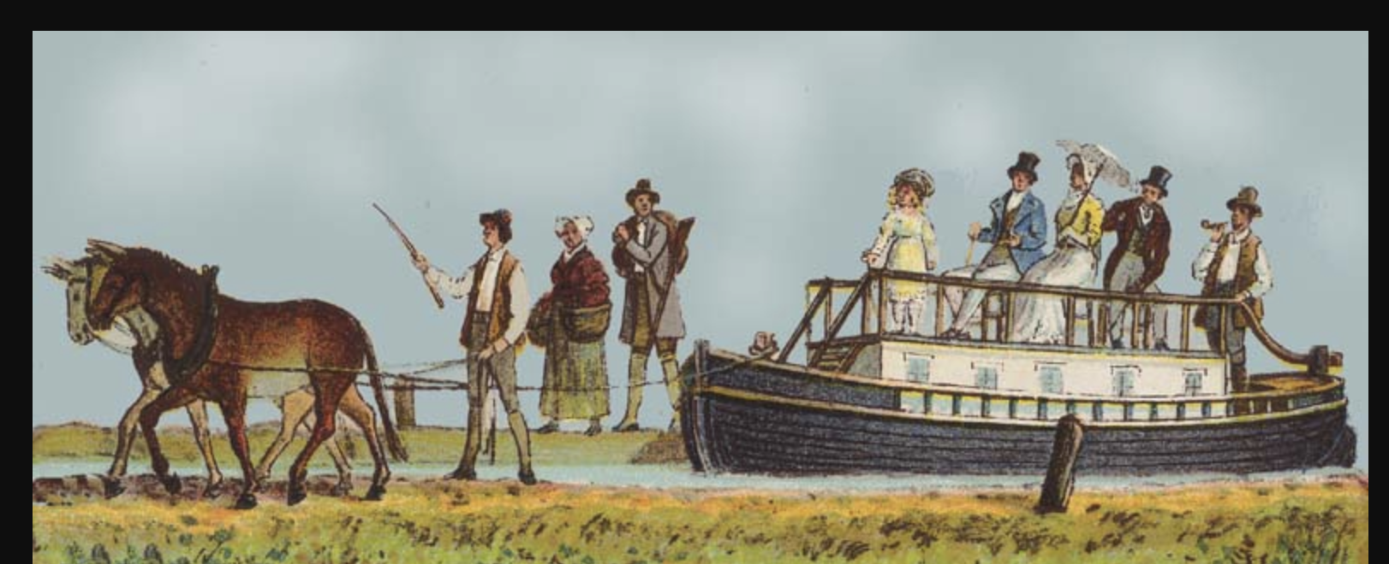

The Erie Canal, a man-made 363-mile waterway, connected Albany and Buffalo in 1825. The canal was originally opposed by New York City as a project designed to specifically to benefit the farmers of Western New York State. Luckily, Governor DeWitt Clinton overcame the resistance of New York City. The canal made it possible for farm goods to be moved from Buffalo to Albany and even New York City. This changed farming and life in Western New York dramatically. Farms moved from being self-sufficient operations to farms that could now grow large cash crops for sale throughout the state. Life in Western New York changed drastically as farmers now entered the world of specialization and mass production. The self-sufficient farm that met all its need was now gone. The age of Homespun, when a family accounted for all their own needs including homespun clothing, now ended.
The effect on New York City was even more dramatic as goods produced in New York City could now be sold in markets all over the state. Coupled with the steam-powered boats on the Hudson, shipping costs were reduced by 95%. New York became the most important commercial city in the world. In fact, New York City became the leading port in the world. The canal also became a gateway to the west for migrants and tourists and even ideas. The economy of the state now became interdependent. For the first time in western New York, crops could be shipped to New York and even sold to world markets.. Life was changed forever by the Erie Canal. Not everyone appreciated the changes as those along the canal waterway saw life change dramatically. The canal brought not only the goods of New York City, but the values as well. Young man sought to live life in the big city and migrated to New York City in large numbers. Life would never be the same. The days of farmers who met all their own needs was gone forever.

(Dr. Kevin Sheehan, 2019)

