Molloy College
Division of Education

Marina Foley Dr. Sheehan
EDU 351 April 10, 2018
Grade 5, Montreal Social Studies

INSTRUCTIONAL OBJECTIVE(s) (Lesson Objective(s)*)

After examining four documents and engaging in historical thinking using the SCIM-C method, students will discuss and make a claim about if the sources presented that depict life in Canada are valid. Students will conclude by writing a response on an exit ticket worksheet that encompasses an overview of how thinking like a historian has shaped their view on life in Canada including at least three references to documents analyzed in class.

NYS-NGLS / +NYS STANDARDS AND INDICATORS

New York State Social Studies Standards

Key Idea:
5.4 GEOGRAPHY IN THE WESTERN HEMISPHERE: The diverse of the Western Hemisphere has influenced human culture and settlement in distinct ways. Human communities in the Western Hemisphere have modified the physical environment.

Key Concept:
5.4c The physical environment influences human population distribution, land use, and other forms of economic activity.

Indicator: This will be evident when students observe and analyze the four documents on the history of life in Canada.

National Social Studies Standards and Themes:

III. People, Places, & Environments
Social studies programs should include experiences that provide for the study of people, places, and environments.

I. Culture
Social studies programs should include experiences that provide for the study of culture and cultural diversity.

Indicator: This will be evident when students act as historians to recognize the various aspects of the history of life in Canada. Students will understand that other cultures have influenced and impacted Canadian culture.

NCSS C3 Inquiry Arc

Dimension 3: Students will work toward conclusions about societal issues, trends, and events by collecting evidence and evaluating its usefulness in developing causal explanations.

Indicator: This will be evident when students use the SCIM-C method to effectively draw conclusions about valid sources.

Dimension 4: Students will draw on knowledge and skills to work individually and collaboratively to conclude their investigations into societal issues, trends, and events and will present their information, portions and findings.

Indicator: This will be evident when students collaboratively work toward conclusions and collect evidence on life in Canada to determine if the presented history is valid.

New York State Next Generation English Language Arts Learning Standard
Writing Standards
Text Types and Purposes
5W1
Write arguments to support claims in an analysis of substantive topics or texts, using valid reasoning and relevant and sufficient evidence.

Indicator: This will be evident when students respond to what we have analyzed in the primary sources on Canada by making a claim on if the information is valid and writing a paragraph referring to the SCIM-C method.

Comprehension and Collaboration
5SL1
Engage effectively in a range of collaborative discussions with diverse partners; express ideas clearly and persuasively, and build on those of others.

Indicator: This will be evident when students complete the SCIM-C method in their groups discussing their analysis on the given documents with their peers.

Social Studies Practices: Habits of Mind:

A. Gathering, Interpreting, and using Evidence
3. Identify evidence and explain content, authorship, purpose and format; identify bias; explain the role of bias and potential audience, with teacher support.

Indicator: This will be evident when the students gather evidence to complete the SCIM-C questions in an analysis of the given documents with their peers.

INSTRUCTIONAL RESOURCES

Smartboard, YouTube (https://www.youtube.com/watch?v=rZG12cx3NAE ), Thinking Like A Historian Powerpoint, Documents handout (1, 2, 3, & 4), SCIM-C questions handout, markers, poster paper with SCIM-C questions, Thinking Like A Historian homework, Exit Ticket, Match It Up! handout

MOTIVATION (Engaging the learner(s)*)

Teacher will begin class by showing students a video on what it means to think like a historian. This will give students a chance to review key terms such as primary and secondary sources that are necessary to understand for this lesson. Students will become motivated to put themselves in the shoes of a historian and act as one for the day as they analyze and observe various documents.

DEVELOPMENTAL PROCEDURES
(including Key Questions)

- Students will review the homework given yesterday. (Does anyone have any questions on the homework?)

- Students will be informed that they are going to act like historians for the day. Students will watch a video that outlines the job of a Historian. Students will review key terms mentioned in the video to introduce the lesson for the day. Students will review CHAMPS before engaging in the lesson. (Does anyone know what a Historian does? What is a primary source? What is a secondary source? What are some examples?)

- Students will be given the SCIM-C questions sheet to observe. Teacher will model the SCIM-C method’s questions and examples of how we could answer them. Students will participate in a class discussion on what the categories general significance in terms of looking at documents. (What does it mean to summarize in your own words? What does it mean to contextualize in your own words? What does it mean to infer in your own words? What does it mean to monitor in your own words? What does it mean to corroborate in your own words? Do you think it is important to analyze all of these pieces when looking at a document?)

- Students will be directed to observe the four documents displayed around the classroom on poster boards. Students will be strategically placed into groups and given a role to complete in each group. Roles are assigned by the color that corresponds to a part of the SCIM-C method that is presented on the top right corner of their Documents handout. (If a student gets the color blue, students will be summarizing. Green, students will be contextualizing. Purple, students will be inferring. Red, students will be monitoring). (What kind of documents do you think are hung around the classroom? How can we observe and analyze these documents? Do you see a color on the top right corner of your Documents handout? What role are you responsible for from the SCIM-C method?)

- Each group will be given a different document on the history of life in Canada to analyze. Students will participate in responding to the document by completing the SCIM-C method with their group. (What do you notice about the documents? Can we respond to the documents using the SCIM-C model? Is this document a primary or secondary source? What is this document telling us about life in Canada? )

- After students have responded to their document, students will meet with their expert groups. At this time, all the summarizers will become an expert group, all the contextualizes will become an expert group, and so on. In these expert groups, students will corroborate between the four documents. (Can you compare these documents to one another? How are they similar? How are they different? What other sources could confirm the evidence presented in all of these documents to be true? Is there any time gaps between the documents? Are these documents accurate?)

- Students will return to their seats to engage in a class discussion about the documents examined today. Students will compare the documents from today to the documents that were analyzed in the previous class. (How do the documents we observed today compare to the documents we observed yesterday? Are they the same kind of source? Do these documents prove the sources from yesterday to be true? Is what we learned about life in Canada valid?)

- Students will independently complete the Exit Ticket worksheet to review what they have learned about life in Canada during the document analysis. (How do we know what we have learned about Canada is true?)

INSTRUCTIONAL STRATEGIES (Learning Strategies*)

- Discussion
Indicator: This is evident when students work as a class to compare primary and secondary documents.

- Modeling
Indicator: This is evident when students watch teacher demonstrate how to utilize the SCIM-C method.

- Demonstration
Indicator: This is evident when teacher shows and explains to students think like historians and effectively use the SCIM-C model to analyze four documents.

ADAPTATIONS (Exceptionality*)

- The student who is easily distracted and struggles to stay focused will be redirected by teacher through the use of specific nonverbal cues.

- The student who struggles to work in small groups or with a partner will be encouraged to select her own group for the SCIM-C document analysis.

DIFFERENTIATION OF INSTRUCTION

- The visual and kinesthetic learners will be accommodated during this lesson. Visual learners will enjoy being able to read the documents in a larger text displayed on a poster hanging up in the classroom. These learners will also benefit from the motivation of the lesson when watching the video on historians. Kinesthetic learners will benefit from being able to move around the classroom during the document analysis. Having these students up and moving maintains their interest and engagement greatly.

- Students learn at different levels (struggling, average, and advanced) and are accommodated at these levels during the SCIM-C document analysis when students are strategically placed into groups. The four documents differ from one another in terms of content. Struggling students will be given the Document 1 that has a clear image with supporting text explanation, average students will be given Documents 2 or 3 that have text and supporting text explanations, and advanced students will be given Document 4 that is a text excerpt with no supporting explanation.

ASSESSMENT (artifacts* and assessment [formal & informal]*)

Students will conclude by writing a response on an exit ticket worksheet that encompasses an overview of how thinking like a historian has shaped their view on life in Canada including at least three references to documents analyzed in class.

INDEPENDENT PRACTICE

Following the lesson on analyzing documents using the SCIM-C method, students will complete the Thinking Like A Historian take home activity for homework that further reviews analyzing a document using the SCIM-C method on the history of life in Canada.

FOLLOW-UP ACTIVITIES: DIRECT TEACHER INTERVENTION AND ACADEMIC ENRICHMENT

Direct Teacher Intervention
After the students are assessed, students who did not meet the criterion will work with the teacher to review further. These students will be pulled aside during ‘morning work’ to go over what was misunderstood. Students will complete the Match It Up! Worksheet with jumbled SCIM-C questions on it. Students will rewrite the questions in the correct category box of summarizing, contextualizing, inferring, or monitoring..

Academic Enrichment
Teacher will challenge students who met the criterion by assigning ‘morning work’ that encompasses higher level thinking. During this time, students will work independently to create their own questions based on the SCIM-C model using the the primary or secondary documents discussed previously in class.

REFERENCES

Next Generation English Language Arts Learning Standards.
http://www.nysed.gov/curriculum-instruction/teachers/new-york-state-next-generation-english-language-arts-learning

Next Generation Social Studies Learning Standards.
http://www.nysed.gov/curriculum-instruction/teachers/new-york-state-next-generation-socialstudies-learning-standards

SCIM-C
Summarizing
- What type of historical document is the source?
- What specific information, details, and/or perspectives does the source provide?
- What are the subject, audience, and/or purpose of the source?
- What does the source directly tell us?

Contextualizing
- Who produced the source?
- When, why, and where was the source produced?
- What was happening locally and globally at the time the source was produced?
- What summarizing information can place the source in time, space, and place?

Inferring
- What is suggested by the source?
- What conclusions may be drawn from the source?
- What biases are indicated in the source?
- What contextualizing information, while not directly evident, may be suggested from the source?

Monitoring
- What is missing from the source in terms of evidence that is needed to answer the guiding historical question?
- What ideas, images, or terms need further defining from the source in order to understand the context or period in which the source was created?
- How reliable is the source for its intended purpose in answering the historical question?
- What questions from the previous stages need to be revisited in order to analyze the source satisfactorily?

Corroborating
- What similarities and differences exist between the sources?
- What factors could account for the similarities and differences?
- What gaps appear to exist that hinder the final interpretation of the source?
- What other sources are available that could check, confirm, or oppose the evidence currently marshaled?

Name: ______________________________ Date: ________________

Thinking Like A Historian
Directions: In class we analyzed various documents on the history of Canada using the SCIM-C method. Use this method again to analyze the text below. Goodluck Historians!
By the slenderest of margins, voters decided today that Quebec would remain a part of Canada. "Don't just love us, recognize us," said Louise Beaudoin, Quebec's Minister for Inter-governmental affairs. "Canada on paper is still a country but clearly there is something wrong with that country." The vote came after a seven-week battle that wound up with both sides frantically seeking to convert 500,000 undecided voters. Quebec now enjoys one of the highest standards of living in the industrialized world. Its per capita income would place it 15th among industrial countries, ahead of Australia, Britain, Sweden, Finland and New Zealand. Ultimately, it is stated by prime minister Jean Chretien that "Canada without Quebec is no more Canada, and Quebec without Canada is no more Quebec."

~ Article written by Clyde H. Farnsworth printed in 1995 by The New York Times
Summarize: What does this source directly tell us?
______________________________________________________________________________
Contextualize: Who produced this source?
______________________________________________________________________________
Infer: What conclusions can be drawn from this source?
______________________________________________________________________________
Monitor: How reliable is the source for its intended purpose in answering the historical question?
______________________________________________________________________________
Name: ______________________________ Date: ________________

EXIT TICKET
IS THIS VALID?
Directions: Today we acted as historians to analyze documents on the history of life in Canada. Think about the documents; how can we be sure what we analyzed is true? We need to check the credibility of our sources! **In the space below, make a claim on the documents. Are they credible or non-credible? Make reference to our SCIM-C method in your response and include three specific examples from the documents.**
___________________________________________________________________________________________________________________________________________________________________________________________________________________________________________________________________________________________________________________________________________________________________________________________________________________________________________________________________________________________________________________________

Match It Up!
Directions: Using your knowledge of what we have learned about SCIM-C, place the jumbled
questions into their correct category below!**Hint: There should be two questions per box.**

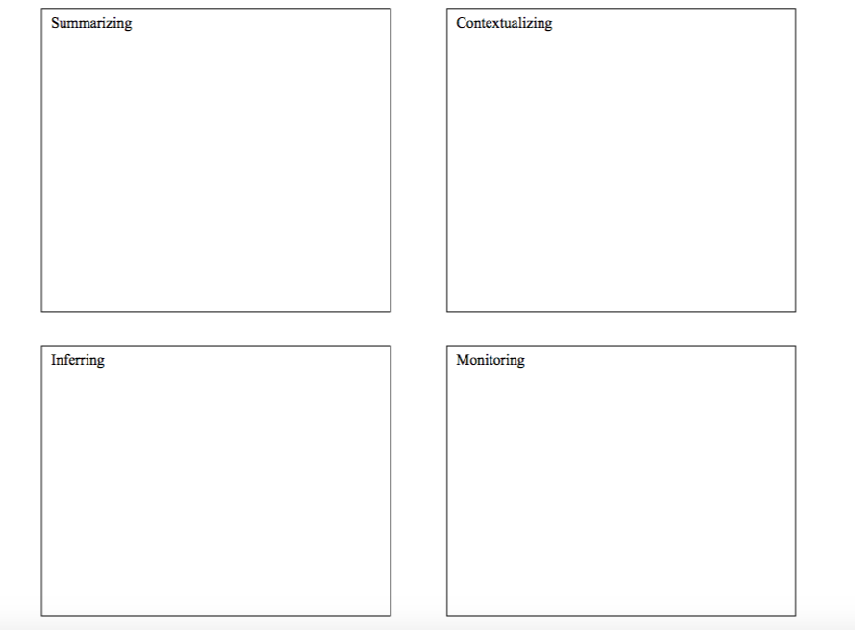

What type of historical document is the source?
What is suggested by the source?
Who produced the source?
What conclusions may be drawn from the source?
What does the source directly tell us?
What is missing from the source in terms of evidence that is needed to answer the guiding historical question?
When, why, and where was the source produced?
How reliable is the source for its intended purpose in answering the historical question?
Summarize
What type of historical document is the source?

Infer
What conclusions may be drawn from the source?
Monitor
How reliable is the source for its intended purpose in answering the historical question?
Contextualize
What was happening locally and globally at the time the source was produced?

Document #1

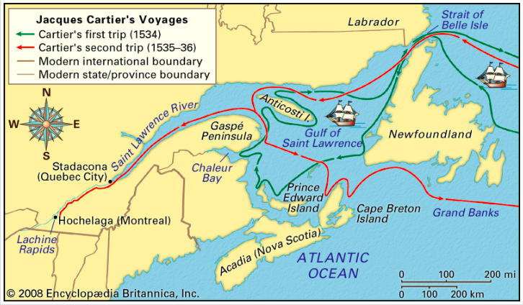

In 1524 king Francis sent a Italian sailor named Giovanni da Verrazano across the Atlantic to look for the Northwest Passage. Jacques Cartier's first voyage was in 1534. His first important discovery was the water way named the strait of Belle lsle that lead to gulf. However, Jacques Cartier's best discovery was when he founded Canada.

Document #2

We had a cross made thirty feet high, which was put together in the presence of a number of the [Stadacona] Indians on the point at the entrance to this harbour, under the cross-bar of which we fixed a shield with three fleurs-de-lys in relief, and above it a wooden board, engraved in large Gothic characters, where was written, LONG LIVE THE KING OF FRANCE. We erected this cross on the point in their presence and they watched it being put together and set up. And when it had been raised in the air, we all knelt down with our hands joined, worshipping it before them….
~ An excerpt from the journal Jacques Cartier kept at the time he was exploring the St. Lawrence River in what is now Canada.

Document #3

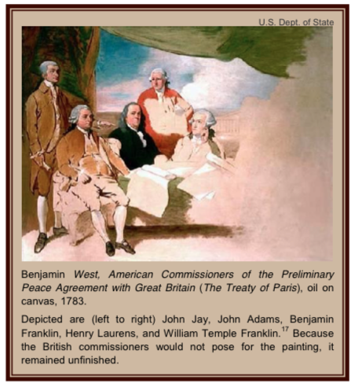

Taken place on March 20, 1783: To Henry Laurens, American peace commissioner, London.“The Bill for establishing Commerce is, I
hear, to be now made law.” It is made official on April 15, 1783; Congress ratifies the preliminary peace treaty.

Document #4

One thinks of Canada as a stable, somewhat staid society. Three elements coincided to produce turmoil. One was Pierre Elliot Trudeau, the “JFK of Canada,” newly elected Prime Minister, young, energetic, glamorous, brilliant, charismatic, eloquent in both national languages, but with an attitude toward the United States of an arrogant French intellectual aristocrat — in a word, scornful dislike. Trudeau’s imperative task was to combat Québec separatism and preserve the unity of Canada. To that end he pursued a three-fold program: to stimulate Canadian patriotism/nationalism; to portray the United States as an ugly, aggressive giant constantly threatening to overwhelm Canada; and to assuage and accommodate Québec as a treasured and protected unique component of Canada.

~ Excerpt from ADST on Quebec’s Separatist Movement

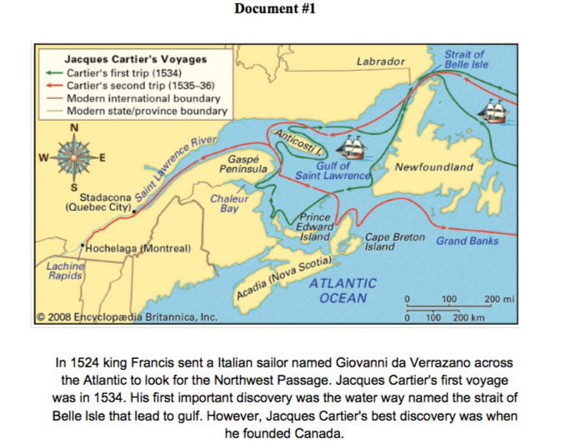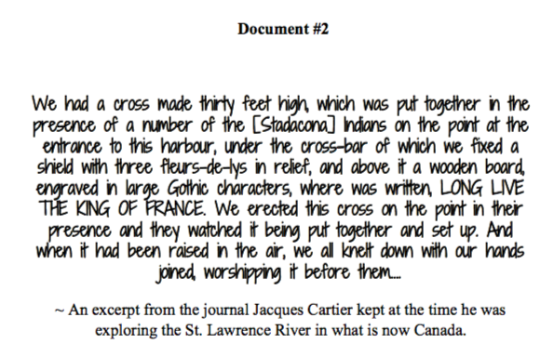
Document # 3
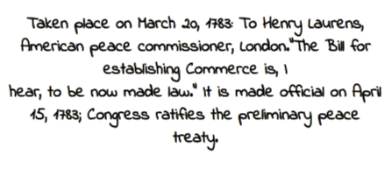
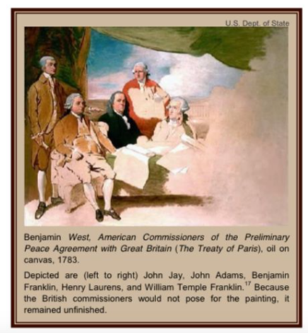
Document # 4
