Gabrielle Morales Professor: Dr. Sheehan
Course EDU 351-01 November 6, 2017
Grade: 6th Topic: Taking Informed Action on Misleading News Content Area: Social Studies

INSTRUCTIONAL OBJECTIVES (s) (Lesson Objective(s)*)
After participating in a class discussion about misleading news and engaging in a group activity where students must identify examples of several types of misleading news on social media outlets, Facebook, Twitter, and Instagram, students will divide into action groups and work together to conduct short, sustained research projects about ways to combat misleading news, by creating a commercial, a Twitter account, or a PowerPoint for their school, scoring a minimum 3 out of 4 based on a teacher created rubric.
NYS STANDARDS AND INDICATORS
New York State Social Studies Standards
Key Idea
6.7 INTERACTIONS ACROSS THE EASTERN HEMISPHERES (ca. 600 C.E. – ca. 1450): Trade networks promoted the exchange and diffusion of language, belief systems, tools, intellectual ideas, inventions, and diseases. (Standards 2, 3, 4: Themes: MOV, TCC, GEO, TECH, EXCH)
Key Concepts
6.7a The Silk Roads, The Indian Ocean, and the Trans-Saharan routes formed the major Afro-Eurasian trade networks connecting the East and the West. Ideas, people, technologies, products, and disease moved along these routes.
Indicator: This will be evident when students use what they learned about closely analyzing their own research by identifying fake and genuine news.
National Social Studies Standards and Themes
1. Culture
3. People, Places, and Environments
5. Individuals, Groups, and Institutions
10. Civic Ideals and Practices
Indicator: This will be evident when students research ways to combat misleading news and creating a commercial, a Twitter account, or a PowerPoint for their school to inform the public.
NCSS C3 Inquiry Arc
Dimension 2:
Students will analyze societal issues, trends, and events by applying concepts and tools from civics, economics, geography, and history. Look with lens and skills of the discipline.
Indicator: This will be evident when students conduct short, sustained research projects about ways to combat misleading news.
Dimension 4:
Students will draw on knowledge and skills to work individually and collaboratively to conclude their investigations into societal issues, trends, and events and will present their information, portions, and findings.
Indicator: This will be evident when students create a commercial, a Twitter account, or PowerPoint for their school on combating misleading news.
Common Core ELA Standards
College and Career Readiness Anchor Standards for Reading
Key Ideas and Details
- Read closely to determine what the text says explicitly and to make logical inferences from it, and cite specific textual evidence when writing or speaking to support conclusions drawn from the text.
Integration of Knowledge and Ideas
- Integrate and evaluate content presented in diverse formats and media, including visually and quantitatively, as well as in words.
- Analyze how two or more texts address similar themes or topics to build knowledge or to compare the approaches the authors take.
College and Career Readiness Anchor Standards for Writing
Text Types and Purposes
- Write informative/explanatory texts to examine and convey complex ideas and information clearly and accurately through the effective selection, organization, and analysis of content.
Research to Build and Present Knowledge
- Conduct short as well as more sustained research projects based on focused questions, demonstrating understanding of the subject under investigation.
College and Career Readiness Anchor Standards for Speaking and Listening
Comprehension and Collaboration
- Prepare for and participate effectively in a range of conversations and collaborations with diverse partners, building on others’ ideas and expressing their own clearly and persuasively.
- Make strategic use of digital media and visual displays of data to express information and enhance understandings of presentations.
Indicator: This will be evident when students divide into action groups and work together to conduct short, sustained research projects about ways to combat misleading news, by creating a commercial, a Twitter account, or PowerPoint for their school.

Social Studies Practices: Habits of Mind
A. Gathering, Interpreting and Using Evidence
3. Identify evidence and explain content, authorship, purpose, and format; identify bias; explain the role of bias and potential audience, with teacher support.
F. Civic Participation
4. Identify opportunities for and the role of the individual in social and political participation at various times and in various locations in the Western Hemisphere outside the United States.
5. Participate in negotiating and compromising in the resolution of differences and conflict.
6. Identify situations with a global focus in which social actions are required and suggest solutions.
Indicator: This will be evident when students work together in action groups and conduct short, sustained research projects about way to combat misleading news by creating a commercial, a Twitter account, or PowerPoint for their school.

INSTRUCTIONAL RESOURCES
- Misleading News Presentation (Teacher Created)
- What is fake news and how to spot it? YouTube Video: https://www.youtube.com/watch?v=icCdAl6TvNM
- Smartphones/Computers/Tablets
- Pencils/Pens
- Fake News Notetaking Guide (Teacher Created)
- Action Group Packets (Teacher Created)
- Kahoot! Game (Teacher created): https://create.kahoot.it/l/#user/bc312d35-7428-4480-a57c-ad454ae23d00/kahoots/created
- Homework Assignment Sheet and Letter Format (Teacher Created)
- Teacher Created Rubric
MOTIVATION (Engaging the learner(s)*)
Students will play a game of telephone to illustrate how fast misleading and inaccurate information can be spread. (7 mins) (What did you notice about this activity? Was the ending message the same as the initial message? Why do you think that is? Is there a way for us to make sure the same message gets passed through everyone? Why did we play this game? What was the point?)
DEVELOPMENTAL PROCEDURES
(including Key Questions)

- The teacher will give out the Fake News Notetaking Guide for the students to fill in during the Misleading News presentation and YouTube video. The teacher will inform the students they will be utilizing the skills they learned from the previous activities (Thinking Like a Historian, History Mystery, and Meeting of the Minds) to identify fact and fiction news stories. The teacher will explain what misleading/fake news is and the three types of it. The teacher will show a YouTube video on fake news and how the students can distinguish it from genuine news. While the video is playing, the students will write down three facts or pieces of information they learned from the video. The teacher would then go over the different motives behind misleading/fake news and the students would write these down on their notetaking guide. (15 mins) (What do you know about fake news? Have you heard the term before? What facts did you write from the video?(L) Why do you think fake news is so prominent?(I) Are there other motives you can think of that were not mentioned?)
- The teacher will inform the students that she will be dividing them up into three action groups. The teacher will go over the CHAMPS slide for behavior and responsibility of each student while working in the groups. The students will first participate in an activity where each group is assigned a different social media outlet (Facebook, Instagram, or Twitter). The students would use their cellphones, laptops, or tablets to scroll through the activity feed of these social media outlets and work together to identify examples of the three types of fake news/advertisements, as well as what the students think the motives are behind them. The students will write these examples on the back of their notetakings guides and share what they have found with the rest of the class. (8 mins) (What examples did you find? How do you know its fake news? What do you think the motivation is behind this story or advertisement? Do you think you would have noticed it before we talked about fake news? How does this newfound knowledge change the way you look at information through media outlets?(M)) (Formative Assessment)
- After practicing identifying fake news on these outlets, the teacher will assign each action group a different research project, where each group must research strategies for identifying fake news, using authentic and factual data and evidence. The action groups will them have to create either a commercial, Twitter account, or PowerPoint presentation to inform not only the school but the public about the epidemic of fake news. The teacher will give students one hour a week for several weeks to work on this project. Students will be assessed on the authenticity, creativity, and organization on a rubric. (Summative Assessment) (15 mins) (Why is fake news important for people to be aware of? How can you inform more people about the difference between fake news and genuine news? How would you start this project? Who in your group is responsible for what? What jobs will you create according to your project?)
- Students will participate in a Kahoot! game as a closure to the unit and to assess students’ knowledge. (5 mins) (Summative Assessment)
INSTRUCTIONAL STRATEGIES (Learning Strategies*)
- Direct Instruction (explicit presentation of information)
Indicator: This will be evident when the teacher is teaching the students what misleading news is and the motives behind it.
- Discussion (engaging in meaningful discussions about the content)
Indicator: This will be evident when the teacher is engaging students in a class discussion about misleading news and students are collaborating in their action groups to identify various types of misleading news on social media outlets, as well as conducting a research project to combat misleading news.
- Cooperative Learning (engaging groups of students in working together on a structured activity)
Indicator: This will be evident when the students work together in their action groups to complete their research project.
ADAPTATIONS (Exceptionality*)
- The student who struggles to focus and attend will be given a handout of rules to refer to.
- The student who is the English learner will be provided with a peer buddy.
- The student who profiles with a vision impairment will be seated towards the front near the SMART board.
- The students who profiles with grapho-motor challenges will be given the opportunity to complete work on a computer.
DIFFERENTIATION OF INSTRUCTION
Visual Intelligence: Students will be accommodated through the use of a Misleading News Presentation, as well as a video.
Social Intelligence: Students will be accommodated using class and peer discussion and collaboration, as well as direct teacher instruction.
Kinesthetic Intelligence: Students will be accommodated by moving into action groups and using cellphones, computers, or tablets to conduct research.
ASSESSMENT (artifacts* and assessment [formal & informal]*)
Students will be assessed by scoring a minimum 3 out of 4 based on a teacher created rubric. (Summative Assessment)

INDEPENDENT PRACTICE
Students will choose a major television news source (ABC, CBS, CNN, FOX, BBC, or NBC) and write a letter to its president asking what strategies they use to reduce misleading news being reported to the world. In the letter, the students will offer facts as to why this is such a big problem in our society today and propose suggestions as to how this issue can be addressed. Teacher will provide feedback based on students work.
FOLLOW-UP ACTIVITIES: DIRECT TEACHER INTERVENTION AND ACADEMIC ENRICHMENT
Direct Teacher Intervention
The teacher and student will re-examine what misleading news means, the numerous types, and motives behind its creation. The student will create a poster that shows an example of one of the types of misleading news, as well as an explanation of it.
Academic Enrichment
The student will research the remaining seven types of misleading news using the URL https://eavi.eu/beyond-fake-news-10-types-misleading-info/. The student will create a brochure that includes these remaining types.

REFERENCES

CBBC. (2017, February 17). What is Fake News and how to spot it. [Video File]. Retrieved from
https://www.youtube.com/watch?v=icCdAl6TvNM
EngageNY. (2017). New York State K-12 Social Studies Framework. Retrieved from
https://www.engageny.org/resource/new-york-state-k-12-social-studies-framework
Kahoot! Game. (2017, November 19). Retrieved from
https://create.kahoot.it/l/#user/bc312d35
7428-4480-a57c-ad454ae23d00/kahoots/created

Name: ______________________________________

MISLEADING/FAKE NEWS NOTES
Misleading (Fake)news is ______________________________
______________________________________________________________________________________________________________
Three major types of “Fake News” are:
1)____________________:

2)____________________:

3)____________________:

Write 3 facts you learned from the video.
1)
2)
3)
Write 3 motives behind “Fake News”.

1)

2)

3)
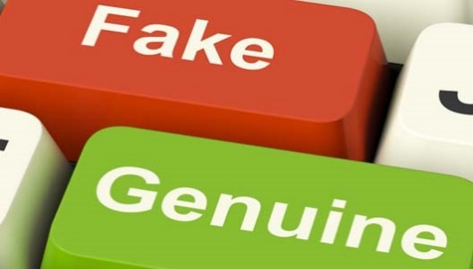

Action Group #1

MEMBER NAMES:__________________________________
_______________________________________________

Mission: Only 25% of high school students can tell the difference between fake and real news/photographs/videos. How can you inform more people about the difference between fake news and genuine news?

Step 1: Research factual evidence and data regarding ways and strategies the public can be more aware of and identify fake news.
Step 2: Using your research, create a skit to perform in a commercial. The skit must include characters, a script, scenery, props, etc.
Step 3: Film the commercial, making sure it is no longer than 60 seconds, and edit as necessary.
Step 4: Work with Action Group #2 to post your commercial on the Fake News Twitter account.

You will have several class periods to plan and complete this assignment. Make sure every member of you group has a job and write a list of each group members job responsibilities!
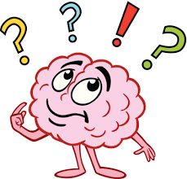
Action Group #1 Ideas/Jobs

Action Group #2

MEMBER NAMES:__________________________________
_______________________________________________

Mission: Only 25% of high school students can tell the difference between fake and real news/photographs/videos. How can you inform more people about the difference between fake news and genuine news?

Step 1: Research factual evidence and data regarding ways and strategies the public can be more aware of and identify fake news.
Step 2: Using your research, create an informational class Twitter account. The account must include accurate and valid information about fake news, a unique Twitter handle, an eye-catching photo, a biography stating the purpose of the account, and an attention-grabbing hashtag.
Step 3: This account will be the responsibility of the entire group for the remainder of the year. Each member must have the login information and alternate updating and checking the account.
Step 4: Work with Action Group #1 and #3 to post their commercial and PowerPoint on your Twitter account.

You will have several class periods to plan and complete this assignment. Make sure every member of you group has a job and write a list of each group members job responsibilities!
Action Group #2 Ideas/Jobs

Action Group #3

MEMBER NAMES:__________________________________
_______________________________________________

Mission: Only 25% of high school students can tell the difference between fake and real news/photographs/videos. How can you inform more people about the difference between fake news and genuine news?

Step 1: Research factual evidence and data regarding ways and strategies the public can be more aware of and identify fake news.
Step 2: Using your research, create an informational PowerPoint to present within the school. The PowerPoint must include the definition of fake news, the motives behind it, at least five ways to identify fake news, including pictures.
Step 3: Each member will be responsible for presenting this PowerPoint to various classrooms within the school.
Step 4: Work with Action Group #2 to post and live stream your PowerPoint on the Fake News Twitter account.

You will have several class periods to plan and complete this assignment. Make sure every member of you group has a job and write a list of each group members job responsibilities!
Action Group #3 Ideas/Jobs

Homework:
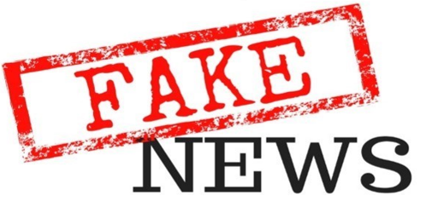
- Choose a major television news source (ABC, CBS, CNN, FOX, BBC, or NBC).
- Write a letter to the president of one of these news stations about the issue of Misleading/Fake News. Your letter should include the following information:
- State facts that you learned and researched as to why misleading news is such a severe problem in this country today.
- Ask what precautions and strategies the company is using to reduce misleading news being reported at their station.
- Propose suggestions on how this issue can be addressed and resolved.

**Use factual evidence and data from your own research and class discussions to back up your claims!**

Name: ____________________________

Research Project: ___________________________

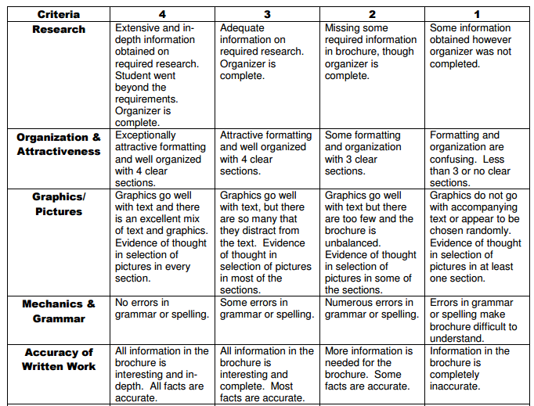

Total Score: ______________

Comments:

