Molloy College
Division of Education

Ashley Keon Dr. Sheehan
EDU 351 3/22/18
Grade:5 Topic:Mexico Content Area: Social Studies

INSTRUCTIONAL OBJECTIVES (s) (Lesson Objective(s)*)

After learning how to determine if evidence is credible, students will evaluate the validity of the reasoning and the relevance and sufficiency of evidence through a history mystery. Students will write arguments to support the claim, “Are Mexicans happier than Americans?” using valid reasoning and relevant and sufficient evidence. Students must include at least 3 pieces of relevant and sufficient evidence from the history mystery to support their answer. Students will be graded based on a teacher designed checklist and must obtain a score of 3/4.

NYS-CCLS / +NYS STANDARDS AND INDICATORS

New York State Social Studies Standards
Key Idea: 5.5 COMPARATIVE CULTURES: The countries of the Western Hemisphere are diverse and the cultures of these countries are rich and varied. Due to their proximity to each other, the countries of the Western Hemisphere share some of the same concerns and issues.

Key Concept: 5.5a The countries of the Western Hemisphere have varied characteristics and contributions that distinguish them from other countries.
Indicator: This will be evident when students compare the life of Mexicans to the life of Americans to determine if Mexicans are happier than Americans.

National Social Studies Standards and Themes
Culture: Social studies programs should include experiences that provide for the study of culture and cultural diversity, so that the learner can:

a. explore and describe similarities and differences in the ways groups, societies, and cultures address similar human needs and concerns
Indicator: This will be evident when students examine the evidence in the history mystery to determine if and why Mexicans are happier than Americans.

Individual Development & Identity: Social studies programs should include experiences that provide for the study of individual development and identity, so that the learner can:

e. identify and describe ways family, groups, and community influence the individual’s daily life and personal choices
Indicator: This will be evident when students discuss the influences of the life of Americans and Mexicans.

NCSS C3 Inquiry Arc

Dimension 3: Students will work toward conclusions about societal issues, trends, and events by collecting evidence and evaluating its usefulness in developing causal explanations.

Indicator: This will be evident when students evaluate the usefulness of evidence in the
history mystery to answer the compelling question.
Dimension 4: Students will draw on knowledge and skills to work individually and collaboratively to conclude their investigations into societal issues, trends, and events and will present their information, portions and findings.
Indicator: This will be evident when students work collaboratively to conclude their investigations from the history mystery and present their findings to the class.

Common Core ELA Standards
Integration of Knowledge and Ideas
7. Delineate and evaluate the argument and specific claims in a text, including the validity of the reasoning and the relevance and sufficiency of the evidence.
Indicator: This will be evident when students including the validity of the reasoning and the relevance and sufficiency of the evidence in the history mystery.
Text Types and Purposes
1. Write arguments to support claims in an analysis of substantive topics or texts, using valid reasoning and relevant and sufficient evidence.
Indicator: This will be evident when students write and support a claim, using valid reasoning and relevant and sufficient evidence from the history mystery.
Social Studies Practices: Habits of Mind
A. Gathering, Interpreting, and using Evidence
2. Recognize and effectively select different forms of evidence used to make meaning in social studies (including primary and secondary sources such as art and photographs, artifacts, oral histories, maps, and graphs).

Indicator: This will be evident when students recognize and effectively select credible evidence in the history mystery to write arguments to support their claims. .

INSTRUCTIONAL RESOURCES
- SMARTboard
- Mystery PowerPoint
- 3 History Mystery Envelopes
- Poster paper(graphic organizer)
- Document finder worksheet
- Supporting claims handout
- Credibility cheat sheet
- Teacher grading checklist
- Tape
- Happy Homework

MOTIVATION (Engaging the learner(s)*)

Students will be shown a picture from CSI and told that they are going to be detectives today. Their mission today is to solve a mystery “Are Mexicans are happier than Americans?”

DEVELOPMENTAL PROCEDURES
(including Key Questions)

- Students will be shown a picture from CSI and be told they are going to be detectives. (What kind of people do you see in this picture? What kind of job do you think these people perform (inferring)? What do you notice about what they are wearing?)
- The students will discuss their homework from last night
- Students will review the historical thinking strategies they learned yesterday. (How can you think like a historian? Why do you think it is important to think like this?)
- The students will discuss what it means to be credible vs. non-credible (How can we determine if the information we are reading if real (sourcing)? Why can’t we believe everything we read (context)? Is it possible for some articles to be more credible than others (corroboration)?)
- The teacher will discuss the rules of the lesson with the students (Why are rules important?)
- Students will participate in a history mystery where they will work in groups of 4 to determine if evidence is credible or not. (What kind of information do you see in the envelope (close reading)? Is there any bias in this evidence (close reading and perspective)?)
- Students will be assigned a job responsibility while working in their groups; Distributor, organizer, leader or communicator.
- In groups students will order the evidence from least to most credible on a provided graphic organizer. (Is there evidence that is more credible then others (Monitoring)? How do you determine credibility of evidence (contextualizing)?)
- Students will create a claim whether Mexicans are happier than Americans using evidence from the history mystery. (What conclusion did the evidence lead to (inferring)? Do you agree with the evidence presented in the envelopes? Is there a reason to question your findings (monitoring)?)
- The teacher will ask each group a question regarding the documents they analyzed, for them to share with the class. (What was your most credible piece of evidence? Did you have more evidence supporting Mexico or America? What is a conclusion we can make based on these documents?)
- The teacher will distribute and discuss the homework for the night
- To close the lesson, the students will review the compelling question; Are Mexicans happier than Americans. Students will share their written claims to support this question with the class. (What were your findings from the history mystery? What did the evidence tell you? What was your most credible piece of evidence (monitoring)? How do you know this?)

INSTRUCTIONAL STRATEGIES (Learning Strategies*)

Collaboration
Indicator: This will be evident when students work together to solve the history mystery.
Discussion
Indicator: This will be evident when students discuss with each other the evidence presented in the history mystery.
Mystery Strategy
Indicator: This will be evident when students use the provided evidence to solve the mystery question, “Are Mexicans Happier than Americans?”

ADAPTATIONS (Exceptionality*)

- The student that struggles to stay focused with be seated near the teacher in the front of the room and be given silent signals when needed
- The student who struggles socially will be able to pick which group they work in during the history mystery.
- The student who struggles with writing will be given the option to write, type or record his answer to his claim.

DIFFERENTIATION OF INSTRUCTION

Auditory Learners:
In order to adapt for the auditory learners, they will be able to listen to the class discussion before the history mystery. They will also be able to listen to their peers when working together during the history mystery.

Visual Learners:
The visual learners will be able to visually look at the evidence in the history mystery. The students will be able to use the given graphic organizer to organize their evidence from least to most credible.

Kinesthetic Learners:
The kinesthetic learners will be able to move around the classroom when working with their groups. They will have to place the evidence from the history mystery onto the graphic organizer from least to most credible.

ASSESSMENT (artifacts* and assessment [formal & informal]*)

- Teacher will assess students homework from the night before
- Teacher will assess students understanding of historical thinking strategies through discussion
- Teacher will assess how the students interact during group work
- Teacher will assess the presentation of the findings from the mystery based on a checklist

INDEPENDENT PRACTICE
Students will listen to the song Happy By: Pharrell Williams. They will pay close attention to the chorus of the song. After listening to the song they will answer the questions on their “Happy Homework”. Students will answer questions about what happiness means to them, and does happiness mean something different to Mexicans and Americans. Students will be asked to justify their answer.
FOLLOW-UP ACTIVITIES: DIRECT TEACHER INTERVENTION AND ACADEMIC ENRICHMENT

Direct Teacher Intervention
For the students who struggled during the lesson, the teacher will work with them on determining what evidence is credible and what evidence is not. The students will be given multiple opportunities to practice determining evidence credibility. The students will be given a cheat sheet for them to refer to when checking evidence credibility. This cheat sheet will walk the students for what to look for in the document. The students will then be able to read the evidence and better be able to analyze them in order to answer the compelling question.

Academic Enrichment
In order to further the lesson, for the students who excelled during the lesson, they will be challenged to find two sources to add to our mystery. They will have to find a document that can be used as evidence to further support their findings from the mystery. Students will need to determine if the evidence is credible enough to be used as valid evidence to support their findings.

REFERENCES

Buchanan, L., Lee, J. C., PeÇanha, S., & Rebecca, K. K. (2017, September 23). Mexico City,Before and After the Earthquake. Retrieved March 22, 2018, from https://www.nytimes.com/interactive/2017/09/23/world/americas/mexico-city earthquake-surveying-destruction-damage.html
Expat insider 2016: pros & cons of life in Mexico | InterNations. (2016). Retrieved from https://www.internations.org/expat-insider/2016/mexico
Hodgekiss, A. (2014, November 21). Revealed, the happiest countries in the world: For a contented life, head to Costa Rica, Vietnam or Mexico. Retrieved from http://www.dailymail.co.uk/health/article-2842403/Revealed-happiest-countries-world contented-life-head-Costa-Rica-Vietnam-Norway-UK-fares-better-Spain-Australia.html
Thompson, G. O. (2015, November 28). Why is Mexico happier than the United States? Retrieved March 22, 2018, from https://mexiconewsdaily.com/opinion/why-is-mexico-happier-than-its-neighbor/

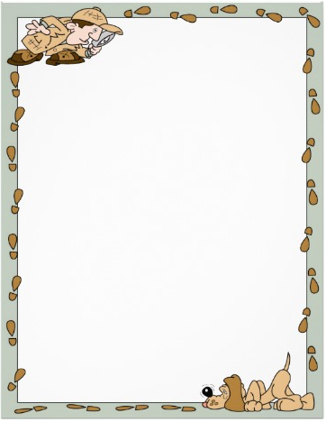

Are Mexicans
Happier Than Americans?
Dear Students,
Enclosed is some evidence to help you solve the happiness mystery. It is your job to work together to determine if the evidence provided is credible or not. You must work together to order the evidence onto the graphic organizer from least to most credible. Your job in this mystery is to determine if Mexicans are happier than Americans, based on the evidence provided.
Once the mystery is solved, be sure to create your own claim to support your answer to the mystery. Record you claim on the supporting claim handout and be sure to include at least three pieces of evidence to support your reasoning.
Happy Findings!
Name:____________________________________
Date:__________________________
Supporting Claim
Directions: After solving the mystery with your group, create a claim that supports your findings from the mystery. Be sure to include at least 3 pieces of evidence that support your answer. Use your document findings worksheet for help!

Mystery Findings:

____________________________________________________________________________________________________________________________
Supporting Claim:
____________________________________________________________________________________________________________________________________________________________________________________________________________________________________________________________________________________________________________________________________________________________________________________________________________________________________________________________________________________________________________________________________________________________________________________________________________________________________________________________________________________________________________________________________________________
Job responsibilities while working in groups
On each student’s document findings worksheet there will be a colored dot in the top corner. That dot will correspond with a job responsibility when it comes to work in their groups.
Job Name | Job Responsibility
Document Distributor (Green Dot) | In charge of distributing the documents for all group members to view and examine
Document Organizer (Blue Dot) | In charge of placing the documents onto the graphic organizer
Group Leader (Red Dot) | In charge of managing the group; time management (2 minutes to observe, 3 minutes to discuss per document). In charge of making sure everyone fulfills their job
Great Communicator (Orange Dot) | In charge of sharing the groups findings with the class during the class discussion

Name:_______________________________________________
Happy Homework
Directions: Listen to the song Happy by Pharrell Williams, pay close attention to the lyrics of the chorus (they are written below). Use the chorus of the song to answer the questions below.

Happy By: Pharrell Williams
(Chorus)
Huh, because I'm happy
Clap along if you feel like a room without a roof
Because I'm happy
Clap along if you feel like happiness is the truth
Because I'm happy
Clap along if you know what happiness is to you
Because I'm happy
Clap along if you feel like that's what you wanna do

- Pharrell Williams says, “Clap along if you know what happiness is to you”. What does happiness mean to you? What makes you happy?
_______________________________________________________________________________________________________________________________________________________________________________________________________________________________________________________________________________________________________

- Does happiness mean something different to Americans and Mexicans? How do you know? Justify your answer.
_______________________________________________________________________________________________________________________________________________________________________________________________________________________________________________________________________________________________________
Name: _________________________________
Document Findings
Directions: After reviewing each document, circle which country the document supports (America or Mexico). Then on the lines provided write down what the document is telling you about that country.

- America or Mexico
___________________________________________________________________________________________________________________________________________________________________________________________________________________________________________

- America or Mexico
___________________________________________________________________________________________________________________________________________________________________________________________________________________________________________

- America or Mexico
___________________________________________________________________________________________________________________________________________________________________________________________________________________________________________

- America or Mexico
___________________________________________________________________________________________________________________________________________________________________________________________________________________________________________

- America or Mexico
___________________________________________________________________________________________________________________________________________________________________________________________________________________________________________

- America or Mexico
___________________________________________________________________________________________________________________________________________________________________________________________________________________________________________

- America or Mexico
___________________________________________________________________________________________________________________________________________________________________________________________________________________________________________

- America or Mexico
___________________________________________________________________________________________________________________________________________________________________________________________________________________________________________

Motivation
As a motivation, students will be shown a picture from CSI and be told that today they are going to be detectives. As detectives their job today is to solve the mystery, “Are Mexicans happier than American?” Students will be asked what kind of people do you see in this picture? What kind of job do you think these people perform? What do you notice about what they are wearing?

Credibility Cheat Sheet

- Who is the Author?
- Does the document have a date?
- Where did the document come from?
- Does the document have bias?
- Are there many mistakes in the document?

Teacher Grading Checklist

Students create a claim stating whether Americans or Mexicans are happier. | YES | NO
Student includes at least 3 pieces of evidence to support their answer. | YES | NO
Student use relevant and valid documents to support their answer. | YES | NO
Students write in complete sentences using Standard English grammar | YES | NO

Documents to Include in the History Mystery

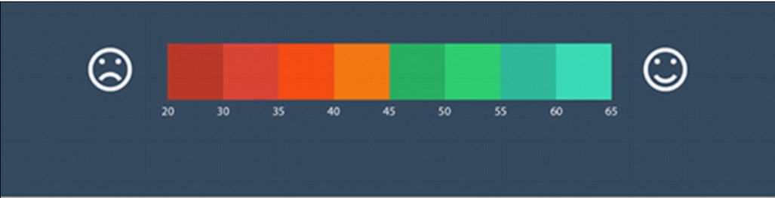
- A new map reported by the Daily News in 2014, that reveals exactly which parts of the world deliver long and happy lives for their citizens. This map was created using information gathered from the Happy Planet Index.

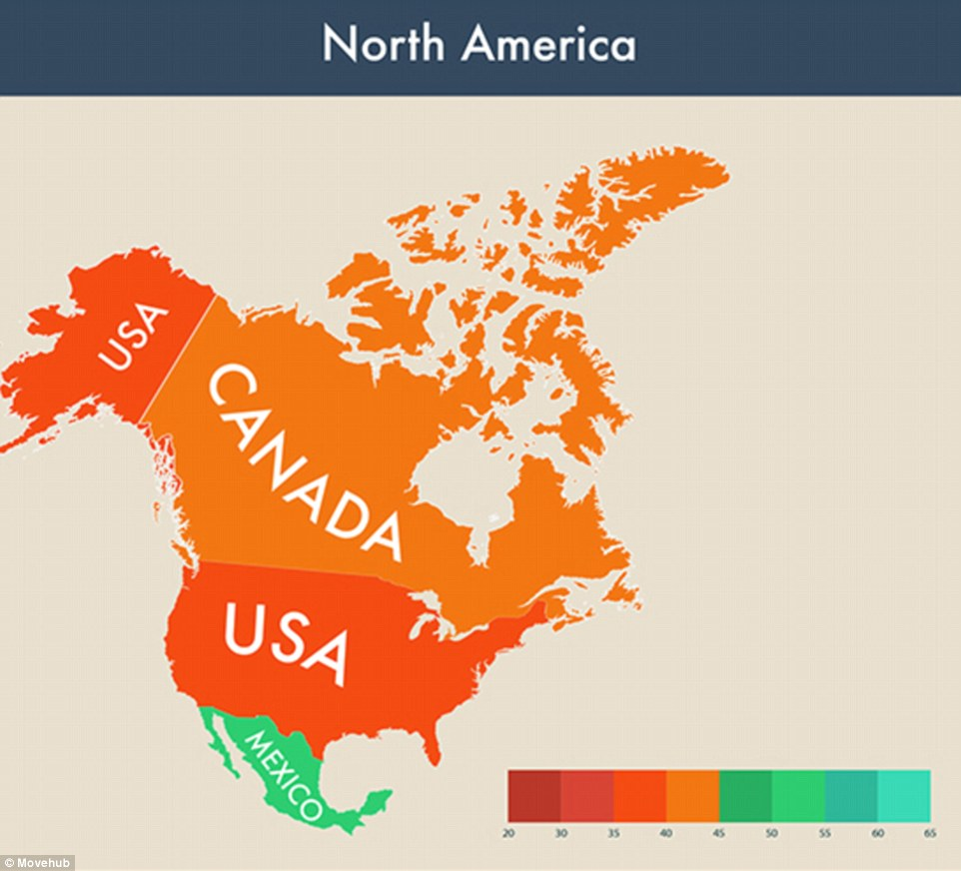

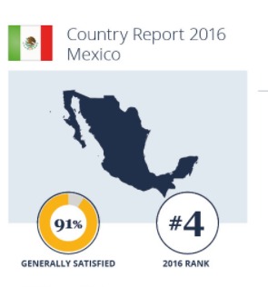
- An InterNations Survey reporting on how satisfied citizens are with their life in Mexico. These statistics are reported from 2016.

- A Quote from Glen Olives (2015) from the Mexican News, reporting on Crime Rates.

“Violent crimes have been declining in the U.S. for over three decades, and have been increasing in Mexico during the same period. More Mexicans have been killed in drug wars than Americans killed in the Iraq and Afghanistan wars combined.”

- A Quote from Glen Olives (2015) from the Mexican News, reporting on Agricultural products in Mexico.

“Mexico is a major producer of products such as avocados and tomatoes. From this, the Mexican middle class grew from 9.1 million 15 years ago to 14.6 million today. This is about half of the country’s households. “

- Facebook post from an American Citizen stating how wonderful life in America is.
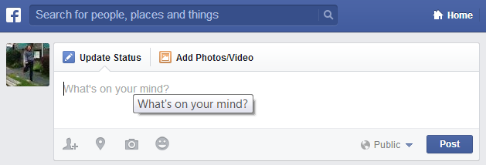
Life in America is great! I have a good paying job and great opportunities! I wouldn’t want to live anywhere else

- A comparison of Depression Rates around the World.
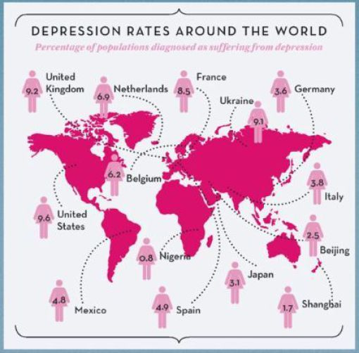

- Pictures of Mexico City before and after an Earthquake
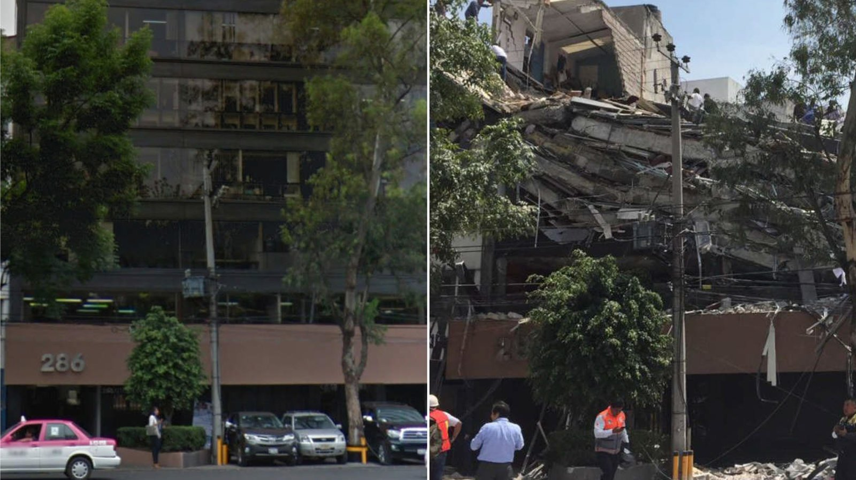

- America Before and After Hurricane Katrina.
