Molloy College
Division of Education

Abigail Montague, Alyson Mooney, Jonathan Krakoff Professor Blair and Dr. Sheehan
Course EDU 5240 01 Date: May 2020
Grade N/A Topic Impacts of Climate Change Content Area Social Studies Science

INSTRUCTIONAL OBJECTIVE(S)

After watching Climate Change Animation Shows Devastating Effects, participating in a turn and talk, actively engaging in class discussions and small group activities, students will analyze and explain the effects of global warming on our planet by correctly connecting 8 out of 10 images to relevant vocabulary/terms listed on the Impacts of Climate Change Worksheet.
ASSESSMENT (formal & informal)

Informal assessment

Guided questioning during direct instruction.
Observing students’ engagement during note-taking and turn and talk activities.
Monitoring students’ contributions while working on their Impacts of Global Warming Comparison worksheet.

Formal assessment

Students will analyze and identify the effects of global warming on our planet by correctly connecting 8 out of 10 images to relevant vocabulary/terms listed on the Impacts of Climate Change Worksheet.

NYS-CCLS / +NYS STANDARDS AND INDICATORS
Civic Literacy: 2017 Standards for Preparing Social Studies Teachers
Standard 5: Professional Responsibility
Candidates will expand on their knowledge, inquiry skills, and civic dispositions to advance social justice and promote human rights through informed action in schools and/or communities
Indicator: This will be evident when the students expand on their knowledge, inquiry skills, and civic dispositions to advance social justice and promote human rights by investigating the impacts of climate change to create a civic action plan.
Next Generation Science Standards:
HS-ESS3-4.
Evaluate or refine a technological solution that reduces the impacts of human activities on natural systems. (NCA-related content: Mitigation, Adaptation)
Indicator: This will be evident when the students evaluate or refine a technological solution that reduces the impacts of human activities on natural systems by investigating the impacts of climate change.

DEVELOPMENTAL PROCEDURES (*Engaging the learner)

- MOTIVATION: When students walk in, they will be assigned groups of 3 or 4.
When they sit in their groups, they will receive their How Climate Change Affects the World packets. These packets will help them with their notes for the lesson. Students will watch Climate Change Animation Shows Devastating Effects video: https://www.youtube.com/watch?time_continue=109&v=S7jpMG5DS4Q&feature=emb_title After the video, the students will participate in a turn and talk. The students will discuss one piece of information the students noticed from the video. The students will have 3 minutes to discuss their answers. (What is climate change? How does climate change impact the different areas of the world? What are the impacts of climate change? What is the most important factor in climate change? How does climate change make you feel?) [6 minutes]
- Students will receive the How Climate Change Impacts the World worksheet that has a graphic organizer that has notes filled out in the sections that coincide with a Thing Link presentation of the world. (https://www.thinglink.com/scene/1291101848379326466). As the teachers go through each section of the world, students will follow along with their charts based on each section. There are seven sections: North America, Europe, South America, North and South Pole, Africa, Australia, and Asia. This portion of the lesson will be interactive as we will ask questions about the different areas of the world. (Why is it problematic to have the fish leave their natural habitat? Could this affect the economy? How do the rising temperatures of the ocean affect animals like polar bears and fish?) [10 minutes]
- After the interactive lecture, students will turn over their worksheets, and they will complete a Write, List, or Draw Activity based on information from the Thing Link presentation. For three minutes, the students will have the choice to write, list, or draw 1) what they think will happen to the world if climate change continues. (Share what you wrote that you think will happen to the world if climate change continues to impact the areas we learned about?) [3 minutes]
- Students will complete the Impacts of Global Warming Comparison worksheet activity with their groups. Students will receive different roles for this assignment: a timekeeper, a scribe, and a facilitator. Each group will be assigned two continents, or areas of the world, to compare and contrast the impacts of climate change around the world. The students will have up to 10 minutes for this activity. The students can use their charts to support them while filling out the Impacts of Global Warming Comparison worksheet. Each group will have different areas of the world for this activity. The students will share their completed responses with the class. (Which impacts of climate change are the same for these two areas of the world? Which impacts of climate change are different for these two areas of the world? What geographical features are the same or different for these two areas of the world?) [10 minutes]
- To close the lesson, students will individually work on the Impacts of Climate Change worksheet, which will be collected as the assessment. This will be a matching worksheet where the students will match a key impact of climate change with the correct continent. [3 minutes]
- To close the lesson, the students will complete the SOS worksheet. The statement will be “Climate change is the most important problem facing mankind”. The students will write their opinion and supporting details on that statement. (In your opinion, is climate change the most important problem facing mankind?) [3 minutes]

DIFFERENTIATION OF INSTRUCTION
Grouping
Students will be given assigned roles for group activities; timekeeper, scribe, teacher, and task keeper. This gives the students each an opportunity to participate in the group work and feel as if they are helping. Grouping will be based on each student's strengths and matched up with others that have complementary strengths
Write out reasons
Choices
Students will be given a choice of how to respond to the questions being asked. The ability to choose to draw, write, or list their response provides options for kinesthetic and visual learners.
Visual Learners
Visual learners will be aided through the Thing Link and Interactive Lecture where they can see images and visuals of the topic being taught.
Auditory Learners
Auditory learners will be aided through guiding questions. By asking the questions out loud it helps these learners to process the information.
Kinesthetic Learners
Kinesthetic learners will be aided through the Thing Link and interactive lecture. By moving around and being able to interact with the lesson it provides a better learning experience.
Tiered questioning
Questioning is brought from different levels of Bloom’s Taxonomy to challenge the students to think deeper.

ADAPTATIONS

Student 1: Since she has difficulty seeing, Britt will have preferential seating in the front of the classroom
Student 2: He likes to take his time and finish his work on time, so he will be the scribe in the group and ample time will be allotted.
Student 3: He will have his aide, Hannah, at his side for anxiety, as well as he will be in the role of facilitator so that his anxiety will be channeled in a productive way.

REFERENCES
AJ+ (2014, June 12). Climate change animation shows devastating effects. [Video file]. Retrieved from
https://www.youtube.com/watch?time_continue=109&v=S7jpMG5DS4Q&feature=emb_title
National Council for the Social Studies Task Force (2017) National standards for the preparation of
social studies teachers. Retrieved from https://www.socialstudies.org/c3
New York State Education Department. (2019). Next generation science learning standards. Retrieved
from http://www.nysed.gov/curriculum-instruction/science-learning-standards

How Climate Change Impacts the World!
Directions: As we go through each area of the world, fill out notes on the impacts for each area of the world!

Area of the World | Impacts of Climate Change
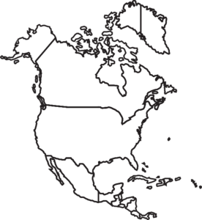  North America | -Ocean temperatures are rising  -New marine life comes closer to the shore  -Water level rising creating new coastlines in coast cities
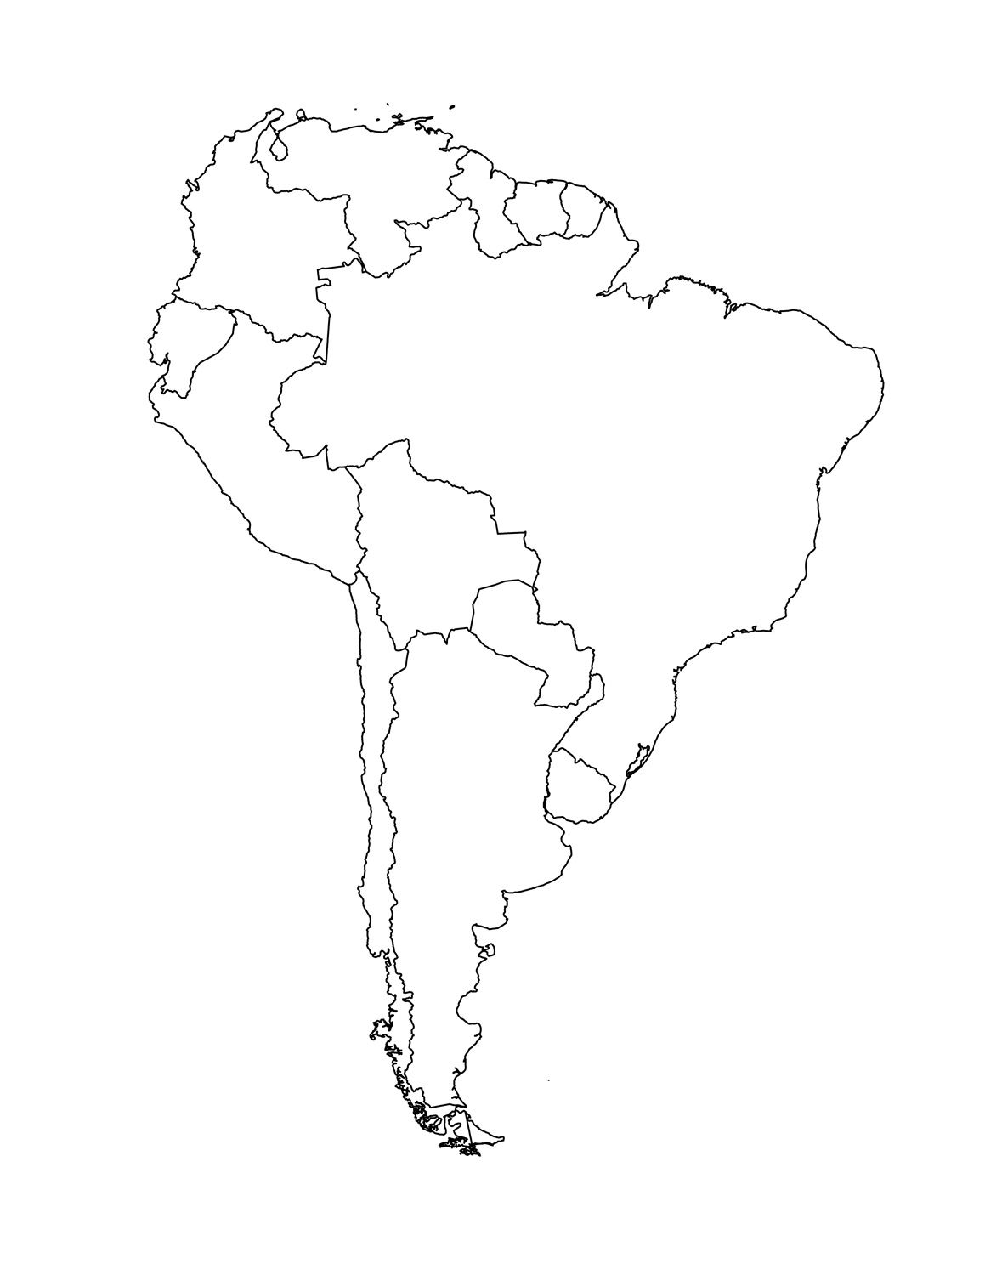  South America | -Deforestation in the rainforests released more carbon dioxide into the air  -Limited drinking water due to the warming temperature on the Andes Mountains
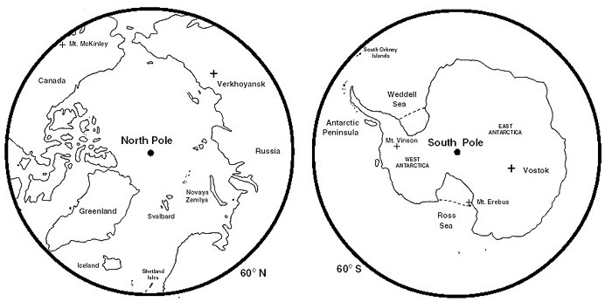  The Arctic and Antarctica  (The North Pole and the South Pole) | -Animals habitats are melting  -Marine life is moving their location to escape the heat
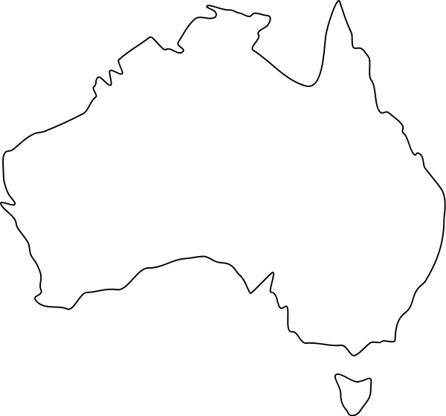  Australia | -Water temperatures are rising  -Pollution in water kills the coral reef  -Not a fish so it cannot move its environment.
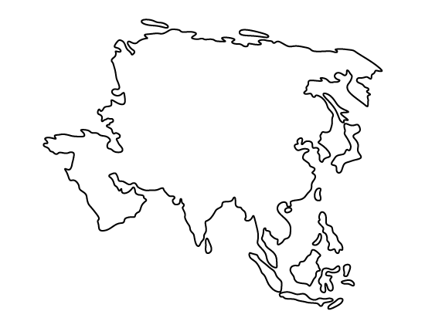  Asia | -Smog from overcrowding  -Lack of rain causes water shortages in cities like Chennai  -Heat waves from rising temperatures.
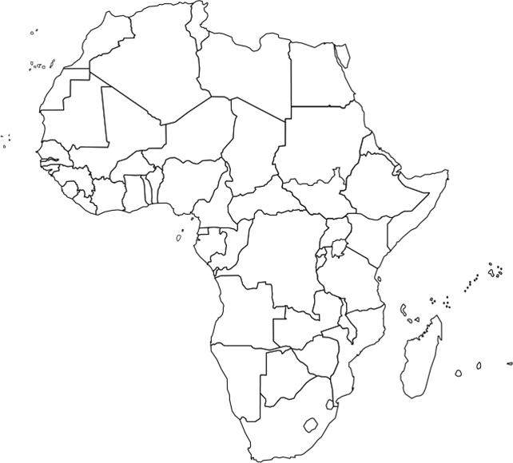  Africa | -Sahara Desert is growing  -Harder to fight diseases  -Experience many floods
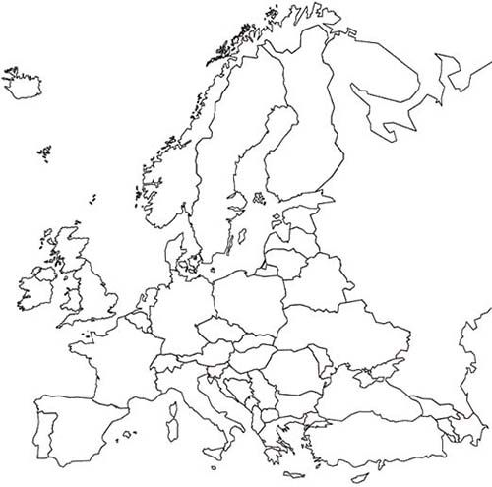  Europe | -Air pollution from overcrowding  -Record-breaking heat waves  -Water temperature is  -Old species cannot live in higher temperatures  -New species are forming with higher tolerance for heat.

Name: Date:
IMPACTS OF GLOBAL WARMING COMPARISON
Directions: Write or draw the similarities and differences between each continent in the box labelled similarities and differences.
SIMILARITIES
DIFFERENCES

Name: Date:
IMPACTS OF GLOBAL WARMING COMPARISON
Directions: Write or draw the similarities and differences between each continent in the box labelled similarities and differences.
SIMILARITIES
DIFFERENCES

Name: Date:
IMPACTS OF GLOBAL WARMING COMPARISON
Directions: Write or draw the similarities and differences between each continent in the box labelled similarities and differences.
SIMILARITIES
DIFFERENCES

Name: Date:
IMPACTS OF GLOBAL WARMING COMPARISON
Directions: Write or draw the similarities and differences between each continent in the box labelled similarities and differences.
SIMILARITIES
DIFFERENCES

Name: Date:
Impacts of Climate Change Worksheet

Directions: Draw a line to match the appropriate impact with the region of the world that will be affected.

A. Marine life moves closer to the shore
B. Animals habitats are melting
C. Pollution in water kills the coral reef

FLIP OVER

D. Record breaking heat waves
E. Sahara Desert is growing
F. Deforestation in the rainforests released more carbon dioxide into the atmosphere
G. Lack of rain causes water shortages in cities like Chennai

NAME:______________________ DATE:_________
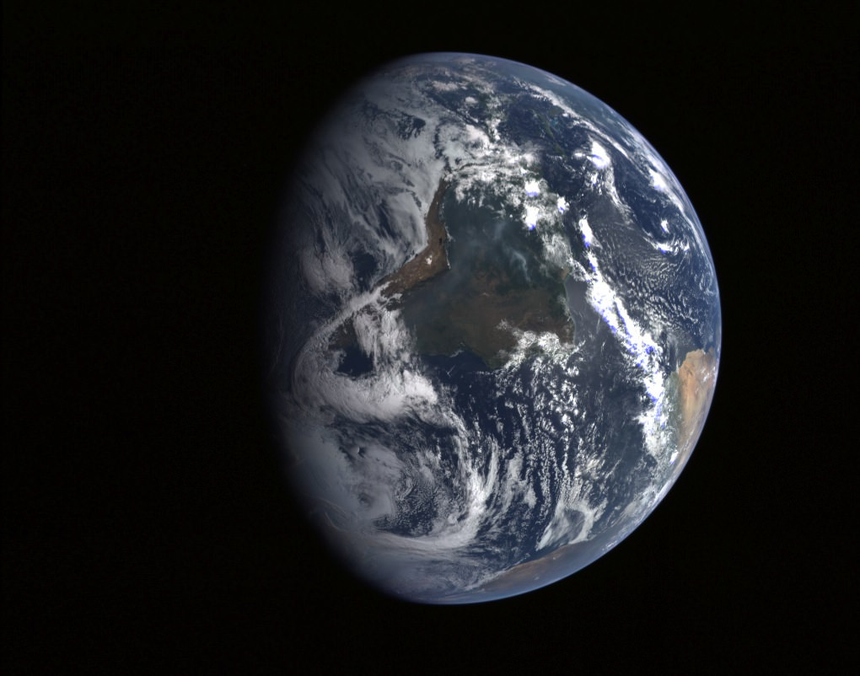
SOS
Directions: Place your opinion about the statement on the top of the page in the space given. After, support that opinion in the space labelled support.

STATEMENT: Climate change is the most important problem facing mankind.

OPINION:

SUPPORT:

