Molloy College
Division of Education
Kelly Mackay Dr. Kevin Sheehan
EDU 509
Spring 2018
Grade: 3 Topic: Montreal Content Area: Social Studies

INSTRUCTIONAL OBJECTIVES

While taking a trip back in time, students will follow along in their “Time Travel Journal” where they will report what they see, what they think and what they wonder about the historical events. Students will then answer what historical events shaped Canada today by partaking in an “Act It Out” skit where students will write narratives of a historical event by using dialogue, action and characters containing three relevant facts from the pictures and time machine PowerPoint, students will be graded based upon a teacher created rubric.

NYS-CCLS / +NYS STANDARDS AND INDICATORS
Time, Continuity, and Change
3.4 Each community or culture has a unique history, including heroic figures, traditions, and holidays.
3.4a People in world communities use legends, folktales, oral histories, biographies, and historical narratives to transmit cultural histories from one generation to the next.
Indicator: This will be evident when students learn about historical events that shaped Montreal into the city it is today.

NATIONAL SOCIAL STUDIES STANDARDS AND THEMES

III. People, Places, & Environments: Social studies programs should include experiences that provide for the study of people, places, and environments, so that the learner can examine the interaction of human beings and their physical environment, the use of land, building of cities, and ecosystem changes in selected locales and regions;
Indicator: This will be evident when students learn of historical events and determine if they have shaped Montreal today.

Individual Development & Identity: Social studies programs should include experiences that provide for the study of individual development and identity.
- Personal identity is shaped by an individual’s culture, by groups, by institutional influences, and by lived experiences shared with people inside and outside the individual’s own culture throughout her or his development.
- Questions related to identity and development, which are important in psychology, sociology, and anthropology, are central to the understanding of who we are.
- The study of individual development and identity will help students to describe factors important to the development of personal identity.

Indicator: This will be evident when students analyze the photographs and act out a skit representing the perspective of people in Montreal.

NCSS C3 Inquiry Arc
Dimension 4: Students will draw on knowledge and skills to work individually and collaboratively to conclude their investigations into societal issues, trends, and events and will present their information, portions and findings.
Indicator: This will be evident when students work collaboratively and individually to create a skit, each student playing a different role, portraying the historical events of the given time periods.

COMMON CORE ELA STANDARDS
Text Types and Purposes
3. Write narratives to develop real or imagined experiences or events, using effective technique, descriptive details, and clear event sequences.
Indicator: This will be evident when students participate in an Act it Out of a historical even that happened in Montreal.

Integration of Knowledge and Ideas
7. Use information gained from illustrations (e.g., maps, photographs) and the words in a text to demonstrate understanding of the text (e.g., where, when, why, and how key events occur).
Indicator: This will be evident when students use the information from their “Time Machine” trip and write about it in their “Time Travel Journal”.

Social Studies Practices: Habits of Mind
A. Gathering, Interpreting, and using Evidence
2. Recognize and effectively select different forms of evidence used to make meaning in social studies (including primary and secondary sources such as art and photographs, artifacts, oral histories, maps, and graphs).
Indicator: This will be evident when students utilize information, and pictures to analyze the mood of the time to create a stance and perform a scene regarding their findings.

INSTRUCTIONAL RESOURCES
SMART board
CHAMPS rules
Writing Utensils
Time Machine PowerPoint
Time Travel Journal
Act it Out Rubric

MOTIVATION
Students will be told that they are going in a time machine where they will be taken back in time to see three historical events that helped shape Montreal to what it is today.

DEVELOPMENTAL PROCEDURES
- Motivation: Students will be told that they are going in a time machine where they will be taken back in time to see three historical events that helped shape Montreal to what it is today. (Follow along in your Time Travel Journal, what do you see? What do you think? What do you wonder? What do you notice?)
- The class will discuss the Time Machine trip they just took and discuss what they thought about each stop. (Which stop was your favorite? Why was it your favorite stop?).
- Students will be split into three groups. Each group will be assigned to act out one of the stops from the Time Travel PowerPoint. The three historical events are: The Meeting of Native Americans, The Battle of Montreal and The Seceding of Montreal. The students will be reminded of the rules of the classroom and how to appropriately act while doing group work. The teacher will then explain what they are to do during the Act It Out scene. (What scene are you acting out? What character are you portraying? What three facts are you including in your scene?).

Instructional Strategies
Cooperative learning (Engage pairs/teams of students in working together on assigned activity)
Indicator: This will be evident when students work together in performing their act it out activity.
Act it Out (Taking on a role of a character in a different point in history based on historical evidence)
Indicator: This will be evident when students go back in time and participate in an Act it Out based on their historical event passages.

ADAPTATIONS
-The student who struggles socially will be pulled aside to discuss their stances and will be provided the option to write out a dialogue depicting their assigned scene instead of acting in front of the class.
-The student who struggles with writing will be assigned to work alongside and aide.
-Students with visual impairments will be seated closer to the SMARTBoard during the Time Machine PowerPoint.

DIFFERENTIATION OF INSTRUCTION
Kinesthetic Learners:
The kinesthetic learners will be able to move around the classroom when working with their groups on their History Alive ‘Act it Out’ performance.

Visual Learners:
The visual learners will be able to visualize these historical events through the provided pictures and information as well as through the ‘Act it Out’. The Act It Out exercise will activate students’ episodic memory.

ASSESSMENT
Students will be assessed by how well they interact during the Time Machine PowerPoint and Act It Out performances. Students will be graded on their Act It Out performance based upon a teacher-based rubric.

INDEPENDENT PRACTICE
Students will post on Flipgrid discussing their favorite stop during the Time Travel PowerPoint and explain why that time in Montreal’s history was their favorite.

FOLLOW-UP ACTIVITIES: DIRECT TEACHER INTERVENTION AND ACADEMIC ENRICHMENT
Direct teacher intervention
The student who struggled during the lesson will, under direct supervision of the teacher, go over their Time Travel Journal discussing each question in the journal and relating the questions back to the photograph representing that historical event.
Academic enrichment
The student who excelled during the lesson will be asked to go into further detail in their Time Travel Journal. Instead of just answering the see, think and feel questions, they would take it a step further and say why they think what they wrote, and why they felt what they wrote.

REFERENCES
Hamilton, G. (2015). Quebec separatists hope nostalgia for 1995 referendum — which they lost — will boost their cause. Retrieved from http://nationalpost.com/news/politics/quebec-separatists-hope-nostalgia-for-1995-referendum-which-they-lost-will-boost-their-cause
Kupperman, K. (2006). Into the Interior: The French. Retrieved from http://nationalhumanitiescenter.org/pds/amerbegin/exploration/text2/text2read.htm

Rubric for History Alive
Act It Out
Historical  Accuracy  (6 points) | Contains three accurate facts from the reading. | Contains one to two accurate facts from the reading. | Contains no accurate facts from the reading.
Performance  Quality  (2 points) | The actors wait for each other to present lines and can be clearly heard. The actors do not need to read lines but actually speak the parts. All students involved. | The actors wait for each other to present lines and can be clearly heard. The actors may need to read lines but these lines can be clearly understood. All students involved but some only minimally. | The actors speak at the same time and/or the actors cannot be heard. Not all students are a part of the presentation.
Creativity and Passion for the  Performance  ( 2 points)  (2 points) | The performance is especially creative and captures the imagination of the audience and brings to life the concept in a unique way.  Or  Actors dramatically and creatively use props and/or quote. | The performance is creative and entertains the class but does not bring to life the concept.  Or  Actors use props or and/or quote. | The performance lacks creativity and the actors lack passion.  Or  Actors do not use props and/or quote.

Name_________________________ Points (10) ______ Grade_______
Name:___________Date:_________

What do I see? What do I think? What do I wonder?
Directions: Using our 5 W’s and our senses of sight and hearing, write down some notes about what you see and what you think. Please take notes along each stop on our time travel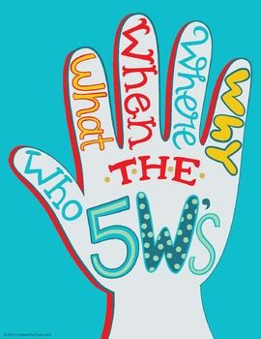!
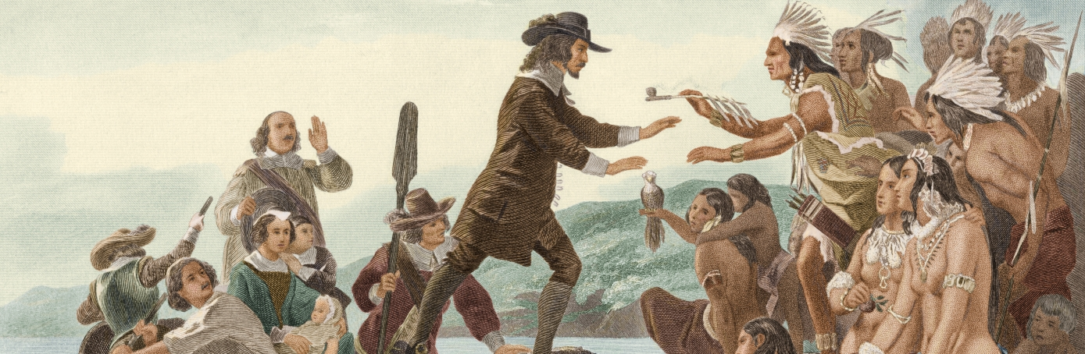
What do I wonder?
What do I think?
What do I see?

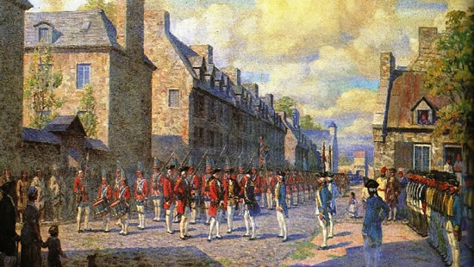
What do I think?
What do I wonder?
What do I see?
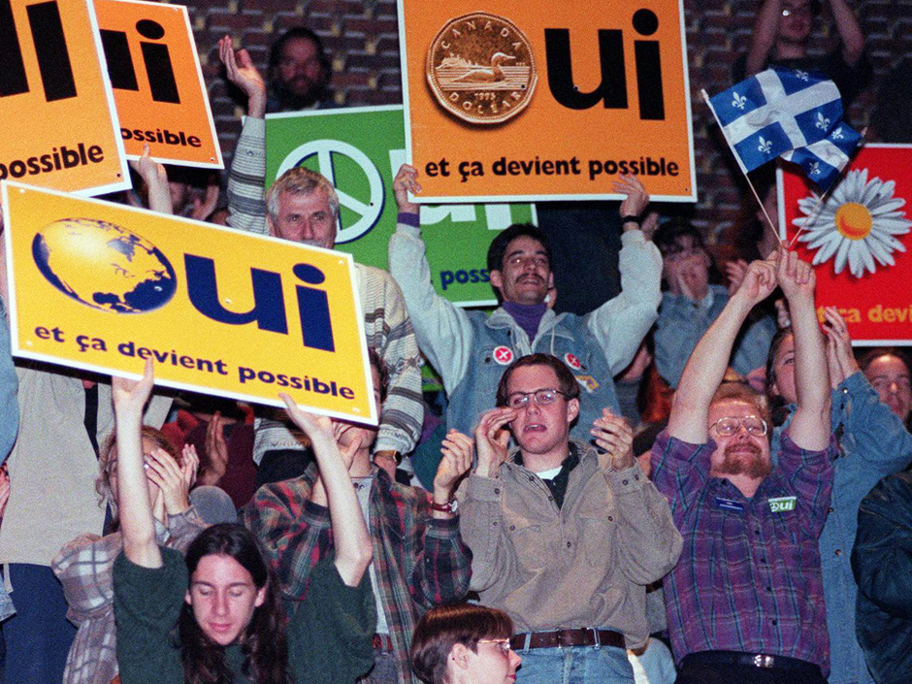
What do I wonder?

