Molloy College
Division of Education

Students: Meaghan O’Callaghan, Kristen McLeod, Lauren Habacker, Andrea Ross
Professor: Professor Blair & Dr. Sheehan
Course: EDU 5240 01 Date: 04/23/2020
Grade: MOST Program Topic: Climate Change Content Area: Science/History

STANDARDS AND INDICATORS

Civic Literacy: 2017 Standards for Preparing Social Studies Teachers
Standard 5: Professional Responsibility
Candidates will expand on their knowledge, inquiry skills, and civic dispositions to advance social justice and promote human rights through informed action in schools and/or communities

Indicators: This will be evident when students expand on their knowledge, inquiry skills, and civic dispositions to advance social justice and promote human rights by learning about climate change to create a civic action plan.

Next Generation Science Standards:
HS-ESS3-4. Evaluate or refine a technological solution that reduces impacts of
human activities on natural systems. (NCA-related content: Mitigation, Adaptation)

Indicators: This will be evident when students evaluate or refine a technological solution that reduces impacts of human activities on natural systems by analyzing and evaluating indicators that suggest climate change.

INSTRUCTIONAL OBJECTIVE(S)

After watching a teacher demonstration, a video titled What is Climate Change?, participating in a class discussion, and an interactive Smart Board activity, students will apply their knowledge on the Causes and Effects of Climate Change Worksheet to explain the possible causes of climate change on three out of four different climate change pictures with relevant, accurate justification.

PRIOR ACADEMIC KNOWLEDGE, CONCEPTIONS/MISCONCEPTIONS

Prior Academic Knowledge
To successfully explore the impacts of climate change, students will use prior knowledge from previous lessons on the book, Just A Dream by Chris Van Allsburg, particularly the illustrations in this book to trigger their Recognition Network and connect with this lesson.
Misconceptions
Some students may not readily recall what climate change is and will need some background information or pictures to recall the topic. Some students might get confused with specific content vocabulary and/or terms.

DEVELOPMENTAL PROCEDURES

- MOTIVATION The teacher will have a small paper-mache globe and a clear glass bowl on her/his desk when the students enter the room. The teacher will set the globe on fire and cover the globe with the glass bowl. As the globe burns, students will watch the smoke accumulate on the glass bowl. (What do you think is happening? What is happening to the smoke? Do you think it is warmer or cooler inside the bowl? Do you think it is easier to breathe inside or outside the bowl? What do you think the bowl around the Earth signifies? What gas do you think smoke contains? How does the bowl trapping in gases affect the environment?)

- The teacher will then transition into a brainstorming discussion. The teacher will write “Climate Change” on the board and elicit from the students’ words that they “connect” to climate change. The teacher will record the student’s brainstorming responses on the board, creating a web of connected ideas. A copy of the book, Just A Dream, will be visible/available to the students for reference and to spark their memory. (Have you ever heard of climate change? What do you think it is? What are some examples? Does anyone remember an illustration from the book, Just a Dream, that reminds them of climate change?)

- After participating in the brainstorming activity, the teacher will play the video, What is Climate Change. The teacher will also provide the students with a What is Climate Change? Notes Worksheet to jot down important ideas while watching the video. To support students’ note taking skills, the teacher will pause the video to pose guided questions. (What is the name of the gas produced by cars, power stations, and airplanes? Where does this gas get released? Do you believe the release of CO₂ causes the temperature of the air to increase or decrease, and why? Can you make a prediction as to how wildlife is affected by an increased air temperature, and explain your reasoning? How does hot air affect wildlife? How does hot air affect plant life? How does hot air affect the weather? What is one example from the video of how the environment is negatively impacted? What can we do to protect our environment? What is one thing you can change in your lifestyle to help protect the environment?)

- The students will participate in a turn and talk. The teacher will ask the students to discuss their responses to teacher prompted questions in a small group. (What is the connection between the globe/glass bowl model and climate change? What can you do to help? Describe what happens when climate change takes place? How would you differentiate between weather and climate? What would the results be if we recycled and travelled using bikes? How is CO2 connected to climate change? What is your opinion of climate change? Devise a way to reduce the negative effects of climate change? What is covering us like a “blanket” and why is it bad? The blanket of CO2 can heat up the earth and cause droughts...what happens to the plants when this occurs? Hot air can cause storms which make big waves. How does this affect coral reefs and fish? Animal habitats (homes) can be damaged which causes animals to do what? Why? When it's hot what happens to snow and ice? Since climate change can change rain and snow patterns what happens to the sea level? Could you make a connection to climate change? If wood gets too hot it can start a fire...explain why would this be dangerous to a forest.)

- The teacher will transition to the website A Student’s Guide to Climate Change on the SmartBoard. The teacher will then ask Turn & Talk pairs to come up to the SmartBoard to find clues that suggest climate change is occurring in the picture. (What does the picture represent? How do you know? Is it affecting the weather or the climate? How is it connected to climate change? How would you explain what is happening? What is the cause/ reason behind this effect? What can you infer will happen? What evidence did you use to infer? What would you suggest people to do to help solve this problem? Predict the outcome if no one does anything to help? Devise a plan on how to spread the word and what can you do to help the earth?)

- The teacher will then hand out the assessment, Causes and Effects of Climate Change Worksheet. The students will be asked to match causes and effects of climate change. After students complete the matching they must go back to each set and write down a relevant justification, explaining the cause/effect relationship.

CLOSURE The teacher will close the lesson by providing a traffic light assessment. Students will receive a traffic light on their desk. If the student puts down red they have questions. If the student puts down yellow they are slightly confused. If the student puts down green the students understand the lesson.

ASSESSMENT

Informal assessment
- Brainstorming discussion
- Turn and talk
- What is Climate Change? Notes Worksheet
- Questioning during the lesson
- Monitoring during turn and talk and completion of worksheets

Formal assessment
Students will apply their knowledge on the Causes and Effects of Climate Change Worksheet
to explain the possible causes of climate change on three out of four different climate change pictures with relevant, accurate justification.

INSTRUCTIONAL STRATEGIES
(include an indicator for each strategy)

Brainstorming:
Indicator: This will be evident when students engage in a brainstorming activity on the topic of climate change.

Turn & Talk: (Organize classroom activities into academic and social learning experiences)
Indicator: This will be evident when each student participates in the turn and talk activity about the YouTube video and comes up to the board to find clues about climate change.

Modeling: (Showing rather than telling by acting out desired behavior)
Indicator: This will be evident during the motivation when the teacher engages in an experiment and poses guided questions.

ADAPTATIONS

- Student 1 and Student 2 have difficulty with spelling/writing. During the What is Climate Change? Notes Worksheet and the Causes and Effects of Climate Change Worksheet. their mentors can support them by scribing the answers.
- To promote engagement with Student 3 and Student 4 who enjoy kinesthetic activities, the lesson will include a smart board activity.
- Student 3 and Student 4 will both be given preferential seating in the front.
- Student 3 works best in groups, so she will feel comfortable and engaged during the turn and talk.
- Student 3 is a visual learner, so we will provide her with pictures and opportunities to draw to express her thoughts.

DIFFERENTIATION OF INSTRUCTION

Visual Learners
The demonstration with the bowl and the small globe, and the video What is Climate Change? will engage the visual learner.

Auditory Learners
The brainstorming activity and the turn and talk that takes place after watching the video, engages the auditory learner.
Tactile/Kinesthetic Learners
The Smart Board activity and the Causes and Effects of Climate Change Worksheet
will engage the tactile/kinesthetic learner.

INDEPENDENT PRACTICE

Students will have homework where they will write about one thing that stuck with them throughout the lesson and draw a picture of them doing something that helps the environment or what we can do to make it better.

INSTRUCTIONAL RESOURCES AND MATERIALS

- What is Climate Change? https://www.youtube.com/watch?v=ko6GNA58YOA
- Smart Board Activity Website https://archive.epa.gov/climatechange/kids/scientists/clues.html
- SmartBoard
- Paper
- Internet
- Computer
- Writing utensils
- Causes and Effects of Climate Change Worksheet
- Causes and Effects of Climate Change Worksheet Answer Key
- What is Climate Change? Notes Worksheet
- What is Climate Change? Note Taking Worksheet Answer Key
- Causes and Effects of Climate Change Word Box

REFERENCES

Clues of Climate Change. (2017, May 9). Retrieved from
https://archive.epa.gov/climatechange/kids/scientists/clues.html
Archipelago Creative. (2011, March 2). What is Climate Change?. [Video file]. Retrieved from
https://www.youtube.com/watch?v=ko6GNA58YOA
New York State Department of Education. (2017). Learning Standards for Social Studies.
Retrieved from http://www.nysed.gov/common/nysed/files/sslearn.pdf
New York State Department of Education. (2019). New York State Next Generation Science
Learning Standards. Retrieved from
http://www.nysed.gov/common/nysed/files/programs/curriculum-instruction/p-12-science-learning-standards.pdf

What is Climate Change? Note Taking Worksheet
Name: _______________________________ Date: ____________________

- When we use a car, the engine makes a gas called_____________.
- The CO₂ rises into the air.
- There is so much CO₂ that it covers us, like a big _____________________.
- CO₂ can make the air __________________________.
- Sometimes, the heat causes drought when there is not enough rain, and all of the ______________________ die.
- Sometimes, the hot air makes great big _________________ called cyclones. Storms make big waves that smash up coral reefs.
- The heat can warm the sea, causing _______________ to go away.
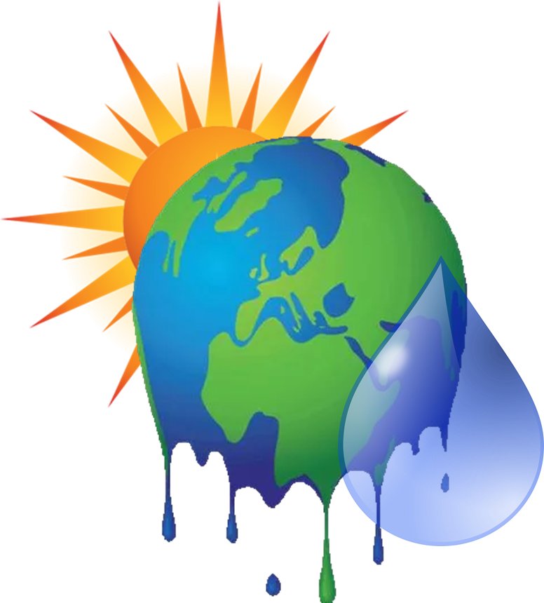
- To make less CO₂, we can cycle or __________________ to places instead of going in the car

What is Climate Change? Note Taking Worksheet Answer Key

- When we use a car, the engine makes a gas called CO₂.
- The CO₂ rises into the air.
- There is so much CO₂ that it covers us, like a big blanket.
- CO₂ can make the air too hot.
- Sometimes, the heat causes drought when there is not enough rain, and all of the plants die.
- Sometimes, the hot air makes great big storms called cyclones. Storms make big waves that smash up coral reefs.
- The heat can warm the sea, causing fish to go away.
- To make less CO₂, we can cycle or walk to places instead of going in the car.

Name:____________________ Date:________
Causes and Effects of Climate Change
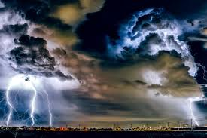
Directions: Draw a line to match the causes to the effects of climate change. After you have completed matching each picture, pick a number from the word box on the back of the worksheet that explains how the cause influences the effect. Place the number next to the image in the left column.
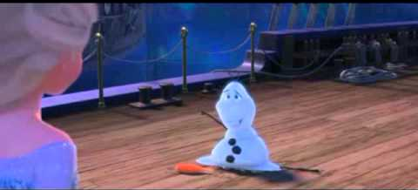

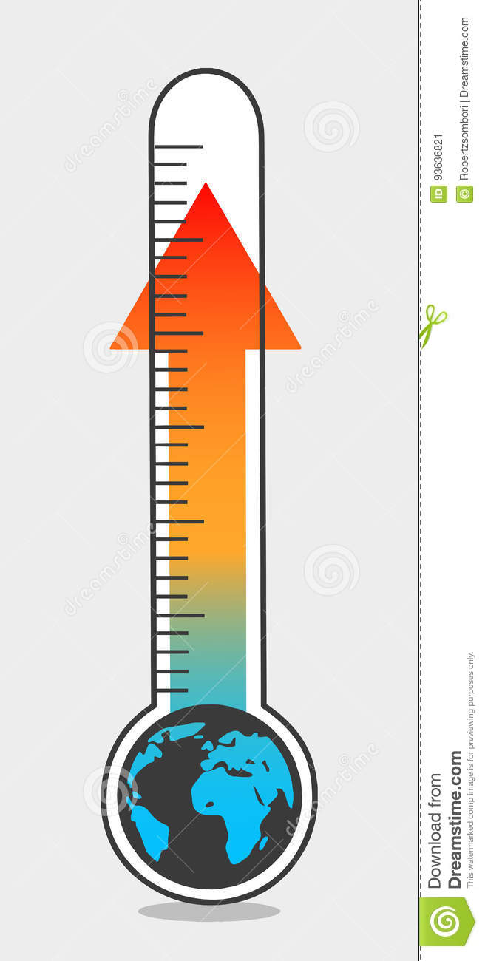
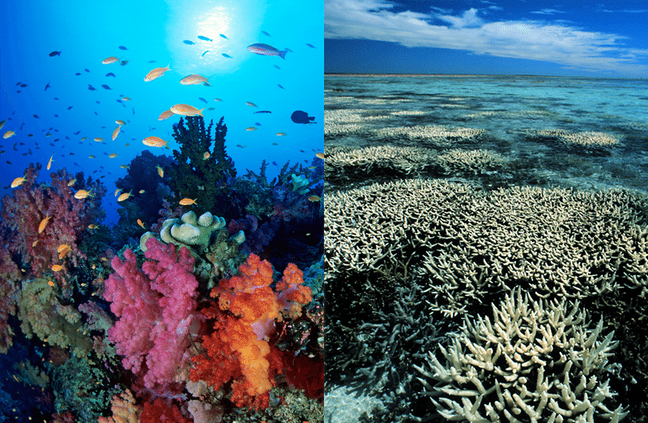

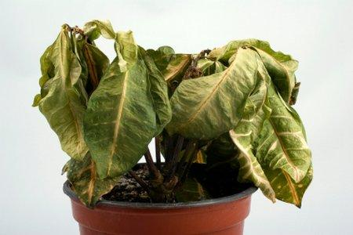
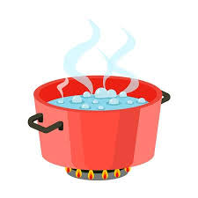

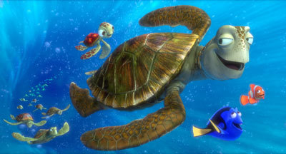
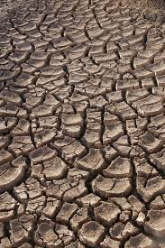

Causes and Effects of Climate Change Word Box

- The storms cause waves that can damage and kill the coral reefs.
- When the Earth is too hot, it causes a drought which causes there not to be enough water to feed the plants, the plants die.
- The increase in temperature occurs because the Earth's “blanket” traps in the heat. This causes snow and ice to melt.
- Water temperature rises because of the increase in the temperature of the air. This causes fish to migrate to a cooler climate.
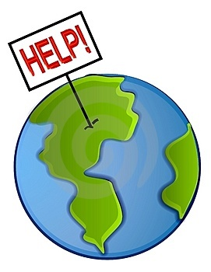

Causes and Effects of Climate Change Answer Key
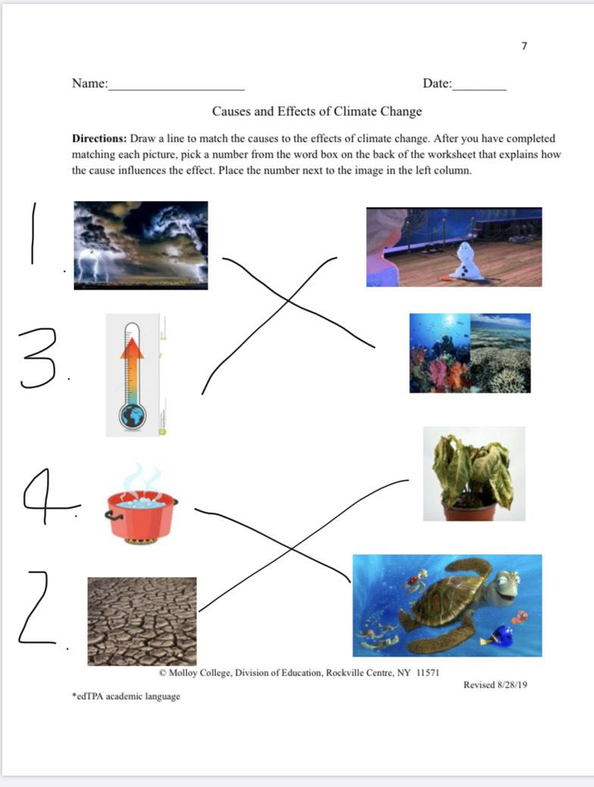

Name: __________________________ Date: _________________
Homework
Directions: Write one thing you learned from the lesson on climate change that stuck with you and draw a picture of you doing something to help the environment.
Example: Draw a picture of you walking instead of driving in the car.

One thing I learned from the lesson on climate change is...

Draw a picture of yourself doing something to help the environment!

