Molloy College
Division of Education

Jennifer Wynne Professor Sheehan
Course EDU5090 Date: 4/10/19
Grade: 4 Topic: Taking Informed Action Content Area: Social Studies

INSTRUCTIONAL OBJECTIVES

After reviewing the unit activities, students will watch a short video on “Kids with Grit”, and will engage effectively in a range of collaborative discussions with diverse partners by building on others’ ideas and expressing their own clearly, by creating a plan to take informed action towards a goal they wish to accomplish. Student’s efforts will be evaluated on the Buncee slide exit ticket, scoring at least a 3 out of 4 on a teacher created rubric.

NYS-CCLS / +NYS STANDARDS AND INDICATORS
New York State Social Studies Standards
Key Idea:
4.6 WESTWARD MOVEMENT AND INDUSTRIALIZATION: New York State played an important role in the growth of the United States. During the 1800s, people traveled west looking for opportunities. Economic activities in New York State are varied and have changed over time, with improvements in transportation and technology.
Key Concepts:
- 4.6e Entrepreneurs and inventors associated with New York State have made important contributions to business and technology.

Indicator: This will be evident when students study the technology that came about from entrepreneurs from the past to present day, and how their grit and growth mindset helped them to accomplish their goals.

National Social Studies Standards and Themes
Social Studies Practices: Habits of Mind
VIII. Science, Technology, & Society Social
a. identify and describe examples in which science and technology have changed the lives of people, such as in homemaking, childcare, work, transportation, and communication;
b. identify and describe examples in which science and technology have led to changes in the physical environment, such as the building of dams and levees, offshore oil drilling, medicine from rainforests, and loss of rainforests due to extraction of resources or alternative uses;
c. describe instances in which changes in values, beliefs, and attitudes have resulted from new scientific and technological knowledge, such as conservation of resources and awareness of chemicals harmful to live and the environment;
d. identify examples of laws and policies that govern scientific and technological applications, such as the Endangered Species Act and environmental protection policies;
e. suggest ways to monitor science and technology in order to protect the physical environmental, individual rights, and the common good.

Indicator: This will be evident when students learn about the science and technology that came about from inventors and entrepreneurs from the past to present day. Students will learn about their positive characteristics and how they can apply that to their personal goals.

NCSS C3 Inquiry Arc
Dimension 4:
Students will draw on knowledge and skills to work individually and collaboratively to conclude their investigations into societal issues, trends, and events, and will present their information, portions, and findings.

Indicator: This will be evident when students present their information about grit and their goal to the class on a Buncee slide.

Common Core ELA Standards
Comprehension and Collaboration
1. Engage effectively in a range of collaborative discussions (one-on-one, in groups, and teacher-led) with diverse partners on grade 4 topics and texts, building on others’ ideas and expressing their own clearly.

Indicator: This will be evident when students work collaboratively in groups discussing, listening, and sharing ideas with peers on the way in which they will take informed action towards a goal.

INSTRUCTIONAL RESOURCES

· “Power of Yet” activity worksheet
· “Buncee slide presentation
· Grit Powerpoint
· “Grit Interview” Worksheet
· “Kids with Character: Grit” https://www.youtube.com/watch?v=lrnihanwVos
· “Pay it Forward” movie clip: https://www.youtube.com/watch?v=nwP36w2074w

MOTIVATION

Students will watch a video “Kids with Character:Grit” to demonstrate how students across the world use grit to help them overcome their challenges and persevere to accomplish their goals.

DEVELOPMENTAL PROCEDURES
- Students will watch a video “Kids with Character:Grit” to demonstrate how students across the world use grit to help them overcome their challenges and persevere to accomplish their goals. (Can anyone relate to the challenges she faced in the video? How did she use grit to overcome her hardships, and accomplish her goals? Does this inspire you to work harder towards a personal goal of your own? Can anyone share with the class a time when they experienced a challenging time in your life that you had to persevere through?)
- Students will follow along to a PowerPoint presentation that reflects on all they learned about grit the past few weeks, and how they will use the information they learned to accomplish a goal of their own. (Who can explain to the class what grit is? Why is it important to have? What famous people did we learn about who had grit? Was grit an important factor during the Industrial Revolution? Why? What technologies and inventions came about during this time? Why do you need grit to go on a show like “Sharktank”?)
- Students will be prompted to think about a goal they would like to take informed action on. The teacher will show students a clip from the movie “Pay it Forward” to motivate them. (What did the teacher want his students to do? Did they think it was easy or hard? Do you think they would need to apply grit to accomplish this task? Why is he asking them to do this? Does this motivate you to think of a goal that might benefit yourself or the world?)
- Students will brainstorm ideas during a “turn and talk” cooperative learning activity to discuss what they think “informed action” means. (What does informed mean? What does action mean? What does it mean to take informed action? How have you taken informed action in your own life or at school before? How can you apply what you learned about grit to use it towards accomplishing a goal you want to take informed action on?)
- Students will complete a “Power of Yet” activity where they outline the goal they would like to take informed action on. (Think about something you would like to achieve but haven’t been able to YET! Outline the steps you will need to get there. Think about any challenges you might face that you will need grit to help you overcome. Think about why this goal is important to you. It’s important to have passion behind your goals. Can anyone explain why passion is important?)
- As an exit ticket, students will create a Buncee presentation outlining their goals and how they are going to take informed action on them. Students will be prompted to create a “vision board” of what they’re goal will look like to include on the presentation. (What is your goal? Is it a personal goal or global issue? How will you take informed action on it? Explain how you will use grit and growth mindset to help you accomplish your goals. Think of someone who inspires you that will motivate you to follow through with your goal. Use pictures to envision what your completed goal will look like.)
- Students will also be prompted to complete a FlipGrid video where students envision themselves having already completed their goal and how they would look and sound like having completed it. Students will also talk about the steps they took to accomplish their goals. For example, if a student’s goal was to learn basketball they could talk about how they practiced everyday after school for 30 minutes. He/she would say they pushed through on the days that they were tired because they knew if they weren’t consistent, they wouldn’t get better. He/she could mention Michael Jordan as a source of inspiration that helped them to persevere.
- Students will present their Buncee slides to the class and thoroughly explain their goal and why it’s important to them.

INSTRUCTIONAL STRATEGIES

Cooperative Learning
Indicator: This will be evident when students participate in a “turn and talk” to discuss what informed action and grit is and how they will apply it towards reaching their goals.

Discussion
Indicator: This will be evident when the teacher and students review all they learned about grit, including how it played a role during the Industrial Revolution, and to present day via shows like SharkTank. Students and teacher will also discuss how they can apply all the knowledge they learned about grit to achieve a personal goal.

ADAPTATIONS

- The student with a visual impairment will sit close to the Smart Board.
- The student with ADHD will be redirected throughout the lesson.
- The English Language Learner will be paired with a peer buddy during the “turn and talk” cooperative learning activity and group work.

DIFFERENTIATION OF INSTRUCTION

· Interpersonal students will interact with their peers during cooperative learning activities and group work.
· The visual learner will watch a video clip on grit and a clip from the movie “Pay it Forward.”
· The kinesthetic learner will use a FlipGrid to act out the future version of themselves after completing their intended goal.
· The linguistic learner will partake in a discussion with their peers and teacher to discuss all they learned about grit and how they will apply this knowledge to their goal.

ASSESSMENT
Informal
Teacher will observe students as they work in small groups and during class discussions.
Formal
Teacher will review the “Power of Yet” Activity worksheet.
Teacher will review students Buncee presentations and FlipGrid videos.

INDEPENDENT PRACTICE

Students will be instructed to think of someone they know that inspires them. They will interview them either in person or via skype to ask them questions on how they accomplished his or her goal. Students will be invited to bring the person they interviewed to class to talk about their interview and findings.

FOLLOW-UP ACTIVITIES: DIRECT TEACHER INTERVENTION AND ACADEMIC ENRICHMENT

Direct Teacher Intervention
The teacher will provide a variety of examples of what grit is and how it influenced the Industrial Revolution. The student will be asked to think of someone they learned about either famous, or during the Industrial Revolution who used grit to accomplish their goals. Teacher and student will brainstorm together a goal the student wishes to succeed and how they can make a plan to achieve that. Teacher will help student if they have trouble using Buncee or FlipGrid technology.

Academic Enrichment
The students will be asked to use grit to help them make a difference towards a global issue. They will be prompted to think back to the movie clip from “Pay it Forward” and think of an issue that would better help the world. Some issues could be making the planet greener, stopping world hunger, volunteering help to a charity, donating their toys to kids in need, etc. They will create an outline of how they are going to complete this goal.

REFERENCES

GROWTH MINDSET Activities | GRIT. (n.d.). Retrieved May 1, 2019, from

https://www.teacherspayteachers.com/Product/GROWTH-MINDSET-Activities-GRIT-3749705

E. (2017, February). New York State K-8 Social Studies Framework. Retrieved from
http://www.p12.nysed.gov/ciai/socst/documents/ss-framework-k-8a2.pdf
National Curriculum Standards for Social Studies. Retrieved from file:///C:/Users/Acer/Downloads/NCSS%20National%20Themes%20(3)%20(5).pdf

New York State Next Generation English Language Arts Learning Standards. (n.d.) Retrieved from http://www.nysed.gov/common/nysed/files/programs/curriculum-instruction/nys-next-generation-ela-standards.pdf
9 Activities To Build Grit and Resilience in Children. (n.d.). Retrieved May 1, 2019, from
https://biglifejournal.com/blogs/blog/activities-grit-resilience-children

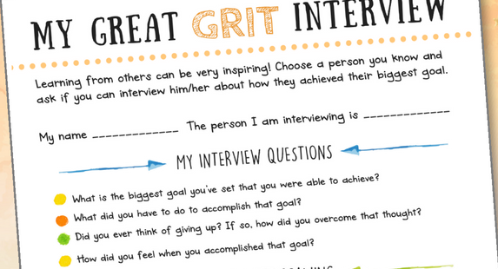

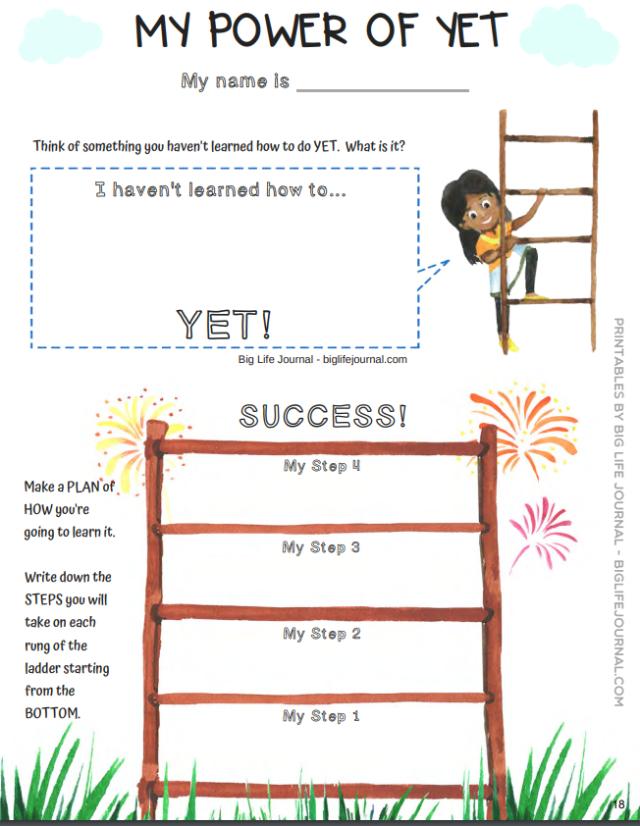

Multimedia Project: Using Grit to take Informed Action
CATEGORY | 4 | 3 | 2 | 1
Presentation | Well-rehearsed with smooth delivery that holds audience attention. | Rehearsed with fairly smooth delivery that holds audience attention most of the time. | Delivery not smooth, but able to maintain interest of the audience most of the time. | Delivery not smooth and audience attention often lost.
Attractiveness | Makes excellent use of font, color, graphics, effects, etc. to enhance the presentation. | Makes good use of font, color, graphics, effects, etc. to enhance to presentation. | Makes use of font, color, graphics, effects, etc. but occasionally these detract from the presentation content. | Use of font, color, graphics, effects etc. but these often distract from the presentaion content.
Content | Covers topic in-depth with details and examples. Subject knowledge is excellent. | Includes essential knowledge about the topic. Subject knowledge appears to be good. | Includes essential information about the topic but there are 1-2 factual errors. | Content is minimal OR there are several factual errors.
Requirements | All requirements are met and exceeded. (Stated goal, steps to complete it, 3 obstacles faced, flip grid video, originality) | All requirements are met. (Stated goal, steps to complete it, 3 obstacles faced, flip grid video) | One requirement was not completely met. | More than one requirement was not completely met.
Organization | Content is well organized using headings or bulleted lists to group related material. | Uses headings or bulleted lists to organize, but the overall organization of topics appears flawed. | Content is logically organized for the most part. | There was no clear or logical organizational structure, just lots of facts.
Oral Presentation | Interesting, well-rehearsed with smooth delivery that holds audience attention. | Relatively interesting, rehearsed with a fairly smooth delivery that usually holds audience attention. | Delivery not smooth, but able to hold audience attention most of the time. | Delivery not smooth and audience attention lost.

