Molloy College
Division of Education

Student: KellyAnn Turton Professor Sheehan
Course EDU 3510 Date: December 4, 2019
Grade: 2nd Topic Elections Content Area: Social Studies

INSTRUCTIONAL OBJECTIVE(S)

After reviewing what makes sources credible/ incredible and if they corroborate, students will participate in collaborative conversations with diverse peers during the WHAC and then vote on their choice topping, citing why they are credible with at least one piece of accurate evidence.

STANDARDS AND INDICATORS

Social Studies Standard
Key Idea:
2.3 The United States is founded on the principles of democracy, and these principles are reflected in all types of communities.
Key Concepts:
2.3c The process of holding elections and voting is an example of democracy in action in schools, communities, New York State, and the nation. Students will learn about the process of voting and what opportunities adults in the community have for participation. Students will participate in voting within the classroom and in school, as appropriate.
Indicator: This will be evident when students vote for their choice of ice cream topping.

New York State Next Generation English Language Learning Standard
Speaking and Listening
Comprehension and Collaboration
2SL1:
Participate in collaborative conversations with diverse peers and adults in small and large groups and during play.
Indicator: This will be evident when students “participate in collaborative conversations” about the credibility and corroboration of different ice cream toppings candidates during the WHAC.

Inquiry Standards
Questions
Indicator: This will be evident when students answer questions throughout the lesson.

Skills
Gathering info
Indicator: This will be evident when students gather information to vote for the best
topping.

DEVELOPMENTAL PROCEDURES (*Engaging the learner)
(Based on a lesson about participating in an election; 60 minutes)

- MOTIVATION
After being introduced to what the word “election” means, students will then sign up to be able to vote in a class election about ice cream toppings. (Have you ever heard of the word election before? [LITERAL] Where have you heard it? [INFERENTIAL] What do we think the word vote means? [METACOGNITIVE] Could we use it in our class?[LITERAL]) [7 minutes]
- Students will be introduced to a new vocabulary word “register”, as well as the word “election” will be added to the unit word wall. Teacher will then discuss with students the importance of researching before voting in an election. (By signing up to vote, you all have actually registered, based off that information, what inferences can we make about what register might mean?[INFERENTIAL] What kind of sources do we look for when we research a topic? [METACOGNITIVE] Do the sources matter? [LITERAL]) [5 minutes]
- Teacher will review with students what it means to have non- credible or credible sources. Students will also review what corroboration means. (What makes a source credible?[INFERENTIAL] How would you know? [METACOGNITIVE] What does it mean when sources corroborate?[INFERENTIAL]) [5 minutes]
- Teacher will introduce to students the 4 contenders in the running for the best ice cream topping. Students will participate in a WHAC with their table groups and move around the room to decipher if the documents are credible and if they corroborate. The toppings and their statements will be hung on the walls around the room. Each group will be given pieces of paper with each ice cream topping contender’s number and with the W (What is the source?), H (How credible is it?), A (What is the Author’s purpose?), C (Which sources corroborate?). Students will rotate from group to group analyzing the statements. Teacher will monitor groups. ( Have you ever eaten sand before? [LITERAL] What makes that source credible? [INFERENTIAL] How did you tell?[METACOGNITIVE] ) [20 minutes]
- The class will then come back together to talk about whether or not each contender is credible and why and which would corroborate. (Let’s have a discussion, and see if we agree which candidates are credible. Why would sprinkles be considered credible? [METACOGNITIVE] Why would sand not be considered credible? [METACOGNITIVE] Did all the statements corroborate? [LITERAL] Which topping’s statements didn’t corroborate? Why?[INFERENTIAL]) [7 minutes]
- The class will pick the top two contenders and rule out the ones who did not have credible sources. Students will then vote for their choice of topping based on the two left on the “VOTE” worksheet. Teacher will count the votes and display the winner on the board. (Which toppings can we rule out based on our sources? [LITERAL] Why did you choose that topping? [INFERENTIAL] How did you know it was credible? [METACOGNITIVE]) [5 minutes]
- Closure: Students will be able to take part in an ice cream party with their choice of toppings! Students will discuss the big picture they learned today. (While enjoying our tasty treat, could we have a few volunteers say what the big takeaway was today?[METACOGNITIVE]) [5 minutes]

ASSESSMENT (formal & informal)

Informal assessment

Questions throughout the lesson
WHAC

Formal assessment

Students will vote on their choice topping by citing at least one accurate and credible source.

INSTRUCTIONAL STRATEGIES

- Cooperative Learning
Indicator: This will be evident when students participate in the WHAC.
- Discussion
Indictor: This will be evident when students participate in the WHAC.
- Independent work
Indicator: This will be evident when students place their vote for ice cream topping and
cite why the candidate is credible.
- Direct Instruction
Indicator: This will be evident when the teacher is going over the new vocabulary
words.

INDEPENDENT PRACTICE

After a lesson on using corroboration and credibility to vote, for homework, students will identify another good choice they believe would be a good ice cream topping and a credible source to share the next day at the morning meeting.

REFERENCES

New York State Department of Education. (2019). New York State Next Generation English Learning
Standards. Retrieved from
http://www.nysed.gov/curriculum-instruction/new-york-state-next-generation-english-language
arts-learning-standards

New York State K-12 Social Studies Framework. (n.d.). Retrieved from https://www.engageny.org/resource/new-york-state-k-12-social-studies-framework.

SIGN UP TO VOTE!

My name is

________________________.

---------------------------------

SIGN UP TO VOTE!

My name is

________________________.

WHAC #1

“Sprinkles add color to your ice cream”- John Smith, Ice Cream Specialist

“Sprinkles can also be used on brownies and other dessert treats!” - Gordon Ramsey, Celebrity Chef

WHAC #2
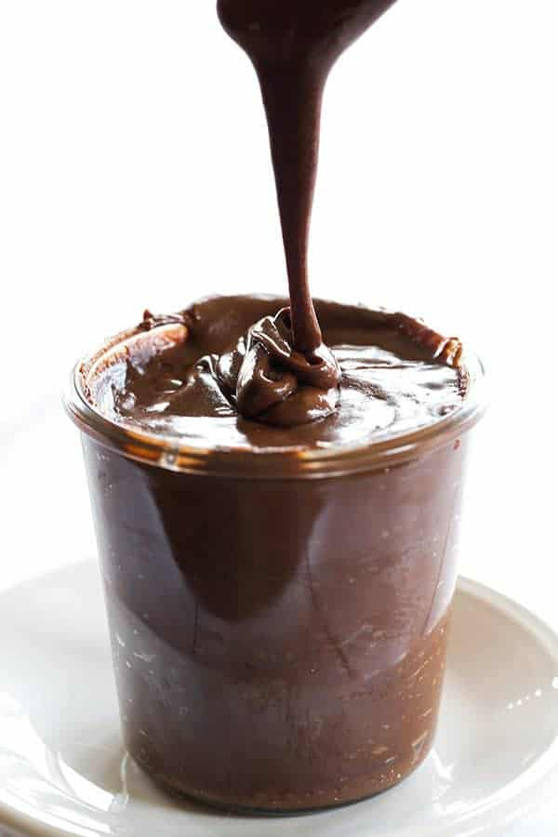
“Hot fudge is a delicious, chocolate ice cream topping”
- Ben & Jerry’s

“Hot fudge comes in different chocolate flavors”
-Mark T. Smuckers, CEO of Smucker’s

WHAC #3

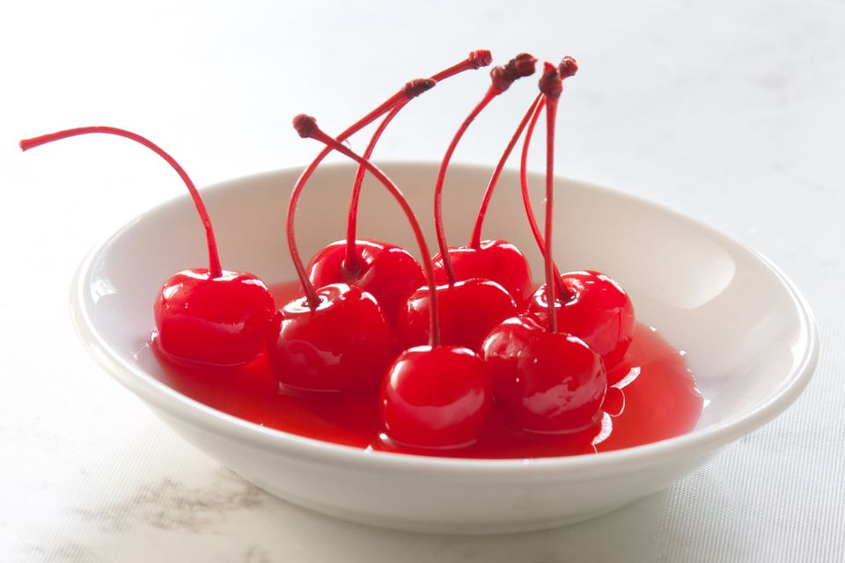
“Cherries are the best on ice cream!”
- Miss Turton’s mom

“Cherries are actually vegetables” - Timmy Jones, Kindergartener

WHAC #4

“Sand makes me you smarter when you put it on ice cream!”
- Spongebob Squarepants, cartoon character

“Sand is not a dessert topping”
- The Food and Drug Administration

WHAC (Picture #1)

What is the source?
- __________________________________________________
- __________________________________________________

How credible is it?
- __________________________________________________
- __________________________________________________

What is the Author’s purpose?
- _________________________________________________
- _________________________________________________

Do the sources Corroborate?
_______________________________________

WHAC (Picture #2)
What is the source?
- __________________________________________________
- __________________________________________________

How credible is it?
- __________________________________________________
- __________________________________________________

What is the Author’s purpose?
- _________________________________________________
- _________________________________________________

Do the sources Corroborate?
________________________________________

WHAC (Picture #3)
What is the source?
- __________________________________________________
- __________________________________________________

How credible is it?
- __________________________________________________
- __________________________________________________

What is the Author’s purpose?
- _________________________________________________
- _________________________________________________

Do the sources Corroborate?
________________________________________

WHAC (Picture #4)
What is the source?
- __________________________________________________
- __________________________________________________

How credible is it?
- __________________________________________________
- __________________________________________________

What is the Author’s purpose?
- _________________________________________________
- _________________________________________________

Do the sources Corroborate?
________________________________________

VOTE:
Name:____________________________
Directions: Check the box to cast your vote! Write why your choice was credible on the lines below!
Hot Fudge Sprinkles

_______________________________________________________________________________________________________________________________________________________________________.

