Molloy College
Division of Education

Student: Jenelle Watler Professor Kevin Sheehan
Course EDU 5090 Date: Thursday, December 12, 2019
Grade: 3 Topic: Culture Content Area: Social Studies

INSTRUCTIONAL OBJECTIVES (s) (Lesson Objective(s)*)

Following an interactive read aloud of “A Ticket Around the World” students will actively discuss the meaning of culture identifying 3 facts and 3 opinions within the cultures portrayed, by writing an informative explanatory paragraph.

NYS-CCLS / +NYS STANDARDS AND INDICATORS

New York State Social Studies Standards
Key Idea: 3.5 Development, Movement, and Interaction of Cultures: Communities share cultural similarities and differences across the world.
Key Concept: 3.5b Communities around the world can be diverse in terms of their members, languages spoken, customs and traditions, and religious beliefs and practices. People in world communities celebrate various holidays and festivals.
Indicator: This will be evident when students participate in a read aloud of “A Ticket Around the World.”
National Social Studies Standards and Themes
Global Connections: Social studies programs should include experiences that provide for the
study of global connections and independence, so that the learner can:
A. Explore ways that language, art, music, belief systems, and other cultural elements may facilitate global understanding or lead to misunderstanding.
Indicator: This will be evident when students collaboratively discuss “A ticket around the world.”
Common Core ELA Standards
Key Ideas and Details
2. Determine the main idea of a text; recount the key details and explain how they support the main idea.
Indicator: This will be evident when students are able to identify 3 facts and 3 opinions about culture from “A ticket around the world.”
Text Types and Purposes
2. Write informative/explanatory texts to examine a topic and convey ideas and information clearly.
Indicator: This will be evident when students are able to write an informative paragraph about how cultures are different.
Social Studies Practices: Habits of Mind
C. Comparison and Contextualization
2. Identify multiple perspectives by comparing and contrasting points of view in differing world communities.
Indicator: This will be evident when students are able to compare and contrast the cultures portrayed in “A ticket around the world.”
NCSS C3 Inquiry Arc
Dimension 3 of the arc features evaluating sources and using evidence. Students will draw on knowledge and skills to work individually and collaboratively to conclude their investigations into societal events and present their information.

DEVELOPMENTAL PROCEDURES
(including Key Questions)

- Students will be given a list of countries traveled while participating in an interactive read aloud of the book “A Ticket Around the World”. (Can anyone tell me their favorite country visited in the book and why? (INFERENTIAL) Was there a popular food you would like to try?(LITERAL) Are there any languages you remember that were spoken?(LITERAL) Why is language important? (METACOGNITIVE) Is language a part of culture and why? (INFERENTIAL))
- Students will use the list of countries provided to make notes on the facts, as well as, the opinions of the author on each country visited. (How many regions is Greece divided into? (LITERAL)Why does the author think people visit Greece?(LITERAL) Can you remind me which of these answers is a fact?Why? (INFERENTIAL)What is the difference between fact and opinion?(INFERENTIAL) Why do we need to know the difference between fact and opinion?(METACOGNITIVE))
- Students will participate in a group discussion about culture. (What do you believe makes up the culture in Greece? (INFERENTIAL) What about China’s culture?(INFERENTIAL) What would you say is one difference between Costa Rica and Australia?(INFERENTIAL) How do these differences in culture affect your view of culture? (METACOGNITIVE))
- Students will be given a compelling question, “what is culture to you?” to think-pair-share their thoughts. (How would you describe your individual culture? (INFERENTIAL)What aspects of your life would you include?(INFERENTIAL) What is something you have in common with your partner?(LITERAL) What is one thing that is different?(LITERAL) How do you think learning about someone else's culture may change the way you see your own?(METACOGNITIVE))
- Students will use the list of countries to identify 3 facts and 3 opinions within the cultures portrayed, by writing an informative explanatory paragraph. (What are three facts that you learned about some of the countries in the book? (LITERAL) What are three opinions expressed by the author about some of the countries in the book? (LITERAL) What are the differences and similarities between these facts and opinions? (INFERENTIAL) How can your relate these similarities and differences to your own culture? (METACOGNITIVE))
- To conclude the lesson students will provide one aspect of their own culture and one from the book in small group discussions to portray their understanding of culture. (Can you share with your group of 4, one aspect of a culture that you could relate the most to from the book? (INFERENTIAL) Why is this relatable to you?(METACOGNITIVE) Why do we need to learn about other cultures?(METACOGNITIVE))
INSTRUCTIONAL STRATEGIES

Cooperative learning

Indicator: This will be evident when the students are working together in small groups discussing their individual culture and differences among themselves.

Questioning
Indicator: This will be evident as the teacher employs strategies of questioning and
follow-up questioning throughout the instructional period to further engage students, lead
them to discovery, or encourage further inquiry.

Scaffolding
Indicator: This will be evident when the teacher helps students understand cultures and how they are different.

Thinking Routines
Indicator: This will be evident as students participate in the think-pair-share activity.
ASSESSMENT

Formal:Students will use the list of countries to identify 3 facts and 3 opinions within the cultures portrayed, by writing an informative explanatory paragraph.

Informal: Teacher will monitor when students are constructing their informative paragraph. Formative assessment will take place throughout the lesson in the form of questioning/follow-up questioning.

INDEPENDENT PRACTICE
For homework, students will create a Flipgrid including three aspects of their own culture and one method that could be used to share their culture with others to create more culturally aware and informed students.

REFERENCES

Diaz, N., & Owens, M. (2015). A Ticket around the World. Berkley, CA: Owlkids Books.
NYS Education Department. (2017). NYS Next Generation English Language Arts Learning Standards. Retrieve from
http://www.nysed.gov/curriculum-instruction/new-york-state-next-generation-english-language-arts-learning-standards
NYS Education Department. (2016). NYS Social Studies Framework. Retrieved from
http://www.nysed.gov/curriculum-instruction/k-12-social-studies-framework

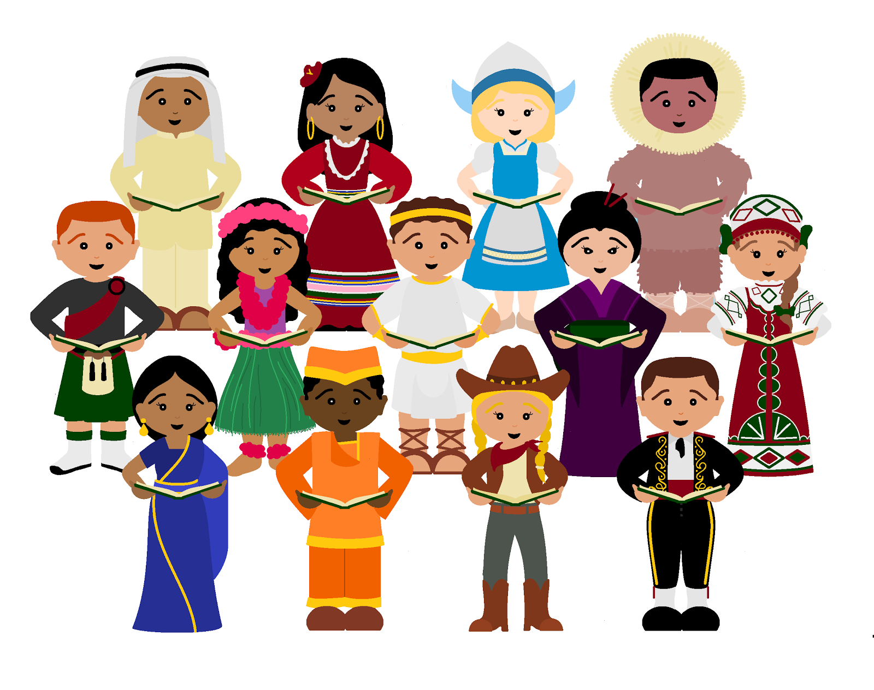
Name:___________________ Date:_________

Directions: Use the list below to write one fact and one opinion from each country as we explore, “A Ticket Around the World.”
Costa Rica
Fact:_________________________________________________________________________________________
Opinion:______________________________________________________________________________________ India
Fact: ________________________________________________________________________________________
Opinion:______________________________________________________________________________________
Morocco
Fact:_________________________________________________________________________________________
Opinion:______________________________________________________________________________________ Greece
Fact:______________________________________________________________________________________
Opinion:______________________________________________________________________________________ Canada
Fact:_________________________________________________________________________________________
Opinion:______________________________________________________________________________________ Brazil
Fact:_________________________________________________________________________________________
Opinion:______________________________________________________________________________________France
Fact:_________________________________________________________________________________________
Opinion:______________________________________________________________________________________

Botswana
Fact:_________________________________________________________________________________________
Opinion:______________________________________________________________________________________ China
Fact:_________________________________________________________________________________________
Opinion:______________________________________________________________________________________ Philippines
Fact:_________________________________________________________________________________________
Opinion:______________________________________________________________________________________ Australia
Fact:_________________________________________________________________________________________
Opinion:______________________________________________________________________________________
United States
Fact:_________________________________________________________________________________________
Opinion:______________________________________________________________________________________
Jordan
Fact:_________________________________________________________________________________________
Opinion:______________________________________________________________________________________

