Lesson Plan
Student: James Snell Professor Sheehan
Course: EDU 3510-01 Date: December 4, 2019
Grade: 4th Topic: Media Literacy
Content Area: Comparing and Contrasting sources

Objective :After the teacher presents the story “The Encounter,” and “The 1492 Poem,” Students will use a Venn Diagram to compare and contrast the treatment of similar themes and topics ( opposition of good and evil) and patterns of events by which Chistopher Columbus and the Native Americans had with each other to ultimately determine whether Christopher Columbus was a Hero or villain with scoring at least 2 out of 3 correct on the exit ticket.

#1 Social Studies Standard
Key concept Key idea
Compare and contrast a firsthand and secondhand account of the same event or topic; describe the differences in focus and the information provided.

Indicator : This will be evident when the students compare and contrast the two stories.

#2 ELA Standard: New York State Next Generation English Language Arts Learning Standard Reading Standards (Literacy and Informational Text)
Key Ideas and Details
CCSS.ELA-LITERACY.RL.4.9
Compare and contrast the treatment of similar themes and topics (e.g., opposition of good and evil) and patterns of events (e.g., the quest) in stories, myths, and traditional literature from different cultures.

Indicator: This will be evident when the students analyze both stories.

Inquiry Standards: Use information from the text to come up with answers and use prior knowledge and experiences to answers questions.

Developmental Procedures:

Motivation: Which came first? The teacher will show two images of the same person or object and students will have to discuss the differences in the images, and come up to the board and list their differences to ultimately determine which image is the new version and old version. ( How can you tell the differences between these images? Can you notice any physical differences? Are there any objects in the image that may help you in making your decision? What is your point of view on these images?)

- Following Which came first, the teacher will then present the story “The Encounter” to the class and during the reading if they want students can write down some of their thoughts on the story. (What is her point of view on Columbus? Do you think her people were happy? Do you think the Natives way of life is different than ours? Thoughts on Columbus being a Hero or Villain so far?)

- The teacher will then present the “ The 1492 Poem” to the class, during the reading if they want to , students can write down their thoughts on it as well. ( How do they view Columbus in this Poem? Does your view on Columbus change after reading this? Why do you think there is such a difference in point of view in these two readings?)

- After the two reading are completed students at their tables will complete a Venn Diagram to compare and contrast the two readings. ( What thoughts come to mind after seeing these two readings)

- When students have completed their Venn Diagrams, some will share their findings, and as a class using our meta-cognitive skills we will determine with this evidence if Christopher Columbus was a Hero or Villain. (Does thinking about a person after gathering information from two points of views change your view on someone?)

- Closure:
Teacher will conclude the lesson passing out an Exit Ticket and by breaking down the day with the class with a headline. (After learning more about Christopher Columbus, How do we feel about today's class?)

Strategies:
Cooperative Learning:
Indicator: This will be evident when students work together at their tables to fill in the Venn Diagram.

Discussion:
Indicator: This will be evident when the students do the Which Came First Activity.

Direct Instruction:
Indicator: This will be evident when the students are given instructions on the Venn Diagram.

Assessment: Students can act out how they would feel if Columbus came to their land and took everything from them.

Independent Practice: Students will choose from either “The Encounter,” or “The 1492 Poem” and will have to write a short response about what it means to them.

References:
- The Encounter: https://www.youtube.com/watch?v=NSRvWlCwlKU

- The 1492 Poem: http://www.teachingheart.net/columbus.htm

VENN DIAGRAM

Name: _____________________ Date:___________________
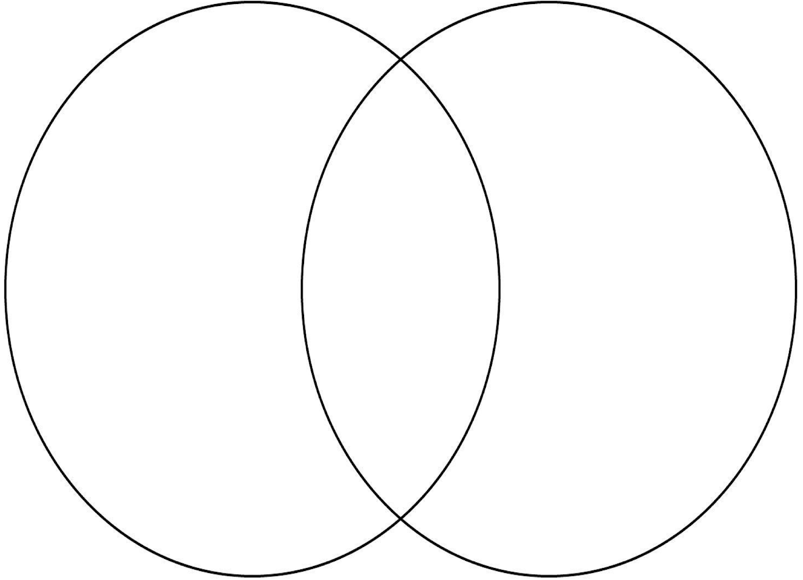
After looking over “The Encounter,” and “The 1492 Poem, as a group please fill out this Venn Diagram comparing and contrasting the two works. After finishing the Venn Diagram, on the lines below please write whether you believe Chirstopher Columbus is a Hero or Villain.

____________________________________________________________________________

____________________________________________________________________________

____________________________________________________________________________

Exit Ticket

- Who is Christopher Columbus?

______________________________________________________________

______________________________________________________________

______________________________________________________________

- Whose point of view was “The Encounter” on?

______________________________________________________________

______________________________________________________________

______________________________________________________________

- How were the Native Americans treated by Christopher Columbus?

______________________________________________________________

______________________________________________________________

______________________________________________________________

Here is the complete 1492 poem:

IN 1492

In fourteen hundred ninety-two
Columbus sailed the ocean blue.

He had three ships and left from Spain;
He sailed through sunshine, wind and rain.

He sailed by night; he sailed by day;
He used the stars to find his way.

A compass also helped him know
How to find the way to go.

Ninety sailors were on board;
Some men worked while others snored.

Then the workers went to sleep;
And others watched the ocean deep.

Day after day they looked for land;
They dreamed of trees and rocks and sand.

October 12 their dream came true,
You never saw a happier crew!

"Indians! Indians!" Columbus cried;
His heart was filled with joyful pride.

But "India" the land was not;
It was the Bahamas, and it was hot.

The Arakawa natives were very nice;
They gave the sailors food and spice.

Columbus sailed on to find some gold
To bring back home, as he'd been told.

He made the trip again and again,
Trading gold to bring to Spain.

The first American? No, not quite.
But Columbus was brave, and he was bright.

Which Came First?
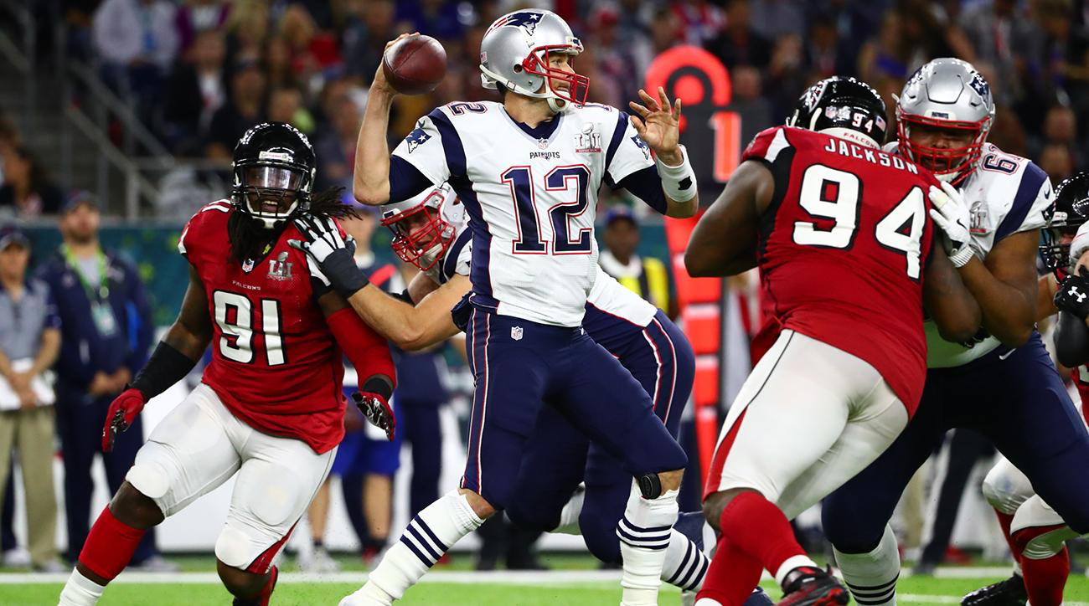

Which Came First?
