Molloy College
Division of Education

Lesson Plan

Jacqueline Christenson Dr. Sheehan
EDU 351 01 April 5th, 2018
Grade: 5 Topic: Puerto Rico Social Studies

INSTRUCTIONAL OBJECTIVE

After a brief discussion on credibility, students will draw evidence from documents provided in order to analyze the validity of evidence through a history mystery activity. Students will write arguments to support the claim, “Are Puerto Ricans happier than Americans?” using sufficient evidence. Students must include at least 3 pieces of relevant evidence from the history mystery activity to support their answer. Groups will present their findings to the class with at least 80% accuracy.

NYS-CCLS / +NYS STANDARDS AND INDICATORS

New York State Social Studies Standards
Key Idea: 5.5 COMPARATIVE CULTURES: The countries of the Western Hemisphere are diverse and the cultures of these countries are rich and varied. Due to their proximity to each other, the countries of the Western Hemisphere share some of the same concerns and issues.

Key Concept: 5.5a The countries of the Western Hemisphere have varied characteristics and contributions that distinguish them from other countries.
Indicator: This will be evident when students compare the life of Puerto Ricans to the life of Americans to determine if Puerto Ricans are happier than Americans.

National Social Studies Standards and Themes
Culture: Social studies programs should include experiences that provide for the study of culture and cultural diversity, so that the learner can:
a. explore and describe similarities and differences in the ways groups, societies, and cultures address similar human needs and concerns
Indicator: This will be evident when students examine the evidence in the history mystery to determine if Puerto Ricans are happier than Americans.

Individual Development & Identity: Social studies programs should include experiences that provide for the study of individual development and identity, so that the learner can:
e. identify and describe ways family, groups, and community influence the individual’s daily life and personal choices
Indicator: This will be evident when students discuss the influences of the life of Puerto Ricans and Americans.
NCSS C3 Inquiry Arc
Dimension 3: Students will work toward conclusions about societal issues, trends, and events by collecting evidence and evaluating its usefulness in developing causal explanations.
Indicator: This will be evident when students evaluate the usefulness of evidence in the
history mystery activity to answer the compelling question.
Dimension 4: Students will draw on knowledge and skills to work individually and collaboratively to conclude their investigations into societal issues, trends, and events and will present their information, portions and findings.
Indicator: This will be evident when students work together to conclude their investigations from the history mystery activity and present their findings.

Common Core ELA Standards
Integration of Knowledge and Ideas
7. Delineate and evaluate the argument and specific claims in a text, including the validity of the reasoning and the relevance and sufficiency of the evidence.
Indicator: This will be evident when students include the validity of the reasoning and the relevance and sufficiency of the evidence in the history mystery activity.
Text Types and Purposes
1. Write arguments to support claims in an analysis of substantive topics or texts, using valid reasoning and relevant and sufficient evidence.
Indicator: This will be evident when students write and support a claim, using valid reasoning and sufficient evidence from the history mystery activity.

Social Studies Practices: Habits of Mind
A. Gathering, Interpreting, and using Evidence
2. Recognize and effectively select different forms of evidence used to make meaning in social studies (including primary and secondary sources such as art and photographs, artifacts, oral histories, maps, and graphs).
Indicator: This will be evident when students recognize and find credible evidence in the history mystery activity to write arguments that support their claims.

INSTRUCTIONAL RESOURCES
- SMART board
- PowerPoint
- The Case of the Broken Vase! An EvanTubeHD Detective Story” video https://www.youtube.com/watch?v=m-zgsuwshIU
- History Mystery envelopes
- Primary sources (documents)
- My Supporting Claim worksheet
- My Documents Findings worksheet
- Happiness Homework

MOTIVATION

Students will watch a mystery video called “The Case of the Broken Vase! An EvanTubeHD Detective Story” in order to see what a mystery is. This will help prepare students for the History Mystery activity, answering the question, “Are Puerto Ricans happier than Americans?”

DEVELOPMENTAL PROCEDURES

- Students will watch a mystery video called “The Case of the Broken Vase! An EvanTubeHD Detective Story” in order to see what a mystery is. They will be told that they are going to be detectives today (What kind of people do you see in the video? What do you notice about what they are wearing? What do you think the job of a detective does?)
- Students will take out their homework from last night and discuss it as a class (Does anyone have any questions?)
- Students will review the historical thinking strategies they learned from the previous lesson (How can we think like historians? In your opinion, why do you think it is important to think like a historian?)
- Students will discuss as a class what credible vs. non-credible is (What does credible mean? What does non-credible mean? How can we determine if information is true? How can we determine if information is false? Why do you feel it is important to not believe everything we read? Can some readings be more credible than other readings?)
- The teacher will discuss the rules of the History Mystery activity with the students (Why are rules important? Why do we need rules? What would it be like if we lived in a world without rules?)
- Students will participate in a History Mystery activity, working in groups of 4 to detect if the evidence provided is credible or non-credible. They will complete the “My Documents Findings” worksheet (What do you see in the envelope? What do you notice? What kind of information do you see? What do the documents say? Are the documents supporting Puerto Rico? Are the documents supporting America? Is there any bias in this evidence?)
- Students will order the evidence from least credible to most credible (What made you put the evidence in that order? Is there evidence that is more credible than others? Is there evidence that is less credible than others? How do you determine credibility of evidence?)
- Students will create a claim whether they feel Puerto Ricans are happier than Americans, or if Americans are happier than Puerto Ricans, using evidence from the History Mystery activity. They will complete the “My Supporting Claim” worksheet (What conclusion did the evidence lead to? Who do you believe is happier? Do you agree with the evidence in the envelope? Do you disagree with the evidence in the envelope? Is there a reason to question your findings?)
- The teacher will ask each group to share with the class what they found (What was your most credible piece of evidence? Did you have more evidence supporting Puerto Rico or more evidence supporting America? What is a conclusion we can make based on these documents?)
- To close the lesson, the students will review the compelling question; “Are Puerto Ricans happier than Americans.” Students will share their written claims to support this question with the class (What were your findings from the history mystery activity? What did the evidence tell you? What did you conclude? What was your most credible piece of evidence? How do you know this?)

INSTRUCTIONAL STRATEGIES

Collaboration: This will be evident when students work together in their History Mystery groups.

Discussion: This will be evident when the teacher and students discuss what a mystery is and their results in the History Mystery activity.

Cooperative Learning: This will be evident when students work together in their groups, sharing their ideas.

ADAPTATIONS

- Students who struggle to focus will sit near the teacher to help him/her refocus.
- Students who struggle to work in groups will be given the opportunity to choose who they work with.
- Students who struggle with reading will be provided with the clues the night before to go over and analyze them before the lesson.
- English Language Learners will be provided with a dictionary for words they may not understand or struggle with.

DIFFERENTIATION OF INSTRUCTION

- Visual Learners: These students will be able to look at the PowerPoint presentation as well as see the clues in the History Mystery activity.

- Kinesthetic Learners: These students will be allowed to move during the History Mystery and physically touching the clues to put them in order.

- Auditory Learners: These students will be will be able to listen to the class discussion before the History Mystery activity and listen to their peers.

ASSESSMENT

- Teacher will assess students homework from the night before
- Teacher will assess how the students interact during group work
- Teacher will assess the presentation of the findings from the History Mystery activity

INDEPENDENT PRACTICE

Students will be given out a short article on happiness with some questions at the end to complete for homework. This will be useful for debate and discussion for next class. The teacher will check the students work and provide feedback and have a class discussion at the beginning of the next class session.

FOLLOW-UP ACTIVITIES: DIRECT TEACHER INTERVENTION AND ACADEMIC ENRICHMENT

Direct Teacher Intervention
Students who do not meet the objective will be able to meet the teacher for extra help where a worksheet and PowerPoint of the clues will be presented more in depth. The teacher will also work with them on determining what evidence is credible and what evidence is non-credible.

Academic Enrichment
Students who exceed the objective requirements will go on the internet through teacher guided research and find even more evidence to make their argument stronger. After students complete the assignment, the teacher will review the assignment and provide the students with feedback. Student will have the opportunity to share their evidence with the rest of the class during the next class session.

REFERENCES

- https://qz.com/1091341/puerto-ricos-eye-popping-economic-situation-in-charts/
- https://www.huffingtonpost.com/entry/charts-puerto-rico-shrinking_us_56f6db62e4b0a372181a21b0
- https://www.statista.com/topics/3088/drug-use-in-the-us/
- http://www.cnn.com/interactive/2017/09/world/hurricane-maria-puerto-rico-cnnphotos/
- http://www.mylifeelsewhere.com/cost-of-living/united-states/puerto-rico

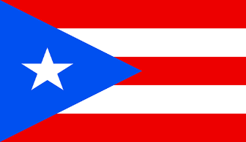
My Supporting Claim
Directions: After solving the history mystery with your group members, create strong claims that supports your findings from the activity. Be sure to include at least 3 pieces of evidence that support why you feel Puerto Ricans are happier or why you feel Americans are happier. You may look back at your documents for help.

My Mystery Findings:

__________________________________________________________________________________________________________________________________________________________________________________________________________________________________________
My Supporting Claims:
- _________________________________________________________________________________________________________________________________________________________________________________________________________________________________________________________________________________________________________________________________________________________
- _________________________________________________________________________________________________________________________________________________________________________________________________________________________________________________________________________________________________________________________________________________________
- _________________________________________________________________________________________________________________________________________________________________________________________________________________________________________________________________________________________________________________________________________________________
My Document Findings
Directions: After studying each document with your group members, choose which country you believe the document supports most. Be sure to explain your answers on the lines provided below.

- America Puerto Rico
____________________________________________________________________________________________________________________________________________________________________________________________________________________________________________________________________________________________________________

- America Puerto Rico
____________________________________________________________________________________________________________________________________________________________________________________________________________________________________________________________________________________________________________

- America Puerto Rico
____________________________________________________________________________________________________________________________________________________________________________________________________________________________________________________________________________________________________________

- America Puerto Rico
____________________________________________________________________________________________________________________________________________________________________________________________________________________________________________________________________________________________________________

- America Puerto Rico
____________________________________________________________________________________________________________________________________________________________________________________________________________________________________________________________________________________________________________

- America Puerto Rico
______________________________________________________________________________________________________________________________________________________
______________________________________________________________________________________________________________________________________________________

- America Puerto Rico
____________________________________________________________________________________________________________________________________________________________________________________________________________________________________________________________________________________________________________

- America Puerto Rico
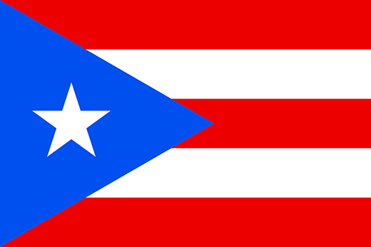
____________________________________________________________________________________________________________________________________________________________________________________________________________________________________________________________________________________________________________
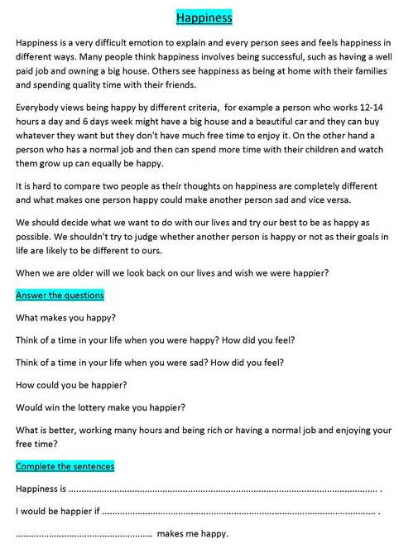
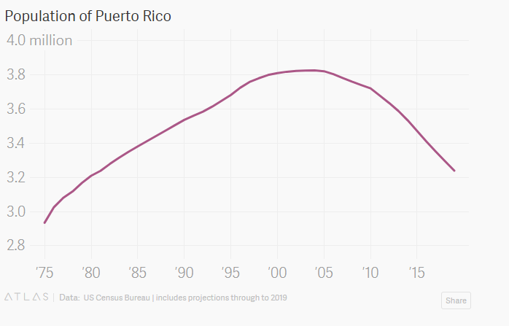
- Population of Puerto Rico. In 2016, the population was estimated to be just 3.4 million, down more than 10% since a peak of 3.8 million in 2004. By 2025, it is projected to fall below 3 million.

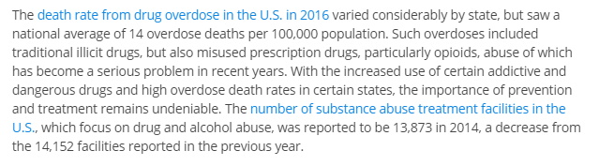
- Drug use in the U.S. - Statistics & Facts

- Puerto Ricans Have Shown They're Happy With Status Quo
The fact that we use American brands of automobiles, fast foods, and bargain shopping and cellular communications, according to Dr. Hill, also means Puerto Ricans yearn to become a state. He also believes that the opinions of people living in the other 50 states will somehow influence the minds of Puerto Rican voters to want to become a state. Not so. All these things occur in Puerto Rico because survival in the global sense requires it.
Yes, we Puerto Ricans are American citizens at birth, and we have proved to be worthy of the label. We are proud to be American citizens. We have fought in every important war or conflict and our boys have given their lives for this country and the freedom it represents. We cherish that same freedom that has allowed us by our own democratic choice to remain "Estado Libre Asociado de Puerto Rico" - Free Associated State of Puerto Rico, the Commonwealth of Puerto Rico

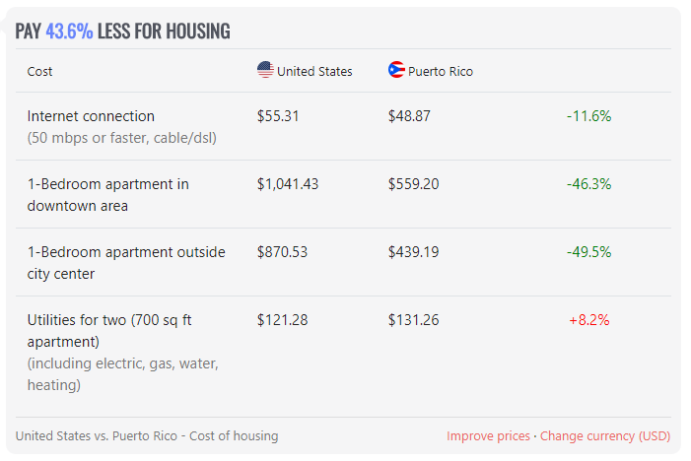
- United States vs. Puerto Rico: Cost of Housing

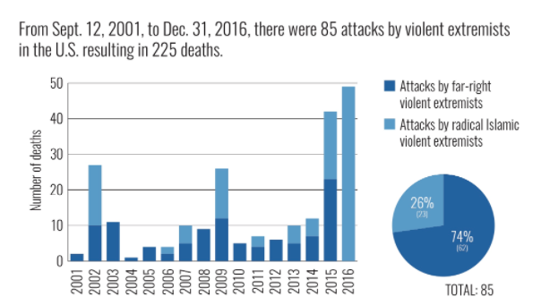
Data on Domestic Terrorism in the U.S. and who’s behind it
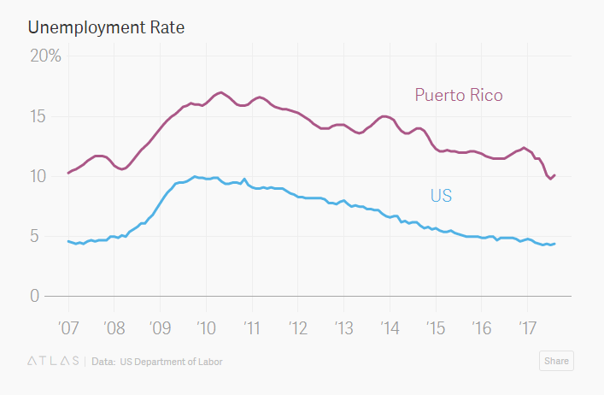
- Unemployment Rate: United States vs. Puerto Rico
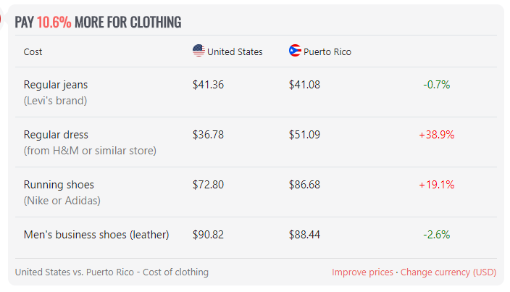
- United States vs. Puerto Rico: Cost of Clothing

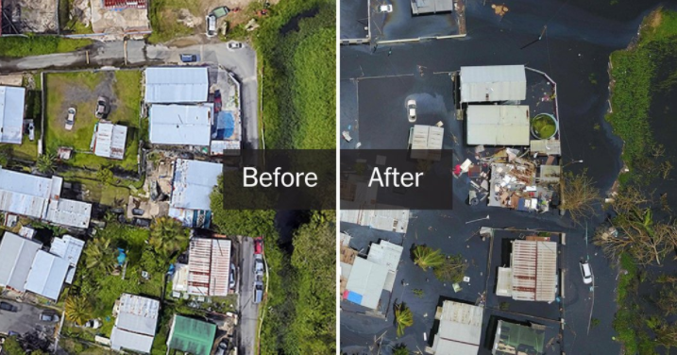
- Pictures of Puerto Rico before and after Hurricane Maria

Are Puerto Ricans Happier Than Americans?
Detectives,

In this envelope contains evidence to help you solve the happiness mystery. As a team, it is your job to work together and determine if the evidence inside the envelope is credible or not. You must put the evidence in order from least credible to most credible. You must determine if Puerto Ricans are happier than Americans, based on the evidence provided. When you complete the mystery, you will record your findings on the supporting claim handout, using at least three pieces of evidence to support your claim.

Good luck Detectives!

