12th Grade

Character Traits vs. Accomplishments
What determines an effective President?
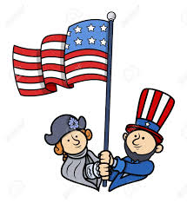

What are character traits? What defines a good president; character traits or accomplishments? This 12th grade Inquiry Design Model curriculum allows students to explore the concept of character traits and how they relate to history, government, and their own lives. This unit will take students through the lives of previous presidents investigating the quality of each president demystifying preconceptions students may have about them. Students will investigate different Presidents through documents and discussion to determine whether character traits or accomplishments define effective leaders.

Compelling Question:

Are the most effective leaders and presidents determined by their character or accomplishments?

Staging the Question

Students will engage in a lesson on character traits through analysis of the song Hamilton and identifying character traits of their classmates.

Standards and Practices:12.G1 FOUNDATIONS of AMERICAN DEMOCRACY: The principles of American democracy are reflected in the Constitution and the Bill of Rights and in the organization and actions of federal, state, and local government entities. The interpretation and application of American democratic principles continue to evolve and be debated.

- Supporting Question:  What are character traits? | Formative Tasks:  Students will write the character traits they believe their classmates have. Students will then partake in a gallery walk explaining why they chose the traits written down. | Sources:  Teacher created character traits sheet

2. Supporting Question:  What character strengths make a good President? | Formative Tasks:  After students debate what character traits make a good president, students will do a read and retell on presidents. | Sources:  Teacher created resources, which include:  -Teacher created character -strength sheet  -Teacher created read and retell  -Teacher created character strengths chart

3. Supporting Question:  What are the accomplishments of a good President? | Formative Tasks:  After students have a discussion on leadership, students will write arguments to support claims and cite evidence by doing a statement strategy and creating an exit ticket stating what president they would vote for with 2 pieces of relevant evidence. | Sources:  Source A: Teacher created Statement Strategy worksheet

4. Supporting Question:  What evidence supports or refutes the compelling question? | Formative Tasks:  After students learn about the policies and characteristics of each president, students will perform a history mystery determining which policies and characteristics match each president. | Sources:  Primary/Secondary sources

5. Supporting Question:  How would you choose the President of the United States? | Formative Tasks:  Using the prior knowledge from previous lessons, students will participate in a debate in which 5 selected students will play the role of JFK, Nixon, Lincoln, Trump and Obama. The rest of the class will pose questions to the candidates, and at the conclusion of the debate, cast their votes for their favorite candidate. | Sources:  Teacher created resources

Summative Performance Task

Students will write a CRQ answering the compelling question, Are the most effective leaders determined by character traits or accomplishment?
Extension
Students will take a position on the compelling question and create a Flipgrid response to the CRQ using the documents.
Taking Informed Action

Students will take informed action by researching how they can get involved within their local, state, or federal government. They will have options such as attending a town hall meeting, registering to vote in local, state, and federal elections, volunteer at an election booth, as well as sending letters to their Congressman. Students will then have to create a powerpoint stating the research they did on the issue and what action they took. Students will present this in a Google Slides presentation outlining their goals and the actions they took.

Molloy College
Division of Education

Student JP Reilly
Dr. Kevin Sheehan
Course EDU 3160Date 12/2/2019
Grade12 Topic Character traitsContent Area Social Studies

INSTRUCTIONAL OBJECTIVE

After hearing a song about the life of Alexander Hamilton students will Introduce precise, knowledgeable claims and establish the significance of the claim by writing character traits of their classmates on the individual posters with at least three relevant facts.

STANDARDS AND INDICATORS

New York State Social Studies Standards

Key Idea:

12.G1 FOUNDATIONS of AMERICAN DEMOCRACY: The principles of American democracy are reflected in the Constitution and the Bill of Rights and in the organization and actions of federal, state, and local government entities. The interpretation and application of American democratic principles continue to evolve and be debated.

Indicator: This will be evident when students determine whether character traits or accomplishments determine the greatness of a president.

Common Core ELA Standards

Key Idea:

WHST1: Write arguments focused on discipline-specific content.

Key Concept:
WHST1a: Introduce precise, knowledgeable claim(s), establish the significance of the claim(s), distinguish the claim(s) from alternate or opposing claims, and create an organization that logically sequences the claim(s), counterclaims, reasons, and evidence.

Indicator: This will be evident when students establish the significance of the claim by writing down their classmates character strengths and commenting on why they chose them.

NCSS C3 Inquiry Arc
Dimension 1:
Dimension 1 of the arc features developing questions and the planning of investigations. With a robust question in mind, teachers and students determine the kind of content they need to create a plan to address their questions.

Indicator: This will be evident through the students’ plan the investigation of character or policy that determines a good leader.

Social Studies Practices: Habits of Mind
A. Gathering, Interpreting, and Using Evidence

Indicator: This will be evident when students interpret different character traits of classmates during the gallery walk activity.

DEVELOPMENTAL PROCEDURES (*Engaging the learner)

- MOTIVATION Students will hear a song about the life of Alexander Hamilton.(Literal(What character traits does Alexander Hamilton have based upon the song you just heard?)

2. Students will be given a chart with character strengths listed and a piece of poster paper(Inferential(Think about these character traits, which of these listed traits do your classmates have?)

3. Students will write their names at the top of the poster paper and tape them to the wall.

4. Students will then partake in a Gallery Walk activity in which they will go to their other classmates poster papers and write at least three character traits they think that student has.(Metacognitive(What evidence is there that represents why you chose to put each trait?)

5. Students will come back together and go from paper to paper with at least two students explaining why they chose the words they picked.

6. Students will complete an exit ticket writing down 2 things they found interesting during the lesson.

ASSESSMENT (formal & informal)

Informal assessment

Questioning

Exit Slip

Formal assessment

Gallery walk

INSTRUCTIONAL STRATEGIES

Gallery walk
Indicator: This will be evident when students go around the room to share why they wrote down the character traits they chose to represent each student.

Scaffolding
Indicator: This will be evident when the teacher is teaching students about what character traits are before assigning their classmates character traits.

Group discussion
Indicator: This will be evident when the class discusses the character traits of Alexander Hamilton.

INDEPENDENT PRACTICE

Students will discuss with their parents what their character strengths are, and make two lists: one of their character strengths based on what their parents said and another of what their parents’ character strengths are. Students will bring their lists to the next class and share them with the class.

INSTRUCTIONAL RESOURCES AND MATERIALS

Alexander Hamilton video

Character traits sheet

Poster Paper

Tape

Markers

REFERENCES

Odom Jr, L. [Leslie Odom Jr.]. (2017, April 20). Alexander Hamilton [Video file]. Retrieved from https://www.youtube.com/watch?v=VhinPd5RRJw.

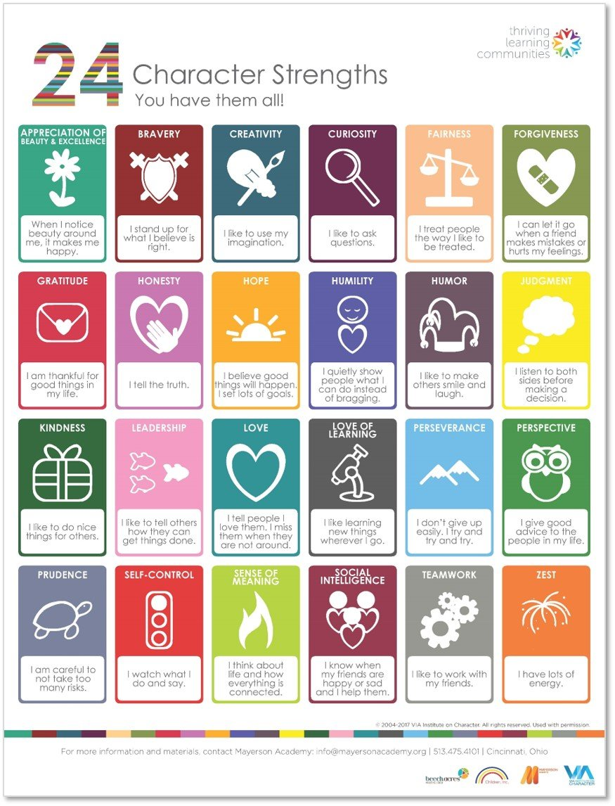

Molloy College
Division of Education

Student: Anthony Antonacci Professor: Kevin Sheehan
Course: EDU 3160
Date: 12/2/19
Grade: 12 Topic: U.S. Presidents Content Area: Social Studies

INSTRUCTIONAL OBJECTIVES (s) (Lesson Objective(s)*)
After debating on what character strengths make a good president, students will do read and retells of U.S. President John F. Kennedy, Abraham Lincoln, and Richard Nixon. Students will then work in groups and do a chart in which they connect those presidents with a specific character trait displayed on the chart.

New York State Social Studies Standards

Key Idea:

12.G1 FOUNDATIONS of AMERICAN DEMOCRACY: The principles of American democracy are reflected in the Constitution and the Bill of Rights and in the organization and actions of federal, state, and local government entities. The interpretation and application of American democratic principles continue to evolve and be debated.
Indicator: This will be evident when students do a “presidential characteristics” chart, in which they match a short paragraph about a certain president to a character trait.

Common Core ELA Standards

Key Idea:

WHST1: Write arguments focused on discipline-specific content.

Key Concept:
WHST1a: Introduce precise, knowledgeable claim(s), establish the significance of the claim(s), distinguish the claim(s) from alternate or opposing claims, and create an organization that logically sequences the claim(s), counterclaims, reasons, and evidence
Indicator:
This will be evident when students argue what character traits/strengths make an effective president.

INQUIRY ARC STANDARD: Dimension 1:
Dimension 1 of the arc features developing questions and the planning of investigations. With a robust question in mind, teachers and students determine the kind of content they need to create a plan to address their questions.

Indicator: This will be evident when students do the read and retell of presidential character strengths.

SOCIAL STUDIES SKILLS STANDARD: Gathering, Interpreting and Using Evidence:
2. Recognize and effectively select different forms of evidence used to make meaning in social studies (including primary and secondary sources such as art and photographs, artifacts, oral histories, maps, and graphs).
4. Identify arguments of others.

Indicator: This will be evident when students determine whether or not they would vote for a president based on character.

DEVELOPMENTAL PROCEDURES
(including Key Questions)
- Motivation: Students will talk about character strengths of people they know (this could be another student in the class, family member, etc.)
- AIM: “What character traits/strengths determine a good president?
- Students will do a “think pair-share” on which character traits determine a good president, and circle which traits they choose based on the “character strengths” sheet.
- Students, with their partner, will participate and tell which traits determine a good president in their opinion.
- Read and retell on Lincoln, J.F.K., and Richard Nixon handed out
- Students complete the read and retell with a partner
- Students will participate and give out what they wrote down for the read and retells
- Teacher will hand out the “Presidential character traits” chart.
- Students, if they choose to do so, will work with a partner to connect the quotation about a president with a character trait on the chart, and write in a few sentences, why they matched the president with the trait.
- Students will give their detailed responses from the chart.
- Debate: “based on what you learned, would you elect a president based on character traits?”
- Students will do an exit slip on what the most interesting thing they learned during the lesson was.

ASSESSMENT (artifacts* and assessment [formal & informal]*)
Informal: Teacher will monitor groups of students while they are talking and working together to do the read and retell, and to find out which character trait is related to which president
Teacher will monitor class to make sure they understand the lesson as it progresses.

Formal: Students will identify the character traits of the presidents in the presidential characteristics chart.

INSTRUCTIONAL STRATEGIES (Learning Strategies*)
Read and Retell: Students will do a read and retell on Lincoln, JFK, and Nixon.
Groups: students will work in groups to figure out which character trait is connected to which president
Debate: groups will debate whether they would elect a president or not based on character traits

INDEPENDENT PRACTICE
At home, will write a short paragraph on whether they would elect a president based on the character traits they learned about that certain presidents had.

References

American Government. “Presidential Character.” Retrieved from
https://www.ushistory.org/gov/7e.asp (Information for the character strengths sheet retrieved from this)

Character Strengths sheet
According to .ushistory.org, some common leadership qualities that good Presidents appear to have are the following:
- A strong vision for the country's future
- An ability to put their own times in the perspective of history
- Effective communication skills
- The courage to make unpopular decisions
- Crisis management skills
- Character and integrity
- Wise appointments
- An ability to work with Congress

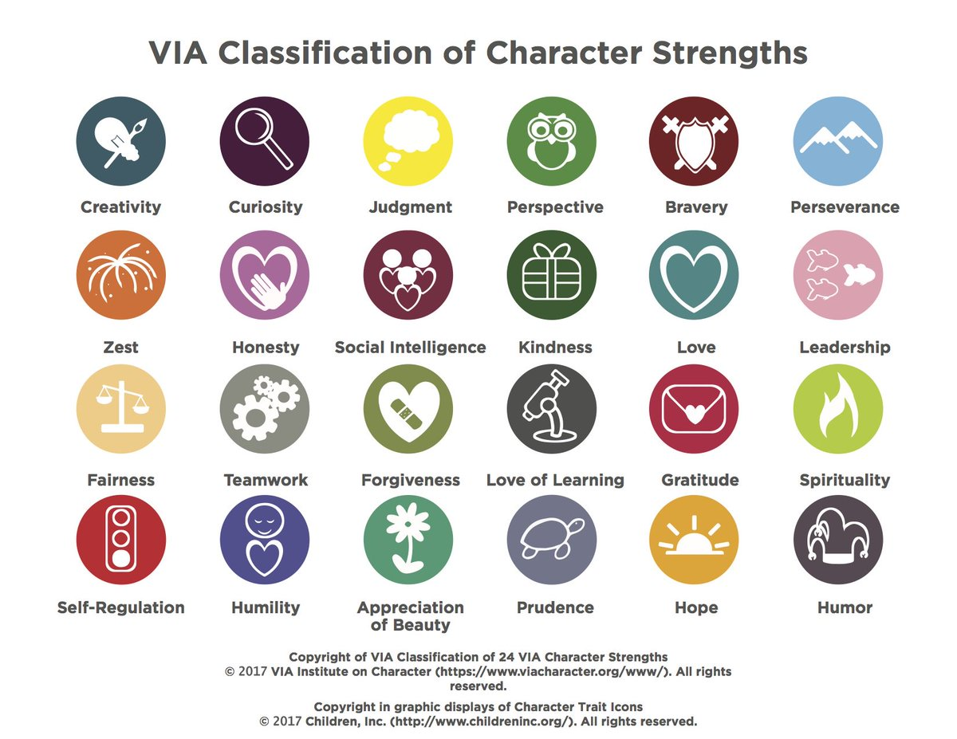

Name Date

Presidential Character Traits
Read and retell (read twice, and please do one paragraph at a time).
Instructor will read paragraphs, write down key words in lines below, with a partner, you will read the paragraph again, they will guess your key words. Writing key words will help you summarize the paragraph you are reading.

John F. Kennedy possessed a great deal of charisma. He was extremely ambitious and was willing to take risks to get what he wanted. This included ambitious goals such as landing on the moon, preventing nuclear war during the Cuban Missile Crisis, and boosting the economy. Kennedy was an outgoing and charming man who used his natural charisma to advance his political career. He was an excellent public speaker who focused on establishing an emotional connection with his audience and speaking positively at all times. His charisma often led him to believe that the normal rules didn't apply to him. Sometimes this confidence took him too far, as he would have affairs with other women despite being married.

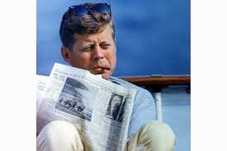

1. ­­________________________

2. __________________________
3. __________________________
4. ___________________________
5. _________________________
A known introvert, Richard Nixon liked to be alone. He rarely used the Oval Office, preferring his hideaway office, from time to time, he would write inspirational notes to himself, about the need for “joy in the job,” and “confidence. Nixon liked to play the role of a tough guy, and was a highly intelligent individual, believing in hard work and dedication. Himself an intellectual who read widely and deeply in political philosophy, who could be truly original in his thinking and who was drawn to intellectuals as advisers. Indeed Nixon practiced what he preached about hard work, attending Whittier College and Duke University, involved in student government for both, he became an attorney after college. After serving the Navy in World War II, he became a congressman, then a senator for California. Nixon then became Eisenhower's vice president, aiding him in many of his policies, running for president against Kennedy (but losing) in 1960, he did not give up, running again in 1968, and winning. Nixon continued his hard work in the White House, like ending the Vietnam war, creating the EPA and other environmental regulations, and opening relations with China after 20 years of hostilities. Nixon’s intelligence sometimes made him overconfident, believing he could get away with anything. As a result, his presidency came to an end in the watergate scandal, where he was accused of sending men to break into DNC offices. Overall, Nixon's hard work and dedication guided him in his life and presidency.

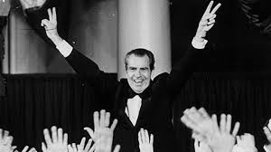

1. ­­________________________

2. __________________________
3. __________________________
4. ___________________________
5. _________________________

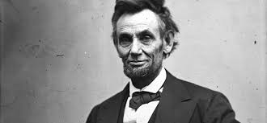

Commonly known as Honest Abe, Abraham Lincoln was a decent, kind, sensitive, compassionate, honest and empathetic. The former president has also been called guarded, patient, energetic and easy going, according to The Lincoln Institute. The man was considered simple, pure and sincere by many. A great, humble leader, Lincoln led the nation during the Civil War and accomplished abolishing slavery with the Emancipation Proclamation in 1863. Lincoln believed that all men were equal under the law and equally deserving of peace and happiness. Lincoln believed in all this, and set to achieve these goals despite dealing with a divided nation. President Obama said he would look up to Lincoln during his campaign, stating he was a “strong character, with leadership and honesty.”

1. ­­________________________

2. __________________________
3. __________________________
4. ___________________________
5. _________________________

Name: Date:
PRESIDENTIAL CHARACTER TRAITS CHART
Directions: On the chart below, you will have descriptions about the presidents we learned below. The presidents are not named, but rather numbered by their description, in the boxes; there are different character traits, (communication, perseverance, charisma, and intelligence.) Write which president you believe the description applies to, and then match that president/description with the character trait you believe best fits him. Under the character trait, explain why you chose that character trait for that specific president. You may apply for a president to more than one trait; just briefly explain why you did so.

Presidential Characteristics graph
 | Communication | Perseverance | Charisma | Intelligence
1. This president never lost sight of the necessity of keeping the United States as one nation, even when it was splitting apart. Always keeping strong character and honesty.

2. This president had an effective speaking voice, and a talent for expressing what he wished to accomplish. |  |  | .
3. This president, despite problems in presidency, had much intelligence and hard work that he used to move a nation forward.  4. This president had a good way of connecting with the American people through his speeches and actions. |  |  | .
 | .
 | .

Presidential Characteristics Essay
Name: Date:

Directions: In a short paragraph, explain why you would, or why you wouldn’t vote for a president based on the characteristics you learned about in class. You may use the read and retell to help write your paragraph.

Student: Emily Skupp
Professor: Dr. Sheehan
Course: EDU 3160 Date: 12/4/2019
Grade: 12 Topic: Government Content Area: Social Studies

Instructional Objective
After students have a discussion on what is leadership, students will read documents to determine what the text says explicitly and to make logical inferences from it; cite specific textual evidence when writing or speaking to support conclusions drawn from it and write arguments to support claims by doing a statement strategy and write an exit ticket stating what president they would vote for with 2 pieces of relevant evidence.

STANDARDS AND INDICATORS

NYSS Standards
Key Idea: 12.G1 FOUNDATIONS of AMERICAN DEMOCRACY: The principles of American democracy are reflected in the Constitution and the Bill of Rights and in the organization and actions of federal, state, and local government entities. The interpretation and application of American democratic principles continue to evolve and be debated.

Key Concept: 12.G1a Enlightenment ideas such as natural rights, the social contract, popular sovereignty, and representative government greatly influenced the framers of the Constitution and Bill of Rights.

Indicator: This will be evident when students complete the Statement Strategy about the
President’s accomplishments

CCSS ELA

Text Types and Purposes:
CCSS.ELA-LITERACY.W.11-12.1
Write arguments to support claims in an analysis of substantive topics or texts, using valid reasoning and relevant and sufficient evidence.
CCSS.ELA-LITERACY.W.11-12.1.A
Introduce precise, knowledgeable claim(s), establish the significance of the claim(s), distinguish the claim(s) from alternate or opposing claims, and create an organization that logically sequences claim(s), counterclaims, reasons, and evidence.
Indicator: This will be evident when students use relevant and sufficient evidence to complete the Statement Strategy and complete their exit ticket.

Key Ideas and Details:
CCSS.ELA-LITERACY.RI.11-12.1
Read closely to determine what the text says explicitly and to make logical inferences from it; cite specific textual evidence when writing or speaking to support conclusions drawn from the text.

Indicator: This will be evident when students cite strong evidence to support analysis in
the Statement Strategy and complete their exit ticket.

NCSS C3 Inquiry Arc
Dimension 3
Students will work toward conclusions about societal issues, trends, and events by collecting evidence and evaluating its usefulness in developing causal explanations.

Indicator: This will be evident when students work towards conclusions and collecting evidence
to complete the Statement Strategy and exit ticket.

Social Studies Practice: Habits of Minds Skills
A. Gathering, Interpreting and Using Evidence
2. Recognize and effectively select different forms of evidence used to make
meaning in social studies (including primary and secondary sources such as art and
photographs, artifacts, oral histories, maps, and graphs).

Indicator: This will be evident when students select different forms of evidence
complete the Statement Strategy and the exit ticket.

DEVELOPMENTAL PROCEDURES

- Students will begin the lesson by having a brainstorming whole class discussion about leadership. (What is a leader? (What Presidents did you learn about yesterday? (Literal) Who is a leader that you know? Do presidents always achieve their goals? (Inferential(Inferential) Why do you think that person is a leader? (Metacognitive)) ( 5 mins)

- Students will then be split up into groups of four and move to designated group areas in the room. (Do you know what group you are in? Do you know where your group is going?) (1 min)
- Students will then listen to the directions of the Statement Strategy (What is a statement strategy? (Literal) Why should we do a statement strategy? (Inferential)) (2 min)
- In the groups, students will work on and complete the statement strategy worksheet (What were the accomplishments? (Literal) Were they a strong leader or weak leader? (Inferential) Why were their actions important? (Metacognitive)) (25 mins)

- After completing the statement strategy, students will then independently complete an exit ticket. (What president would you vote for? (Literal) Why would you vote for this President? (Inferential)

- The teacher will then reveal who each of the candidates are to the students (Do you know who the presidents are? (Literal) Why is it important to know biographies about people who are running for president? (Inferential))

ASSESSMENT:

Informal Assessment: Students will complete the Statement Strategy Worksheet and cite evidence to support their answers. The teacher will also monitor the classroom while the students are working on the statement strategy worksheet to see if the students understand the information and task.

Formal Assessment: Students will complete an exit ticket stating what President they would vote for and cite 2 pieces of evidence why they would choose that President.

STRATEGIES:

Cooperative learning: engaging groups of students in working together on a structured activity

Indicator: This will be evident when students work in groups to complete the statement
strategy

Discussion: engaging in meaningful discussions about the content

Indicator: This will be evident when students partake in a brainstorm discussion about
leadership

Independent Work: any work students complete on their own to make a discovery or practice a new skill

Indicator: This will be evident when students complete their exit ticket.

INDEPENDENT PRACTICE

Homework: Students will research a President of their choice and create a Flipgrid explaining the accomplishments of the President .

REFERENCES

Friedel , F., & Sidey , H. (2006). Abraham Lincoln “The Presidents of the United States of
America.” Retrieved from
https://www.whitehouse.gov/about-the-white-house/presidents/abraham-lincoln/.

Friedel , F., & Sidey , H. (2006). Richard Nixon “The Presidents of the United States of
America.” Retrieved from
https://www.whitehouse.gov/about-the-white-house/presidents/richard-m-nixon/

JFK in History. (n.d.). Retrieved from https://www.jfklibrary.org/learn/about-jfk/jfk-in-history.

John F. Kennedy - Key Events. (2018, May 21). Retrieved from
https://millercenter.org/president/john-f-kennedy/key-events.

John F. Kennedy and People with Intellectual Disabilities. (n.d.). Retrieved from
https://www.jfklibrary.org/learn/about-jfk/jfk-in-history/john-f-kennedy-and-people-with-intellectual-disabilities.

Name:___________________ Date:___________

The Statement Strategy

Directions: For this activity, you will read three different biographies about three different Presidents (President A, President B, President C). After reading the passage, answer whether you agree or disagree with the statement written and provide evidence to support your choice.

President A

President A is from a famous political family. He went to Harvard University, but soon joined the Navy soon after. During battle, he survived a sunken ship and swam to safety, however sustained a war-aggravated spinal injury. During his presidency, there were turbulent times for the United States and the world. There were significant events and challenges during this time period that defined his administration.
In October of 1962, Candidate A successfully negotiated a peaceful resolution of the Cuban Missile Crisis and avoided a nuclear war from the tensions of the Cold War. He made a negotiation with Soviet Union. to have them remove their missiles from Cuba while the US removed their missiles from Turkey.
One of President A’s biggest accomplishments was signing into law the Maternal and Child Health and Mental Retardation Planning Amendment to the Social Security Act. This was the first major legislation to combat mental illness and intellectual disabilities. This legislation provided support and funding for people with these disabilities. The bill also increased funding to train teachers of children with disabilities.

Statement: Candidate A was able to peacefully negotiate the Cuban Missile Crisis
Agree____ Disagre____

Evidence: _______________________________________________________________________________________________________________________________________________________________________________________________________________________________________________________________________________________________________________________________________________

Statement: Candidate A was a big supporter of the mental and physical health of the American people.
Agree____ Disagre____

Evidence: _______________________________________________________________________________________________________________________________________________________________________________________________________________________________________________________________________________________________________________________________________________

President B

President B has a background in politics as he served as a U.S. Representative and U.S. Senator from California, as well as Vice President. During World War II, he served as a Navy lieutenant commander in the Pacific. He also went to Whittier College and Duke University Law School before beginning the practice of law.
His accomplishments while in office included revenue sharing, the end of the draft, new anti crime laws, and a broad environmental program. Some of his most acclaimed achievements came in his quest for world stability. He successfully ended American fighting in Vietnam and improved international relations with the U.S.S.R. and China.
During his presidency, he reduced tensions with China and the U.S.S.R. His summit meetings with Russian leader Leonid I. Brezhnev produced a treaty to limit strategic nuclear weapons.

Statement: President B did not have a political background before running for president.
Agree____ Disagre____

Evidence: _______________________________________________________________________________________________________________________________________________________________________________________________________________________________________________________________________________________________________________________________________________

Statement: President B had many accomplishments in improving world stability
Agree____ Disagre____

Evidence: _______________________________________________________________________________________________________________________________________________________________________________________________________________________________________________________________________________________________________________________________________________

President C

President C was the son of a Kentucky frontiersman, and had to struggle for a living and for learning. He was a captain in the Black Hawk War, spent eight years in the Illinois legislature, and rode the circuit of courts for many years.
As President, he built the Republican Party into a strong national organization. Further, he rallied most of the northern Democrats to the Union cause. One of his biggest accomplishments in office was issuing the Emancipation Proclamation that declared forever free those slaves within the Confederacy.
He successfully ended the Civil War rejoining the Union and the Confederacy avoiding the fall of the United States. In his planning for peace, the President was flexible and generous, encouraging Southerners to lay down their arms and join speedily in reunion instead of being harsh and reprimanding them for seceding.

Statement: President C had an easy life growing up.
Agree____ Disagre_____

Evidence: _______________________________________________________________________________________________________________________________________________________________________________________________________________________________________________________________________________________________________________________________________________

Statement: President C was harsh on the southerners who tried returning to the Union.
Agree____ Disagre____

Evidence: _______________________________________________________________________________________________________________________________________________________________________________________________________________________________________________________________________________________________________________________________________________

Name:________________ Date:_________

VOters Ballot
Directions: In the space below, vote for which president you would want to win in an election and explain why you voted for the President you chose. Please provide 2 pieces of relevant evidence.

President A ____ President B ____ President C _____

__________________________________________________________________________________________________________________________________________________________________________________________________________________________________________________________________________________________________________________________________________________________________________________________________________________________________________________________________________________________________________________________________________________________________________________________________________________________________________________________________________________________________________________________________________________________

Molloy College
School of Education

Student: Nolan Kelly Date: 12/4/19
Professor: Dr. Sheehan Content Area: Social Studies
Course: EDU 3340
Topic: History Mystery – Is a great leader determined by their policy or their character?

STANDARDS AND INDICATORS

12.G5a Each level of government has its own process of shaping, implementing, amending, and enforcing of public policy. Customarily, the executive branch will outline it’s plan and agenda in an executive address to the legislative body.
12.G5d: Active and engaged citizens must be effective media consumers in order to be able to find, monitor, and evaluate information on political issues. The media have different venues, which have particular strengths and serve distinct and shared purposes. Knowing how to critically evaluate a media source is fundamental to being an informed citizen.
WHST2b: Analyze a topic thoroughly by selecting the most significant and relevant facts, data, extended definitions, concrete details, citations, or other information and examples appropriate to the audience’s knowledge of the topic.
Indicators: This will be evident when students are to analyze the primary and secondary sources about policy and character for each president and determining what sources are most credible and what sources are least credible.

INSTRUCTIONAL OBJECTIVE(S)

After analyzing excerpts from primary source documents and taking part in a History Mystery, students will draw evidence from the documents provided in order to analyze if character or policies mold a great leader. Students will also source these documents from most to least credible. Groups will present their findings to the class with at least 80% accuracy.

DEVELOPMENTAL PROCEDURES

1. Motivation: In a restorative circle, based off knowledge from the previous lessons, the teacher will ask the question, “What makes a great president, their policies or their character?” Students will then individually be asked to respond to this question with their own opinions.
2. After each student provides their own opinion, the teacher will then divide the class into groups and will provide a large history mystery poster. (depending on class size can be split up however the teacher wants)
3. On each the poster there will be a picture each president (JFK, Lincoln or Nixon) and students will be provided primary and secondary sources for each president.
4. As a group, the students will then analyze and interpret each primary and secondary source and categorize each source from most credible to least credible for each president. (Which source is helpful/not helpful? Which source is accurate/inaccurate?)
5. After the students complete the poster, the students will then determine as a group whether or not the policy of each president is what made them a great leader, or if the characteristics of each president made them a great leader. (Create a well-developed argument for their cases)
6. Each group will then present their case for each president, explain why they organized their sources the way they did, and provide evidence for their response to the question “Does character or policy make a great president”. (Important to make sure every student in the group has a voice when making their case)
7. At the end of the lesson, the teacher will then ask the students to reflect on the restorative circle activity and their opinions in order for the students to determine if their opinions changed or if they stayed the same.

INSTRUCTIONAL STRATEGIES
Cooperative Learning: engaging groups of students to work together on a structured activity.
Indicator: This will be evident when students are asked to group up and work together on the history mystery poster.
Discussion:engaging in meaningful discussions about the content
Indicator:This will be evident when the students are asked to present their case to the class on whether policy or character makes a great president.

INSTRUCTIONAL RESOURCES AND MATERIALS
- History Mystery poster
- Primary/secondary sources
- Tape/glue

Reference

Molloy College
Division of Education

Student Robert Ojeda Professor Kevin Sheehan
Course EDU 3160 Date 12/2/2019
Grade 12 Topic: Debate! Great people or great ideas? Content Area Social Studies

INSTRUCTIONAL OBJECTIVE

After [BLANK], students will begin to prepare for a 2 day lesson revolving around a class debate. Five students will take the roles of candidates running for President of the United States, and the rest of their peers will formulate questions to ask them during a debate. At the end of the activity, students will vote for their preferred candidate. Students will be able to justify the reasoning behind why they voted for their candidate in an in class discussion and a post class reflection essay.

STANDARDS AND INDICATORS

New York State Social Studies Standards

Key Idea:

12.G1 FOUNDATIONS of AMERICAN DEMOCRACY: The principles of American democracy are reflected in the Constitution and the Bill of Rights and in the organization and actions of federal, state, and local government entities. The interpretation and application of American democratic principles continue to evolve and be debated.

Indicator: This will be evident when students determine whether character traits or accomplishments determine the greatness of a president.

Common Core ELA Standards

Key Idea:

WHST1: Write arguments focused on discipline-specific content.

Key Concept:
WHST1a: Introduce precise, knowledgeable claim(s), establish the significance of the claim(s), distinguish the claim(s) from alternate or opposing claims, and create an organization that logically sequences the claim(s), counterclaims, reasons, and evidence.

Indicator: This will be evident when students establish their debate questions and are able to respond to the questions of their peers.

NCSS C3 Inquiry Arc
Dimension 4:
Students will draw on knowledge and skills to work individually and collaboratively to
conclude their investigations into societal issues, trends, and events and will present their
information, portions and findings

Indicator: This will be evident through the students’ preparation for the debate of character or policy that determines a good leader.

Social Studies Practices: Habits of Mind
A. Gathering, Interpreting, and Using Evidence

Indicator: This will be evident when students interpret the policy and character of the candidates and cast their votes at the end of the debate.

DEVELOPMENTAL PROCEDURES (*Engaging the learner)

Day 1
- MOTIVATION: Students will be informed that the class will be preparing and participating in an election for the next two days.

- Five students will be selected to play the role of one of the three Presidents discussed throughout the unit. John F. Kennedy, Richard Nixon and Abraham Lincoln, Donald Trump and Barack Obama.

- The rest of the students will be told that they are serving as the role of both interviewers and voters in the upcoming election, and will be presenting questions to the candidates.

- The teacher will model for students how to perform research using school databases and other helpful resources. (Literal) Why do we not just use Google to perform research?
- For the remainder of the class period, students will begin researching information. Candidates will begin researching their role’s policy and character traits, completing the information sheet provided.
- Students will complete an exit ticket at the end of class. Interviewers will write down the question they have crafted for the debate. Candidates will write down one character trait, and whether they believe it will have a positive or negative effect on their chances of winning the election.
Day 2
- The desks in the classroom will be set up in a half circle facing 5 desks in the middle of the room where the Candidates will be sitting.
- The debate begins! Interviewers will begin asking their prewritten questions for the Candidates to answer and discuss.
- After each student has asked their prepared question, the election will begin. Students, including the Candidates, will be handed a note card and asked to write in who they would elect as President of the United States.
- After all the votes are accounted for, the teacher will announce the results of the election, declaring on of the candidates the new President of the United States. (Inferential) Before I announce the winner, based on our candidates’ performance, who do you think won the election?
- Following the results of the election, a class discussion will be held to reflect upon what was learned during the lesson. (Inferential) Are you happy with the result of the election? (Inferential) What made you select the candidate you voted for? Was the candidates’ character traits, or policy more important for you? (Metacognitive) Why do you think X won the election?

ASSESSMENT (formal & informal)

Informal assessment

Exit Slip

Formal assessment

Essay Reflection

INSTRUCTIONAL STRATEGIES

Scaffolding
Indicator: This will be evident when the teacher is teaching students how to properly research their candidates before allowing them to independently do so.

Research
Indicator: This will be evident when students collect information about their candidate or to form their questions prior to the debate.

Group discussion
Indicator: This will be evident when the class begins the debate.

INDEPENDENT PRACTICE

At the conclusion of the lesson, students will be assigned an essay where they reflect on the debate in class. In the essay, students will be expected to explain why they voted for the candidate they chose in class and if they based their vote more on the candidate’s character traits or their policy decisions.

INSTRUCTIONAL RESOURCES AND MATERIALS

Candidate Information Sheet
School provided laptops
School databases

Name:____________________ Date _____

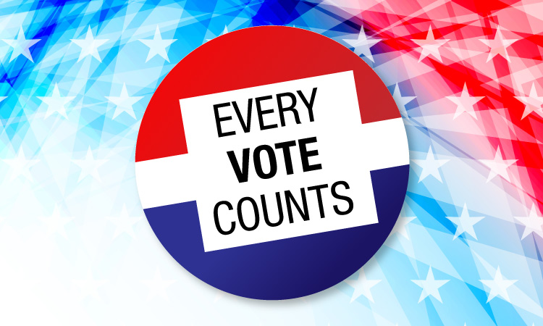
Candidate Information Sheet
Directions: Fill out this information sheet so you are prepared for tomorrow's debate!

Name of Candidate: _____________________

- Character Traits of Candidate:

______________________________________________________________________________________________________________________________________________________________________________________________________________________________
- Significant Policy Decisions of Candidate:
______________________________________________________________________________________________________________________________________________________________________________________________________________________________
- Would you vote for this Candidate? Why, or why not?
______________________________________________________________________________________________________________________________________________________________________________________________________________________________

CRQ

Analyze the documents and answer the short-answer questions that follow each document in the space provided.
President Kennedy spent less than three years in the White House. His first year was a disaster, as he himself acknowledged. The Bay of Pigs invasion of Communist Cuba was only the first in a series of failed efforts to undo Fidel Castro’s regime. His 1961 summit meeting in Vienna with the Soviet leader Nikita Khrushchev was a humiliating experience. Most of his legislative proposals died on Capitol Hill.
In shaping his legend, Kennedy’s personal charm helped. A witty and articulate speaker, he seemed built for the age of television. To watch him on film today is to be struck by the power of his presence and the wit and elegance of his oratory. His celebrated inaugural address was filled with phrases that seemed designed to be carved in stone, as many of them have been. Borrowing a motto from his prep-school days, putting your country in place of Choate, he exhorted Americans: “Ask not what your country can do for you—ask what you can do for your country.”
Document 1
Source: Alan Brinkley, The Atlantic

- Who wrote this article and why did they write it? ________________________________________________________________________________________________________________________________________________________________________________________________________________________________________________________________________________________________________________________________________________________________________________________________________________________________________________________________________________________________________________________

Document 2
In 1982, forty-nine historians and political scientists were asked by the Chicago Tribune to rate all the Presidents through Jimmy Carter in five categories: leadership qualities, accomplishments/crisis management, political skills, appointments, and character/integrity. At the top of the list stood Abraham Lincoln. He was followed by Franklin Roosevelt, George Washington, Theodore Roosevelt, Thomas Jefferson, Andrew Jackson, Woodrow Wilson, and Harry Truman. None of these other Presidents exceeded Lincoln in any category according to the rate scale. Roosevelt fell into second place because he did not measure up to Lincoln in character. Washington, close behind, ranked third because of his lesser political skills. It is the general opinion of pollsters, moreover, that the average American would probably put Lincoln at the top as well. In other words, the judgment of historians and the public tells us that Abraham Lincoln was the nation's greatest President by every measure applied. Interestingly, had the average Union citizen been asked the same question in the spring of 1863, there can be no doubt but that Lincoln would have fared poorly. Not much more could have been said for him even a year later, when Lincoln thought that he would lose his bid for reelection. It would take Lee's surrender at Appomattox Courthouse and his own death a week later to propel Lincoln into the pantheon of presidential greatness.

Source: Michael Burlingame, Millercenter.org

- Who wrote this article and what are they trying to prove?
______________________________________________________________________________________________________________________________________________________________________________________________________________________________________________________________________________________________________________________________________________________________________________________________________

Document 3

- More Americans are now employed than ever recorded before in our history.
- We have created more than 400,000 manufacturing jobs since my election.
- Manufacturing jobs growing at the fastest rate in more than THREE DECADES.
- Economic growth last quarter hit 4.2 percent.
- New unemployment claims recently hit a 49-year low.
- Median household income has hit highest level ever recorded.
- African-American unemployment has recently achieved the lowest rate ever recorded.
- Hispanic-American unemployment is at the lowest rate ever recorded.
- Asian-American unemployment recently achieved the lowest rate ever recorded.
- Women’s unemployment recently reached the lowest rate in 65 years.
- Youth unemployment has recently hit the lowest rate in nearly half a century.
- Lowest unemployment rate ever recorded for Americans without a high school diploma.

Source: The White House

- Who wrote this article and what does it set out to prove?

______________________________________________________________________________________________________________________________________________________________________________________________________________________________________________________________________________________________________________________________________________________________________________________________________

Base your answer to question 4 on documents 1, 2, and 3 and on your knowledge of social studies.

Cause - Refers to something that contributes to the occurence of an event, the rise of an idea, or the bringing about of a development.

Effect - Refers to what happens as a consequence (result, impact, outcome) of an event, an idea, or a development.

- Identify and explain how the cause-and-effect relationship associated with the events or ideas in documents 1, 2, and 3. Analyze if it is in fact policy or character that makes a good president.

_________________________________________________________________________________________________________________________________________________________________________________________________________________________________________

