Molloy College
Division of Education
Annmarie Sivert and Lauren Czarnecki Dr. K. Sheehan
EDU 3510 01 March 10, 2020
Grade: 5 Topic: Meeting of the Minds Social Studies

Instructional Objective(s) (Lesson Objective*)
After watching a time traveling video and participating in a statement strategy, students will present information, findings, and supporting evidence such that listeners can follow the line of reasoning, and the organization, development, and style are appropriate to task, purpose, and audience by engaging in a Meeting of the Minds about events that shaped Mexico’s history and national character. Students will make an accurate, relevant picture profile conveying the historical position of a person in Mexican history.
NYS Standards and Indicators
Key Idea and Key Concept:
5.5 Comparative Cultures: The countries of the Western Hemisphere are diverse and the cultures of these countries are rich and varied. Due to their proximity to each other, the countries of the Western Hemisphere share some of the same concerns and issues. (Standards: 1, 2; Themes: ID, MOV, SOC)

5.5a The countries of the Western Hemisphere have varied characteristics and contributions that distinguish them from other countries.

Indicator: This will be evident when students gather information from their documents about their assigned individual. Students will share their findings through a “Meetings of the Minds” activity.

Common Core ELA Standards
Comprehension and Collaboration
4. Present information, findings, and supporting evidence such that listeners can follow the line of reasoning, and the organization, development, and style are appropriate to task, purpose, and audience.

Indicator: This will be evident when students present information, findings, and supporting evidence to their groups about their assigned regions.

New York State Next Generation English Language Arts Learning Standards
Key Ideas and Details
5R2: Determine a theme or central idea and explain how it is supported by key details; summarize a text. (RI&RL)
Indicator: This will be evident when the students find the main idea and explain how it is supported by key details.
Speaking and Listening
5SL2: Summarize information presented in diverse format.
Indicator: This will be evident when students take the information given and decide which events shaped Mexico’s history and national character.
NCSS Inquiry Standards

Dimension 3: Students will work toward conclusions about societal issues, trends, and events by collecting evidence and evaluating its usefulness in developing causal explanations.

Indicator: This will be evident when students evaluate the usefulness of evidence in the creating their character for the Meeting of the Minds.

Dimension 4: Students will draw on knowledge and skills to work individually and collaboratively to conclude their investigations into societal issues, trends, and events and will present their information, portions and findings.

Indicator: This will be evident when students work collaboratively to present their information, portions and findings by engaging in the Meeting of the Minds activity.

Social Studies Habits of Mind: (There are six major skills, which defines your lesson best)
Gathering, Interpreting, and Using Evidence
- Develop questions to help identify evidence about topics related to the historical events occurring in the Western Hemisphere that can be answered by gathering, interpreting, and using evidence.

Indicator: This will be evident when students gather, interpret, and use evidence to develop a sound argument as to whether their countries could live in peace and work together and when students write their own essay using the information they gathered as evidence to support their claim.
Developmental Procedures
- Motivation:
The teacher will play the time traveling for the class, where we say we want to go back in time and explore. The teachers will say we will go back into the past and learn about Mexico’s historical figures (five minutes). (Does anyone want to go time traveling? Where would you like to time travel to? What do we know already about Mexico’s history?)
- The students will be put into four groups. Each group will be given one biography about one of the four historical figures that will be discussed. In addition, the students will be provided with the “Historical Figure Question Sheet,” as a guide to their discussions. They will gain knowledge and understand the figure (15 minutes). (Who is the person? How were they brought up? Where are they from? How did they contribute to Mexico’s history? What was important about this person? How did these people impact Mexico? Was it positive, was it negative?)
- The students will then, in their jigsaw groups, where each person in the group was assigned with a different person. The students will then share more information about the people they were assigned to. This will allow for each child to learn from each other and gain a better understanding of the figures (10 minutes). (Who is your historical figure? How were they brought up? What are they best known for? Did they have a positive or negative impact on Mexico, why? What is something different that the historical figure could have done?)
- The teachers will then hand out the “Mexico’s Historical Figure Profile” and have the students make a profile. Each student will make the profile using the original historical figure that they were given. The teacher will also give out different pictures to each group. As a group they will decide what picture to use, that best depicts the historical figure. Once they pick a photo then the students will make a caption that supports the picture (fifteen minutes). (What type of person was the historical figure? Was he kind, or mean? Did he care about others? What does this picture show?What perspective are these pictures being viewed as? What did the people of Mexico think of him?)
- After completing the profiles, the groups will do a presentation on the historical figures for the class. The students will explain why they chose each picture (ten minutes). (Why did you use that picture? What does it show? Was he a good person? Did he positively or negatively impact Mexico? In what perspective are you looking at? Is there a perspective that would make you think differently? How can you tell? What could have been done differently?)
Closure:
Ask the students what they learned and ask the following key questions (Who were these historical figures? What did they believe in, what were their views? Who would most likely be allies? Why were these people considered historic? What did they do for Mexico? Do different people have different perspectives on him? How have these people affected Mexico today? Was it positive? Was he negative? If these historical figures were not around, what would Mexico be like today? Would Mexico be different?). Also, have the students raise their hands and rate how they feel about this lesson. The thumbs up means they understand, thumbs down means they need some more help and when they put their thumb on the side/middle that means they need a little more practice but they are going to get it (five minutes).
Assessment (artifacts and assessment [formal & informal]*)
- Students will be able to discuss in small groups and come to an understanding of what their historical figures are about.
- Students will be able to decipher the different historical figures and what they believe.
- Students will be using collaboration and communication to be able to follow through with the meeting of the minds activity.
- Students will pick a photo that depicts the actions that were taken by the historical figure on their profile. The students will be able to explain why they chose each picture.

References
King Charles V. (n.d.). Retrieved from https://kids.britannica.com/students/article/Charles -V/273608
National Council for Social Studies. (2010). National Curriculum Standards for Social Studies: Chapter 2 - The Themes of Social Studies. Retrieved from https://www.socialstudies.org/standards/strands
New York State Education Department. (2017). New York State Next Generation English Language Arts Learning Standards. Retrieve March 20, 2020, from http://www.nysed.gov/common/nysed/files/programs/curriculum-instruction/nys-next-generation-ela-standards.pdf.
New York State Education Department. (2016). New York State K-12 Social Studies Framework. Retrieved from http://www.p12.nysed.gov/ciai/socst/documents/ss-framework-k-8a2.pdf
Teaching Resources & Lesson Plans. (2020). Retrieved March 23, 2020, from https://www.teacherspayteachers.com/?gclid=EAIaIQobChMI9sC-1syx6AIVFGKGCh2_LgPKEAAYASAAEgKht_D_BwE
The Editors of Encyclopaedia Britannica. “Miguel Hidalgo y Costilla.” Encyclopædia Britannica, Encyclopædia Britannica, Inc., 19 Mar. 2020, www.britannica.com/biography/Miguel-Hidalgo-y-Costilla.
Name: _____________________________________ playing as the role of . Miguel Hidalgo y Costilla
Miguel Hidalgo y Costilla
MEXICAN LEADER
Miguel Hidalgo y Costilla, (born May 8, 1753, Corralejo, near Guanajuato, Mexico—died July 30, 1811, Chihuahua), Roman Catholic priest and revolutionary leader who is called the father of Mexican independence.
Hidalgo was the second child born to Cristóbal Hidalgo and his wife. He studied at a Jesuit secondary school, received a bachelor’s degree in theology and philosophy in 1773 from San Nicolás College (now Michoacán University of San Nicolás de Hidalgo) in Valladolid (now Morelia), and was ordained a priest in 1778. He had an uneventful early career, but in 1803 Hidalgo assumed his recently deceased elder brother’s duties as parish priest in Dolores (now Dolores Hidalgo, Guanajuato state). His interest in the economic advancement of his parishioners—for example, through the introduction of newer methods of agriculture—and his political convictions regarding the oppression of the people by the Spanish authorities caused the latter to regard him with suspicion.
In 1808 Spain was invaded by French troops, and Napoleon I forced the abdication of King Ferdinand VII in favour of the French emperor’s brother Joseph Bonaparte. Though Spanish officials in Mexico were loath to oppose the new king, many Mexicans formed secret societies—some supporting Ferdinand, others advocating independence from Spain. Hidalgo belonged to a pro-independence group in San Miguel (now San Miguel de Allende), near Dolores. When the plot was betrayed to the Spanish, several members were arrested. Warned to flee, Hidalgo decided instead to act promptly. On September 16, 1810, he rang the church bell in Dolores to call his parishioners to an announcement of revolution against the Spanish. His speech was not only an encouragement to revolt but a cry for racial equality and the redistribution of land. It became known as the Grito de Dolores (“Cry of Dolores”).
What he began in San Miguel as a movement for independence became a social and economic war of the masses against the upper classes. Joined by thousands of Indians and mestizos, Hidalgo marched forth from Dolores under the banner of Our Lady of Guadalupe. With his followers he captured the city of Guanajuato and other major cities west of Mexico City. Soon Hidalgo was at the gates of the capital, but he hesitated, and the opportunity was lost. His followers melted away. Royalists as well as other elements in Mexico were frightened by the prospect of social upheaval and supported the suppression of the rebellion. After his defeat at Calderón Bridge, outside Guadalajara, on January 17, 1811, Hidalgo fled north, hoping to escape into the United States. He was caught, expelled from the priesthood, and executed by firing squad as a rebel.
Though his accomplishments were not lasting ones, Hidalgo’s name became the symbol of the independence movement for most Mexicans. September 16, the anniversary of the Grito de Dolores, is now celebrated as Mexico’s Independence Day.

Name: ___________________________________ playing the role of Charles V

Charles V
Seven rulers of the Holy Roman Empire were named Charles. The first was Charlemagne, the founder of the empire, whose name means “Charles the Great.” Of the other six, Charles V is especially notable for his widespread holdings and eventful reign.
Charles’s territories stretched across most of Europe—except for England, France, and Russia—and into the Americas. For decades he defended them tirelessly. Yet at 56 he voluntarily gave up his vast realm and retired to spend his last days in a Spanish monastery.
Charles was born on February 24, 1500, at Ghent in the Netherlands (now Belgium). His father was Philip of Hapsburg, whose own father was Maximilian, archduke of Austria and Holy Roman emperor. Charles’s mother was Joan the Mad, daughter of Ferdinand and Isabella, king and queen of Spain. Charles was raised in the Netherlands. His father died in 1506, bequeathing to him the kingdoms of Castile (in Spain) and the Netherlands. With the death of his grandfather Ferdinand 10 years later, Charles gained control of the rest of Spain—and of Spain’s colonies in the New World—as Charles I. He also became king of Sicily and Naples (in Italy). In 1517 he went to Spain for the first time to set up a court at Valladolid. In 1519 his grandfather Maximilian died, leaving him the German Hapsburg realms. Shortly afterward, in a vote of nobles, he was elected Holy Roman emperor as well, though he was not actually crowned until later.
Charles’s chief rival for power in Europe was Francis I of France, who had wanted to be emperor himself. The French king claimed Charles’s possessions in Italy. Between 1522 and 1544, Spanish armies defeated French forces three times before Francis gave up his claim.
Muslim forces posed another threat. The armies of Süleyman the Magnificent, sultan of the Ottoman Turks, pressed up the Danube River into central Europe. Charles led a defense of Vienna in 1532. He later sailed to northern Africa to fight the Muslim pirates who raided his coast towns in Spain and Italy.
Across the Atlantic Ocean, Charles’s Spanish armies were conquering the rich empires of Mexico and Peru. In the 1550s, late in Charles’s reign, gold and silver were brought back from the New World in large quantities. (See also Americas, early exploration of the.)
Charles was a devoted Roman Catholic. However, he was unable to stop the great religious and social revolution, called the Reformation, that was started by the German monk Martin Luther. Luther’s efforts to reform the Catholic church led to the establishment of Protestant forms of Christianity, including Lutheranism. Charles defeated a group of Protestant princes at Mühlberg in April 1547. Nevertheless, only eight years later he was forced to allow the Peace of Augsburg, which acknowledged the legitimacy of Lutheranism within the Holy Roman Empire.
Charles had great military skill, which he demonstrated in both land warfare and naval expeditions. He also had great courage. Once when his aides rebuked him for exposing himself to danger, he replied, “We were short of men, and I could not set a bad example.”
In intervals of peace, he turned to forming alliances through royal marriages in order to stabilize his realm. He married Isabella, the daughter of the king of Portugal. He also arranged for his sister Mary to marry the king of Hungary, his brother Ferdinand to marry the sister of the Hungarian king, and his son Philip to marry the English queen Mary I. The last marriage failed to further Charles’s cause as the English Parliament refused to crown a Catholic king.
Tired by his long and tumultuous reign, Charles resigned in 1555 and 1556, dividing his realm between his son Philip and his brother Ferdinand. Charles kept the title of Holy Roman emperor until his death but did not use its power. He retired to a small home adjoining St. Jerome’s monastery at Yuste, where he died on September 21, 1558.

Name: _______________________________ playing the role of Davy Crockett

Davy Crockett

Considered a hero in the battle for Texas independence at the Alamo, David (Davy) Crockett was born on August 17, 1786 to a pioneer family living along the Nolichucky River in east Tennessee. He was the fifth of nine children. His family, which was common for pioneer families, moved three times by the time Davy was twelve years old. His father taught him to shoot a rifle at the age of 8 and he often went with his older brothers on hunting trips. At the age of 13, his father insisted he enroll in school. After a few days in attendance, Crockett fought the class bully and was afraid to return to school. Rather than face the possibility of punishment, he ran away from home and spent more than two years wandering and improving his skills as a woodsman. By the age of 16, he returned home to help his father and just a few days before he turned 20, he married Mary Finley. They had two children before she died and he later married Elizabeth Patton with whom he had two children as well.
Davy Crockett fought in the war of 1812 and upon returning home to his family in Tennessee, he became a member of the Tennessee State House of Representatives. During this time, he developed a reputation as a frontiersman, or a person who lives or works on a frontier. While he was a skilled woodsman, many stories of Crockett are exaggerated causing him to become a folk legend. Some believe the exaggerated stories were created to win him votes in elections. He served in various areas of the government from 1821-1835.
After he was defeated in 1835, he decided to move his family to Texas and the following year, he swore his allegiance to Texas. In 1836, he joined in the fight for the Texas war for independence. At the time, Texas was governed by Mexico and settlers wanted their freedom.
March 6, 1836, Davy Crockett died defending the Alamo. Details of his death are unknown however, there is one account that was written by Susanna Dickinson. She was the wife of Almaron Dickinson, an officer at the Alamo. Her life was spared because she was a woman. She said that Crockett died, at the age of 49, on the outside of the Alamo and was one of the last men to fall.
It is also believed that Davy Crockett was all over the Alamo during the battle encouraging soldiers to “do their duty”. Some believe he was responsible for killing five Mexican gunners in succession, or one after another, as they attempted to fire a cannon on the fort. Crockett and five or six others were captured at about 6 o’clock in the morning even though Santa Anna had ordered no prisoners be taken. These soldiers were executed immediately.
Davy Crockett has been honored in numerous ways. In 1831, a play, “The Lion of the West” was written using Davy Crockett as a model for the main character. Books about his life have been written including, Life and Adventures of Colonel David Crockett of West Tennessee. In Ozona, Texas a museum is dedicated to his memory and his birth place in Tennessee is now a state park. The city of Crockett, Texas, a site where he camped on his way to the Alamo, is named after him.
Davy Crockett, also known as “King of the Wild Frontier” lived by this motto which captures his spirit beautifully, “Be always sure you are right, then go ahead.”

Name:_______________________________ playing the role of Hernan Cortes

Hernan Cortes

EARLY LIFE:
Hernan Cortes was born in 1485 in Medellin, Spain. Even though most people refer to him as Hernan today, he was actually known as Hernando or Fernando most of his life. His father was a captain in the Spanish army and their family was fairly famous. Hernan’s parents wanted him to become a lawyer so they sent him to school to study when he was 14. However, Cortes had no interest in becoming a lawyer and returned home at age 16. Cortes learned about Christopher Columbus’ discoveries in the New World, sparking a desire to travel, see new lands, make a fortune, and become famous.
NEW WORLD:
In 1504 Cortes sailed to the New World, arriving on the island of Hispaniola in the city of Santo Domingo. He became a notary and made a name for himself on the island over the next five years. Cortes joined Diego Velazquez on an expedition to Cuba in 1511. Velazquez conquered Cuba and became the governor. He liked Cortes and helped him rise in the government ranks. Cortes became a powerful and wealthy figure in Cuba before long.
MEXICO:
Cortes was put in charge of an expedition to the mainland of Mexico in 1518, something he had desired for many years. However, Governor Velazquez became worried Cortes would become too powerful and ordered him not to sail. Cortes disobeyed him though and set sail anyway. AZTECS
In April of 1519, Cortes and his men landed at the Yucatan Peninsula of Mexico. They had 11 ships, about 500 men, horses, and cannons. Cortes met a native woman named Dona Marina, La Malinche, who spoke the Nahuatl language of the Aztecs, so she helped interpret for Cortes. The Aztecs were rumored to have gold and treasures so Cortes wanted to conquer them and take the treasures for Spain. Cortes requested a meeting with Montezuma II, the Aztec Emperor, but was repeatedly turned down. Cortes took matters into his own hands and marched to Tenochtitlan, the Aztec capital. Cortes started to march to Tenochtitlan with a small force of 500 men. He met with other cities and people along the way, learning that a number of other tribes were not happy with their Aztec rulers. He formed alliances with them, including the powerful Tlaxcala people, throughout his three month journey.
MONTEZUMA II:
On November 8, 1519, Cortes arrived at Tenochtitlan, where he was welcomed by the Aztec Emperor Montezuma II. Even though Montezuma was distrustful, he felt there may be a chance Cortes was the god Quetzalcoatl in human form. Montezuma gave Cortes and his men gifts of gold hoping it would prevent them from taking over the city. Unfortunately it had the opposite effect, making Cortes hungry for more. Montezuma was taken captive by Cortes in Tenochtitlan. Governor Velasquez from Cuba had sent another expedition under conquistador Panfilo de Narvaez to take command from Cortes though. This took Cortes away from Tenochtitlan to fight Narvaez, and when he returned he discovered his men had killed Montezuma. Cortes chose to flee the city on June 30, 1520. Many of his men joined him, but ended up dying. The night of their escape is known as La Noche Triste, or “The Sad Night.”
CONQUERING THE AZTECS:
Cortes quickly returned to Tenochtitlan with a large army of his allies, including the Tlaxcala. After a three month siege of the city, eventually conquering it and the Aztec Empire. GOVERNOR
Cortes renamed Tenochtitlan as Mexico City, after conquering the Aztecs. The city became the capital of the Spanish territory named New Spain. King Charles I of Spain named Cortes as governor of the land.
DEATH:
Cortes fell out of the King of Spain’s favor and was forced to return to Spain to defend himself. Cortes returned to Mexico with greatly reduced powers in 1530. He continued to explore Central America, leading to his discovery of California. In 1541, Cortes returned to Spain full of resentment at the claims of his power abuse and in debt for financing his expeditions. He spent time in Algeria fighting the Moors. Cortes died from inflammation of his lungs at age 62 on December 2, 1547 in Spain.

Name: ___________________________________________
Historical Figure Question Sheet
Use these questions to keep in mind about your historical figure:
Who was your historical figure?

When and where was the historical figure born?

What is your historical figure known for?

What were their contributions to Mexico?

How did this person impact Mexico?

Did this individual positively or negatively impact Mexico? Why?

Name:_____________________________
Mexico’s Historical Figure Profile
Glue picture here

Historical Figure: _________________________________
Caption:_________________________________________________
________________________________________________________
________________________________________________________
________________________________________________________
________________________________________________________
________________________________________________________
Father Hidalgo:
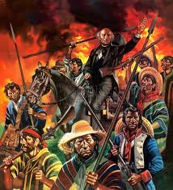
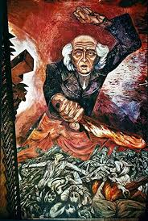
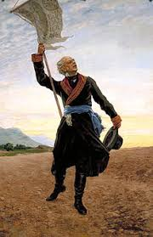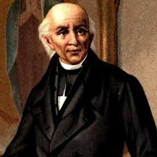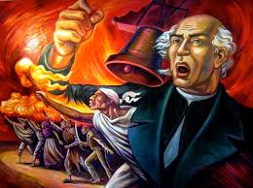

Hernan Cortes:
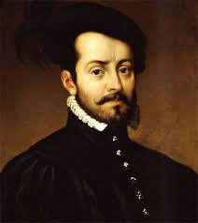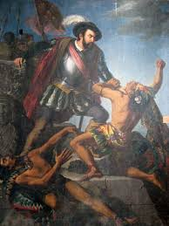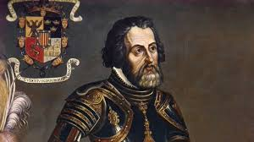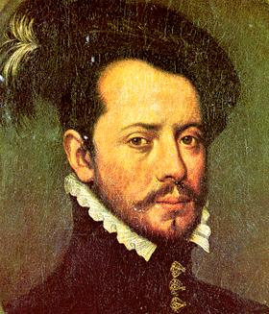

Charles V:
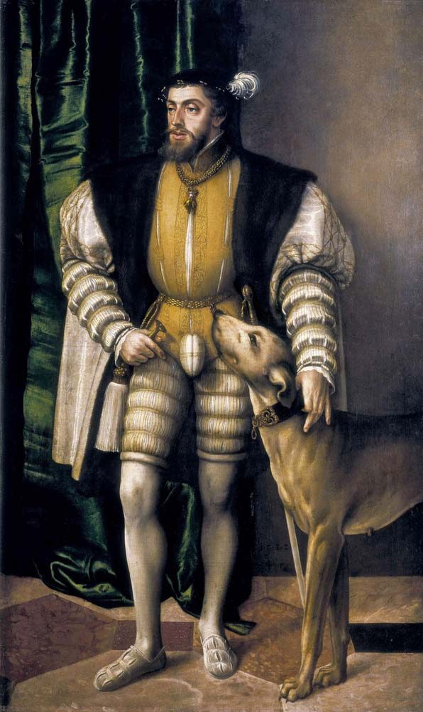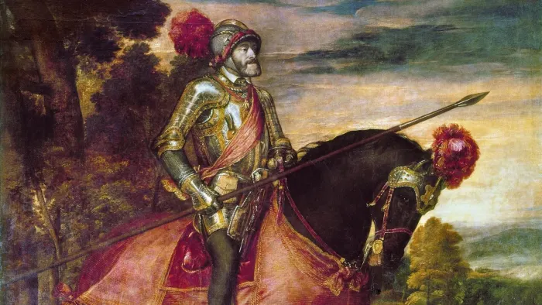
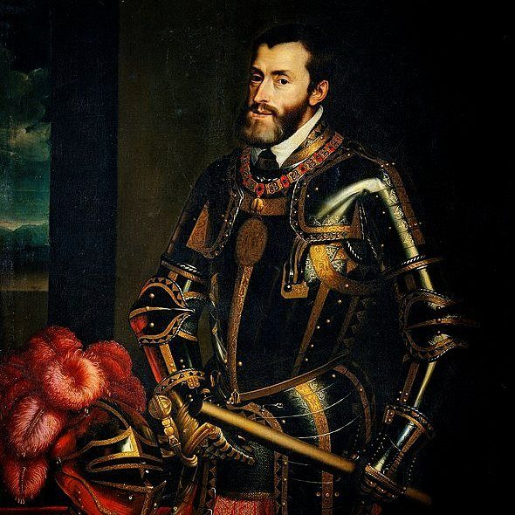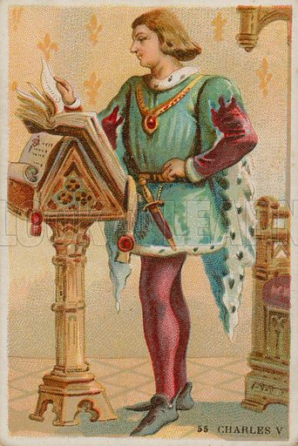

Davy Crockett:
