Molloy College
Division of Education
Students: Arianna Anzano and Megan Herder Professor: Sheehan
Course EDU 3510-01 Date: 1 April 2020
Grade: 5 Topic: Writing Skills Content Area: Social Studies

STANDARDS AND INDICATORS
New York State Social Studies Standards
Key Idea:
5.5 COMPARATIVE CULTURES: The countries of the Western Hemisphere are diverse, and the cultures of these countries are rich and varied. Due to their proximity to each other, the countries of the Western Hemisphere share some of the same concerns and issues.
Indicator: This will be evident when students compare the information gathered from each of the documents in their essays.
Key Concept:
5.5a The countries of the Western Hemisphere have varied characteristics and contributions that distinguish them from other countries.
Indicator: This will be evident when students read and analyze the documents discussing Mexican history.

Common Core ELA Standards
Reading: Integration of Knowledge and Ideas
8. Delineate and evaluate the argument and specific claims in a text, including the validity of the reasoning and the relevance and sufficiency of the evidence.
Indicator: This will be evident when students delineate and evaluate the argument and specific claims in a text and gather two pieces of evidence from the documents to construct a response to the question, “Is what we have learned about Mexican history true?”
Writing: Text Types and Purposes
1. Write arguments to support claims in an analysis of substantive topics or texts, using valid reasoning and relevant and sufficient evidence.
Indicator: This will be evident when students write arguments to support claims in an analysis of substantive topics or texts, using valid reasoning, relevant and sufficient evidence, and the TDFC model to effectively structure their response to the question, “Is what we have learned about Mexican history true?”
Social Studies Practices: Habits of Mind
C. Comparison and Contextualization
3. Describe and compare events in the history of the Western Hemisphere in societies in similar chronological contexts and in various geographical contexts.
Indicator: This will be evident when students compare and contextualize two key details from the documents to support the claim in their response.

NCSS C3 Inquiry Arc:
Dimension 3: Students will work toward conclusions about societal issues, trends, and events by collecting evidence and evaluating its usefulness in developing causal explanations.
Indicator: This will be evident when students work toward conclusions about societal issues, trends, and events by collecting evidence and evaluating its usefulness in developing causal explanations, using the TDFC model to develop a response to the practice question, “Should Fortnite be banned?”
INSTRUCTIONAL OBJECTIVE(S)
After participating in a Tug-of-War thinking routine, students will delineate and evaluate the argument and specific claims in a text and gather two pieces of evidence from the documents, using the TDFC model to write constructed responses to answer the question, “Is what we have learned about Mexican history true?”, successfully completing at least four out of five components on the TDFC outline.

DEVELOPMENTAL PROCEDURES
(Including Key Questions)
- MOTIVATION: Students will participate in a Tug-of-War thinking routine and will be presented with the question, “Is a hotdog a sandwich?” The class will generate their justifications on post-it notes. A rope will be used to visibly represent the argument. The students will bring their post-it notes to the front of the room and stand on the corresponding side of the rope. (Do you think a hot dog is a sandwich? Why or why not?) [6 minutes]
- Teacher will go over procedures using the CHAMPs acronym (Expectations for: conversation, help, activity, movement, and participation). (How do we show respect to our peers when we are collaborating and sharing ideas? How do we respectfully ask for help?) [3 minutes]
- Teacher will use direct instruction to explain the different parts of TDFC (topic, detail, follow-up, and clincher) to support their writing in the activity and to prepare them for the New York State Regents. (What is TDFC? Can you explain each part? How do we use TDFC? Why is it important?) [10 minutes]
- Teacher will model how to use TDFC by using the example, “Is a hotdog a sandwich?” Students and teacher will discuss how to create a topic sentence, two details, two follow-ups, and a clincher sentence to construct a paragraph response. (What are the four things we need to create a paragraph for the DBQ? What is a topic sentence? What is a follow-up to a detail? How do we tie all of our details together to create a clincher sentence?) [5 minutes]
- Using the TDFC model that students were previously presented with, students will generate a response to the popular question, “Should Fortnite be banned?” (Do you play Fortnite? Do you like Fortnite? Why or why not? Do you think that Fortnite is an appropriate game to play? Why or why not?) [6 minutes]
- Students will transition into a discussion about Mexican history and analyze the documents provided. Teacher will then model how to create a topic sentence using the documents. (What information do you think is important to include in a topic sentence? Why?) [5 minutes]
- Teacher will ask students to gather two pieces of evidence to construct a response to the question, “Is what we have learned about Mexican history true?” Students will complete their responses independently. (Can you share two key details evident in the text? Why do you feel these are important?) [5 minutes]
- Closure: Teacher will ask for student volunteers to read their constructed response to the class. Then, students in the class will identify each component of TDFC in the response. (Are there any volunteers that would like to share their response? Can you identify the T, the D, the F, and the C in this response?) [5 minutes]

ASSESSMENT (formal & informal)
Informal Assessment
Questions, Monitoring During Classwork

Formal Assessment
Students will delineate and evaluate the argument and specific claims in a text and gather two pieces of evidence from the documents, using the TDFC model to write constructed responses to answer the question, “Is what we have learned about Mexican history true?”, successfully completing at least four out of five components on the TDFC outline.

INSTRUCTIONAL RESOURCES AND MATERIALS
- Tug-of-War rope
- Post-it notes
- Pens/pencils
- TDFC anchor chart
- TDFC PowerPoint slides
- TDFC Outline Structure Sheet

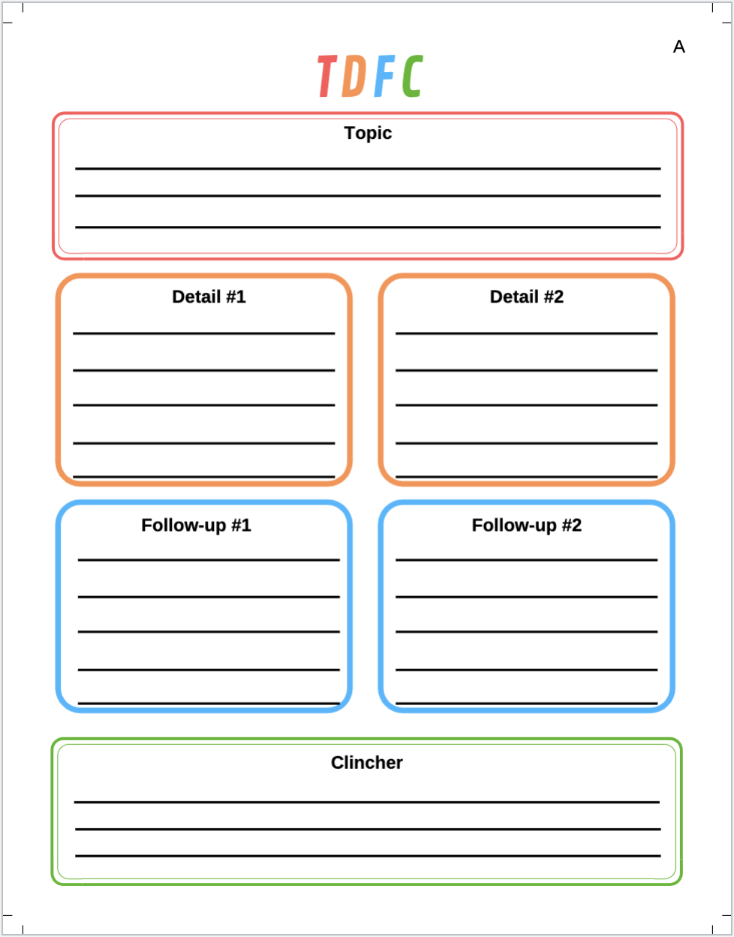

GRADE 5: Question 1
Is What We Have Learned About Mexican History True?
Student Name__________________________
Date_______________________

Part I: This part consists of a short answer question based on the new Regents Format. On this part, you will be provided with one version of the test based on your readiness to handle critical thinking challenges.

Document Based Question
Directions: The task below is based on documents 1 through 5-6. The task is designed to test your ability to work with documents. Examine each document and answer all questions beneath the document. Use the answers to the questions to help write your essay.
Background: The country of Mexico has had to struggle for its Independence over the years. This struggle involved conflicts in which many Mexicans gave their lives for the Independence of Mexico. Below you will be introduced to Mexicans who fought for Mexican Independence and freedom. Use your historical skills to connect these stories to Mexican Independence and to determine the credibility of the history that you have learned in this unit

This Short Answer Essay question is based on the accompanying documents and is designed to test your ability to work with historical documents. Each Short Answer Essay Question set will consist of two documents. These documents have been edited for the purposes of the question. Keep in mind that the languages and images used in the document may have been edited for the purposes of the question.

Task: Read and analyze the following documents, applying your knowledge of social studies and skills to write an essay of two or three paragraphs in which you:
- Describe the historical context surrounding the documents by explaining how the two documents are related. (Cause and Effect or Similarity or Difference)
- Analyze Document 1 and explain how the source, audience, and purpose relate this document to Document 2. Based on your analysis, is this document credible?

Describe means to “illustrate something in words or tell about it.”
Cause means “something that gives rise to something else, the rise of an idea, or brings about a development.”
Effect refers to “what happens as a consequence (result, impact, outcome) of an event, an idea, or a development.”
Similarity tells how “something is alike or the same as something else.”
Difference tells “something is not alike or not the same as something else.”
Historical Context refers to the “historical circumstances surrounding or connecting the events, ideas, or developments in the documents.”
Analyze means to “examine a document and determine its elements and relationships.”

Document 1
Mexican War of Independence

Cry of Dolores—Father Hidalgo 1816

Napoleon’s invasion and occupation of Spain from 1808 to 1813 heightened the revolutionary fervor in Mexico and other Spanish colonies. On September 16, 1810, Miguel Hidalgo y Costilla, a respected Catholic priest issued a passionate rallying cry known as the “Grito de Dolores” (“Cry of Dolores”) that amounted to a declaration of war against the colonial government. So named because it was publicly read in the town of Dolores, the Grito called for the end of Spanish rule in Mexico, the redistribution of land and a concept that the criollos’ earlier plans had deliberately omitted: racial equality.

“My Children, a new dispensation comes to us today…Will you free yourselves? Will you recover the lands stolen 300 years ago from your forefathers by the hated Spaniards? We must act at once.

Come march with us for country and religion…”
”The Grito de Dolores” ("Cry of/from Dolores") was the battle cry of the Mexican War of Independence, uttered on September 16, 1810, by Miguel Hidalgo y Costilla, a Roman Catholic priest from the small town of Dolores, near Guanajuato, Mexico.

Document 2
Mexico's Plan of Iguala, 1821
On the eve of declaring independence from Spain, Mexican elites intended the Plan of Iguala to act as a compromise between Mexico's divided classes.
Article 1. The Mexican nation is independent of the Spanish nation, and of every other, even on its own Continent.
Article 2. Its religion shall be the Catholic, which all its inhabitants profess.
Article 3. They shall be all united, without any distinction between Americans and Europeans.
In 1821, Agustín de Iturbide, the leader of the Royalist forces, negotiated the Plan of Iguala with Vicente Guerrero. Under the plan,
Mexico would be established as an independent constitutional monarchy, the privileged position of the Catholic Church would be maintained, and Mexicans of Spanish descent would be regarded as equals to pure Spaniards. Mexicans of mixed or pure Indian blood would have lesser rights.
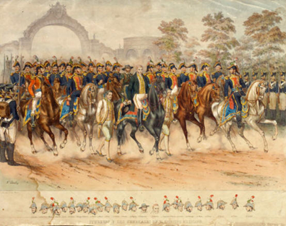

Parade of Independence 1821

GRADE: 5: Question 2
Is What We Have Learned About Mexican History True?
Student Name_____________________
Date______________________________

Part II: This part consists of a short answer question based on the new Regents Format. On this part, you will be provided with one version of the test based on your readiness to handle critical thinking challenges.

Document Based Question

Directions: The task below is based on documents 1 through 5-6. The task is designed to test your ability to work with documents. Examine each document and answer all questions beneath the document. Use the answers to the questions to help write your essay.

Background: The country of Mexico has had to struggle for its Independence over the years. This struggle involved conflicts in which many Mexicans gave their lives for the Independence of Mexico. Below you will be introduced to Mexicans who fought for Mexican Independence and freedom. Use your historical skills to connect these stories to Mexican Independence and to determine the credibility of the history that you have learned in this unit.

This Short Answer Essay question is based on the accompanying documents and is designed to test your ability to work with historical documents. Each Short Answer Essay Question set will consist of two documents. These documents have been edited for the purposes of the question. Keep in mind that the languages and images used in the document may have been edited for the purposes of the question.

Task: Read and analyze the following documents, applying your knowledge of social studies and skills to write an essay of two or three paragraphs in which you:
- Describe the historical context surrounding the documents by explaining how the two documents are related. (Cause and Effect or Similarity or Difference)
- Analyze Document 1 and explain how the source, audience, and purpose relate this document to Document 2. Based on your analysis, is this document credible?

Describe means to “illustrate something in words or tell about it.”
Cause means “something that gives rise to something else, the rise of an idea, or brings about a development.”
Effect refers to “what happens as a consequence (result, impact, outcome) of an event, an idea, or a development.”
Similarity tells how “something is alike or the same as something else.”
Difference tells “something is not alike or not the same as something else.”
Historical Context refers to the “historical circumstances surrounding or connecting the events, ideas, or developments in the documents.”
Analyze means to “examine a document and determine its elements and relationships.”

Document 1
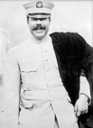

“My sole ambition is to rid Mexico of the class that has oppressed her and given the people a chance to know what real liberty means. And if I could bring that about today by giving up my life, I would do it gladly.”

~ Pancho Villa

Francisco "Pancho" Villa (born José Doroteo Arango Arámbula; June 5, 1878–July 20, 1923) was a Mexican revolutionary leader who advocated for the poor and land reform. He helped lead the Mexican Revolution, which ended the reign of Porfirio Díaz and led to the creation of a new government in Mexico. Today, Villa is remembered as a folk hero and a champion of the lower classes.

Document 2

Mexico's Plan of Iguala, 1821
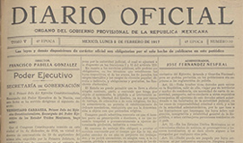

On the eve of declaring independence from Spain, Mexican elites intended the Plan of Iguala to act as a compromise between Mexico's divided classes.

Article 1. The Mexican nation is independent of the Spanish nation, and of every other, even on its own Continent.
Article 2. Its religion shall be the Catholic, which all its inhabitants profess.
Article 3. They shall be all united, without any distinction between Americans and Europeans.

In 1821, Agustín de Iturbide, the leader of the Royalist forces, negotiated the Plan of Iguala with Vicente Guerrero. Under the plan,

Mexico would be established as an independent constitutional monarchy, the privileged position of the Catholic Church would be maintained, and Mexicans of Spanish descent would be regarded as equals to pure Spaniards. Mexicans of mixed or pure Indian blood would have lesser rights.

REFERENCES

English Language Arts Learning Standards. (n.d.). Retrieved from http://www.nysed.gov/curriculum
instruction/new-york-state-next-generation-english- language-arts-learning-standards
New York State K-12 Social Studies Framework. (n.d.). Retrieved from https://www.engageny.org/resource/new-york-state-k-12-social-studies-framework
Visible Thinking Routines. (n.d.). Retrieved March 23, 2020, from http://www.visiblethinkingpz.org/VisibleThinking_html_files/03_ThinkingRoutines/03e_Fairnes sRoutines/TugOfWar/TugOfWar_Routine.html

