Molloy College
Division of Education

Student: Angela Bollettieri, Bridget McRae & Nicole Tufano Professor: Dr. Sheehan
Course: EDU 5090 Date: 4/2/2020
Grade:5 Topic: Effects of Social Media Content Area: Social Studies

STANDARDS AND INDICATORS
NEW YORK STATE SOCIAL STUDIES STANDARDS
5.3 EUROPEAN EXPLORATION AND ITS EFFECTS: Various European powers explored and eventually colonized the Western Hemisphere. This had a profound effect on Native Americans and led to the transatlantic slave trade. (Standards: 1, 2, 3, 4; Themes: MOV, TCC, GEO, ECO, EXCH)
5.3a Europeans traveled to the Americas in search of new trade routes, including a northwest passage, and resources. They hoped to gain wealth, power, and glory.
5.3b Europeans encountered and interacted with Native Americans in a variety of ways.
Indicator: This will be evident when students learn how to use the SPACE strategy to analyze credibility of a source in their unit deciding on whether Columbus was a hero or villain.
ELA Standard: New York State Next Generation English Language Arts Learning Standard
Text Types and Purposes
5W1:
Write an argument to support claims with clear reasons and relevant evidence.
Indicator: This will be evident when students write arguments to support how cyberbullying could have been defeated through social media literacy using the SPACE strategy.
ELA Standard: New York State Next Generation English Language Arts Learning Standard
Comprehension and Collaboration
5SL1:
Engage effectively in a range of collaborative discussions with diverse partners; express ideas clearly and persuasively, and build on those of others.
Indicator: This will be evident when the students engage in collective discussion using the SPACE strategy to determine how cyberbullying could have been defeated through social media literacy.
NCSS Inquiry Standard:
NCSS C3 Inquiry Arc
Dimension 3: Students will work toward conclusions about societal issues, trends, and events by collecting evidence and evaluating its usefulness in developing causal explanations.
Indicator: This will be evident when students collect evidence and evaluate its usefulness in determining if cyberbullying could have been defeated.
Dimension 4: Students will draw on knowledge and skills to work individually and collaboratively to conclude their investigations into societal issues, trends, and events and will present their information, portions and findings.
Indicator: This will be evident when students work collaboratively in their group to conclude their investigations from the SPACE strategy and present their findings.

Social Studies Habits of Mind:
1. Gathering Evidence
Indicator: This will be evident when students engage in identifying evidence and explaining content, authorship, purpose, and format; identify bias; explain the role of bias and potential audience, with teacher support.

INSTRUCTIONAL OBJECTIVE(S)

After students are introduced to the SPACE strategy through an example, students will write arguments to support a claim and engage in collective discussion using the SPACE strategy to determine how cyberbullying could have been defeated through social media literacy by analyzing five tweets and determining their credibility. Students will correctly identify all five of the SPACE categories.

DEVELOPMENTAL PROCEDURES (*Engaging the learner)
- Students will begin the lesson by participating in a “barometer activity”. The teacher will have a series of “tweets” from a public figures account whose name for the purpose of the activity will remain unknown. The teacher will state the tweets out loud, and ask students to determine if the claims made in the tweets are fact or false. If the students believe the tweets are fact, they must congregate towards the fact poster in one corner of the classroom. If they believe the tweet is false, they must then go towards the false poster on the opposite side of the room. Students must then converse amongst one another, and justify why they think the source or information is credible or not.

- Students will participate in a “turn and talk” activity where they will be asked the essential question “how do we validate the credibility of a source.” (Why is it important to make sure a source is credible? Have you ever accidentally shared information that was false? What components or characteristics make a source reliable?)

- Students will then watch a demonstration on the proper use of the “SPACE strategy”. The teacher will utilize tweets introduced in the barometer activity to coach students through the SPACE strategy. (Who is the author of this tweet? What is the purpose of the tweet? Who is the intended audience? Is the information presented fact or opinion, and how can you determine the difference? After evaluating all the information gathered, is the tweet overall credible? What led you to this conclusion?)

- Students will then be separated into groups. Within their group, each student will have a designated role. One student will be the scribe, another student the “captain” of the group, the third student “devil's advocate” who is responsible for questioning and challenging the group's decision and the fourth member will be tasked to try to collect information on the author of the tweet. (What tools can we use to effectively complete our task? Why is it important to divide and conquer? What is our overall goal as a group?)

- Each group will then receive 1 tweet from various political/ public figures. Students within their groups will then be tasked to implement the SPACE strategy to validate the credibility of the source. (Why is it important that we know about the author of the tweet’s background? How are we sure that the information in the tweet is biased? How does knowing and evaluating the tweet, audience, information, and author help us assess the legitimacy of the source?)

- After each group has completed the SPACE strategy with their tweet, each group will present their document to the class.

- Students will then participate in a class discussion utilizing their findings and organizing their thoughts to answer the essential question after their findings “how cyberbullying could have been defeated through social media”. (Why is cyberbullying such an epidemic? What can we do to prevent cyberbullying on social media? How do we identify cyberbullying and help eliminate its outreach/ impact?)

- Students will then close the lesson by participating in a reflective activity. Students will be asked to participate in a fishbowl discussion about why during the political election and times of crisis (pandemic) it is detrimental to validate a source and prevent cyberbullying. (Is there cyberbullying present between politicians? How do we determine what platforms are reliable? Can we trust media such as the news to provide us with accurate information about the current pandemic? How can mitigate or help the situation and be proactive as citizens to prevent the spread of false information? What is our role/obligation as citizens using social media during a time of crisis?)

ASSESSMENT (formal & informal)
Informal Assessment
The teacher will closely monitor the collective discussion and students oral contributions.

Formal Assessment
At the end of the lesson, each group will present their document to the class.

REFERENCES

CDC. (2019, March 25). As of March 25, 41 states and 1 U.S territory report some community spread of #coronavirus (COVID-19). Of those, thirteen states report #COVID-19 cases are “widespread.” See CDC’s map to stay up to date on what is happening in your state. [Tweet]

Dtrump. (2013, May 8). Sorry losers and haters, but my I.Q. is one of the highest - and you all know it! Please don’t feel so stupid or insecure, it’s not your fault [Tweet]

Dtrump. (2018, January 6). ...Actually, throughout my life, my two greatest assets have been mental stability and being, like, really smart. Crooked Hilary Clinton also played these cards very hard and, as everyone knows, went down in flames. I went from VERY successful businessman, to top T.V. Star… [Tweet]

Dtrump. (2019, August 23). For many years China (and many other countries) has been taking advantage of the United States on Trade, Intellectual Property Theft, and much more. Our Country has been losing HUNDREDS OF BILLIONS OF DOLLARS a year to China, with no end in sight…[Tweet]

NYCPublicSchools. (2019, March 30). The NUMBER ONE way to stop the spread of COVID-19? STAY HOME. Protect your family, friends, loved ones and neighbors: act like you already have the virus and stay inside. [Tweet]

New York State Department of Education. (2020). [PDF file]. English Language Arts Learning
Standards.
Retrieved from
http://www.nysed.gov/common/nysed/files/programs/curriculum-instruction/nys-next-generation-ela-standards.pdf

The SPACE Strategy

Summarizing: THIS IS THE "S" (Sourcing)
1. Who wrote this article?
2. When was it written?
3. Is the author a credible source about what (s)he is writing about? (Is the author known for what is (s)he is writing about and does (s)he have experience about what is being written about?)
4. Is the author a reliable source in general? (Does the author tend to be truthful, can you trust the author?)
5. Is the information presented by the author biased or unbiased? Where is the bias?
6. Is the author anonymous? (Name withheld)

Perspective: THIS IS THE "P" (Purpose and Point of View)
1. What is the author's purpose in writing? (Inform/Explain, Persuade, Entertain)
2. What is the author's perspective on the issue? Does the author's presentation favor one side or the other?
3. Does the author present one point of view or is the presentation balanced?
4. Are points of view missing from the article?

Audience: THIS IS THE "A" Audience--Context
1. Who is the desired audience for the author? Is the audience general or specific?
2. Why might the author be writing this piece to this audience? (purpose-goal)
3. Has an event happening in the world inspired the author to write this piece? (context)
4. What does the author want the audience to think after reading this piece?

Credibility: THIS IS THE "C" Corroboration
1. Is the information presented fact or opinion? (Opinions are much harder to corroborate but this can be done by checking the facts that the opinion is based on.)
2. Can the information presented be corroborated in other sources?
3. Where could you go to corroborate the information in the article? (What sources on the Internet might enable you to do this quickly and easily?)
4. Do you need primary sources to corroborate this account? Which sources might help corroborate this account, even if not accessible? What is missing?)
5. Have you tried to corroborate this source? What did you find?

Corroborating: THIS IS THE "E" Evaluation of Credibility and Reliability
1. When you review all of the questions above, does the information seem credible (believable) ? Which concept (letter) was most powerful in leading you to that conclusion?
2. When you review all of the questions above, is the information incredible ( not believable) ? Which concept (letter) was most powerful in leading you to that conclusion??
3. When you review all of the questions above, is the information reliable (trustworthy) ? Which concept (letter) was most powerful in leading you to that conclusion?
4. When you review all of the questions above, is the information unreliable (not trustworthy) ? Which concept (letter) was most powerful in leading you to that conclusion?
5. Are you unable to determine reliability and credibility based on the information provided? What other sources are available that could check, confirm, or oppose the evidence currently marshaled?

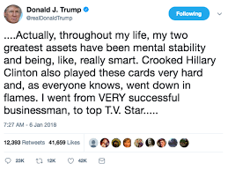
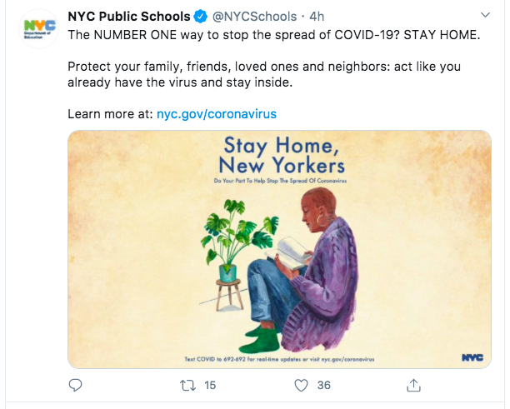
Twitter Sources