Molloy College
Division of Education

Hailey Wehr and Shannon Atwell Dr. Sheehan
EDU 3510 3/25/20
Grade 5: Topic: Cyberbullying, Social Media Literacy Content Area: Social Studies

STANDARDS AND INDICATORS

New York State Social Studies Standard
Key Idea:
5.5 COMPARATIVE CULTURES: The countries of the Western Hemisphere are diverse and the cultures of these countries are rich and varied. Due to their proximity to each other, the countries of the Western Hemisphere share some of the same concerns and issues.
Key Concepts:
5.5a The countries of the Western Hemisphere have varied characteristics and contributions that distinguish them from other countries.
Indicator: This will be evident when students learn the tools of audience and purpose in
determining credibility in evaluating a source.

Common Core ELA Anchor Standards for Social Studies
Integration of Knowledge and Ideas
7. Delineate and evaluate the argument and specific claims in a text, including the validity of the reasoning and the relevance and sufficiency of the evidence.

Indicator: This will be evident when students include the validity of the reasoning and the relevance and sufficiency of the evidence in the history mystery.

Text Types and Purposes
1. Write arguments to support claims in an analysis of substantive topics or texts, using valid reasoning and relevant and sufficient evidence.

Indicator: This will be evident when students write and support a claim, using valid reasoning and relevant and sufficient evidence from the history mystery.

NCSS C3 Inquiry Arc

Dimension 3: Students will work toward conclusions about societal issues, trends, and events by collecting evidence and evaluating its usefulness in developing causal explanations.

Indicator: This will be evident when students evaluate the usefulness of evidence in the
history mystery to answer the compelling question.

Dimension 4: Students will draw on knowledge and skills to work individually and collaboratively to conclude their investigations into societal issues, trends, and events and will present their information, portions and findings.

Indicator: This will be evident when students work collaboratively to conclude their investigations from the history mystery and present their findings.

Social Studies Practices: Habits of Mind

A. Gathering, Interpreting, and using Evidence
2. Recognize and effectively select different forms of evidence used to make meaning in social studies (including primary and secondary sources such as art and photographs, artifacts, oral histories, maps, and graphs).

Indicator: This will be evident when students recognize and effectively select credible evidence in the history mystery to write arguments to support their claims.

INSTRUCTIONAL OBJECTIVE(S)

After learning how to determine if evidence is credible, students will evaluate the validity of the reasoning, the relevance and sufficiency of evidence through a history mystery. Students will write and present arguments to support the claim, “Did the Houston Astros earn their World Series Championship title in 2017?” using valid reasoning and relevant and sufficient evidence. Students must include at least 3 pieces of relevant and sufficient evidence from the history mystery to support their answer. Students will score at least a 3/4 on a teacher created checklist.

DEVELOPMENTAL PROCEDURES (*Engaging the learner)

- MOTIVATION: Students will watch two videos about the 2017 Houston Astro’s scandal and be introduced to their role as detectives. Video one “HOUSTON ASTROS - WIN the WORLD SERIES (Final Outs) Game 7” will introduce the topic and show their final game victory. Video two “2017 MLB champions accused of cheating”, will introduce the scandal. Students will be introduced to their role as detectives. [3 min]
2. After the teacher reads a couple of pages from the story “Arthur's TV Trouble”, the students will discuss what it means to be credible vs. non-credible. (How can we determine if the information we are reading if real? Why can’t we believe everything we read? Is it possible for some articles to be more credible than others?) [5 min]
3. Students will participate in a history mystery game called “Clue” where they will work in 3 groups of 4. to determine if evidence is credible or not. (Is there any bias in this evidence? (Is there evidence that is more credible than others? How do you determine credibility of evidence?) [12 min]
5. Students will make a claim using evidence from the history mystery and write down three accurate facts to support their claim. (What conclusion did the evidence lead to? Do you agree with the evidence presented in the envelopes? Did you have more evidence supporting the Houston Astros or refuting them? What is a conclusion we can make based on the evidence provided?) [5 min]
6.Students will present their three accurate facts to support their claim based on compelling question; “Did the Houston Astros earn their World Series Championship title in 2017” to the class. (What were your findings from the history mystery? What did the evidence tell you? What was your most credible piece of evidence? How do you know this?) [5 min]

THE BIG IDEA
In today’s lesson, the students evaluated the validity of the reasoning, the relevance and sufficiency of evidence through a history mystery. Their uncovered definition of credibility of a source will lead the class into determining the credibility of a source utilizing SPACE.

Key Questions
Why can’t we believe everything we read?
How do you determine credibility of evidence?
Is there any bias in this evidence?
What was your most credible piece of evidence?

ASSESSMENT (formal & informal)

Informal assessment
- The teacher will assess student interactions during group work.
- The teacher will assess student knowledge and understanding of the topic based on class discussion before, during and after the history mystery.
Formal assessment
- The teacher will monitor and evaluate students’ presentation of their findings from the history mystery based on a teacher created checklist.
INSTRUCTIONAL STRATEGIES
Mystery Strategy: using the idea of becoming detectives and solving a mystery as students formulate ideas and clues.
● Indicator: This will be evident when students act as detectives and provide sound evidence to solve the history mystery question.
Collaboration: (engaging groups of students in working together on a structured activity)
● Indicator: This will be evident when students are put into groups to share ideas about the history mystery and work together to finalize a conclusion.
Discussion: (engaging in meaningful discussions about the content)
● Indicator: This will be evident when students present their findings and conclusions to the class based on the evidence examined.

INSTRUCTIONAL RESOURCES AND MATERIALS

- SMARTboard
- History Mystery PowerPoint
- 4 History mystery “Clue Gameboards”(World Series 2017 Edition)
- “Evidence Envelopes”
- Credibility cheat sheet
- History Mystery Presentation Checklist
REFERENCES
Brown, Marc. (1995). Arthur's TV Trouble.
New York State K-12 Social Studies Framework. Retrieved from https://www.engageny.org/resource/new-york-state-k-12-social-studies-framework
2017 MLB Champions Accused of Cheating. Youtube, 2019 www.youtube.com/watch?v=3LQQ5fGtXWY.
Houston Astros- Win the World Series (Final Outs) Game 7. Youtube, 2017
www.youtube.com/watch?v=R5hI5_t5BJk.

Teacher created “Clue Game” (World Series 2017 Edition)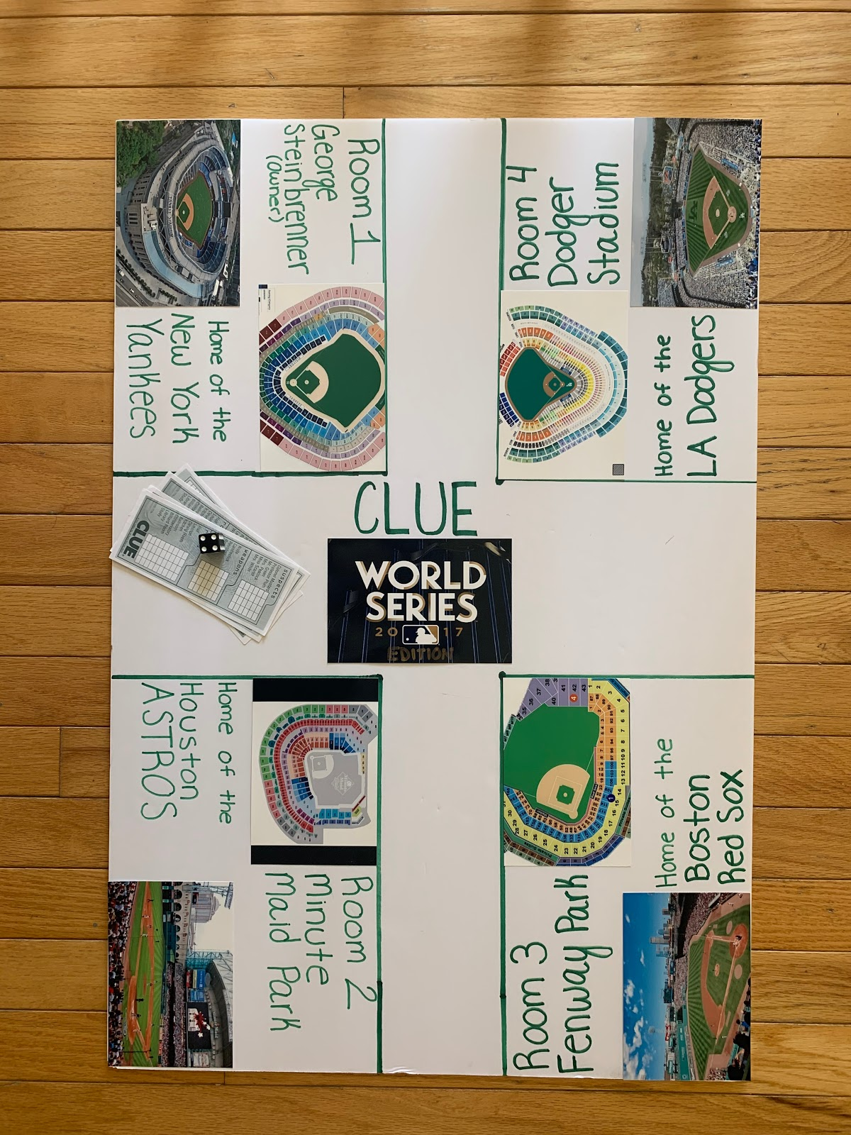
Evidence (For Clue Game)
(Credible Clues)

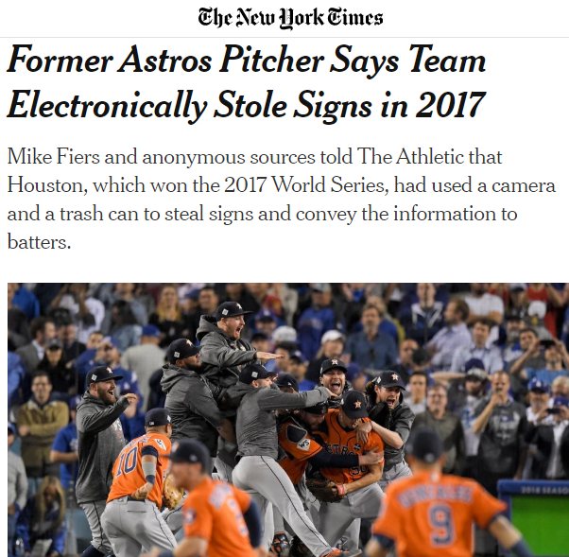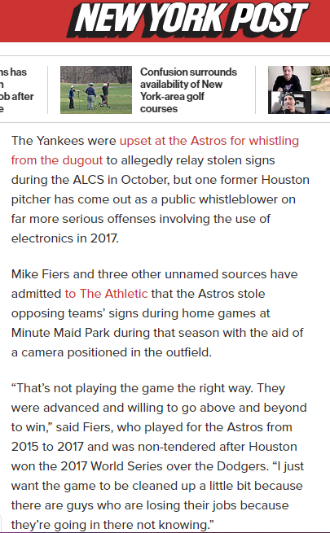
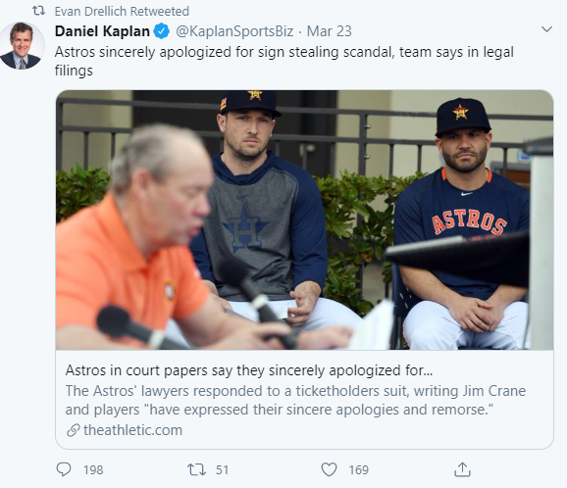
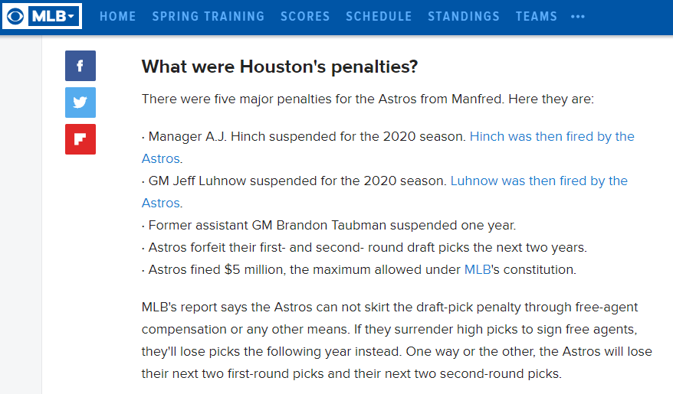

Evidence (For Clue Game)
(Noncredible Clues)

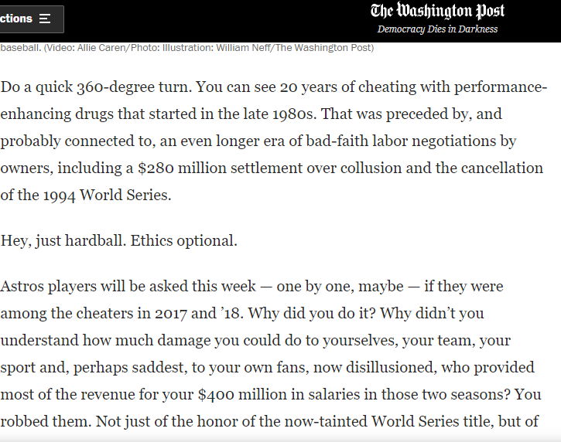
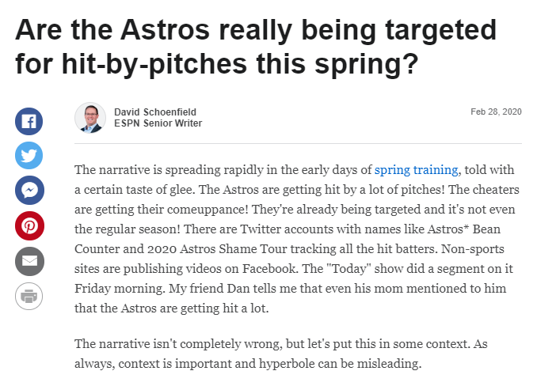

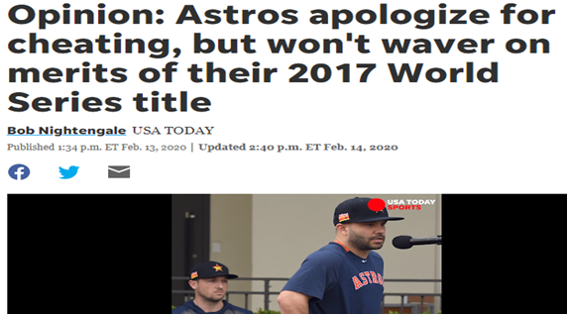
History Mystery
Presentation Checklist
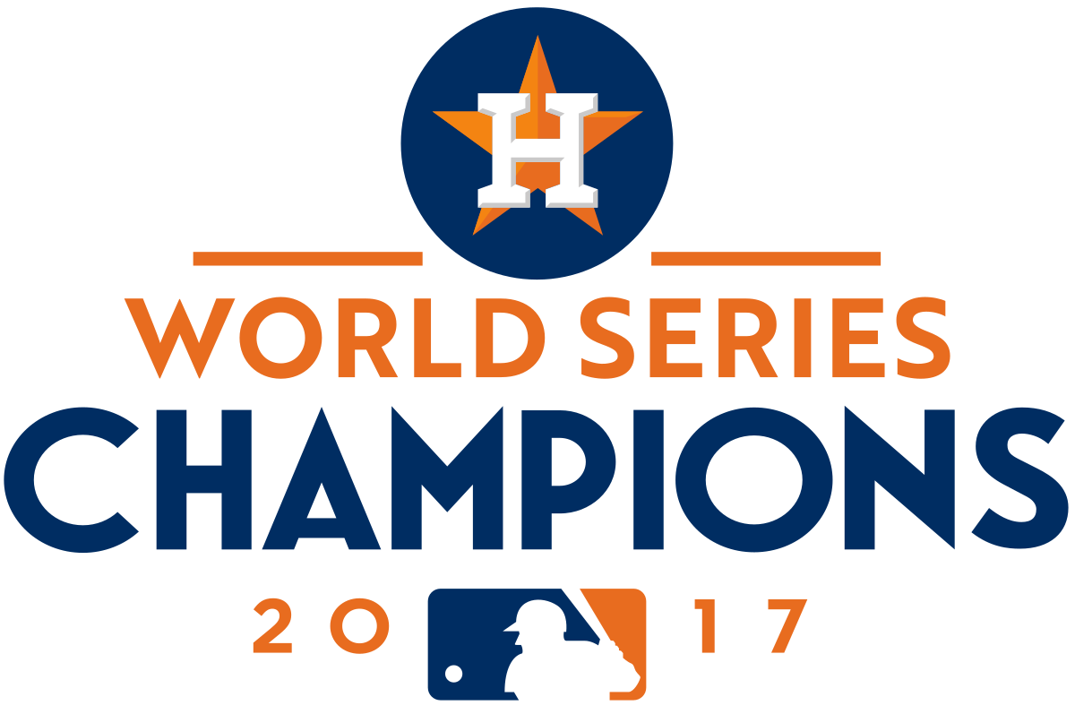

- Make a claim based on compelling question; “Did the Houston Astros earn their World Series Championship title in 2017?”

_____/ 1
- Present three sound facts based on evidence to support their claim.

_____/ 3
Total: _______/ 4

