GRADE: 5

Does Where You Live in the Hemisphere Determine Your Happiness?

Student Name_____________________
Date______________________________
E
Part III: This part consists of a document-based question. On this part, you will be provided with one version of the test based on your readiness to handle critical thinking challenges.

Document Based Question

Directions: The task below is based on documents 1 through 6. The task is designed to test your ability to work with documents. Examine each document and answer all questions beneath the document. Use the answers to the questions to help write your essay.

Background: This question asks you to form an opinion based on the evidence in the documents that follow. Although you may have your own opinion, based your answer on proving your position with the documents. You can add outside information

Task: Use the information from the documents and your knowledge of social studies, write an essay in which you:
Use the information from the documents and your knowledge of social studies, write an essay in which you:

● Evaluate If Where You Live in the Hemisphere Determines Your Happiness
In your essay remember to
● Write an opinion essay, arguing whether people live a happier life in Mexico or America
● Include an introduction, a body, and a conclusion
● Use information from at least four documents in your answer
● Include historical facts, relevant details, and reason in developing your ideas

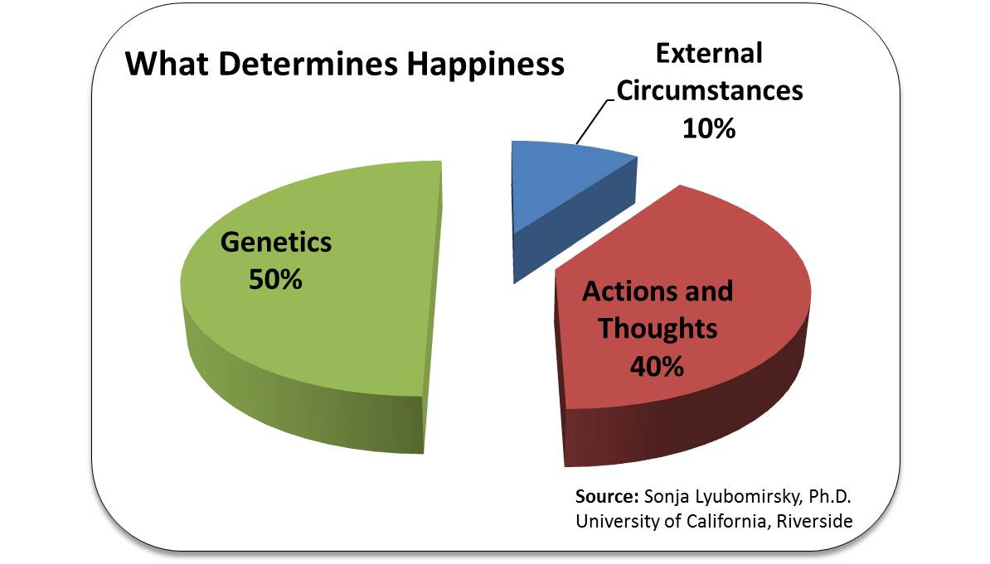
Document #1:
How you react to what happens to you in life
What happens to you in life
10%

- According to the document, which section of the pie chart do psychologists believe contributes
________________________________________________________ [1]
2. Referring to the chart, what is responsible for 50% of our happiness?
_________________________________________________________ [1]
3. Referring to the chart, what does 40% of our happiness relate to?
_________________________________________________________ [1]

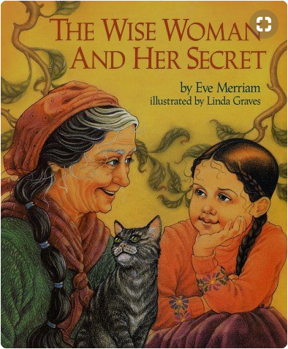
Document #2

The Wise Woman and her Secret
Eve Merriam

Renowned for her wisdom, an old woman is sought out by people who come from far and wide, eager to discover the secret source of her insights. "You will have to discover it for yourself", she tells them, and so their search begins. But one little girl, who likes to wander and wonder, lag and linger, has already found the secret that eludes her elders".

1. Based on the document above, what does the wise woman say about finding happiness?
_________________________________________________________________________________________________________________________________________ [1]

2. According the above document, what two things does the wise woman say have led to Jenny’s happiness?
________________________________________________________________________________________________________________________________________ [2]

3. Based on this definition of happiness, would having more money automatically make you a happier person? What would make a person happier?
_________________________________________________________________________________________________________________________________________ [2]
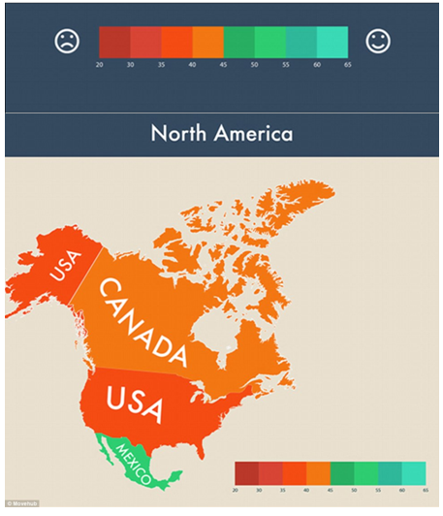
Document #3:

World Happiness Report
March 20, 2019
- Based on the document above, which country is happiest on the chart?
___________________________________________________________________ [1]
2. Do you think a test can determine the happiness of an entire country? Why or Why Not?
_______________________________________________________________________________________________________________________________________________________________________________________________________________ [2]

Document #4a

“Violent crimes have been declining in the U.S. for over three decades, and have been increasing in Mexico during the same period. More Mexicans have been killed in drug wars than Americans killed in the Iraq and Afghanistan wars combined.”
-Glen Olives (2015) from the Mexican News

Document #4b

Crinte Index Safey Index

NYC 43.06 56.94

Montreal 31.06 68.94

Gallup Poll 2017

- According to the document 4a, how do crime rates in Mexio and the United State Compare?
___________________________________________________________________ [1

2 According to the document 4b, how do crime rates and safety in Montreal and the NYC Compare?
_______________________________________________________________________________________________________________________________________________________________________________________________________________[2]

3. Do you think crime rates can tell us which people in which city are happier? Why or Why Not?
______________________________________________________________________________________________________________________________________________________________________________________________________________________________________________________________________________________[2]

Document #5

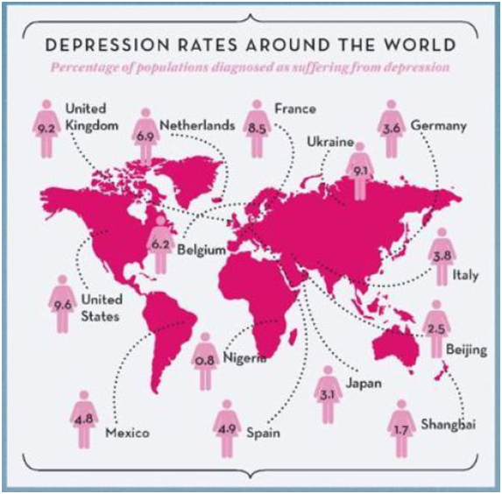

The most depressed people it appears live in the United States, United Kingdom, Ukraine, and France. The fact that the top three all begin with the letter “U” does not go unnoticed, so it is best to avoid living in countries that begin with “U.”

Dave Moulton’s Blog
December 2018

- According to the document, how does the percentage of people suffering from depression in the United States compare to the rest of the world?
_______________________________________________________________________________________________________________________________________________________________________________________________________________[1]

- Why do you think more people in the United States, one of the richest countries in the world, has such a high rate of depression? (refer to document #1)
_______________________________________________________________________________________________________________________________________________________________________________________________________________[2]

Document Seven:

New York City= Average Weather in January in New York City New York, United States. Daily high temperatures decrease by 2°F, from 41°F to 40°F, rarely falling below 26°F or exceeding 55°F. The lowest daily average high temperature is 39°F on January 23.
Montreal= January in Montreal is extremely cold with temperature dipping to new lows of -14 degrees Celsius with highs of just about -4 degrees Celsius. The average temperature throughout the course of the month is a freezing -9 degrees Celsius, with the 29th of January regarded as the coldest day of the month. (24 degrees Celsius)
Mexico City= Daily high temperatures are around 71°F, rarely falling below 65°F or exceeding 77°F. The lowest daily average high temperature is 70°F on January 7.

ACCU Weather
2019

- According to the document, which city has the most favorable weather on New Years Day?
_______________________________________________________________________________________________________________________________________________________________________________________________________________[1]

- Do you think the weather of a region is responsible for the happiness of the people in that city? Why or Why Not?
_______________________________________________________________________________________________________________________________________________________________________________________________________________[2]

Task: Use the information from the documents:

Directions: The task below is based on documents 1 through 5. The task is designed to test your ability to work with documents. Examine each document and answer all questions beneath the document. Use the answers to the questions to help write your essay.

Background: This question asks you to form an opinion based on the evidence in the documents that follow. Although you may have your own opinion, based your answer on proving your position with the documents. You can add outside information

Task: Use the information from the documents and your knowledge of social studies, write an essay in which you:
Use the information from the documents and your knowledge of social studies, write an essay in which you:

● Evaluate If Where You Live in the Hemisphere Determines Your Happiness

In your essay remember to
● Write an opinion essay, arguing whether where you live determines your happiness
● Include an introduction, a body, and a conclusion
● Use information from at least three documents in your answer
● Include historical facts, relevant details, and reason in developing your ideas

DBQ Scoring Rubric
(From the Revised Generic Scoring Rubric for Regents Examinations.)

Score of 5 | *Thoroughly develops all aspects of the task evenly & in depth | *Is more analytical than descriptive (applies, analyzes, evaluates, & creates information) | *Incorporates relevant information from at least the requested number of documents | *Incorporates substantial relevant outside information | *Richly supports the theme with many relevant facts, examples, & details | *Demonstrates a logical & clear plan of organization; includes and introduction & conclusion that are beyond a restatement of the theme
Score of 4 | *Develops all aspects of the task but may do so somewhat unevenly | *Is both descriptive & analytical (applies, analyzes, evaluates, and/or creates information) | *Incorporates relevant information for at least the requested number of documents | *Incorporates relevant outside information | *Supports the theme with relevant facts, examples, & details | *Demonstrates a satisfactory plan of organization; includes an introduction & a conclusion that are beyond a restatement of the theme
Score of 3 | *Develops all aspects of the task with little depth or develops most aspects of the task in some depth | *Is more descriptive than analytical (applies, may analyze and/or evaluate information) | *Incorporates relevant information from some documents | *Incorporates limited relevant outside information | *Includes some relevant facts, examples, & details; may include some minor inaccuracies | *Demonstrates a satisfactory plan of organization; includes an introduction & a conclusion that may be a restatement of the theme
Score of 2 | *Minimally develops all aspects of the task or develops some aspects of the task in depth | *Is primarily descriptive; may include faulty, weak, or isolated application or analysis | *Incorporates limited relevant information from the documents or consists primarily of relevant information copied from the documents | *Presents little or no relevant outside information | *Includes few relevant facts, examples, & details; may include some inaccuracies | *Demonstrates a general plan of organization; may lack focus; may contain digressions; may not clearly identify which aspect of the task is being addressed; may lack an introduction an/or an conclusion
Score of 1 | *Minimally develops some aspects of the task | *Is descriptive; may lack understanding, application, or analysis | *Makes vague, unclear references to the documents or consists primarily of relevant & irrelevant information copied from the documents | *Presents no relevant outside information | *Includes few relevant facts, examples, or details; may include inaccuracies | *May demonstrate a weakness in organization; may lack focus; may contain digressions; may not clearly identify which aspect of the task is being addressed; may lack an introduction and/or a conclusion
Score of 0 | *Fails to develop the task or may only refer to the theme in a general way; OR includes no relevant facts, examples or details; OR includes only the historical context and/or task as copied from the test booklet; OR includes only entire documents copied from the test booklet; OR is illegible: OR is a blank paper

