Molloy College
Division of Education

Erin Dougan Kevin Sheehan
EDU 509 4/6/18
Grade 8, Social Studies Great Depression

INSTRUCTIONAL OBJECTIVES (s) (Lesson Objective(s)*)

After working together as a class to analyze Document A, using the SSMS method, students will be able to cite textual evidence while evaluating a novel document, while working in small groups. Students will complete an exit ticket explaining why a particular portion of this strategy is the most important, defending their answers with three reasons.

NYS-CCLS / +NYS STANDARDS AND INDICATORS
(you may need more than one standard)

Key Idea:
8.5 GREAT DEPRESSION: Economic and environmental disasters in the 1930s created hardships for many Americans. Amidst much debate about the appropriate role of government, President Franklin D. Roosevelt helped to create intensive government interventions in the United States economy and society. (Standards: 1, 3, 5; Themes: TCC, SOC, GOV, ECO)

Key Concept:
8.5c President Roosevelt issued the New Deal in an attempt to revive the economy and help Americans deal with the hardships of the Great Depression. These New Deal reforms had a long-lasting effect on the role of government in American society and its economic life, but did not resolve all of the hardships Americans faced.
Indicator: This will be evident when students analyze sources to discover President Roosevelt’s impact on Great Depression America.

National Social Studies Standards and Themes:

VI. Power, Authority, & Governance: Social studies programs should include experiences that provide for the study of how people create and change structures of power, authority, and governance.
Indicator: This will be evident when students corroborate the evidence they found to determine how President Roosevelt changed the role of the government in economy.

NCSS C3 Inquiry Arc

Dimension 3: Students will work toward conclusions about societal issues, trends, and events by collecting evidence and evaluating its usefulness in developing causal explanations.

Dimension 4: Students will draw on knowledge and skills to work individually and collaboratively to conclude their investigations into societal issues, trends, and events and will present their information, portions and findings

Indicator: This will be evident when students work collaboratively to investigate the documents and then share their findings with other students after changing groups.

Common Core ELA Standards 8

RH 1: Cite specific textual evidence to support analysis of primary and secondary sources.

Indicator: This will be evident when students answer questions based on the textual evidence of the documents.

Social Studies Practices: Habits of Mind

- Gathering, Interpreting and Using Evidence

Indicator: This will be evident when students use sources to make their own conclusions.

INSTRUCTIONAL RESOURCES

- Document A, FDR First Inaugural Address (print)
- Document B, Fireside Chat on Banking (print)
- Document C, Great Depression, Great Recession (print)
- Document D, An Evaluation of the New Deal (print)
- Document E, Political Cartoon (print)
- Document A, FDR First Inaugural Address (audio)
- Document B, Fireside Chat on Banking (audio)
- Document C, Great Depression, Great Recession (audio)
- Document D, An Evaluation of the New Deal (audio)

MOTIVATION (Engaging the learner(s)*)

Once class begins students will complete a “Do Now” activity. The prompt on the board for them to respond to will be “In what ways is a historian like a detective?” Students will have the opportunity to share their answers aloud. After sharing they will have to choose one word to represent the job of a “historian” and post it to the polleverywhere link to create a word cloud on the board.

DEVELOPMENTAL PROCEDURES
(including Key Questions)

Learning Tasks:
- Students will be given a copy of Document A, which is an excerpt from Franklin Roosevelt’s First Inaugural Address. Each student will read or listen to a recorded version of the document independently. What is this document about? Who is the primary person of interest? What time period are you reading about?
- Students will then listen as a volunteer re-reads the document aloud.
- As a class we will work through the SSMS questions. As we work together the students will fill out a worksheet. The worksheet will define the task that we are completing for each section of SSMS. What is this document about? Who/where/when are they discussing? Where did we get this document from? Is it a primary source document of a secondary source document? Who is the author? Is there an intended audience? Is the author purposefully including or discluding specific information?
- Students will then work in groups of 4 to complete the same graphic organizer on the back of their worksheet with a second document. What is this document about? Who/where/when are they discussing? Where did we get this document from? Is it a primary source document of a secondary source document? Who is the author? Is there an intended audience? Is the author purposefully including or discluding specific information?
- Student groups will then “jigsaw” in such a way that each group member will have analyzed a different document. While in these groups students will work on the corroboration piece of SSMS. What did you learn from the other members of your group? Are the other documents your peers read more similar or more different than your document? Is there anything that doesn’t quite add up?

INSTRUCTIONAL STRATEGIES (Learning Strategies*)

Do Now Activity
Indicator: This will be evident when students respond to and share their responses to the “Do Now” prompt.

Cooperative Learning
Indicator: This will be evident when students work as a group to analyze Document A, and then in small groups to analyze document B.

ADAPTATIONS (Exceptionality*)

- The student who is visually impaired, or not reading at grade level, will have access to a recorded version of the document they were assigned.
- The student who is visually impaired will not be assigned the political cartoon as their document but will have a recorded description of the image available to them.
- The student who has is physically unable to write will have access to the note taking worksheet on google docs. These students can also type their responses to the “Do Now” and the assessment question electronically and submit them digitally.
- The english language learners will have copies of the text in their native language, as well as the english version with each line being numbered to make communication with their group easier.

DIFFERENTIATION OF INSTRUCTION

Auditory Learners
- Recorded versions of all of the documents will be available to all students in addition to a copy of the text, in case listening enhances their comprehension.
- Auditory learners will also benefit from the group discussion of the lesson.

Visual Learners
- Visual learners will benefit from the reading the text copy of the document.
- Visual learners will also benefit from the given worksheet that organizes the notes graphically.

ASSESSMENT (artifacts* and assessment [formal & informal]*)

Students will complete an exit ticket that will ask them to choose one component of SCIM-C that they think is the most important to understanding a document and defend their choice with three reasons why.

INDEPENDENT PRACTICE

Based on what was discussed in class students will independently consider which document used in class was the most compelling and why. Students will type up and hand in a two paragraph short essay the following day.

FOLLOW-UP ACTIVITIES: DIRECT TEACHER INTERVENTION AND ACADEMIC ENRICHMENT

Direct Teacher Intervention
Students who are struggling with the objective can meet one on one with the teacher to complete an additional document evaluation to reinforce the skills learned in class. Student’s will be provided with a more detailed graphic organizer asking leading questions specific to the document to better communicate the purpose of the task.

Academic Enrichment
One of the sources we looked at in class was a political cartoon, and we applied SCIM-C to analyze it. As academic enrichment students can find other multimedia sources and apply the SCIM-C strategy to those sources.

REFERENCES

An evaluation of the New Deal (2018). In U.S. History Online Textbook. Retrieved from
http://www.ushistory.org/us/49g.asp
Berryman, C. (Author). (1934). Of Course We May Have to Change Remedies If We Don’t Get
Results [Cartoon]. Washington Star.
Roosevelt, F. D., (1933, March 4). Retrieved from
http://www.presidency.ucsb.edu/ws/index.php?pid=14473
Roosevelt, F. D., (1933, March 12). Retrieved from
http://www.presidency.ucsb.edu/ws/index.php?pid=14540
The Roosevelt Institute, (2010, September 15). Retrieved from
http://rooseveltinstitute.org/great-depression-great-recession/

Document A: Excerpt from FDR’s First Inaugural Address

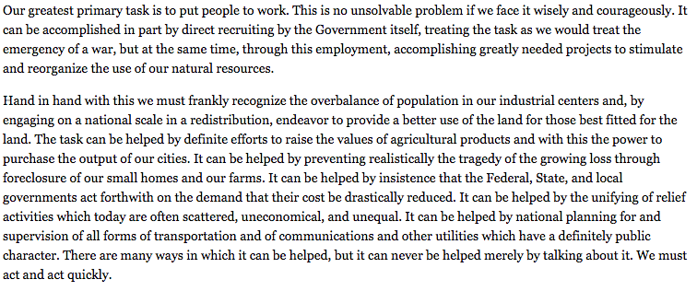

Document B: Excerpt from FDR’s Fireside Chat on Banking

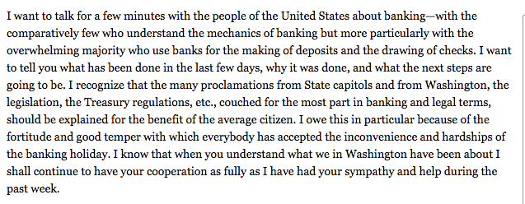

Document C: Excerpt from Great Depression, Great Recession, an article written by the Roosevelt Institute

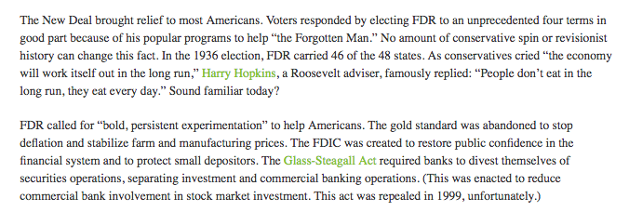

Document D: Excerpt from, An Evaluation of the New Deal

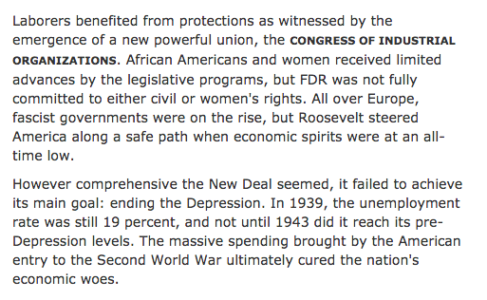

Document E: Political Cartoon

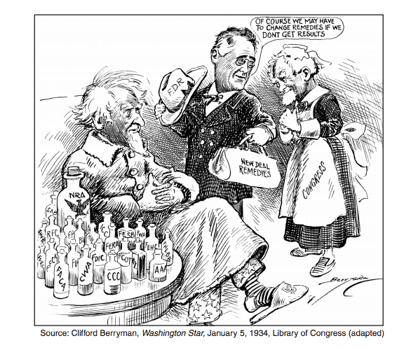

SSMS Model:

S- Summary
S- Source
M- Maybe there’s more?
S- Side by side comparison

Summary:
- What type of source is this?
- What historical information is it providing to the reader?
- Who/What is being discussed?
- What time period is the source referencing?

Source:
- Who wrote the document?
- When did they write it?
- How long after the historical event being discussed was the document written?
- Where did they write the document?
- Is this the same place or area that the historical event took place in?

Maybe there’s more?
This is when students dig into the document, look at things like diction and intended audience, who the author was and why they might have written or created the document.
- Who is the intended audience, why does it matter?
- Why do you think the author made the choices he or she made?
- What do we know about the author and how might this affect their word choice?
- Can you make any inferences, for example are you learning anything indirectly?
- What questions do you still have?

Side by side comparison
This is when students take a look at other documents to compare information they have learned from multiple sources.
- Are they the same or different?
- Are there any major contradictions?
- How does the sourcing compare from each?
- Compare what you found from each when you considered if maybe there was more?
- Was any information intentionally left out or added as compared to other documents?

Graphic Organizer Worksheet:

Name:

Document Name:

Summarize:

Sourcing:

Maybe There’s More?:

Side-by-Side Comparison:

