Emily Festa Professor Sheehan
Course EDU 351 December 4, 2019
Grade: 2 Topic: Elections Content Area: Social Studies
Objective
After reviewing corroboration, credibility, and elections, students will read information about current presidential candidates and sort out sources to credible/ not credible while voting at the end and completing a teacher created worksheet.

Standard
Civil Ideals and Practices
2.3 The United States is founded on the principles of democracy, and these principles are reflected in all types of communities
2.3c The process of holding elections and voting is an example of democracy in action in schools, communities, New York State, and the nation.
- Students will learn about the process of voting and what opportunities adults in the community have for participation.
- Students will participate in voting within the classroom and in school, as appropriate.
Indicator: This will be evident when students gather information to vote for a president.

English Language Arts New York State Standard
Research to Build and Present Knowledge
2W7: Recall and represent relevant information from experiences or gather information from provided sources to answer a question.
Indicator: This will be evident when students use evidence to back up their agreement or
disagreement.
Inquiry Standard
Questions
Indicator: This will be evident when students are asked questions about whether a
source is credible or if it is not.

Skills
Gathering Information
Indicator: This will be evident when students gather and review information based on
documents shown to determine who would be a better presidential candidate.

DEVELOPMENTAL PROCEDURES
- Motivation: Students will gather at the meeting rug and asked to do a turn and talk to review what an election means and why we use them. (Why do we need elections? (INFERENTAL) What purpose do they serve? (METACOGNITIVE) What election is coming up? What will your parents be voting for? (LITERAL) ) [5 minutes]
- Students will then discuss why it is important to understand the facts about each person before making an informed decision on who they want to vote for. (Why is it important to know all of the information about something or someone before voting for it?(METACOGNITIVE) When you’re at a restaurant, would you not look at the menu, point to a random thing and say “I want that”?(LITERAL) What is the importance of research? (INFERENTAL) ) [5 minutes]
- Teacher will explain that students will learn facts about two candidates for the “presidential election”. (Who is the current President of the United States? (LITERAL) Who are two of the candidates for the upcoming presidential election? (INFERENTAL) What do you know about the presidential election?(METACOGNITIVE) ) [2 minutes]
- Teacher will show a sheet of information about two of the candidates, Joe Biden and Donald Trump, and ask the students to look for similarities and differences about each candidate. (What are some differences you can spot? (LITERAL) What do you think the donkey means? What do you think the elephant means? (INFERENTAL) Why do you think we have political parties? (METACOGNITIVE) ) [3 minutes]
- Teacher will send students back to their seats and give them a worksheet which they must cut out a “fact” and paste it under a column that states whether it is a credible source or not. (Why is this source credible? Why is it not credible? (INFERENTAL) Why do we have to know if a source is credible? (LITERAL) Why do you think this is important? (METACOGNITIVE) ) [15 minutes]
- Students will then go over their answers for the credible/not credible sources and then be asked to explain why they chose them for those sections. (Why did you say ‘Joe Biden is the best candidate for president because he likes dogs -by Ms. Festa’s mom’ is not a credible source? (INFERENTAL) What does it mean to be credible? (LITERAL) What can you tell about Donald Trump from the credible information presented? (METACOGNITIVE) )
- The students will then examine the strengths and weaknesses of each candidate and say who they would vote for as president with the information they have been given. (Who will you vote for? (LITERAL) Why did you vote for them? (INFERENTAL) Why do you think they would be a good president? (METACOGNITIVE) ) [5 minutes]
- Closure: Students will be asked to independently answer the question “What kind of a person they would want for president?” and make a list to explain important facts about what would make a good president. [10 minutes]

INSTRUCTIONAL STRATEGIES
Scaffolding (providing support and moving students toward greater independence)
Indicator: This will be evident when the teacher helps students
examine the importance of corroboration, understanding, credibility,
and asking questions to determine what makes a good president.

Discussion (engaging in meaningful discussions about the content)
Indicator: This will be evident when students are discussing what
makes a good president.

ASSESSMENT
Informal Assessment
Students will be informally assessed through the use of questions (literal, inferental, and metacognitive)

Formal Assessment
Students will complete a teacher created worksheet on what kind of person would they want for president by making a list, writing a short speech if they were running for president, and they will be graded with a 3 out of 4 on a teacher created rubric.

Independent Practice
Following the lesson on presidential elections, students will create a speech about why they would be a good president to present to the class and they will need to find a speech online to compare theirs too.

REFERENCES

English Language Arts Learning Standards. (n.d.). Retrieved from
http://www.nysed.gov/curriculum-instruction/new-york-state-next-generation-english-language-arts-learning-standards.
New York State K-12 Social Studies Framework. (n.d.). Retrieved from https://www.engageny.org/resource/new-york-state-k-12-social-studies-framework.

Name _________________________ Date _____________

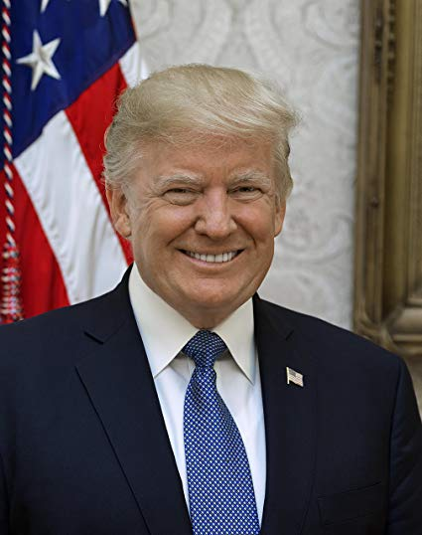
Credible Not Credible

Name ___________________________ Date _____________
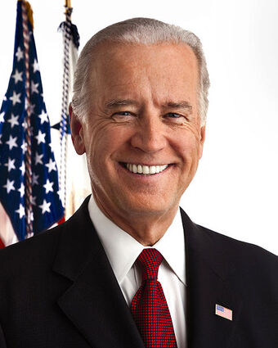

Credible Not Credible

Directions: Take these sources and cut them out. On the worksheets above, please paste in the correct columns if a source is credible or not credible.

Donald Trump Sources

”Donald Trump is the best president ever!” -Donald Trump’s Mom | Donald Trump was elected for president in 2016 - The White House
Donald Trump is the current President of the United States of America. - The White House | Donald Trump does not like chocolate chip cookies. - Donald Trump Fan Club
Donald Trump owns businesses. - Donald Trump INC. | Donald Trump is allergic to shellfish - Anti Donald Trump Fan Club
Donald Trump is the 50th President of the United States. -The White House | Donald Trump is Donald Duck - Not the Real Mickey Mouse
Donald Trump is a businessman runs a company. -Donald Trump INC | Donald Trump has purple hair - Not a real source.com

Joe Biden Sources

Joe Biden was the Vice President to former President Barack Obama- The White House | Joe Biden has one toe on his right foot- Barack Obama’s left foot
Joe Biden is an American politician. - The White House | Joe Biden invented donuts! -The Fake News
Joe Biden invented the first airplane. - Ms. Festa’s Aunt | Joe Biden was in the United States Senate from 1973 to 2009. - White House Records
Joe Biden knows the Tooth Fairy - the turtle from the petting zoo | Joe Biden was re-elected six times to be a senator- Joe Biden Biography
Joe Biden is in the Democratic Party - United States of America files | Joe Biden can do 100 jumping jacks in a row! - Mr. Sheehan’s Uncle

EXIT TICKET

Name ___________________________ Date _____________

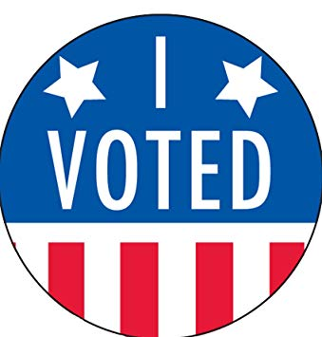
Directions: After you have sorted out your sources, now place your vote with who you would vote for president in the upcoming election

WRITE CANDIDATES NAME HERE

Formal Assessment

Name _________________________ Date _____________

Directions: Please write in the box below a couple things that would make a good president.

Now that you wrote what makes a good president, write a speech of your own with why you would be a good president.

