Grade Level: Fourth Grade
Industrial Revolution
Compelling Question:
How do we know what we learned about the inventors during the Industrial Revolution is true?
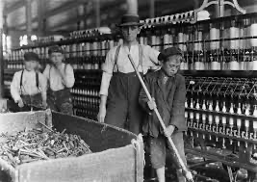
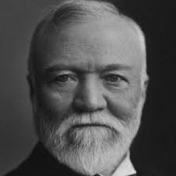
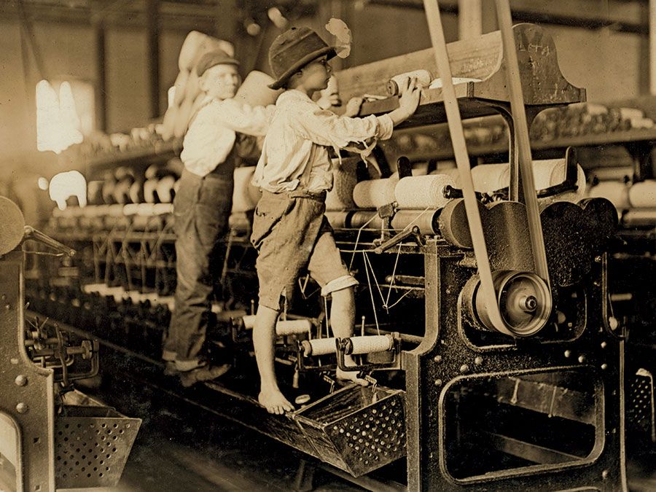
Narrative Background
For our unit, the overall goals are to allow the students to learn how to source and to corroborate facts in order to conclude whether or not the information presented about the inventors of the Industrial Revolution is supported. An additional goal is that the students will learn how to independently source and corroborate facts in order for them to do it in the future. Some materials in this unit plan are two books, Mr. Peabody’s Apples by Madonna and I Wanna Iguana by Karen Kaufman Orloff, along with primary and secondary sources.

Compelling Question: How do we know what we learned about the inventors during the Industrial Revolution is true?
Staging the Question: Have you ever looked at a new toy, and wondered, “why was this ever made?” or “Thank goodness someone created this toy!” In this unit, we will learn about the Industrial Revolution, explore why some of the inventions were created as well as how to source and how to corroborate.
Standards and Practices:
Social Studies: New York State Next Generation Social Studies Standards:
4.6e: Entrepreneurs and inventors associated with New York State have made important contributions to business and technology.
Students will research several people who made important contributions to business, technology, and New York State communities. Some people to consider include Thomas Jennings, Thomas Edison, Henry Steinway, John Jacob Bausch, Henry Lomb, Cornelius Vanderbilt, Lewis H. Latimer, Jacob Schoellkopf, Nikola Tesla, George Westinghouse, George Eastman, Amory Houghton, Willis Carrier, John D. Rockefeller, Edward H. Harriman, J.P. Morgan, Hetty Green, Emily Roebling, and Elisha Otis, and others, as locally appropriate.

Social Studies Practice Habits of Mind: Gathering, Interpreting and Using Evidence
Inquiry Arcs Standard: Evaluating Sources and Using Evidence

E.L.A.:New York Next Generation E.L.A. Standards:
4R1: Locate and refer to relevant details and evidence when explaining what a text says explicitly/implicitly and make logical inferences.
4R3: In informational texts, explain events, procedures, ideas, or concepts, including what happened and why, based on specific evidence from the text.
4W5: Draw evidence from literary or informational texts to respond and support analysis, reflection, and research by applying the grade 4 Reading Standards.

- Supporting Question:  - What is sourcing? Why is sourcing an important skill? | Formative Tasks:  After participating in a read-aloud of the book Mr. Peabody’s Apples and discussing the importance of sourcing and the use of primary sourcing questions, students will classify and sort sources by locating and referring to relevant details and evidence when explaining what the text says explicitly/implicitly and by making logical inferences, with no less than six sources correctly sorted. | Sources:  Buncee on Sourcing  Mr. Peabody’s Apples by Madonna  Primary and Secondary sources

2. Supporting Question:  What is corroboration? | Formative Tasks:  After reading the book, I Wanna Iguana, the students will locate and refer to relevant details and evidence when explaining what a text says explicitly/implicitly and the students will complete a worksheet by corroborating three statements from the book with the accurate source provided by the teacher along with finding additional sources for each statement, with an accuracy rate of two out of three. | Sources:  Book: I Wanna Iguana  Websites to determine whether the statements from the book are corroborated :  http://petiguanacare.org/food-diet/  http://www.greenigsociety.org/taming.htm  https://www.reptilevalley.com/iguanas/do-iguanas-make-a-sound/  http://www.anapsid.org/iguana/agesize.html  Worksheet

3. Supporting Question:  Who were some of the inventors and inventions of the American Industrial Revolution and what was their impact on New York State communities? | Formative Tasks:  After the students watch the “three most successful pitches on ‘Shark Tank’”, perform research, complete a worksheet, and role play as different inventors, the students will be able to research several people who made important contributions to business, technology, and New York State communities by performing a pitch to the “shark” (teacher) in “Shark Tank” and will include three out of four facts/benefits/impactfulness about the inventors and their inventions on New York State communities in their pitch. | Sources:  American Historama. (n.d.). Industrial revolution inventions. Retreived from http://www.american-historama.org/industrial-revolution-inventions.htm  American Historama (n.d.). Eli Whitney cotton gin. Retrieved from http://www.american-historama.org/1790-1800-new-nation/eli-whitney-cotton-gin.htm  American Historama (n.d.). Steamboats in the 1800s. Retrieved from http://www.american-historama.org/1801-1828-evolution/steamboats-of-1800s.htm  American Historama (n.d.). McCormick reaper. Retrieved from http://www.american-historama.org/1829-1841-jacksonian-era/mccormick-reaper.htm  Bellis, Mary. (2019, July 26). The history of steamboats. Retrieved from https://www.thoughtco.com/history-of-steamboats-4057901  Hilborn, S. (2016, Aug. 24). Winning shark tank pitches. Retrieved from https://www.britannica.com/biography/Cyrus-McCormickhttps://www.youtube.com/watch?v=k3PY_p_M-8w  History. (2019, Dec. 9). Erie canal. Retrieved from https://www.history.com/topics/landmarks/erie-canal  Longley, Robert. (2019, Dec. 6). Biography of Robert Fulton, inventor of the steamboat. Retrieved from https://www.thoughtco.com/robert-fulton-steamboat-4075444  New Georgia Encyclopedia. (2019). Eli Ehitney in georgia. Retrieved from https://www.georgiaencyclopedia.org/articles/history-archaeology/eli-whitney-georgia  O’Donnell, E.T. (2012, Oct. 21). The erie canal - the original economic stimulous plan. Retrieved from http://inthepastlane.com/erie-canal-this-week-oct-21-2012/  Sheehan, K. (2019). Revised read and retell (cotton gin). Retrieved from https://molloy.instructure.com/courses/15558/pages/module-5-making-history-come-alive-with-literacy-strategies?module_item_id=223339  Sheehan, K. (2019). Revised reading discovery (erie canal). Retrieved from https://molloy.instructure.com/courses/15558/pages/module-5-making-history-come-alive-with-literacy-strategies?module_item_id=223339  Study. (2019). Mechanical reaper: Invention, impact & facts. Retrieved from https://study.com/academy/lesson/mechanical-reaper-invention-impact-facts.html  Thwaites, R. G., State Historical Society of Wisconsin. (1909). Cyrus Hall McCormick and the reaper: (From the proceedings of the state historical society of Wisconsin for 1908). Madison [Wis.]: The Society.  Wilson, M.. (22, Oct. 2019). Cyrus McCormick. Retrieved from https://www.britannica.com/biography/Cyrus-McCormick

4. Supporting Question:  How do we know what we learned about the inventors during the Industrial Revolution is true? | Formative Tasks:  After the teacher explains and demonstrates how to use ‘USER’, students will get primary sources on inventors from the industrial revolution. They will take notes using ‘USER’ to organize and analyze their understanding, sourcing, elaboration, and reliability on their source. Students will have a clear understanding on how to find out if sources are reliable. | Sources:  A print depicting Robert  Fulton's steamboat, the  Clermont, which had its first successful journey in 1807.  (n.d.). Retrieved from https://dp.la/primary-source-  sets/full-steam-ahead-the-  Steam-engine-and-  transportation-in-the-nineteenth-century/sources/1100.  Cotton Gin and the Expansion of Slavery. (n.d.). Retrieved from https://dp.la/primary-source-sets/cotton-gin-and-the-expansion-of-slavery.  Fulton, R. (1797). Letter from Robert Fulton to President George Washington . Retrieved from https://www.eriecanal.org/texts/Fulton-1797.html.  “Mechanical Reaper Advertisement.” NCpedia, https://www.ncpedia.org/media/mechanical-reaper.

Summative Performance Task
Students will go home and write a one page reflection on our compelling question, “How do we know what we learned about the inventors during the American Industrial Revolution is true?”. Students will be required to give at least two examples from the week’s lessons.
Extension
For struggling students, they will be able to record their reflection on flipgrid.
Taking Informed Action
As a part of the unit, students can take part in Don’t Press Send. Students can reinforce what they have learned about the credibility and reliability of sources in this unit by joining in “Don’t Press Send” Pledge community. Don’t Press Send is a civic organization that educates students and empowers them to use technology responsibly and with good intent. The organization reinforces emotional life skills of discipline, responsible communication and writing, and mindfulness when using technology and social media. Some practices that students can carry out, acting as responsible citizens, are thinking before sending, not trusting everything they read on the internet or on social media, practicing safety and caution on social media, and using kind words when communicating with others.

http://www.nysed.gov/common/nysed/files/programs/curriculum-instruction/ss-framework-k-8a2.pdf

Lesson One
Molloy College
Division of Education
Student: Emily R. Sledge Professor Sheehan
Course EDU 5090 Date: December 12, 2019
Grade: 4 Topic: Sourcing Content Area: E.L.A.
STANDARDS AND INDICATORS
E.L.A.: New York State Next Generation E.L.A. Standard:
Domain: Reading
Cluster: Key Ideas and Details
Standard: 4R1: Locate and refer to relevant details and evidence when explaining what a text says explicitly/implicitly and make logical inferences.
Indicator: This will be evident when students classify and sort documents into primary and secondary sources as well as when students analyze the documents using the primary sourcing questions.

E.L.A.: New York State Next Generation E.L.A. Standard:
Domain: Speaking and Listening
Cluster: Comprehension and Collaboration
Standard: 4SL1: Engage effectively in a range of collaborative discussions with diverse partners, expressing ideas clearly, and building on those of others.
Indicator: This will be evident when students work in groups to classify and sort primary and secondary sources.

Social Studies: New York State Next Generation Social Studies Standard:
4.6 WESTWARD MOVEMENT AND INDUSTRIALIZATION: New York State played an important role in the growth of the United States. During the 1800s, people traveled west looking for opportunities. Economic activities in New York State are varied and have changed over time, with improvements in transportation and technology. (Standards: 1, 3, 4; Themes: MOV, TCC, GEO, ECO, TECH)
4.6e Entrepreneurs and inventors associated with New York State have made important contributions to business and technology.
Students will research several people who made important contributions to business, technology, and New York State communities. Some people to consider include Thomas Jennings, Thomas Edison, Henry Steinway, John Jacob Bausch, Henry Lomb, Cornelius Vanderbilt, Lewis H. Latimer, Jacob Schoellkopf, Nikola Tesla, George Westinghouse, George Eastman, Amory Houghton, Willis Carrier, John D. Rockefeller, Edward H. Harriman, J.P. Morgan, Hetty Green, Emily Roebling, and Elisha Otis, and others, as locally appropriate.

Social Studies Practice Habits of Mind: Gathering, Interpreting and Using Evidence
Indicator: This will be evident when students identify evidence and explain content, authorship, purpose, and format; identify bias; explain the role of bias and potential audience, with teacher support.

INSTRUCTIONAL OBJECTIVE(S)
After participating in a read-aloud of the book Mr. Peabody’s Apples and discussing the importance of sourcing and the use of primary sourcing questions, students will classify and sort sources by locating and referring to relevant details and evidence when explaining what the text says explicitly/implicitly and by making logical inferences, with no less than six sources correctly sorted.

DEVELOPMENTAL PROCEDURES (*Engaging the learner)
- MOTIVATION
Students will be invited to bring their attention to the SMART Board where a Buncee with the word Sourcing will be displayed. (Based on prior knowledge what is sourcing? What is a source? Where might we use sourcing in E.L.A.?)

- Teacher and students will discuss the concept of sourcing, primary and secondary and the importance of knowing where what the students read is coming from. Students will reflect on what they read that may or may not be considered a credible source. (What is sourcing? Who would like to share a source they think may is credible? Who would like to share a source they think may not be a credible source? Do you think the author's purpose is a major part of sourcing?)

3. Students will then discuss the primary sourcing questions which will be shown on the SMART Board. (Who wrote the document? What is the author’s perspective? What is the author’s purpose? Why was it written? Is the source reliable? Is the source credible?)

4. Students will then be invited to listen to the story, Mr. Peabody’s Apples. The teacher will ask the students why they believe it is important to know not only how to source documents but also the negative effect rumors/false information have due to the reliability and accuracy of what is said. (What happened to Mr. Peabody when Billy spread rumors about him stealing? How does the book relate to what we learned about sourcing? How can we “source” information given to us in our everyday lives? Why did Madonna write this book? How does she convey this?)

5. The teacher will introduce the activity for the lesson using primary sourcing questions. Students will be put into groups of three or four. Students will be instructed to classify and sort documents and excerpts into primary and secondary sources based on the primary sourcing questions. After the documents are sorted, students will choose one document and analyze it using the primary sourcing questions based on the information in the text. (Based on what we have discussed, how can you classify primary and secondary sources? How can you utilize the primary sourcing questions to help classify the documents/sources?)

6. Students will be instructed to work collaboratively in groups completing the activity while the teacher circulates the room assisting students who may have questions.

7. The teacher will ask for student volunteers to share their responses for their stories. (Who in this section would start by sharing what documents they were given? What document did you analyze? What sourcing questions did you use?)

ASSESSMENT (formal & informal)
Informal assessment
- Teacher will assess students’ understanding of sourcing through questioning.
- Teacher will assess how the students interact with peers during group work/discussion during a collaborative group activity.
Formal assessment
- Teacher will assess students’ understanding of sourcing by circulating and observing the groups sorting of documents.
- Teacher will assess understanding of content through the sourcing graphic organizer and concluding exit ticket.
INSTRUCTIONAL STRATEGIES
Strategy: Cooperative Learning
Indicator: This will be evident when students work in groups to classify documents as primary and secondary sources and to analyze one of the documents using sourcing questions.
Strategy: Scaffolding
Indicator: This will be evident when the teacher demonstrates how to analyze a document using sourcing questions.
INDEPENDENT PRACTICE
Students will find one primary or secondary source at home (the teacher will provide on to any student who may not have the resources readily available at home.) The students must analyze the document, article, book, etc, completing a graphic organizer by using the primary sourcing questions. The graphic organizer will be similar to the one used during the lesson to reiterate the skills of organization and sourcing.

REFERENCES

Madonna, & Long, L. (2003). Mr. Peabody’s Apples. New York: Callaway.

New York State Department of Education. New York State Next Generation ELA Standards. Learning Standard retrieved from: http://www.nysed.gov/common/nysed/files/programs/curriculum-instruction/nys-next-generation-ela-standards.pdf

Primary and Secondary Sources will be placed on these

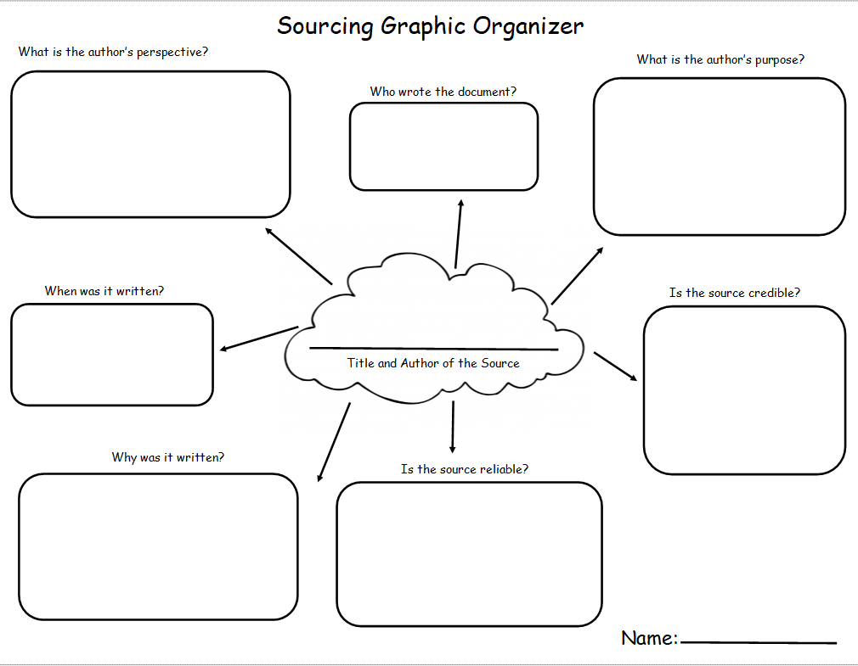
Lesson Two
Molloy College
Division of Education
Student: Jennifer Tortora Professor: Dr. Kevin Sheehan
Course EDU 5090 Date: December 12, 2019
Grade: 4 Topic: Corroboration Content Area: E.L.A

STANDARDS AND INDICATORS
E.L.A.: New York State Next Generation E.L.A. Standard:
Domain: Reading
Cluster: Key Ideas and Details
Standard: Locate and refer to relevant details and evidence when explaining what a text says explicitly/implicitly and make logical inferences.
Indicator: This will be evident when the students locate and refer to relevant details and evidence when explaining what a text says explicitly/implicitly when they read the sources to determine the corroboration of the statements.
E.L.A.: New York State Next Generation E.L.A. Standard:
Domain: Speaking and Listening
Cluster: Comprehension and Collaboration
Standard: 4SL1: Engage effectively in a range of collaborative discussions with diverse partners, expressing ideas clearly, and building on those of others.
Indicator: This will be evident when the students collaboratively discuss with diverse partners, expressing ideas clearly, and building on those of others when working in cooperative learning groups when completing the worksheet.
E.L.A.: New York State Next Generation E.L.A. Standard:
Domain: Writing
Cluster: Text Types and Purposes
Standard: 4W5: Draw evidence from literary or informational texts to respond and support analysis, reflection, and research by applying the grade 4 Reading Standards.
Indicator: This will be evident when the students draw evidence from literary or informational texts to reflect and research whether the statements from the book are corroborated.
Social Studies Practice Habits of Mind: Gathering, Interpreting and Using Evidence
Indicator: This will be evident when the students identify arguments of others from the book and then furthermore determine whether or not these statements are corroborated.
Inquiry Arcs Standard: Evaluating Sources and Using Evidence
Indicator: This will be evident when the students are evaluating whether sources are corroborating their statements.
Social Studies: New York State Next Generation Social Studies Standard:
4.6 WESTWARD MOVEMENT AND INDUSTRIALIZATION: New York State played an important role in the growth of the United States. During the 1800s, people traveled west looking for opportunities. Economic activities in New York State are varied and have changed over time, with improvements in transportation and technology. (Standards: 1, 3, 4; Themes: MOV, TCC, GEO, ECO, TECH)
4.6e Entrepreneurs and inventors associated with New York State have made important contributions to business and technology.
Students will research several people who made important contributions to business, technology, and New York State communities. Some people to consider include Thomas Jennings, Thomas Edison, Henry Steinway, John Jacob Bausch, Henry Lomb, Cornelius Vanderbilt, Lewis H. Latimer, Jacob Schoellkopf, Nikola Tesla, George Westinghouse, George Eastman, Amory Houghton, Willis Carrier, John D. Rockefeller, Edward H. Harriman, J.P. Morgan, Hetty Green, Emily Roebling, and Elisha Otis, and others, as locally appropriate.
INSTRUCTIONAL OBJECTIVE(S)
After reading the book, I Wanna Iguana, the students will locate and refer to relevant details and evidence when explaining what a text says explicitly/implicitly and the students will complete a worksheet by corroborating three statements from the book with the accurate source provided by the teacher along with finding additional sources for each statement, with an accuracy rate of two out of three.
DEVELOPMENTAL PROCEDURES (*Engaging the learner)
- Before the start of the lesson, the teacher will place four different statements from the book I Wanna Iguana with its QR codes around the room. It will be faced against the wall so the students cannot view it yet.
- Motivation: The teacher will start the lesson by reading the book I Wanna Iguana by Karen Kaufman Orloff. (Has anyone ever wanted a pet before? Did you have to convince your parents to get the pet? (LITERAL) Which animal did you want as a pet? Did you end up getting the pet? Did you have to convince your parents for a long time or a short time for the pet (LITERAL) What made you want the animal and why? (INFERENTIAL?) If you have a pet, what did you learn when you brought the animal home that you could not learn from a book? (METACOGNITIVE).
- After the teacher finishes the book, the students will begin a brief whole-group discussion to discuss how one may determine how a statement is factual by using corroboration. During the discussion, the teacher will explain how to corroborate statements. The teacher will be there as a support and will support the discussion with some of the questions to allow the students to think and discuss with each other (Can anyone remember what some of the statements from the book? What are some of these statements from the book? (LITERAL) Do you agree or disagree with some of the statements? (LITERAL) Which statements do you agree with? Why? Which statements do you disagree with? Why? (INFERENTIAL) How can we prove if the statements are true? What is corroboration? (LITERAL) Are the sources providing evidence or corroboration to support the statements? (LITERAL))
- The students will get into cooperative learning groups to complete an activity. With this activity, there will be four statements from the book for the students to corroborate with to ensu, They will pick three out of the four different statements from the book that are located on the walls around the room. For each statement, there will be one QR code underneath each statement for the students to scan, using ChromeBooks, to determine whether these statements are supported with facts.
- When the students have completed writing whether their statements are corroborated, they will use the ChromeBooks again to find an additional source to help prove that their statements fully supported. The teacher will be there as a support system.
- When the students are done with this worksheet, the class will come back as a group to discuss whether their statements were corroborated with the sources. (Was it interesting to find out which statements were corroborated by the sources? (LITERAL) What do other documents say about the statements? (LITERAL) Have you heard anything from someone and wondered if it was factual? (LITERAL) What are you going to do when told someone tells you something that you are unsure is true? (LITERAL) How would you corroborate a source? Why is it important to corroborate a statement? (INFERENTIAL) If there is advice that you could give someone about statements that they hear, what would you say?(METACOGNITIVE))
- As a way to end the lesson, the teacher will explain the homework for the night. The directions are that the students will have to create a checklist to help guide them in the future on ways to corroborate. On the checklist, they will provide questions they could ask themselves about how to corroborate along with statements that could help them to corroborate facts with the sources.
ASSESSMENT (formal & informal)
A formal assessment is the worksheet that the students complete as they need to successfully complete two out of the three statements, determine whether it is corroborated with the teacher provided source along with the additional source that the students will find independently in their groups. Another assessment is the exit ticket. An informal assessment is how the students work with their partners as well as the discussion that is being held during the small group and whole group discussion

INSTRUCTIONAL STRATEGIES
STRATEGY: Cooperative Groups
Indicator: This will be evident when the students work in cooperative groups to complete the worksheet.
Strategy: Whole Group Discussion
Indicator: This will be evident when the students and the teacher discuss the different statements that are from the book. In the discussion, they will communicate whether or not it is beneficial or not to corroborate a statement.
Strategy: Small Group Discussion
Indicator: This will be evident when the students communicate with their cooperative learning groups when completing the worksheet.
INDEPENDENT PRACTICE
For homework, the students will make a checklist to help guide future references on ways to corroborate. On the checklist, they will provide questions they could ask themselves about how to corroborate along with statements that could help them to corroborate facts with the sources.
INSTRUCTIONAL RESOURCES AND MATERIALS
Book (I Wanna Iguana by Karen Kaufman Orloff) Pencils
Worksheet ChromeBooks
QR codes with these websites:
http://petiguanacare.org/food-diet/
http://www.greenigsociety.org/taming.htm
https://www.reptilevalley.com/iguanas/do-iguanas-make-a-sound/
http://www.anapsid.org/iguana/agesize.html

REFERENCES
Do Iguanas Make a Sound? (n.d.). Retrieved from https://www.reptilevalley.com/iguanas/do-iguanas-make-a-sound/.
Food & Diet. (n.d.). Retrieved from http://petiguanacare.org/food-diet/.
Kaplan, M. (2014, January 1). Iguana Age and Expected Size. Retrieved from http://www.anapsid.org/iguana/agesize.html.
New York State English Language Next Generation English Language Arts Standards. New York State Education Department (2017). Received http://www.nysed.gov/common/nysed/files/programs/curriculum-instruction/nys-next-generation-ela-standards.pdf
Rigertas, N., Spielman, D., Baze, D., & Wong, D. (n.d.). The Green Iguana Society. Retrieved from http://www.greenigsociety.org/taming.htm.

Statement 1:
Green iguanas can grow to be over six feet long

Statement 2:
If I had an iguana, I could teach it tricks and things.

Statement 3:
Iguanas are really quiet.
Statement 4:
I would feed the iguana lettuce

Name: ________________________________________________Date:__________________
Directions: Go around the room and pick 3 statements. First, write down each statement you pick then scan the QR code for each statement. When you scan the QR code, write down if each statement is supported by evidence from the website.
- Statement:_______________________________________________________________________________________________________________________________________________________________________________________________________________________________________________________________________________________Is it supported by the website? How so?: _______________________________________ _______________________________________________________________________________________________________________________________________________________________________________________________________________________________________________________________________________________________
- Statement:_______________________________________________________________________________________________________________________________________________________________________________________________________________________________________________________________________________________________________________________________________________________________________________________________________________________________________Is it supported by the website? How so?: _______________________________________ ________________________________________________________________________________________________________________________________________________________________________________________________________________________________________________________________________________________________
- Statement:_______________________________________________________________________________________________________________________________________________________________________________________________________________________________________________________________________________________________________________________________________________________________Is it supported by the website? How so?:_______________________________________ _______________________________________________________________________________________________________________________________________________________________________________________________________________________________________________________________________________________________Turn the page over
Directions: Now it is your turn! Find an additional source for each statement that you picked to make sure that each statement is fully supported. You could open up Microsoft Word document to complete this part of the assignment. Just remember to save it!
- Statement:_______________________________________________________________________________________________________________________________________________________________________________________________________________________________________________________________________________________Source: _________________________________________________________________ _______________________________________________________________________________________________________________________________________________________________________________________________________________________________________________________________________________________________
- Statement:_______________________________________________________________________________________________________________________________________________________________________________________________________________________________________________________________________________________________________________________________________________________________________________________________________________________________________Source: _________________________________________________________________ ______________________________________________________________________________________________________________________________________________________________________________________________________________________________________________________________________________________________
- Statement:_______________________________________________________________________________________________________________________________________________________________________________________________________________________________________________________________________________________Source: _________________________________________________________________ ________________________________________________________________________________________________________________________________________________________________________________________________________________________________________________________________________________________________

Lesson Three
Molloy College
Division of Education
Student Allison Fleming Professor Sheehan
Course EDU 5090 Date December 12th, 2019
Grade 4 Topic Industrial Revolution Content Area Social Studies and ELA

STANDARDS AND INDICATORS

Social Studies Standard:

4.6 WESTWARD MOVEMENT AND INDUSTRIALIZATION: New York State played an important role in the growth of the United States. During the 1800s, people traveled west looking for opportunities. Economic activities in New York State are varied and have changed over time, with improvements in transportation and technology. (Standards: 1, 3, 4; Themes: MOV, TCC, GEO, ECO, TECH)

4.6e Entrepreneurs and inventors associated with New York State have made important contributions to business and technology.
Students will research several people who made important contributions to business, technology, and New York State communities. Some people to consider include Thomas Jennings, Thomas Edison, Henry Steinway, John Jacob Bausch, Henry Lomb, Cornelius Vanderbilt, Lewis H. Latimer, Jacob Schoellkopf, Nikola Tesla, George Westinghouse, George Eastman, Amory Houghton, Willis Carrier, John D. Rockefeller, Edward H. Harriman, J.P. Morgan, Hetty Green, Emily Roebling, and Elisha Otis, and others, as locally appropriate.

Indicator: This will be evident when the students are able to role play different inventors and pitch their inventions and their impact on New York State communities to the “sharks” (teacher) in “Shark Tank” and will include three out of four facts/benefits/impactfulness about the inventors and their inventions on New York State communities in their pitch.

ELA Standard:
4R3: In informational texts, explain events, procedures, ideas, or concepts, including what happened and why, based on specific evidence from the text.

Indicator: This will be evident when the students use the research they gathered to discuss inventions and inventors, the reasoning behind the invention, and the benefits of the invention on New York State communities in a “Shark Tank” pitch.

Habits of Mind Practices:
B. Chronological Reasoning
5. Distinguish between long-term and immediate causes and effects of an event from current events or history.

Indicator: This will be evident when the students will discuss the impact of the invention on New York State communities in their “Shark Tank” pitch.

Inquiry Arcs Standard:
Evaluating Sources and Using Evidence

Indicator: This will be evident when the students perform research on their inventors and their inventions and use their research in writing a successful “Shark Tank” pitch.

INSTRUCTIONAL OBJECTIVE(S)

After the students watch the “three most successful pitches on ‘Shark Tank’”, perform research, complete a worksheet, and role play as different inventors, the students will be able to research several people who made important contributions to business, technology, and New York State communities by performing a pitch to the “shark” (teacher) in “Shark Tank” and will include three out of four facts/benefits/impactfulness about the inventors and their inventions on New York State communities in their pitch.

DEVELOPMENTAL PROCEDURES (*Engaging the learner)
- MOTIVATION: Teacher will have the students watch the “three most successful pitches” from the show “Shark Tank”: https://www.youtube.com/watch?v=k3PY_p_M-8w
- Students will take notes while performing a turn and talk with their peers about what made these “Shark Tank” pitches successful. (Were these pitches successful? (Literal) Why do you think these ptiches were successful? (Metacognitive) What did they have in common? (Inferential) Did they show a demonstration of the product or invention? (Literal))
- Students will get into cooperative learning groups and perform research on a specific inventor and their invention during the American Industrial Revolution (Who is your inventor? (Literal) What did he invent? (Literal) How did it impact society? (Inferential) How did it impact New York State communities? (Inferential) Why was the invention created? (Inferential) What was the problem that was happening for the invention to be created? (Inferential) Why do you think this invention was created? (Metacognitive) Was it beneficial to New York State communities? Why or Why not? (Metacognitive)).
- Students will complete a worksheet that will help guide them in writing their pitch.
- Students will write their pitch and included three to four facts/benefits/impacts on the inventor and the invention to New York State communities.
- Students will role play being the inventor and pitch the “shark” (teacher) their invention.
- The teacher will invest in the student’s invention and give feedback as to why they would.

ASSESSMENT (formal & informal)
Informal assessment
The informal assessment will be when the students complete the “Shark Tank” questionnaire.

Formal assessment
The formal assessment will be the pitch the students perform to the “shark” (teacher) that will include three out of four facts/benefits/impacts on New York State communities.

INSTRUCTIONAL STRATEGIES
Turn and Talk
Indicator: This will be evident when the students take notes and have a turn and talk with their peers about why the three pitches in the “Shark Tank” video were successful.

Cooperative Learning
Indicator: This will be evident when the students get into small groups to conduct research and create a pitch to perform to the “shark” (teacher) and will include three out of four facts about the inventors and their inventions and its impact on New York State communities

INDEPENDENT PRACTICE

Students will be able to write a reflection on their experience role playing as an inventor on “Shark Tank”. In this reflection, they will be able to write about their experience researching the inventor they had and their inventions as well as write about their thoughts on the invention. For example, they can talk about if they feel that their invention they researched was beneficial to New York State communities or not or if it had a positive or negative impact on American society as a whole.

REFERENCES

American Historama. (n.d.). Industrial revolution inventions. Retreived from http://www.american-historama.org/industrial-revolution-inventions.htm
American Historama (n.d.). Eli Whitney cotton gin. Retrieved from http://www.american-historama.org/1790-1800-new-nation/eli-whitney-cotton-gin.htm
American Historama (n.d.). Steamboats in the 1800s. Retrieved from http://www.american-historama.org/1801-1828-evolution/steamboats-of-1800s.htm
American Historama (n.d.). McCormick reaper. Retrieved from http://www.american-historama.org/1829-1841-jacksonian-era/mccormick-reaper.htm
Bellis, Mary. (2019, July 26). The history of steamboats. Retrieved from https://www.thoughtco.com/history-of-steamboats-4057901
Hilborn, S. (2016, Aug. 24). Winning shark tank pitches. Retrieved from https://www.britannica.com/biography/Cyrus-McCormickhttps://www.youtube.com/watch?v=k3PY_p_M-8w
History. (2019, Dec. 9). Erie canal. Retrieved from https://www.history.com/topics/landmarks/erie-canal
Longley, Robert. (2019, Dec. 6). Biography of Robert Fulton, inventor of the steamboat. Retrieved from https://www.thoughtco.com/robert-fulton-steamboat-4075444
New Georgia Encyclopedia. (2019). Eli Ehitney in georgia. Retrieved from https://www.georgiaencyclopedia.org/articles/history-archaeology/eli-whitney-georgia
O’Donnell, E.T. (2012, Oct. 21). The erie canal - the original economic stimulous plan. Retrieved from http://inthepastlane.com/erie-canal-this-week-oct-21-2012/
Sheehan, K. (2019). Revised read and retell (cotton gin). Retrieved from https://molloy.instructure.com/courses/15558/pages/module-5-making-history-come-alive-with-literacy-strategies?module_item_id=223339
Sheehan, K. (2019). Revised reading discovery (erie canal). Retrieved from https://molloy.instructure.com/courses/15558/pages/module-5-making-history-come-alive-with-literacy-strategies?module_item_id=223339
Study. (2019). Mechanical reaper: Invention, impact & facts. Retrieved from https://study.com/academy/lesson/mechanical-reaper-invention-impact-facts.html
Thwaites, R. G., State Historical Society of Wisconsin. (1909). Cyrus Hall McCormick and the reaper: (From the proceedings of the state historical society of Wisconsin for 1908). Madison [Wis.]: The Society.
Wilson, M.. (22, Oct. 2019). Cyrus McCormick. Retrieved from https://www.britannica.com/biography/Cyrus-McCormick

Name: ___________________________ Date: __________________
Shark Tank Pitch Questionnaire

- Who is your inventor and what is invention will you be pitching to the sharks?

- Why was this invention created? What was the problem that this invention fixed?

- What were the benefits of this invention on New York State communities?

- How much of an investment are you asking from the Sharks and how much equity will they get from your company after they invest?

Background Information on the Cotton Gin:

The most important plantation crop in the South was cotton. The South’s warm weather and rich soil had always been good for growing cotton. Cotton growers generally made little money until Eli Whitney invented the cotton gin in 1793. The cotton gin separated the seeds from cotton with a speed that changed the nature of the industry. Cotton could now be mass-produced and cotton growers now sought more land and more slaves. This machine cleaned cotton at a rate fifty times faster than they had ever been able to clean cotton before. By 1860, three quarters of the world’s cotton was now grown on Southern plantations.

(Dr. Kevin Sheehan, 2019)

Reading Discovery: The Erie Canal
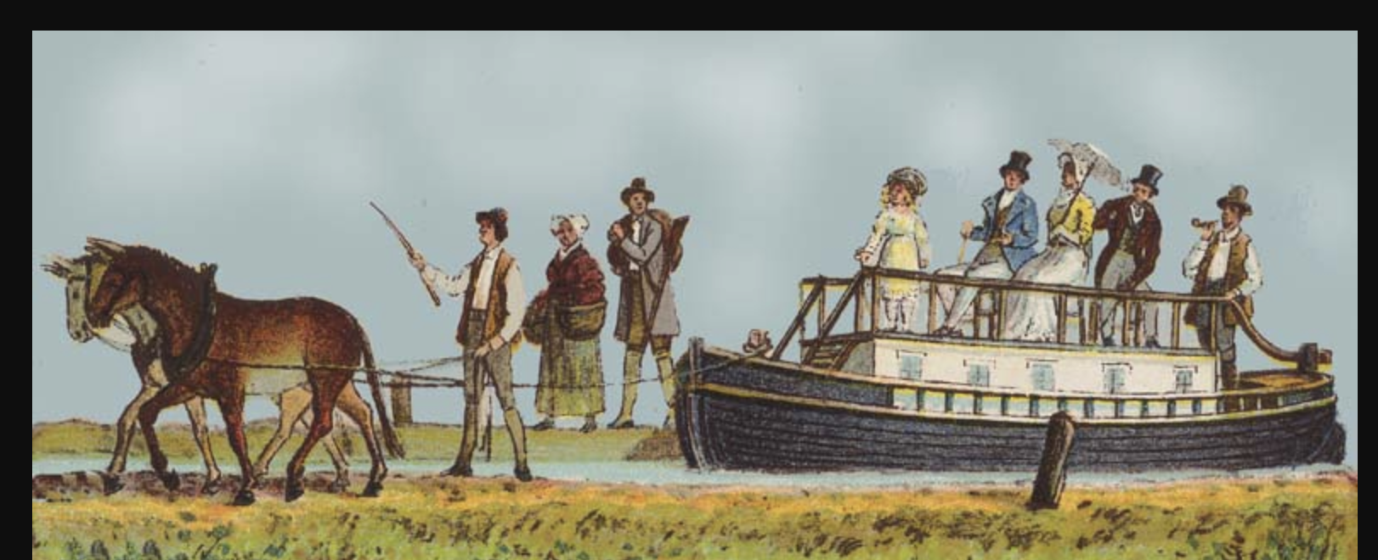

The Erie Canal, a man-made 363-mile waterway, connected Albany and Buffalo in 1825. The canal was originally opposed by New York City as a project designed to specifically to benefit the farmers of Western New York State. Luckily, Governor DeWitt Clinton overcame the resistance of New York City. The canal made it possible for farm goods to be moved from Buffalo to Albany and even New York City. This changed farming and life in Western New York dramatically. Farms moved from being self-sufficient operations to farms that could now grow large cash crops for sale throughout the state. Life in Western New York changed drastically as farmers now entered the world of specialization and mass production. The self-sufficient farm that met all its need was now gone. The age of Homespun, when a family accounted for all their own needs including homespun clothing, now ended.
The effect on New York City was even more dramatic as goods produced in New York City could now be sold in markets all over the state. Coupled with the steam-powered boats on the Hudson, shipping costs were reduced by 95%. New York became the most important commercial city in the world. In fact, New York City became the leading port in the world. The canal also became a gateway to the west for migrants and tourists and even ideas. The economy of the state now became interdependent. For the first time in western New York, crops could be shipped to New York and even sold to world markets.. Life was changed forever by the Erie Canal. Not everyone appreciated the changes as those along the canal waterway saw life change dramatically. The canal brought not only the goods of New York City, but the values as well. Young man sought to live life in the big city and migrated to New York City in large numbers. Life would never be the same. The days of farmers who met all their own needs was gone forever.

(Dr. Kevin Sheehan, 2019)

Lesson Four
Molloy College
Division of Education

Student: Alexandria DelVecchio Professor: Sheehan
Course: EDU 5090 Date: December 5th, 2019
Grade: 4 Topic: Industrial Revolution Content Area: Social Studies & ELA

STANDARDS AND INDICATORS
4.6 WESTWARD MOVEMENT AND INDUSTRIALIZATION: New York State played an important role in the growth of the United States. During the 1800s, people traveled west looking for opportunities. Economic activities in New York State are varied and have changed over time, with improvements in transportation and technology. (Standards: 1, 3, 4; Themes: MOV, TCC, GEO, ECO, TECH)
4.6e Entrepreneurs and inventors associated with New York State have made important contributions to business and technology. Students will research several people who made important contributions to business, technology, and New York State communities. Some people to consider include Thomas Jennings, Thomas Edison, Henry Steinway, John Jacob Bausch, Henry Lomb, Cornelius Vanderbilt, Lewis H. Latimer, Jacob Schoellkopf, Nikola Tesla, George Westinghouse, George Eastman, Amory Houghton, Willis Carrier, John D. Rockefeller, Edward H. Harriman, J.P. Morgan, Hetty Green, Emily Roebling, and Elisha Otis, and others, as locally appropriate.
Indicator: This will be evident when the students are able to research different inventors and their inventions from the Industrial Revolution with primary resources by using ‘USER’ to determine whether the resources are reliable sources.
ELA Standard:
Domain: Reading
Cluster: Key Ideas and Details
Standard: 4R3: In informational texts, explain events, procedures, ideas, or concepts, including what happened and why, based on specific evidence from the text.
Indicator: This will be evident when the students are able to discuss inventors and their inventions with details and reasoning on the primary source by using ‘USER’ to determine the sources reliability.
Social Studies Practice Habits of Mind: Gathering, Interpreting and Using Evidence
Indicator: This will be evident when students recognize and effectively select different forms of evidence used to make meaning in social studies (including primary and secondary sources such as art and photographs, artifacts, oral histories, maps, and graphs).
Inquiry Arcs Standard: Evaluating Sources and Using Evidence
Indicator: This will be evident when the students are evaluating whether their resources are reliable sources.
INSTRUCTIONAL OBJECTIVE(S)
Students will be able to use ‘USER’ (Understand Sourcing Elaborate Reliable) in order to determine how primary documents on inventors of the industrial revolution are reliable. At the end of the lesson, students will be able to give a reflection on our compelling question, “How do we know what we learned about the inventors during the American Industrial Revolution is true?” Students will be able to give at least two examples from the week’s lessons.

DEVELOPMENTAL PROCEDURES (*Engaging the learner)
- MOTIVATION Teacher will have students turn and talk about what kind of articles they looked at yesterday. (Who were the inventions? What were the inventions? What kind of articles were we looking at?)
- Teacher will review what a reliable source consists of and will go over ‘USER’ (Understand Sourcing Elaborate Reliable) using primary resources. (Can you find any clues on what it is about? Who wrote the document? What is some important detail? Is this a reliable/credible source?)
- Students will get into cooperative learning groups with a partner and handed a primary resource on inventors from the industrial revolution.
- Students will use ‘USER’ to take notes on each of the resources just how we did as a class. (What do you understand is going on in this article? When was it written? Are there any facts? Is this a reliable/credible source? Why?)
- Papers will be collected for teacher to make sure students have a clear understanding on how to find out if a source is reliable on the industrial revolution.
- The correct answers for the classwork will be reviewed as a class.
ASSESSMENT (formal & informal)
Informal assessment
· Group discussion and group interaction while completing the ‘USER’ worksheet on primary resources during the industrial revolution.
Formal assessment
· Student’s complete ‘USER’ worksheet
· Reflection on our compelling question, “How do we know what we learned about the Industrial Revolution is true?”

INSTRUCTIONAL STRATEGIES
Demonstration
Indicator: This will be evident when the teacher explains to the students the term, ‘USER’, and does an example together with them as a class.
Turn and Talk
Indicator: This will be evident when the students have a turn and talk with their neighbors on what they learned yesterday and are able to tell the teacher about reliable and credible sources.
Cooperative Learning
Indicator: This will be evident when the students work with a partner to look over their primary resource and work together to take notes using ‘USER’.
Scaffolding
Indicator: This will be evident when the teacher walks around to the different groups helping the students with any questions that they have on their specific primary source.
INDEPENDENT PRACTICE
Students will go home and write a one page reflection on our compelling question, “How do we know what we learned about the inventors during the American Industrial Revolution is true?” Students will be required to give at least two examples from the week’s lessons.

For struggling students, they will be able to record their reflection on flipgrid.

REFERENCES
A print depicting Robert Fulton's steamboat, the Clermont, which had its first successful journey
in 1807. (n.d.). Retrieved from https://dp.la/primary-source-sets/full-steam-ahead-the-
steam-engine-and-transportation-in-the-nineteenth-century/sources/1100.

Cotton Gin and the Expansion of Slavery. (n.d.). Retrieved from https://dp.la/primary-source-
sets/cotton-gin-and-the-expansion-of-slavery.

Fulton, R. (1797). Letter from Robert Fulton to President George Washington . Retrieved from
https://www.eriecanal.org/texts/Fulton-1797.html.

“Mechanical Reaper Advertisement.” NCpedia, https://www.ncpedia.org/media/mechanical-
reaper.

Next Generation Learning Standards. Retrieved from http://www.nysed.gov/next-generation-
learning-standards

Name___________________________________________________________
Directions: Use ‘USER’ (Understand Sourcing Elaborate Reliable) to determine if your document is reliable and credible?
U (Understand)  What do you understand?  What is the title/heading?  What stands out? | S (Sourcing)  Who wrote the document?  What is the author’s purpose?  Why was it written?  When was it written?
E (Elaborate)  What are the important details?  What are the facts?  What can you conclude? | R (Reliability)  Is the source reliable?  Is the source credible?  Why?

U | S
E | R
