GRADE 6

Did the character traits of Marco Polo and Ibn Battuta create the beginnings of the interconnected world we know today?

Student Name_____________________
Date______________________________

Part III: This part consists of a document-based question. On this part, you will be provided with one version of the test based on your readiness to handle critical thinking challenges. (You may opt for a more difficult version than your teacher provides, but you will be graded on the version that you complete.

Document Based Question

Directions: The task below is based on documents 1 through 5-6. The task is designed to test your ability to work with documents. Examine each document and answer all questions beneath the document. Use the answers to the questions to help write your essay.

Background: Marco Polo and Ibn Battuta were explorers that started their travels at a young age. Marco Polo traveled from Italy to China from 1271 to 1295. He remained in China for a few years documenting their culture and establishing relationships for diplomacy and trade. Ibn Battuta traveled from Tangier to Mecca from 1325 to 1354. His travels were part of his Pilgrimage to Islam’s holiest city. Along the way, Battuta recorded his travels to over 40 countries and covered over 75,000 miles of land and sea.

Task: Use the information from the documents and your knowledge of social studies, write an essay in which you:
Use the information from the documents and your knowledge of social studies, write an essay in which you.

- Discuss: What psychologists have defined as character strengths.
- Discuss: How Ibn Battuta and Marco Polo created an interconnected world from their travels.
- Evaluate: If the character traits of Marco Polo and Ibn Battuta led to their adventures and helped create an interconnected world.

In your essay remember to:
- Write an opinion essay, arguing whether the character strengths of Marco Polo and Ibn Battuta created the beginnings of the interconnected world we know today
- Include an introduction, a body, and a conclusion
- Use information from at least three documents in your answer
- Include historical facts, relevant details, and reason in developing your ideas

Document #1:

Character Strengths are the positive parts of your personality that impact how you think, feel and behave and are the keys to you being your best self. When applied effectively they are beneficial both to you and society as a whole. They are different than your other strengths, such as your unique skills, talents, interests and resources, because character strengths reflect the "real" you — who you are at your core.

- VIA Institute on Character

1. According to the document, what are character strengths?
__________________________________________________________________________

_______________________________________________________________________ [1]

2. Referring to the text, what are the benefits of having good character strengths?
__________________________________________________________________________

_______________________________________________________________________ [1]

Document #2:
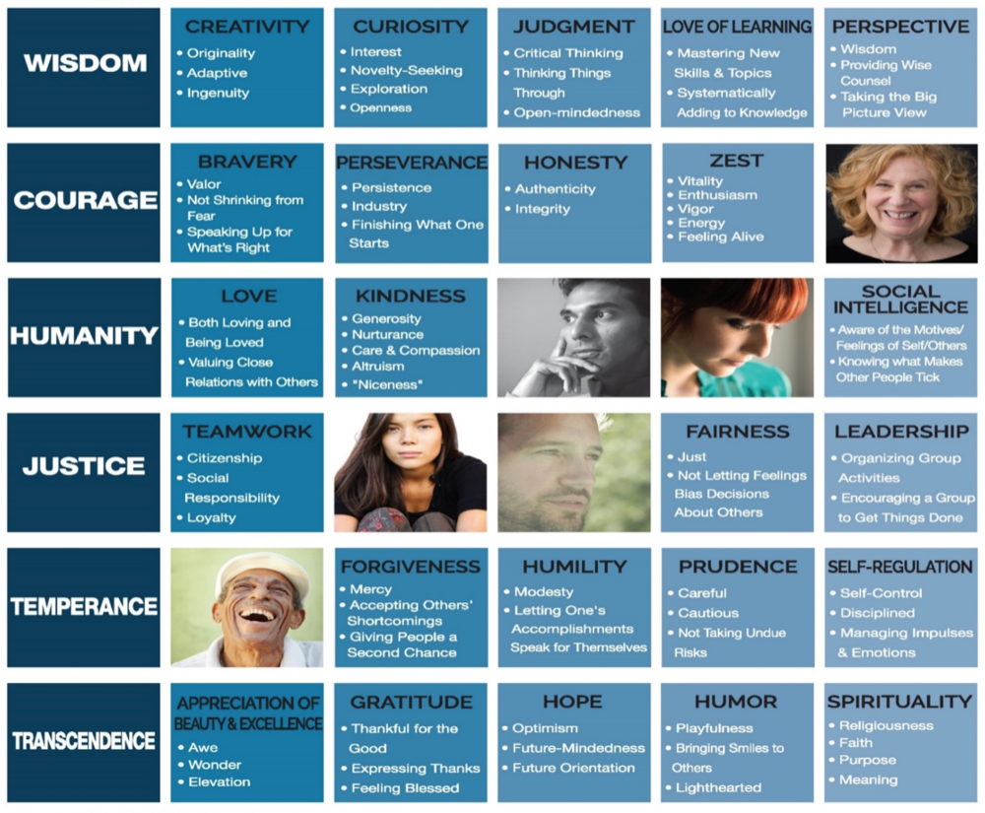

VIA has identified six classes of virtues (listed on the far left of the chart, e.g. Wisdom, Courage, Humanity, Justice, Temperance, Transcendence) that are made up of 24 character strengths. Every individual possesses all 24 character strengths in different degrees, giving each person a unique character profile.

1. According to the document, what are the six virtues?

_______________________________________________________________________ [1]
2. What are the four character strengths that make up the virtue of Courage in the document?

__________________________________________________________________________

_______________________________________________________________________ [1]

Document #3:
“Marco Polo (1254-1324) was a merchant from Venice,Italy. As a member of a wealthy merchant family in Venice, he was both a well-educated businessman and keen observer. In 1271, at the young age of 17, he traveled with his father and uncle across Persia along the Silk Road to China, ending in present-day Beijing. Marco Polo served under the Mongol leader Kublai Khan as a messenger for the emperor. He traveled extensively throughout Asia for 20 years, marveling at China’s progress and splendor under the Yuan Dynasty. Eventually, Marco Polo returned and described his journey in a book.”
- Anonymous
1. According to the document, where did Marco Polo travel?

_______________________________________________________________________ [1]

2. Referring to the text, what experiences did Marco Polo have that could inform the people in Europe about life in China?
__________________________________________________________________________

_______________________________________________________________________ [1]

Document #4:
“Ibn Battuta started on his travels when he was 20 years old in 1325. His main reason to travel was to go on a Hajj, or a Pilgrimage to Mecca, as all good Muslims want to do. But his traveling went on for about 29 years and he covered about 75,000 miles visiting the equivalent of 44 modern countries which were then mostly under the governments of Muslim leaders of the World of Islam, or "Dar al-Islam".

Near the end of Ibn Battuta's own life, the Sultan of Morocco insisted that Ibn Battuta dictate the story of his travels to a scholar and today we can read translations of that story called "Rihla - My Travels". Much of it is fascinating, but some of it seems to be made up and even is inaccurate about places we know about. However, it is a valuable and interesting record of places which add to our understanding of the Middle Ages.”

-The source is: Ibn Battuta, Travels in Asia and Africa 1325-1354, tr. and ed. H. A. R. Gibb (London: Broadway House, 1929)

1. According to the document, how extensively did Ibn Battuta travel?

_______________________________________________________________________ [1]

2. Based on document one, what character strengths did Ibn Battuta need to live the style of life that he did?

__________________________________________________________________________

_______________________________________________________________________ [1]

Document #5

“I left Tangier, my birthplace, on Thursday, June 14, 1325, being at that time twenty-two years of age, with the intention of making the Pilgrimage to the Holy House Mecca and the Tomb of the Prophet at Medina. I set out alone, finding no companion to cheer the way with friendly intercourse, and no party of travellers with whom to associate myself. Swayed by an overmastering impulse within me, and a long-cherished desire to visit those glorious sanctuaries, I resolved to quit all my friends and tear myself away from my home.”
- Travels In Asia and Africa, 1325-1354 by Ibn Battuta (P. 43)
1. According to the document, when did Ibn Battuta leave his home? How old was he?

_______________________________________________________________________ [1]

2. What character strength does this demonstrate?

_______________________________________________________________________ [1]

Document #6
"Sometimes in the night travelers hear a noise like the clatter of a great company of riders away from the road; if they believe that these are some of their own company and head for the noise, they find themselves in deep trouble when daylight comes and they realize their mistake....For this reason bands of travelers make a point of keeping very close together. Before they go to sleep they set up a sign pointing in the direction in which they have to travel, and round the necks of all their beasts they fasten little bells, so that by listening to the sound they may prevent them from straying off the path."

- Marco Polo, Travels (Primary Source)

1. According to the document, what was a way travelers avoided danger when traveling at night?
________________________________________________________________________

_______________________________________________________________________ [1]

2. What character strength does this demonstrate? ________________________________________________________________________
_______________________________________________________________________ [1]

Document Based Question

Directions: The task below is based on documents 1 through 5-6. The task is designed to test your ability to work with documents. Examine each document and answer all questions beneath the document. Use the answers to the questions to help write your essay.

Background: Marco Polo and Ibn Battuta were explorers that started their travels at a young age. Marco Polo traveled from Italy to China from 1271 to 1295. He remained in China for a few years documenting their culture and establishing relationships for diplomacy and trade. Ibn Battuta traveled from Tangier to Mecca from 1325 to 1354. His travels were part of his Pilgrimage to Islam’s holiest city. Along the way, Battuta recorded his travels to over 40 countries and covered over 75,000 miles of land and sea.

Task: Use the information from the documents and your knowledge of social studies, write an essay in which you:
Use the information from the documents and your knowledge of social studies, write an essay in which you.

- Discuss: What psychologist have defined as character strengths.
- Discuss: How Ibn Battuta and Marco Polo created an interconnected world from their travels.
- Evaluate: If the character traits of Marco Polo and Ibn Battuta led to their adventures and helped create an interconnected world.

In your essay remember to:
- Write an opinion essay, arguing whether the character strengths of Marco Polo and Ibn Battuta created the beginnings of the interconnected world we know today
- Include an introduction, a body, and a conclusion
- Use information from at least three documents in your answer
- Include historical facts, relevant details, and reason in developing your ideas

