The Northwest Passage
In the 1400s, many Europeans believed there was a water route across North America to Asia that would aid in trading goods such as spices, jewels and silk. The search for this water route occurred in Northern Canada, through arctic waters. Explorers called this route the Northwest Passage, but it was never made successfully. For over 300 years, European Explorers tried to make the journey, all ending in failure. In 1835, Sir John Franklin of Britain attempted to lead a team through the Northwest Passage. Neither he, or any of his crew members survived the journey.
The Northwest Passage was finally navigated in the 1900s, however the ship that made the journey was an icebreaker. Today, there is a debate over which country owns the claims to the Northwest Passage. While Canada claims the arctic waters, other countries like the U.S. and European nations believe the passage is an international strait.
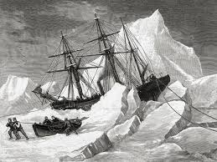
1.______________________________
2._____________________________
3._____________________________
4._____________________________
5._____________________________

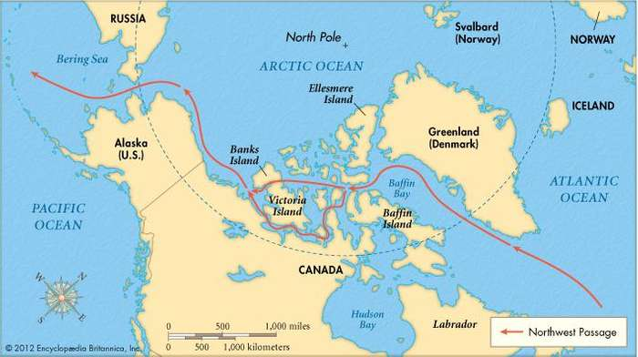
Now try to guess your partner’s!
1.
2.
3.
4.
5.

French Explorers in Canada
In the 1500s, European Explorers who wanted to find a new water route to Asia found Canada and began to claim land. France claimed the area around the St. Lawrence River in 1534 and called the area New France. The French sent explorers, settlers, and missionaries to New France and they founded several cities. The first was the trading post at Quebec. The traded with the Natives for beaver furs, which the French sold in Europe for a lot of money. The French fur traders were called voyageurs, which means “travelers” in French. The voyageurs traveled by canoes across the Great Lakes to trade fabrics, guns, and other goods for beaver fur. The fur trade became very popular and everyone back in Europe wanted to wear a beaver hat.
Many of the cities and waterways in Canada still have French roots today. Lake Champlain, the St. Croix River, Montreal, and Quebec are some that have French influence. Also, about 20% of Canada’s population speaks French today.
1.______________________________
2._____________________________
3._____________________________
4._____________________________
5._____________________________
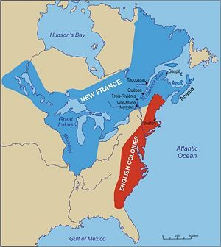

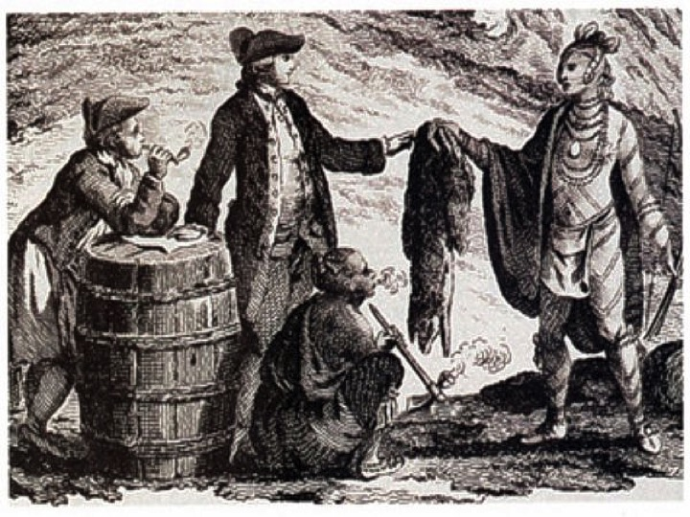

Now try to guess your partner’s!
1.
2.
3.
4.
5.

French Loss to the English
During the 1600s and 1700s, the English and French were fighting each other for territory around the globe. While the French ruled New France in Canada, the English controlled the 13 colonies to the south. Soon, conflict erupted between the two nations known as the Seven Year’s War from 1754 to 1763, also known as The French and Indian War. The French asked the Natives for assistance during the war, called an ally. However, warfare and disease killed many of the Natives by this time. Many of the fighting and battles occurred in the New France area, and south into the northern colonies. While the French won some of the beginning battles of the war, the British ultimately took the upper hand towards the end at the Battle of Quebec in 1759 and the Battle of Montreal in 1760.
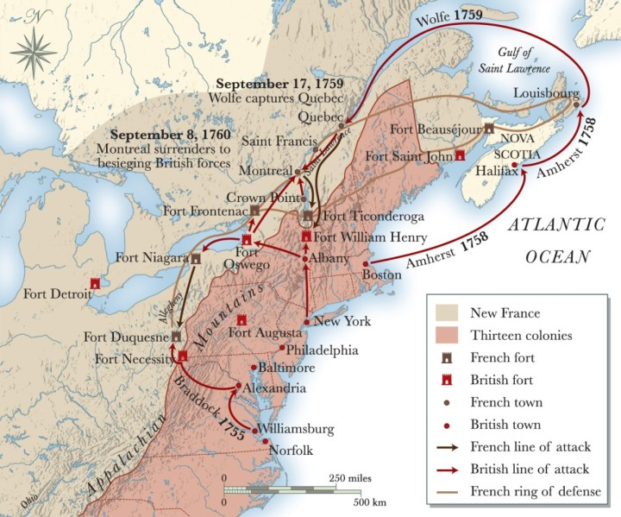
The French lost the war to the British, and the Treaty of Paris was signed in 1763. This treaty not only ended the war but ended the French control of Canada. Britain now controlled Canada and all French land east of the Mississippi.
1.______________________________
2._____________________________
3._____________________________
4._____________________________
5._____________________________

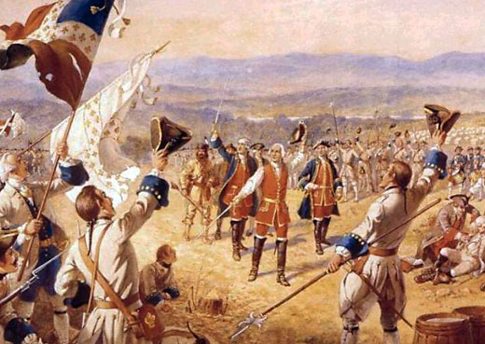

Now try to guess your partner’s!
1.
2.
3.
4.
5.

Rubric for Act It Out Performances
Historical  Accuracy  6pts | Performance contains three relevant facts from the passage | Performance contains one or two relevant facts from the reading | Performance contains no accurate facts from the reading
Performance  Quality  2pts | All students are involved in the skit and are able to be heard by the audience | All students are involved, but some minimally. Sometimes it is hard to hear the actors | Not all students are part of the skit and/or the actors cannot be heard
Creativity and  Passion  2pts | The performance brings to life the historical event in a unique way by student use of dramatic props. | The performance is entertaining but it does not bring to life the concept from the passage. Actors use props minimally | The performance lacks creativity and actors do not use props

Group Topic_______________________ Total Points_________

