Was the Industrial Revolution Fueled by a Growth Mindset?

DOCUMENT-BASED QUESTION
This question is based on the accompanying documents. The question is designed to test your ability to work with historical documents. Some of these documents have been edited for the purposes of this question. As you analyze the documents, take into account the source of each document and any point of view that may be presented in the document. Keep in mind that the language used in a document may reflect the historical context of the time in which it was written.

Historical Context:

During the period in American history known as the Industrial Revolution, dramatic changes in America were driven by a new breed of powerful inventors and entrepreneurs. Although the world marveled at these giants of industry and science, they often had difficult paths before they were successful. Without their efforts, America might not have been transformed from an small agricultural nation to an industrial superpower.

Task:
Using the information from the documents and your knowledge of United States
history, answer the questions that follow each document in Part A. Your answers
to the questions will help you write the Part B essay in which you will be asked to write a well-organized essay that includes an introduction, several paragraphs, and a conclusion. Use evidence from at least five documents in your essay. Support your response with relevant facts, examples, and details. Include additional outside information. Your essay should answer the following two questions:
- Discuss two inventors who displayed a growth mindset (with evidence from the document).
- Discuss two entrepreneurs who displayed a growth mindset (with evidence from the document).
- Evaluate whether the Industrial Revolution was fueled by a growth mindset?
- Discuss whether your life is governed by a growth mindset (with evidence from your life

In developing your answers to Part III, be sure to keep these general definitions in mind:
(a) describe means “to illustrate something in words or tell about it”
(b) discuss means “to make observations about something using facts, reasoning,
and argument; to present in some detail”
(c) evaluate whether their personality traits created the roots of political parties

Name_______________________________________________

Part A
Short-Answer Questions
Direction: Analyze the documents and answer the short-answer questions that follow each
document in the space provided.

Document 1a
One of several letters written by Milton Hershey to his Uncle pleading for financial assistance before he officially filed for bankruptcy in 1882.

Dear Uncle, Philadelphia, Jan 14, 1881
You [wrote to me that you were sorry to have] disappointed me…. but money matters are so tight with me that it is impossible to comply with your request for it takes considerable money to “Get up a Cabinet,”which I am introducing and which will bring me some money back if wrightly [rightly] handled. You have to excuse me till I can [get money to you until] aunt Martha is satisfied.
Your Respects,
Nephew M S Hershey

Document 1b
“I failed. It was a bad beginning… I suppose I never would have done anything if I hadn’t kept coming back.”
Milton Hershey
Source: Hershey Archives

- According to document 1a, why did Milton’s uncle turn down his request for money? [1] __________________________________________________________________
__________________________________________________________________

- Combining document 1a and 1b, what was the start of Milton Hershey’s business career like? [2]
________________________________________________________________________
______________________________________________________________________

- According to Hershey in document 1b, why did he succeed? [1]
________________________________________________________________________
_______________________________________________________________________

Document 2a

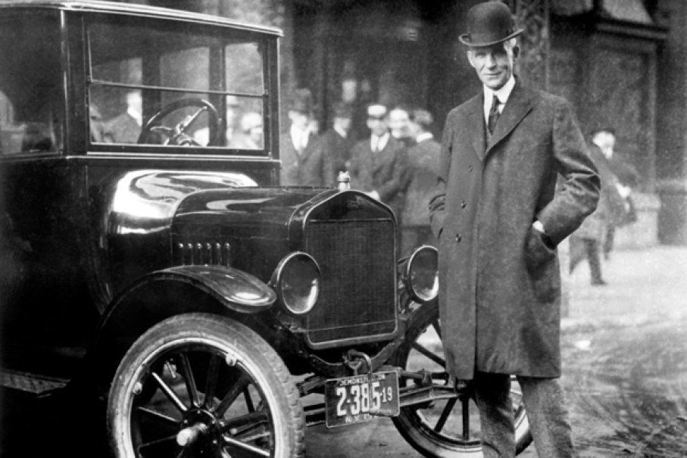
The first batch of the Model A’s were anything but flawless. In fact, they had so many problems that the Ford Motor Company had to send mechanics to every corner of the country to fix cars. But when the mechanics came back, they came back with feedback; feedback that Ford immediately implemented in his assembly line. With the help of Couzens, they kept shipping, kept making mistakes and kept learning.
It would take 5 more years and countless failures before the Ford Motor Company came out with the world’s best automobile – the Model T. The Model T revolutionized the automobile industry and brought Ford to the forefront of that industry. Not only that, he helped establish Detroit as one of the biggest, wealthiest cities in America

Overcoming Failure: The Perseverance of Henry Ford
Morgan Ostrowski
Document 2b
“Whether you think you can, or think you can't- You're right”
- Henry Ford

- According to document 2a, why wasn’t the first batch of Model A’s successful? [2]
__________________________________________________________________
__________________________________________________________________

- According to the document 2a, how did Henry Ford react to the failures in the Model A? [2]
__________________________________________________________________
_______________________________________________________________
- What does Ford mean by the quote in document 2b? [2]
__________________________________________________________________
__________________________________________________________________
_______________________________________________________________

Document 3
John D. Rockefeller
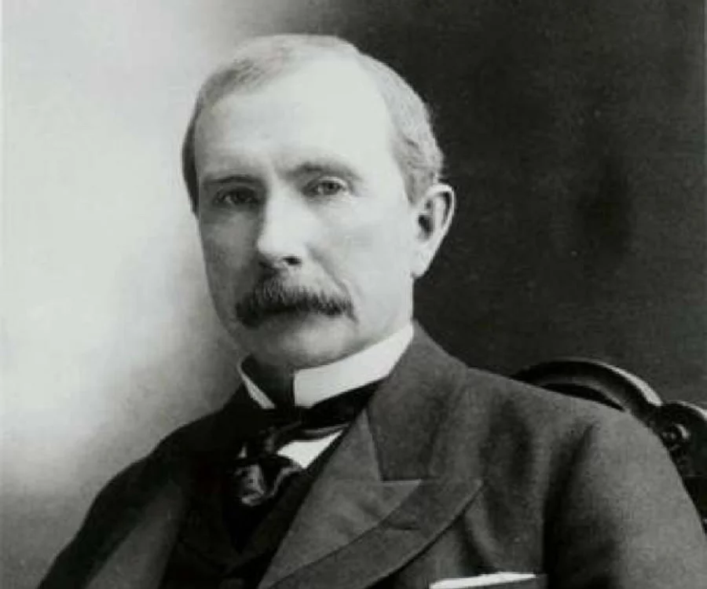
“I always tried to turn every disaster into an opportunity” - Rockefeller

“I do not think that there is any other quality so essential to success of any kind as the quality of perseverance. It overcomes almost everything, even nature.” - Rockefeller

Source: Titan: The Life of John D. Rockefeller by Ron Chernow

- What does Rockefeller say about perseverance in the documents above? [1] ________________________________________________________________________________________________________________________________________________
- What two phrases in the quotes above suggest that Rockefeller has a growth mindset? [2] _______________________________________________________________________________________________________________________________________________________________________________________________________________________

Document 4

Document 4a.
“Our virtues and our failings are inseparable, like force and matter. When they separate, man is no more.” – Nikola Tesla
Excerpt from the Department of Energy

Document 4b.
Tesla was not a savvy businessman and suffered financially, despite his achievements. He lost financial backing from Morgan, who felt he couldn’t profit from Tesla’s wireless electricity concept, and sold his assets to make up for dual foreclosures on Wardenclyffe. The property was later sold to a film processing company. In 1917, the U.S. government demolished Tesla’s partially completed tower because it worried German spies would use it to intercept communications during World War 1.

Despite these setbacks,Tesla went on to invent alternating current and the remote control.
Source: The life of Nikola Tesla 1993
- According to the quote in document 4a, what does Nikola Tesla suggest will happen if failure and virtue are separated? [2] ________________________________________________________________________________________________________________________________________________________________________________________________________________________

- a) According to document 4b, what were two financial setbacks Tesla faced? [2] ________________________________________________________________________________________________________________________________________________________________________________________________________________________
b) How was Tesla affected by these setbacks? [2] ________________________________________________________________________________________________________________________________________________________________________________________________________________________

Document 5a
“Our greatest weakness lies in giving up. The most certain way to succeed is always to try just one more time.” -Thomas Edison

Document 5b
“ In years gone by, one Edison, the “Wizard”, was a laughing stock, but he has turned the laugh until it is now being ripped out all over the earth through the medium of the phonograph”

Excerpt from Chronicle supplement 1901

- How does Edison feel about giving up according to document 5a? [2] ________________________________________________________________________________________________________________________________________________________________________________________________________________________
- Does document 5b demonstrate Edison has a fixed or a growth mindset? [1] ________________________________________________________________________________________________________________________________________________________________________________________________________________________

Document 6
One day Thomas Edison came home and gave his mother a note. He told her, “My teacher gave me this paper and told me to only give it to my mother.”

His mother’s eyes were cheerful as she read the letter out loud to her child: “Your son is a genius and the school is too small for him.and doesn’t have good enough teachers for training him.

Many years after Edison’s mother died and he was he was now one of the great inventors of the century. Edison’s saw his mother’s note folded in the corner of a drawer in desk. On the paper was written: “Your son is addled (mentally ill). We won’t let him come to school any more.”

Source: Facebook

- After reading the document above, why do you think Edison’s mother write the note? [2] ________________________________________________________________________________________________________________________________________________________________________________________________________________________
- How do you think the note helped to form Thomas Edison’s growth mindset? [2] ________________________________________________________________________________________________________________________________________________________________________________________________________________________
- Does the source make you question this evidence? [2] ________________________________________________________________________________________________________________________________________________________________________________________________________________________

Document 7a

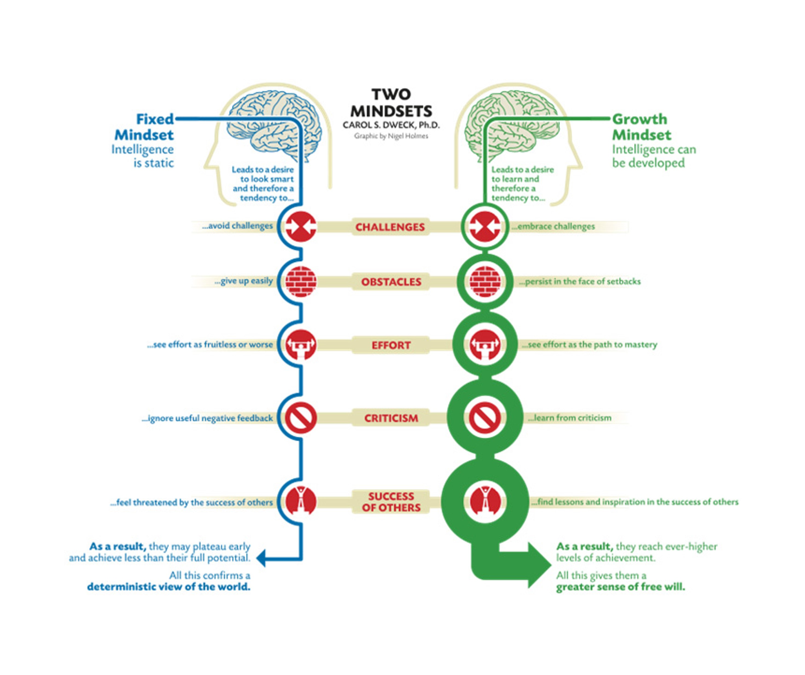
Document 7b

“ I haven’t failed, I have just found 10,000 ways that won’t work.
Thomas Edison
Diary
- Based on document 7a, what are two characteristics of a growth mindset? [2] ________________________________________________________________
________________________________________________________________

- Based on the quote of Edison’s in document 7b, what two characteristics of a growth mindset reflected in the quote? [2] ________________________________________________________________________________________________________________________________________________________________________________________________________________________

Document 8

Andrew Carnegie and John D. Rockefeller were prime examples of those who had accumulated fortunes due to their investments during the Industrial Revolution; their wealth totaled hundreds of millions of dollars. Because of the immensity of their fortunes they had to think in wholesale terms: simple acts of kindness and generosity to widows and orphans or a traveler found wounded on a highway were not sufficient for their means. (Bremner,1996).
Now philanthropy could aid in the poor in gaining a real place in the American dream. Those, with no advantages in life, could rise to the level of the philanthropist by developing talent and abilities.

1. According to the documents, who were the first recipients of Carnegie and Rockefeller's generosity? [2 points]
_______________________________________________________________________________________________________________________________________________________________________________________________________________________________________ (2)

2. According to the document, what opportunity did the “new” philanthropy offer to the poor. [2]
____________________________________________________________________________________________________________________________________________________________

3. Name one way that giving to the poor represents a growth mindset thinking philosphy? [2]
____________________________________________________________________________________________________________________________________________________________

Part B
Essay
Directions: Write a well-organized essay that includes an introduction, several paragraphs,
and a conclusion. Use evidence from at least five documents in your essay.
Support your response with relevant facts, examples, and details. Include
additional outside information.

Historical Context:
After the Constitution was created in the United States of America, many questions arose
on exactly how the young country was to be governed. Some, such as Alexander
Hamilton, believed that the United States needed a strong central government, while others, such as Thomas Jefferson, feared strong government and preferred to leave as much power as possible to the states. As cabinet members in Washington’s administration, Hamilton and Jefferson had many disagreements on government policy.

Task: Using the information from the documents and your knowledge of United States
history, write an essay in which you

- Discuss two inventors who displayed a growth mindset (with evidence from the document)
- Discuss two entrepreneurs who displayed a growth mindset (with evidence from the document)
- Evaluate whether the Industrial Revolution was fueled by a growth mindset?
- Discuss whether your life is governed by a growth mindset (with evidence from your life)

Guidelines:
In your essay, be sure to
- Develop all aspects of the task
- Incorporate information from at least five documents
- Incorporate relevant outside information
- Support theme with relevant facts, examples, and details
- Use a logical and clear plan of organization, including an introduction and conclusion that are beyond a restatement of the theme

