3rd Grade
Canada Unit
By: Samantha Berna, Madison Dodd, Duncan Fraser, Kaitlin Lacasse, Christina Lindo, Kelly MacKay, and Emily Wolcott

This third grade Inquiry Design Model (IDM) curriculum allows students to explore the meaning of happiness and its relation to a person’s location in the world. Students will undertake the compelling question, “Does where you live in the Western Hemisphere determine your happiness?”

Compelling Question:
Does where you live in the Western Hemisphere determine your happiness?

Standards and Practices:
3.3 Geographic factors often influence where people settle and form communities. People adapt to and modify their environment in different ways to meet their needs.
3.3a Geographic factors influence where people settle and their lifestyle. Some geographic factors make a location more suitable for settlement, while others act as deterrents.
3.5 Communities share cultural similarities and differences across the world.
3.5a The structure and activities of families and schools share similarities and differences across world communities.

Staging the Question:
“The Wise Woman and Her Secret” by Eve Merriam

1. Supporting Question:  What determines happiness? | Formative Task:  The teacher will frame the question: Does the community you live in determine your happiness? In order to do this, the students and teacher will participate in a discussion about happiness after reading the book “The Wise Woman and Her Secret.” The teacher will discuss how there are many kinds happiness that people can experience. After our discussion, students will write down three things that make them happy, attaining a score of a two out of three. | Sources:  Source A: “The Wise Woman and Her Secret” by Eve Merriam  Source B: Happiness Presentation  Source C: Worksheets (Happiness Instructions, Homework Instructions)

2. Supporting Question:  How does the geography of life in Canada affect life there? | Formative Task:  Students will be taken on a bus tour of Montreal, Canada. During the tour students will be asked to follow along on a worksheet to take notes of each place they visit and indicate with a sticker how each place made them feel. After the tour, students will be placed in groups of five and each student will be given one theme of geography to explain to their group with an example from their hometown. Students will then be asked to reflect on the similarities and differences between Montreal and their hometown and complete a Venn diagram. To achieve mastery, students will respond to the question: What do these landmarks say about the culture of Montreal? And will then explain where they would be happier citing evidence to support their choice. | Sources:  Source A: Google Slides tour presentation  Source B: Tour worksheet to take notes  Source C: Venn diagram

3. Supporting Question:  How did Canada come to be Canada? What historical events have shaped the country? | Formative Task:  While taking a trip back in time, students will follow along in their “Time Travel Journal” where they will report what they see, what they think and what they wonder about the historical events. Students will then answer what historical events shaped Canada today by partaking in an “Act It Out” skit where students will write narratives of a historical event by using dialogue, action and characters containing three relevant facts from the pictures and time machine PowerPoint, students will be graded based upon a teacher created rubric. | Sources:  Source A: Time Machine Powerpoint Presentation  Source B: Think, feel, wonder

4. Supporting Question:  How do we know what we have learned about Canada is true? | Formative Task:  After students are presented with the question, “Are people happier in Rockville Centre or Montreal?,” students will engage effectively in a range of collaborative discussions with partners building on others’ ideas and expressing their own clearly to analyze documents with historical thinking strategy WHAM. Students will be able to fill out three of the four questions on the WHAM chart. | Sources:  Source A:  PowerPoint Presentation  Source B:  Four Primary Source Documents to complete WHAM  Source C:  WHAM homework worksheet

5. Supporting Question:  Are Canadians happier than Americans? Evaluate the credibility of the sources | Formative Task:  After completing a history mystery, students will create a claim on where they think is happier, Montreal or RVC. Students will evaluate the credibility of the sources provided. | Sources:  Source A: History Mystery packets with included articles  Source B: Powerpoint Presentation  Source C: Supporting Claim Handout

6. Supporting Question:  What can we do to connect with Canada to improve our understanding? | Formative Task:  After watching a short video on Nunavik, students will engage effectively in a range of collaborative discussions with diverse partners on building on others’ ideas and expressing their own clearly and creating a plan for taking informed action to help the students in Nunavik. Student’s efforts will be evaluated by an exit ticket, successfully answering at least 2 questions correctly. | Sources:  Source A: Informed Action Powerpoint  Source B: Skype with students in Nunavik Canada  Source C: The Global Goals model

7. Supporting Question:  Can we express what we have learned in writing? | Formative Task:  After engaging in a practice Google Slides pre-writing exercise on the Yankees using TDFC, students will provide logically ordered reasons that are supported by facts and details from various sources by completing a TDFC on their required DBQ on communities and happiness. | Sources:  Source A: Powerpoint Presentation  Source B: Reading material on weather in Montreal and on women’s soccer in RVC.  Source C: TDFC planning sheet

Summative Performance Task

Argument: Students will write a DBQ essay answering the question: Are people happier living in communities in Rockville Centre or Montreal?

Extension: Students will create an iMovie video expressing how where you live can determine a person’s happiness.

Taking Informed Action: What can we do to connect with Canada to improve our understanding?
- Students will skype with a third grade class from Canada, discussing and sharing how their lives are similar and different.
- Students will create signs with informative information on Nunavik regarding a supply drive, to help students in Nunavik.
- Students will organize a supply/book drive to gather resources to send to help the school life in Nunavik.
- Students will create and informative posters and speeches to educate the rest of the school on life in Nunavik Canada . .

GRADE: 3

Are people happier living in communities in Rockville Centre or Montreal?

Student Name_____________________
Date______________________________

Part III: This part consists of a document-based question. On this part, you will be provided with one version of the test based on your readiness to handle critical thinking challenges.

Document Based Question

Directions: The task below is based on documents 1 through 5. The task is designed to test your ability to work with documents. Examine each document and answer all questions beneath the document. Use the answers to the questions to help write your essay.

Background: All of us in Rockville Centre live in a community and there are parts of life in our community that make us happy. North of us in Montreal, Canada people also live in communities. There are parts of life in the community of Montreal that make people happy. In the paragraph you write, you are to make a judgement on who is happier based on the documents in this packet.

Task: Use the information from the documents and your knowledge of social studies, write an essay in which you:
Use the information from the documents and your knowledge of social studies to write an essay in which you:

● Discuss one part of life in the community of Rockville Centre that makes you happy.
● Discuss one part of life in the community of Montreal, Canada that make people happy.
● In which community do you think people are happier and why?

In your essay remember to
● Write an opinion essay, arguing whether people live a happier life in Montreal or Rockville Centre.
● Include an introduction, a body, and a conclusion.
● Use information from at least four documents in your answer.
● Include historical facts, relevant details, and remember to be a critical thinker whe developing your ideas.

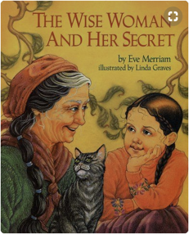
Document #1:

Known for her wisdom, an old woman is sought out by people who come from far and wide, eager to discover the secret source of her insights. "You will have to discover it for yourself," she tells them, and so their search begins. But one little girl, who likes to wander and wonder, lag and linger, has already found the secret that eludes her elders".

1. Based on the document above, what does the wise woman say about finding happiness?
_____________________________________________________________________________________________
___________________________________________________________________________________________ [1]

2. According to the above document, what two things does the wise woman say have led to Jenny’s happiness?
______________________________________________________________________________________________________________________________________________________________________________________ [1]

3. Based on this definition of happiness, would having more money automatically make you a happier person? What would make you happier?
___________________________________________________________________________________________________________________________________________________________________________________________________________________________________________________________________________________ [2]

Document # 2:
Weather Facts
Montreal | Rockville Centre
- 247 sunny days, on average, each year. | - Rockville Centre averages 170 sunny days per year.
- Averages 40 inches of rain per year. | - RVC gets about 4 feet of rain each year.
- In an average year, it snows 59 times. | - On average, it snows 23.6 inches each year in RVC.
- In a typical year, Montreal gets 82.5 inches of snow. That’s almost 7 feet of snow!

1. According to the document above, which city has more sunny days? ____________________________ [1]
2. According to the document above, Montreal averages about how many inches of rain per year?__________________ [1]
3. Based on the weather above, which city’s weather would make you happier and why? ________________________________________________________________________________________
_______________________________________________________________________________________[2]
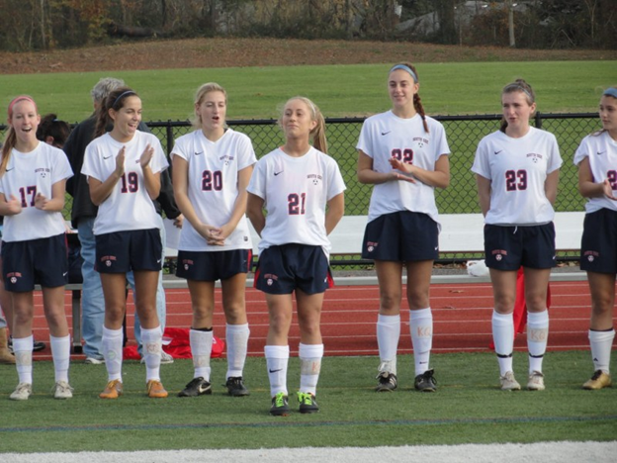
Document # 3:
Sports Facts
Montreal | Rockville Centre
- Montreal’s NHL team is The Canadiens. | - The Rockville Centre Lady Cyclones have won 17 girls soccer state championships in the last 25 years.
- The Canadiens have won an NHL record 24 Stanley Cups. | - Won the Men’s Lacrosse State Championship in 2004.
- Has hosted the winter Olympics. | - There are 8 professional sports teams that play within an hour of RVC.

1. Based on the document above, what is the name of Montreal’s NHL hockey team?
___________________________________________________________________________________________ [1]

2. According the above document, in what year did RVC Men’s lacrosse win the State Championship?
___________________________________________________________________________________________ [1]

3. Does winning more games make you happier?
________________________________________________________________________________________________________________________________________________________________________________________ [2]

Document # 4:
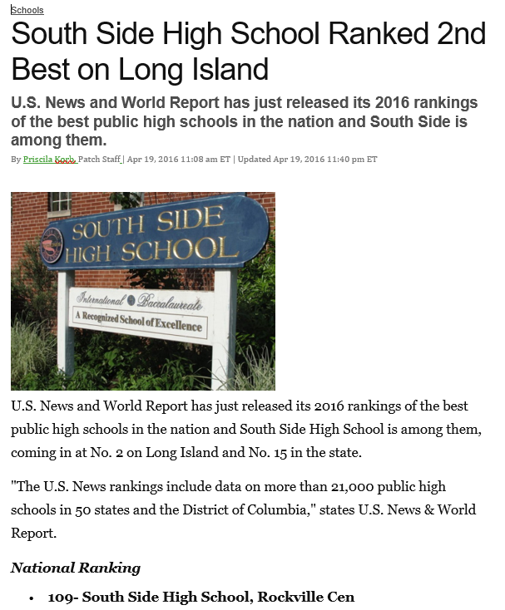
1. According the above document, what is South Side High School’s national ranking? ______________________[1]

2. Based on your definition of happiness, would attending South Side High School make you a happier person? Explain your answer. ____________________________________________________________________________
________________________________________________________________________________________________________________________________________________________________________________________ [2]
Document # 5:
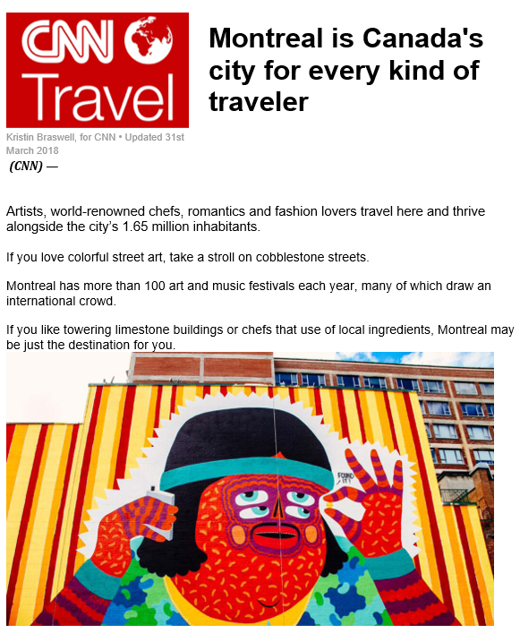
1. According to Document #5, how many art and music festivals does Montreal have each year?_________________ ___________________________________________________________________________________________ [1]

2. Would living in a city with lots of street art and great chefs make you happier? Why or why not?

____________________________________________________________________________________________________________________________________________________________________________________________________________________________________________________________________________________________________________________________________________________________________________________________________________________________________________________________________________________________________________________________________________________________________________ [3]
DBQ Scoring Rubric
(From the Revised Generic Scoring Rubric for Regents Examinations.)

Score of 5 | *Thoroughly develops all aspects of the task evenly & in depth | *Is more analytical than descriptive (applies, analyzes, evaluates, & creates information) | *Incorporates relevant information from at least the requested number of documents | *Incorporates substantial relevant outside information | *Richly supports the theme with many relevant facts, examples, & details | *Demonstrates a logical & clear plan of organization; includes and introduction & conclusion that are beyond a restatement of the theme
Score of 4 | *Develops all aspects of the task but may do so somewhat unevenly | *Is both descriptive & analytical (applies, analyzes, evaluates, and/or creates information) | *Incorporates relevant information for at least the requested number of documents | *Incorporates relevant outside information | *Supports the theme with relevant facts, examples, & details | *Demonstrates a satisfactory plan of organization; includes an introduction & a conclusion that are beyond a restatement of the theme
Score of 3 | *Develops all aspects of the task with little depth or develops most aspects of the task in some depth | *Is more descriptive than analytical (applies, may analyze and/or evaluate information) | *Incorporates relevant information from some documents | *Incorporates limited relevant outside information | *Includes some relevant facts, examples, & details; may include some minor inaccuracies | *Demonstrates a satisfactory plan of organization; includes an introduction & a conclusion that may be a restatement of the theme
Score of 2 | *Minimally develops all aspects of the task or develops some aspects of the task in depth | *Is primarily descriptive; may include faulty, weak, or isolated application or analysis | *Incorporates limited relevant information from the documents or consists primarily of relevant information copied from the documents | *Presents little or no relevant outside information | *Includes few relevant facts, examples, & details; may include some inaccuracies | *Demonstrates a general plan of organization; may lack focus; may contain digressions; may not clearly identify which aspect of the task is being addressed; may lack an introduction an/or an conclusion
Score of 1 | *Minimally develops some aspects of the task | *Is descriptive; may lack understanding, application, or analysis | *Makes vague, unclear references to the documents or consists primarily of relevant & irrelevant information copied from the documents | *Presents no relevant outside information | *Includes few relevant facts, examples, or details; may include inaccuracies | *May demonstrate a weakness in organization; may lack focus; may contain digressions; may not clearly identify which aspect of the task is being addressed; may lack an introduction and/or a conclusion
Score of 0 | *Fails to develop the task or may only refer to the theme in a general way; OR includes no relevant facts, examples or details; OR includes only the historical context and/or task as copied from the test booklet; OR includes only entire documents copied from the test booklet; OR is illegible: OR is a blank paper

