GRADE 8 DBQ

Did Franklin Roosevelt Get America Out of The Depression by Creating Hope or Sound Economic Policy?

Student Name________________________
Date___________________________

Part III: This part consists of a document-based question. On this part, you will be provided with one version of the test based on your readiness to handle critical thinking challenges. (You may opt for a more difficult version than your teacher provides, but you will be graded on the version that you complete)

Document Based Question

Directions: The task below is based on documents one through six. The task is designed to test your ability to work with documents. Examine each document and answer all of the questions beneath each document. Use the answers to the questions to help write your essay.

Background
President Franklin Roosevelt is credited with getting the United States out of the Depression, one of the worst economic periods in our history. He was able to turn around the economy but it is questionable whether he accomplished this by eliciting hope that things will get better or by implementing sound economic theory that helped create jobs and resurrect the economy.
Task: Use the information from the documents and your knowledge of social studies; write an essay in which you:

- Discuss two conditions that people faced in the Great Depression
- Discuss two instances in which FDR created by hope during the depression through his actions
- Evaluate whether FDR ended the depression by creating hope or because of economic policy

In your essay remember to
● Write an opinion essay, arguing whether FDR got us out of the depression by
creating hope OR by using sound economic theory, using evidence from the
documents.
● Include an introduction, a body, and a conclusion.
● Use information from at least four documents in your answer.
● Include facts, relevant details, and reason in developing your ideas.

Document 1:

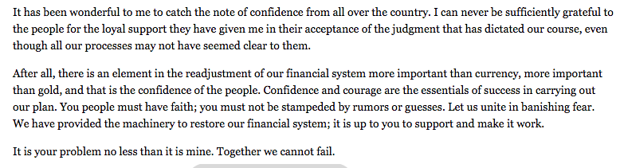
[Excerpt from President Roosevelt’s Fireside Chat on Banking, March 12, 1933]

- What does President Roosevelt claim is more important than currency?

[2]

2. According to the document what does faith have to do with banking?

[2]
Document 2:

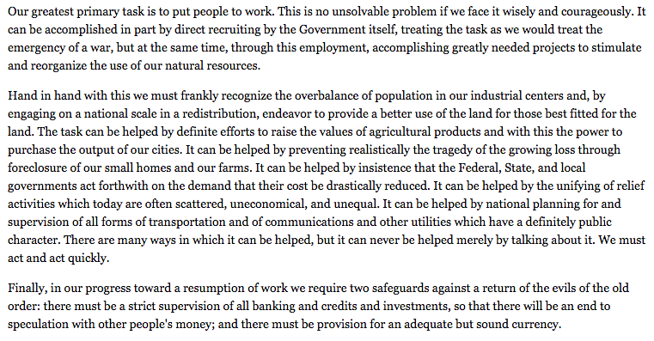
[Excerpt from President Roosevelt’s First Inaugural Address, March 4, 1933]

- What are the three ways President Roosevelt describes what he is going to do?

[2]

2. According to the document, what is President Roosevelt’s ultimate goal for the suffering economy?

[2]
Document 3:

Many “kitchens” similar to this one in Chicago in 1931 were opened by various individuals or groups.

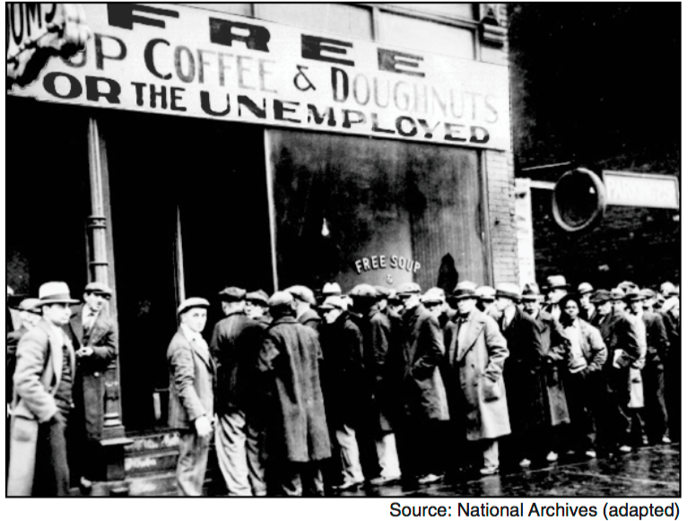

- Based on this photograph, what assistance is being offered to the people standing in line?

Document 4:

Hoovervilles start to become more popular throughout Washington D.C.
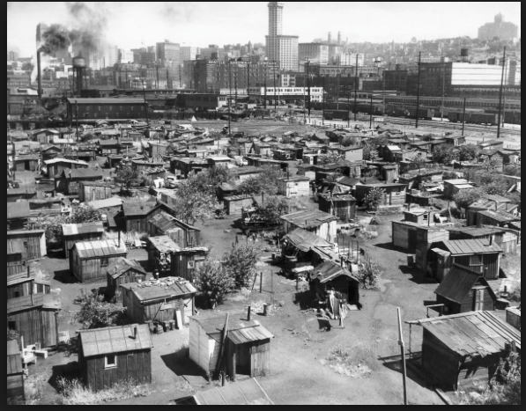

- Based on this photograph, what were most Hooverville homes made out of?

- What does this reveal about the quality of people’s lives and the state of their hope during the Great Depression?

Document 5:

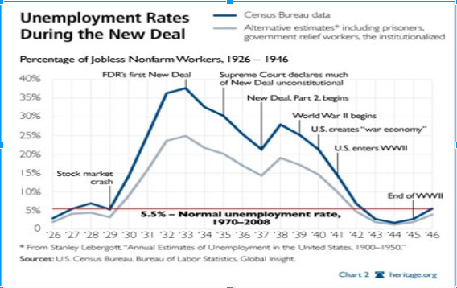

- What happens to unemployment after the stock market crash?

[2]

2. What happens to unemployment after FDR’s first new deal?

[2]

Document 6:
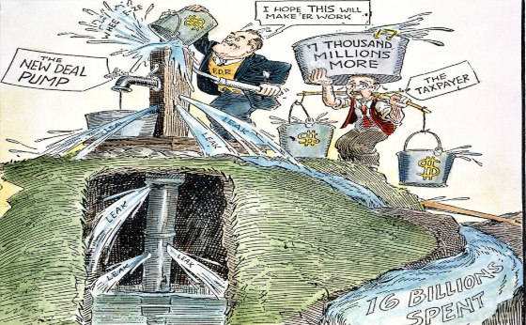
“FDR primed the pump by spending money to create jobs, many people believed this would be an answer to the Great Depression but others believed this would destroy the country”

- Who is priming the pump of the political cartoon?

[2]

2. What is the taxpayer doing in the cartoon?

