Does Where you live determine your happiness?
GRADE 5 DBQ

Does where you live in the Western Hemisphere shape
your life? Is life in some places happier than others?

Student Name_____________________
Date______________________________

Part III: This part consists of a document-based question. On this part,you will be provided with one version of the test based on your readiness to handle critical thinking challenges. (You may opt for a more difficult version than your teacher provides, but you will be graded on the version that you complete.

Document Based Question

Directions: The task below is based on documents 1 through 6. The task is designed to test your ability to work with documents. Examine each document and answer all questions beneath the document. Use the answers to the questions to help write your essay.

Background: The Western Hemisphere can be divided into regions. Regions within the Western Hemisphere include North America, Mesoamerica, The Caribbean, and South America. These regions may differ based on landscape, geographical features, climate, food, recreational activities, monuments, style of homes, and could have rural urban or suburban spaces within them. All of the differences between the four regions of the Western Hemisphere may or may not affect the happiness of the people living within those regions.

Task: Use the information from the documents and your knowledge of social studies, write an essay in which you:
Use the information from the documents and your knowledge of social studies, write an essay in which you:

- Discuss two factors that psychologists believe make people happy.
- Discuss life in Mexico compared to life in America.
- Evaluate whether the region where you live in this hemisphere determines your happiness.

In your essay remember to
- Write an opinion essay, arguing whether people live a happier life in Mexico or America
- Include an introduction, a body, and a conclusion
- Use information from at least four documents in your answer
- Include historical facts, relevant details, and reason in developing your ideas

Document #1

Optimism and Resilience: Optimism leads to Persistence

Psychologists have long been interested in optimism and we have a good understanding of what it is and why it matters. There have been hundreds of studies of optimism and what we find is that people who think optimistically report fewer symptoms of depression, do better in school and in sports, are more productive at work, and are physically healthier than people who think pessimistically.

How does optimistic thinking lead to all of these good outcomes? We know that optimism is a necessary ingredient of resilience. Research shows that part of what enables people to thrive, despite setback, failure, and hardship, is the ability to think optimistically in the face of adversity. Optimistic thinking motivates people - adults and children - to continue to persist and to work to find solutions, even when situations look bleak. Optimism shines light where it is dark. Optimistic thinkers ask themselves, "Where do I have control? What can I do to make this situation better? What can I learn from this struggle?" Because optimistic thinkers focus on control, they don't slip into helplessness. And because they persist, they tend to succeed.

Excerpt from an Article by Dr. Karen Reivich, Fishful Thinking

1. According to the document, what are three benefits of people who think optimistically?
_____________________________________________________________________________________________________________________________________________________________________________________________________________________________________________________________________________________________________________________[1]

2. According to the document, how does optimism enable people to thrive despite failure and hardship?

_____________________________________________________________________________________________________________________________________________________________________________________________________________________________________________________________________________________________________________________[2]

Document #2

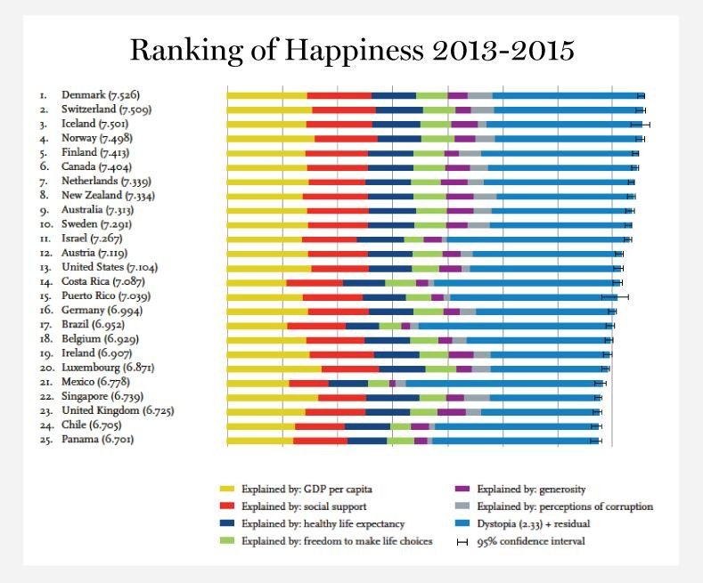
“We are a small island, and people are nice to each other. Everybody gets along. When we pass in the street, we say hello to each other.”
Quotation from Enrique Rodriguez, a retired government worker

1. Where does Puerto Rico rank in world happiness in 2013-2015? ___________[1]

2. According to this ranking, what are three factors that determine happiness?
________________________________________________________________________________________________________________________________________________________________________________________________________________[1]

3. According to Enrique Rodriguez, how do people in Puerto Rico socially support one another? How does this create happiness?
________________________________________________________________________________________________________________________________________________________________________________________________________________[2]

Document #3

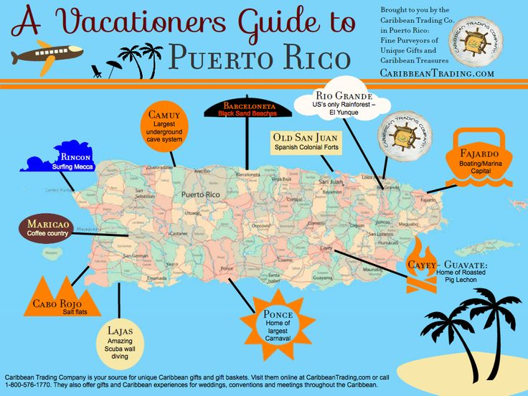

- List 3 activities to do in Puerto Rico
__________________________________
__________________________________
__________________________________[1]

2. How does Puerto Rico’s geography affect the activities to do there?
_________________________________________________________________________________________________________________________________________________________[1]

3. Do these activities affect the people of Puerto Rico’s happiness.
____________________________________________________________________________________________________________________________________________________________
___________________________________________________________________________[2]

Document #4

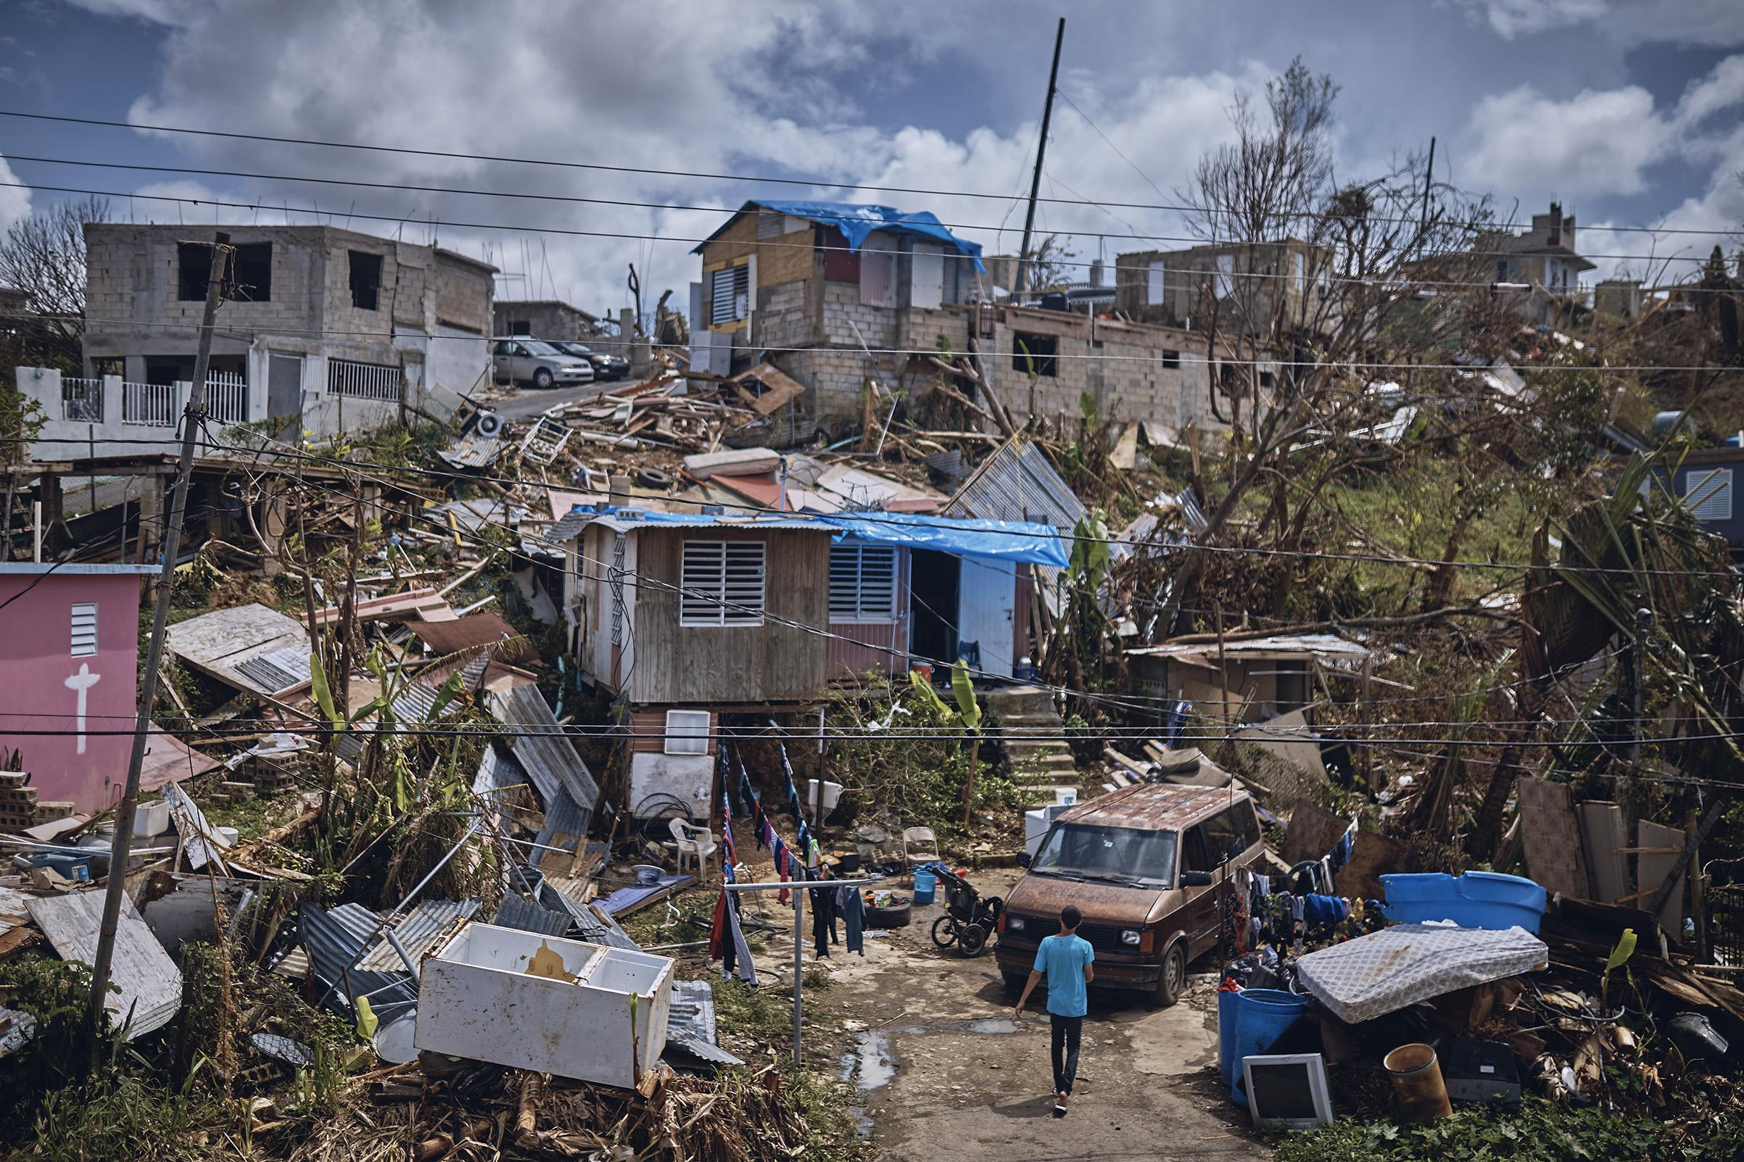
Hurricane Maria (Puerto Rico)

- According to the picture above, do you think the devastation caused in Puerto Rico by Hurricane Maria affected the people’s happiness that live there?

______________________________________________________________________
____________________________________________________________________[1]

2. How do you think you can you help the people in Puerto Rico who were affected by
Hurricane Maria?

______________________________________________________________________
___________________________________________________________________[2]

Document #5

“Puerto Rico ranks number one, as the most blissed-out place in the world, followed by Mexico and Denmark. That's according to a study of over 80 countries by the non-profit group, World Values Survey Association. They ranked the countries based on the answers to various question about happiness from both men and women--Questions like:
- How important are family and friends in your life?
- Looking at every aspect of your life, how happy are you?
- No matter what your parent's faults are, do you agree that they should be loved and respected?
- And do you think most people can be trusted?”

- According to the document how many countries were included in this study?
_______________________________________________________________[1]
2. Referencing the document, how were the countries ranked to determine their happiness?
_________________________________________________________________________________________________________________________________________________________[2]

Document #6:
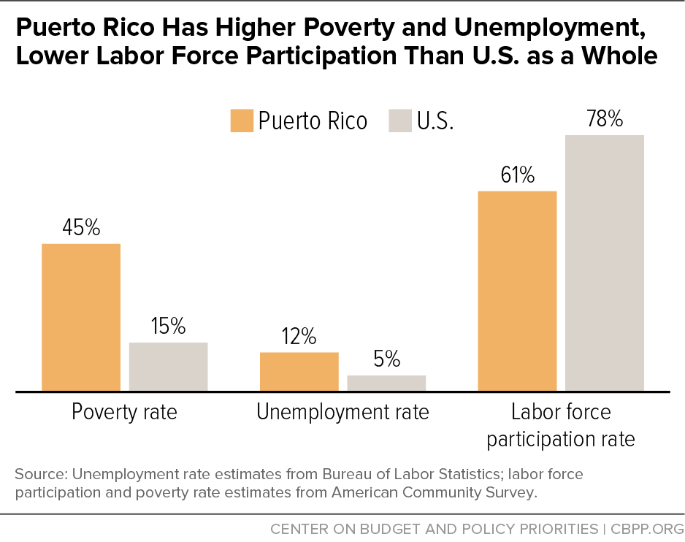

1. What is the percentage of poverty rate, unemployment rate, and labor force participation rate of Puerto Rico compared to the United States?

______________________________________________________________________
____________________________________________________________________[1]

2. Do you think poverty, unemployment, and labor force participation contributes to people’s happiness?

______________________________________________________________________
____________________________________________________________________[2]

Task: Use the information from the documents:

Directions: The task below is based on documents 1 through 5. The task is designed to test your ability to work with documents. Examine each document and answer all questions beneath the document. Use the answers to the questions to help write your essay.

Background: The Western Hemisphere can be divided into regions. Regions within the Western Hemisphere include North America, Mesoamerica, The Caribbean, and South America. These regions may differ based on landscape, geographical features, climate, food, recreational activities, monuments, style of homes, and could have rural urban or suburban spaces within them. All of the differences between the four regions of the Western Hemisphere may or may not affect the happiness of the people living within those regions.

