GRADE: 3

Are people happier living in communities in Rockville Centre or Montreal?

Student Name_____________________
Date______________________________

Part III: This part consists of a document-based question. On this part, you will be provided with one version of the test based on your readiness to handle critical thinking challenges.

Document Based Question

Directions: The task below is based on documents 1 through 5. The task is designed to test your ability to work with documents. Examine each document and answer all questions beneath the document. Use the answers to the questions to help write your essay.

Background: All of us in Rockville Centre live in a community and there are parts of life in our community that make us happy. North of us in Montreal, Canada people also live in communities. There are parts of life in the community of Montreal that make people happy. In the paragraph you write, you are to make a judgement on who is happier based on the documents in this packet.

Task: Use the information from the documents and your knowledge of social studies, write an essay in which you:
Use the information from the documents and your knowledge of social studies to write an essay in which you:

● Discuss one part of life in the community of Rockville Centre that makes you happy.
● Discuss one part of life in the community of Montreal, Canada that make people happy.
● In which community do you think people are happier and why?

In your essay remember to
● Write an opinion essay, arguing whether people live a happier life in Montreal or Rockville Centre.
● Include an introduction, a body, and a conclusion.
● Use information from at least four documents in your answer.
● Include historical facts, relevant details, and remember to be a critical thinker whe developing your ideas.

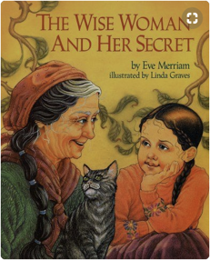
Document #1:

Known for her wisdom, an old woman is sought out by people who come from far and wide, eager to discover the secret source of her insights. "You will have to discover it for yourself," she tells them, and so their search begins. But one little girl, who likes to wander and wonder, lag and linger, has already found the secret that eludes her elders".

1. Based on the document above, what does the wise woman say about finding happiness?
_____________________________________________________________________________________________
___________________________________________________________________________________________ [1]

2. According to the above document, what two things does the wise woman say have led to Jenny’s happiness?
______________________________________________________________________________________________________________________________________________________________________________________ [1]

3. Based on this definition of happiness, would having more money automatically make you a happier person? What would make you happier?
___________________________________________________________________________________________________________________________________________________________________________________________________________________________________________________________________________________ [2]

Document # 2:
Weather Facts
Montreal | Rockville Centre
- 247 sunny days, on average, each year. | - Rockville Centre averages 170 sunny days per year.
- Averages 40 inches of rain per year. | - RVC gets about 4 feet of rain each year.
- In an average year, it snows 59 times. | - On average, it snows 23.6 inches each year in RVC.
- In a typical year, Montreal gets 82.5 inches of snow. That’s almost 7 feet of snow!

1. According to the document above, which city has more sunny days? ____________________________ [1]
2. According to the document above, Montreal averages about how many inches of rain per year?__________________ [1]
3. Based on the weather above, which city’s weather would make you happier and why? ________________________________________________________________________________________
_______________________________________________________________________________________[2]
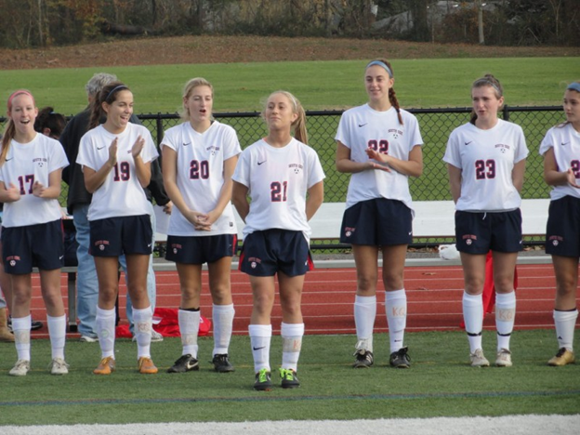
Document # 3:
Sports Facts
Montreal | Rockville Centre
- Montreal’s NHL team is The Canadiens. | - The Rockville Centre Lady Cyclones have won 17 girls soccer state championships in the last 25 years.
- The Canadiens have won an NHL record 24 Stanley Cups. | - Won the Men’s Lacrosse State Championship in 2004.
- Has hosted the winter Olympics. | - There are 8 professional sports teams that play within an hour of RVC.

1. Based on the document above, what is the name of Montreal’s NHL hockey team?
___________________________________________________________________________________________ [1]

2. According the above document, in what year did RVC Men’s lacrosse win the State Championship?
___________________________________________________________________________________________ [1]

3. Does winning more games make you happier?
________________________________________________________________________________________________________________________________________________________________________________________ [2]

Document # 4:
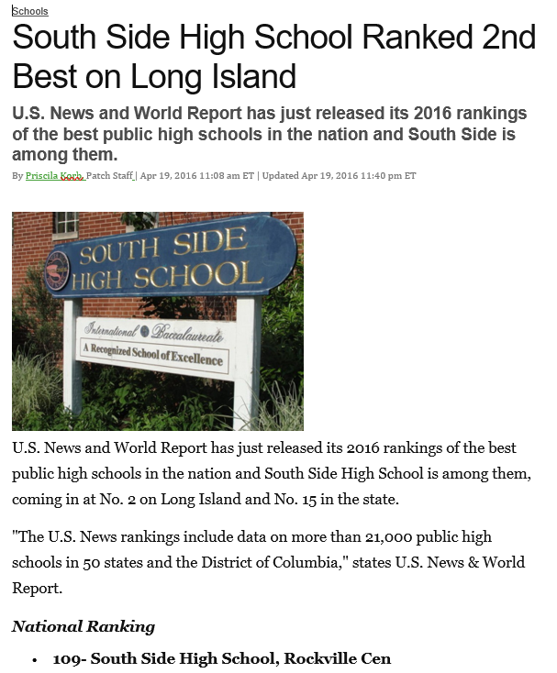
1. According the above document, what is South Side High School’s national ranking? ______________________[1]

2. Based on your definition of happiness, would attending South Side High School make you a happier person? Explain your answer. ____________________________________________________________________________
________________________________________________________________________________________________________________________________________________________________________________________ [2]
Document # 5:
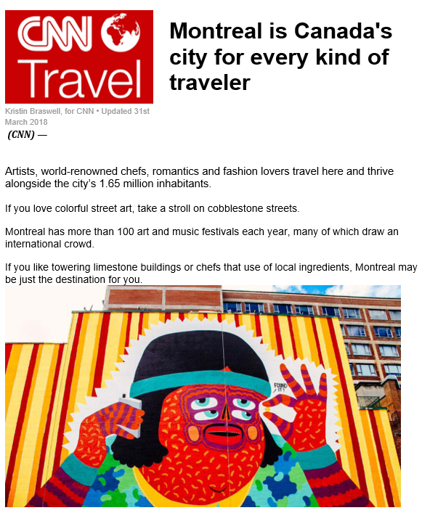
1. According to Document #5, how many art and music festivals does Montreal have each year?_________________ ___________________________________________________________________________________________ [1]

2. Would living in a city with lots of street art and great chefs make you happier? Why or why not?

____________________________________________________________________________________________________________________________________________________________________________________________________________________________________________________________________________________________________________________________________________________________________________________________________________________________________________________________________________________________________________________________________________________________________________ [3]
DBQ Scoring Rubric
(From the Revised Generic Scoring Rubric for Regents Examinations.)

Score of 5 | *Thoroughly develops all aspects of the task evenly & in depth | *Is more analytical than descriptive (applies, analyzes, evaluates, & creates information) | *Incorporates relevant information from at least the requested number of documents | *Incorporates substantial relevant outside information | *Richly supports the theme with many relevant facts, examples, & details | *Demonstrates a logical & clear plan of organization; includes and introduction & conclusion that are beyond a restatement of the theme
Score of 4 | *Develops all aspects of the task but may do so somewhat unevenly | *Is both descriptive & analytical (applies, analyzes, evaluates, and/or creates information) | *Incorporates relevant information for at least the requested number of documents | *Incorporates relevant outside information | *Supports the theme with relevant facts, examples, & details | *Demonstrates a satisfactory plan of organization; includes an introduction & a conclusion that are beyond a restatement of the theme
Score of 3 | *Develops all aspects of the task with little depth or develops most aspects of the task in some depth | *Is more descriptive than analytical (applies, may analyze and/or evaluate information) | *Incorporates relevant information from some documents | *Incorporates limited relevant outside information | *Includes some relevant facts, examples, & details; may include some minor inaccuracies | *Demonstrates a satisfactory plan of organization; includes an introduction & a conclusion that may be a restatement of the theme
Score of 2 | *Minimally develops all aspects of the task or develops some aspects of the task in depth | *Is primarily descriptive; may include faulty, weak, or isolated application or analysis | *Incorporates limited relevant information from the documents or consists primarily of relevant information copied from the documents | *Presents little or no relevant outside information | *Includes few relevant facts, examples, & details; may include some inaccuracies | *Demonstrates a general plan of organization; may lack focus; may contain digressions; may not clearly identify which aspect of the task is being addressed; may lack an introduction an/or an conclusion
Score of 1 | *Minimally develops some aspects of the task | *Is descriptive; may lack understanding, application, or analysis | *Makes vague, unclear references to the documents or consists primarily of relevant & irrelevant information copied from the documents | *Presents no relevant outside information | *Includes few relevant facts, examples, or details; may include inaccuracies | *May demonstrate a weakness in organization; may lack focus; may contain digressions; may not clearly identify which aspect of the task is being addressed; may lack an introduction and/or a conclusion
Score of 0 | *Fails to develop the task or may only refer to the theme in a general way; OR includes no relevant facts, examples or details; OR includes only the historical context and/or task as copied from the test booklet; OR includes only entire documents copied from the test booklet; OR is illegible: OR is a blank paper

