GRADE: 6

Are People Happier Living in Uganda or in America?

Student Name________________________________
Date______________________________

Part III: This part consists of a document-based question. On this part, you will be provided with one version of the test based on your readiness to handle critical thinking challenges.

Document Based Question
Directions: The task below is based on documents 1 through 8. The task is designed to test your ability to work with documents. Examine each document and answer all questions beneath the document. Use the answers to the questions to help write your essay.

Background: This question asks you to form an opinion based on the evidence in the documents that follow. Although you may have your own opinion, based your answer on proving your position with the documents. You can add outside information

Task: Use the information from the documents and your knowledge of social studies, write an essay in which you:
Use the information from the documents and your knowledge of social studies, write an essay in which you:

● Evaluate whether Ugandans or Americans are happier.

In your essay remember to:
● Write an opinion essay, arguing whether people live a happier life in Uganda or America
● Include an introduction, a body, and a conclusion
● Use information from at least four documents in your answer
● Include historical facts, relevant details, and reason in developing your ideas.

Document #1:

“Like everyone else, Anna has an invisible bucket. When it’s empty, she feels bad. But when it’s full, she feels great. Didn’t you ever notice your own bucket?” - Grandpa

“The class grew quiet. They laughed at all the right places and “oohed” at the scary parts. When Felix finally read, “The End,” everyone clapped — even Emily, who sat next to him and didn’t usually like dinosaurs. Felix felt a whole shower of drops land in his bucket. Maybe the day wouldn’t be so bad after all.”
1. Based on the document above, what does the grandpa mean when he says, When it’s empty, she feels bad?
______________________________________________________________________________

___________________________________________________________________________[2]

2. Based on the above document, what has made Anna feel bad?

______________________________________________________________________________

___________________________________________________________________________[2]

3. Based on this second quote, why did a whole shower of drops land in Felix’s bucket and how did this affect his happiness?

______________________________________________________________________________

___________________________________________________________________________ [2]

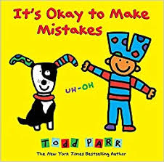
Document #2:

“It’s okay to make mistakes sometimes. Everyone does - even grown-ups! That’s how the learn.” -Todd Parr

- According to the document above, what does the author mean when he says, “It’s okay to make mistakes sometimes. Everyone does - even grown-ups! That’s how the learn.”
______________________________________________________________________________

___________________________________________________________________________[2]

2. Is how you respond to mistakes a choice?
______________________________________________________________________________

___________________________________________________________________________[2]

Document#3
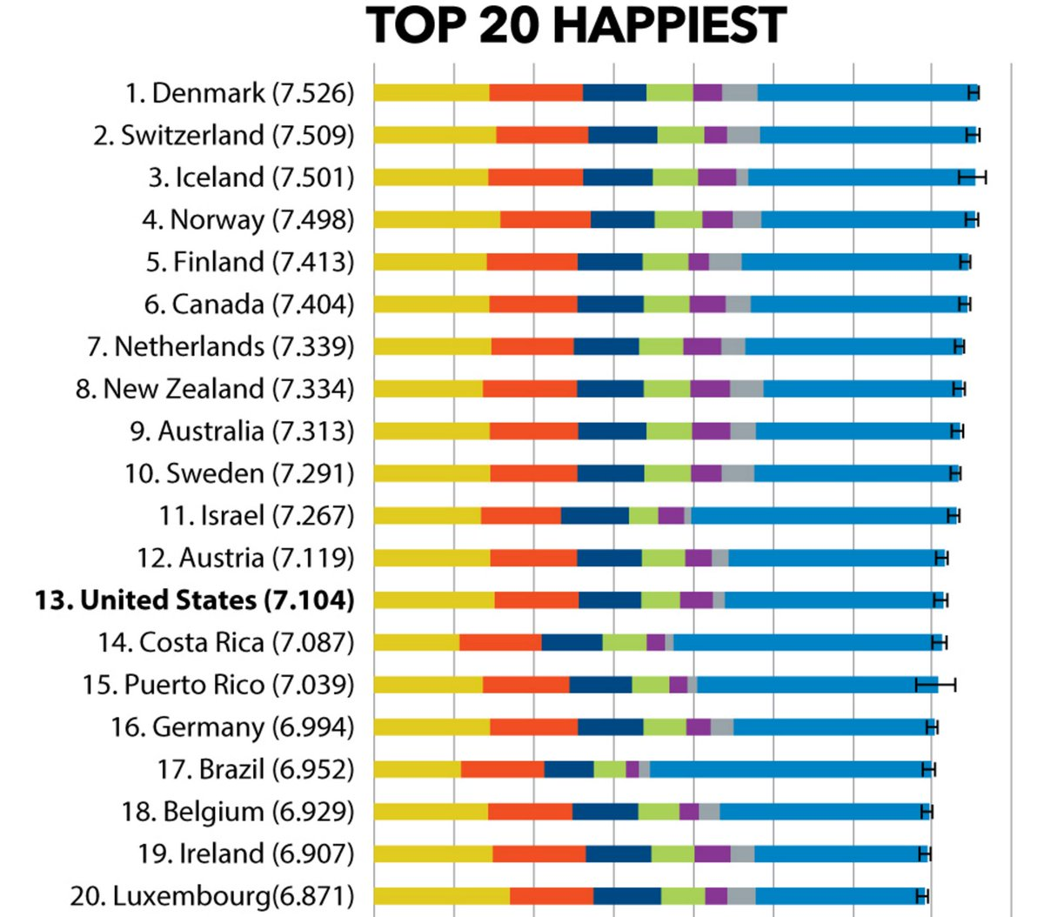
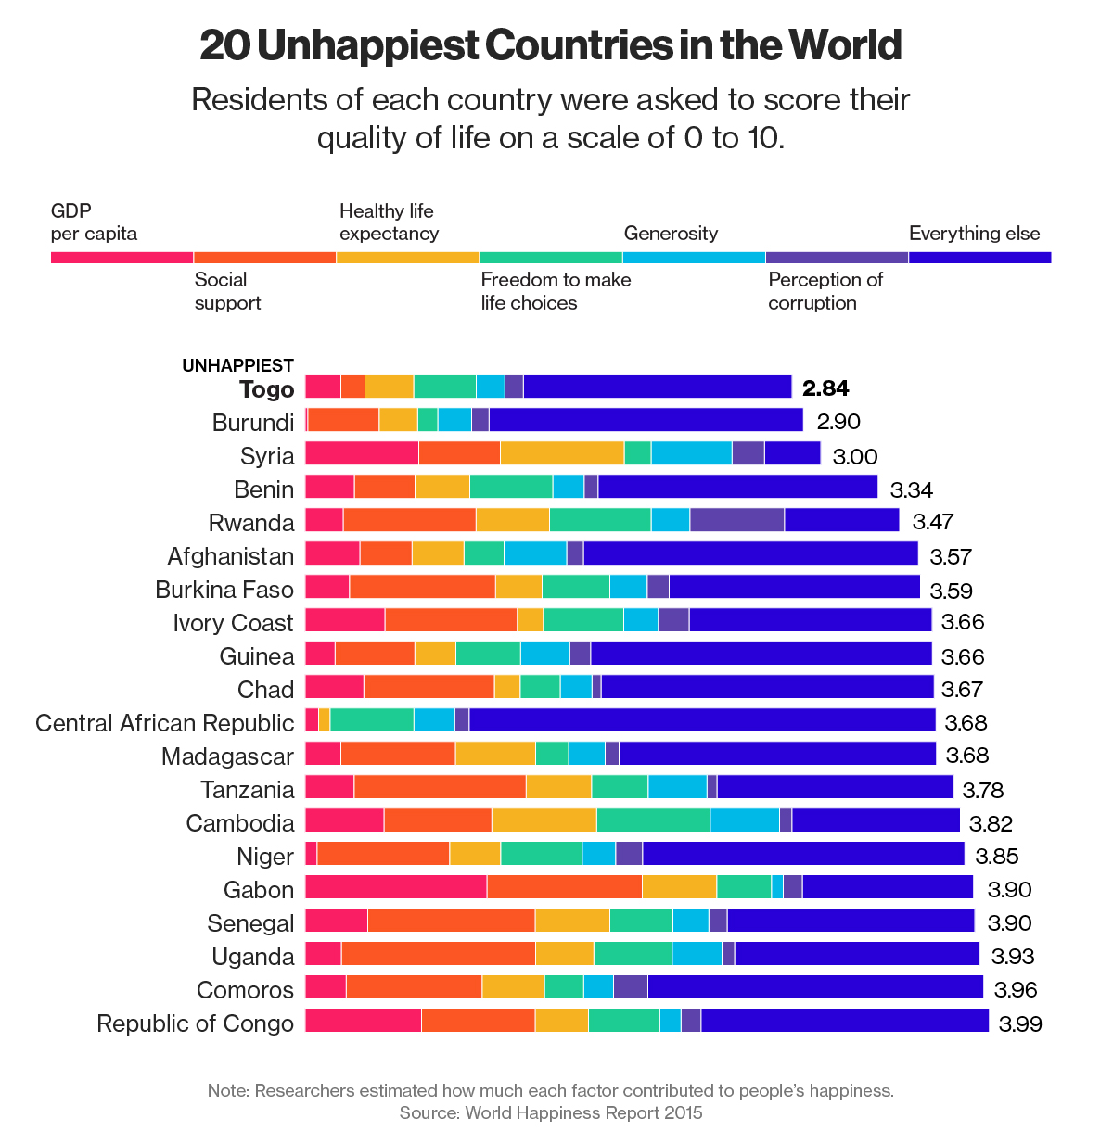
https://www.zerohedge.com/news/2015-04-24/america-ranks-below-israel-world-happiness-index

- Based on the document above, which country falls at #13 on the “Happiest Countries” chart?

___________________________________________________________________________ [1]

- Based on the document above, where is Uganda on the unhappiest chart?

___________________________________________________________________________ [1]

3. Based on the source and the information provided, do you think that these charts are credible? Why or why not?

___________________________________________________________________________

___________________________________________________________________________

___________________________________________________________________________ [2]

Document #4

“During the summer of 2016, I traveled to Uganda in order to perform first-hand research on the effects colonialism had on the country's education system as a part of a Summer Fellowship at Ursinus College. I spent one of my final days at Three R's Secondary School in Kasokoso, Uganda. There, I interviewed three teachers – Fredrick Mwesigye, Alphonse Tomas Olupot, and Janssen Mukhozi – about their experiences working in Ugandan schools. One of my questions concerned the differing experiences of boys and girls in the education system; I received an unexpected answer. The men began lamenting the increased emphasis placed on educating female students and blamed these policies for the increased crime rates in the capital of Kampala: without school, the boys were resorting to violent activities for survival and entertainment.”
-Marcella AM McGill

https://digitalcommons.ursinus.edu/cgi/viewcontent.cgi?article=1005&context=history_hon

- Is this an example of a primary or secondary source?

__________________________________________________________________________________

___________________________________________________________________________________

________________________________________________________________________________[1]

2. Based on the document above, what reason do the teachers give for the increasing crime rate in Uganda ?

__________________________________________________________________________________

___________________________________________________________________________________

________________________________________________________________________________[2]

Document #5
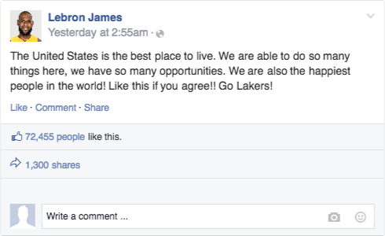

www.twitter.com & www.facebook.com

- Are the statements made by Justin Bieber and Lebron James considered fact or their opinion?

_________________________________________________________________________ [1]

- Based on the documents above, can these be considered credible? Why or why not?
__________________________________________________________________________________

__________________________________________________________________________________

________________________________________________________________________________[2]

Document #6

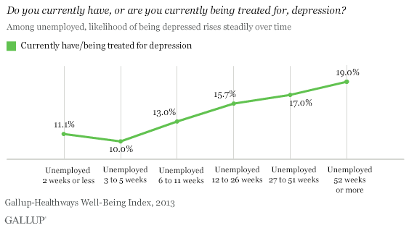

In U.S., Depression Rates Higher for Long-Term Unemployed (https://news.gallup.com/poll/171044/depression-rates-higher-among-long-term-unemployed.aspx)

- Based on the chart, what contributed to the increase in depression for Americans?

_____________________________________________________________________[1]

- Is this conclusive evidence that people in Uganda are happier than people in America? Why or Why Not
______________________________________________________________________

______________________________________________________________________

______________________________________________________________________

_____________________________________________________________________[2]

Time to Write Your Essay

Directions: The task below is based on documents 1 through 8. The task is designed to test your ability to work with documents. Examine each document and answer all questions beneath the document. Use the answers to the questions to help write your essay.

Background: This question asks you to form an opinion based on the evidence in the documents that follow. Although you may have your own opinion, based your answer on proving your position with the documents. You can add outside information

Task: Use the information from the documents and your knowledge of social studies, write an essay in which you:
Use the information from the documents and your knowledge of social studies, write an essay in which you:

● Evaluate whether Ugandans or Americans are happier.

In your essay remember to:
● Write an opinion essay, arguing whether people live a happier life in Uganda or America
● Include an introduction, a body, and a conclusion
● Use information from at least four documents in your answer
● Include historical facts, relevant details, and reason in developing your ideas.

