LESSON 1

Danielle Ciervo Professor Sheehan
EDU 3510-01 12/2/19
Grade 3 Topic Fact or opinion Social Studies

INSTRUCTIONAL OBJECTIVE

After students read the story Arthur’s TV Trouble, students will develop and answer questions to locate relevant and specific details in a text to support an answer determining fact or opinion by telling fact or opinion on several teacher made statements with receiving at least 80% correct.

STANDARDS AND INDICATORS
Key concept
Gathering and Interpreting
Evidence
Key idea
Identify and explain creation/authorship, purpose, and format for evidence. Where appropriate, identify point of view and bias.
Indicator: This will be evident when students discuss their findings of fact or opinion on teacher made statements.

English
Key Ideas and Details
3R1: Develop and answer questions to locate relevant and specific details in a text to support an
answer or inference.
Indicator: This will be evident when students use evidence from Arthur’s TV Trouble to detect fact or opinion.

Social Studies Standard: New York State Next Generation Social Studies Learning Standard.
Geography, Humans and the Environment
3.3 Geographic factors often influence where people settle and form communities. People adapt to and modify their environment in different ways to meet their needs.
3.3a Geographic factors influence where people settle and their lifestyle. Some geographic factors make a location more suitable for settlement, while others act as deterrents.
Students will examine the geographic factors of each selected world community, including physical features and climate, noting how certain factors are likely to support settlement and larger populations. Students will investigate the lifestyle of the people who live in each selected world community and how the lifestyle has been influenced by the geographic factors.

INQUIRY STANDARDS

1. Questions - raise questions
2. Eye of discipline
3. Gather information
4. Present information

SKILLS
1. Gathering info
2. Compare and contrast
3. Chronological reasoning
4. Geographic
5. Economic reasoning
6. Civics

DEVELOPMENTAL PROCEDURES
1. Motivation: Teacher will read to students the book Arthur’s TV trouble and ask students to do a think pair share on what they think this book will be about. (What do you think Arthur’s trouble is going to be?(METACOGNITIVE) Do you think there will be a solution to Arthur’s trouble? (METACOGNITIVE) Have any of you ever bought something off of TV and it wasn’t what you expected (LITERAL) ) [8 minutes]
2. The teacher will then transition into an introduction of the terms fact and opinion going over various examples on the board. (Who can tell me what a fact is?(LITERAL) Who can tell me what an opinion is?(LITERAL) How do you know if something is a fact or opinion? (LITERAL) ) [8 minutes]
3. The teacher will then ask the students if they noticed anything in Arthur’s TV Trouble that can be a fact or opinion from the TV commercial ad. (Did you notice anything in the commercial ad that was a fact or opinion, if so, what? (METACOGNITIVE) What was Arthur trying to buy? (LITERAL) Was the item presented in the commercial as a fact or opinion? (LITERAL) )[5 minutes]
4. After the discussion about Arthur’s TV Trouble, the teacher will then show the students examples of the facts or opinions in the book. (Is this a fact or opinion? (LITERAL) How do you know this is fact?(METACOGNITIVE) How do you know this is an opinion? (METACOGNITIVE) )[5 minutes]
5. The teacher will tell the students to create 2 fact and 2 opinion sentences in their notebooks. The teacher will circulate around the room checking for clarification and understanding of the assignment given (Who can remind us what a fact is? (LITERAL) Who can remind us what an opinion is?(LITERAL) )[5 minutes]
6. After students create their own sentences the teacher will then ask the students who wants to share their fact or opinion sentences. (Who can share one of their fact sentences? (INFERENTIAL) Who can share one of their opinion sentences? (INFERENTIAL) ) [2 minutes]
7. Closure: The teacher will then close the lesson by assigning the students an exit ticket which will be to complete several teachers made sentences where the students will have to determine if it is a fact or opinion. (Do any of you have questions on what a fact or opinion is? (LITERAL) ) [7 minutes]

INSTRUCTIONAL STRATEGIES

Scaffolding (providing support and moving students toward greater independence)
Indicator: This will be evident when the teacher helps students understand the definition of fact and opinion.

Discussion (engaging in meaningful discussions about the content)
Indicator: This will be evident when students are discussing during their think pair share on what they think will happen in Arthur’s TV Trouble.

ASSESSMENT
Informal Assessment
Students will be informally assessed when the teacher circulates around the room checking for clarification and understanding of the fact or opinion sentences they created.

Formal Assessment
Students will be formally assessed through an exit ticket attaining a score of at least 80% correct.

INDEPENDENT PRACTICE

Following the lesson on fact or opinion, students will create a story in their workbooks of how they could’ve helped Arthur out during his TV Trouble.

REFERENCES

English Language Arts Learning Standards. (n.d.). Retrieved from http://www.nysed.gov/curriculum-instruction/new-york-state-next-generation-english-language-arts-learning-standards.

Teaching Resources & Lesson Plans. (n.d.). Retrieved from
https://www.teacherspayteachers.com/.

Teacher created fact or opinion sentences EXIT TICKET

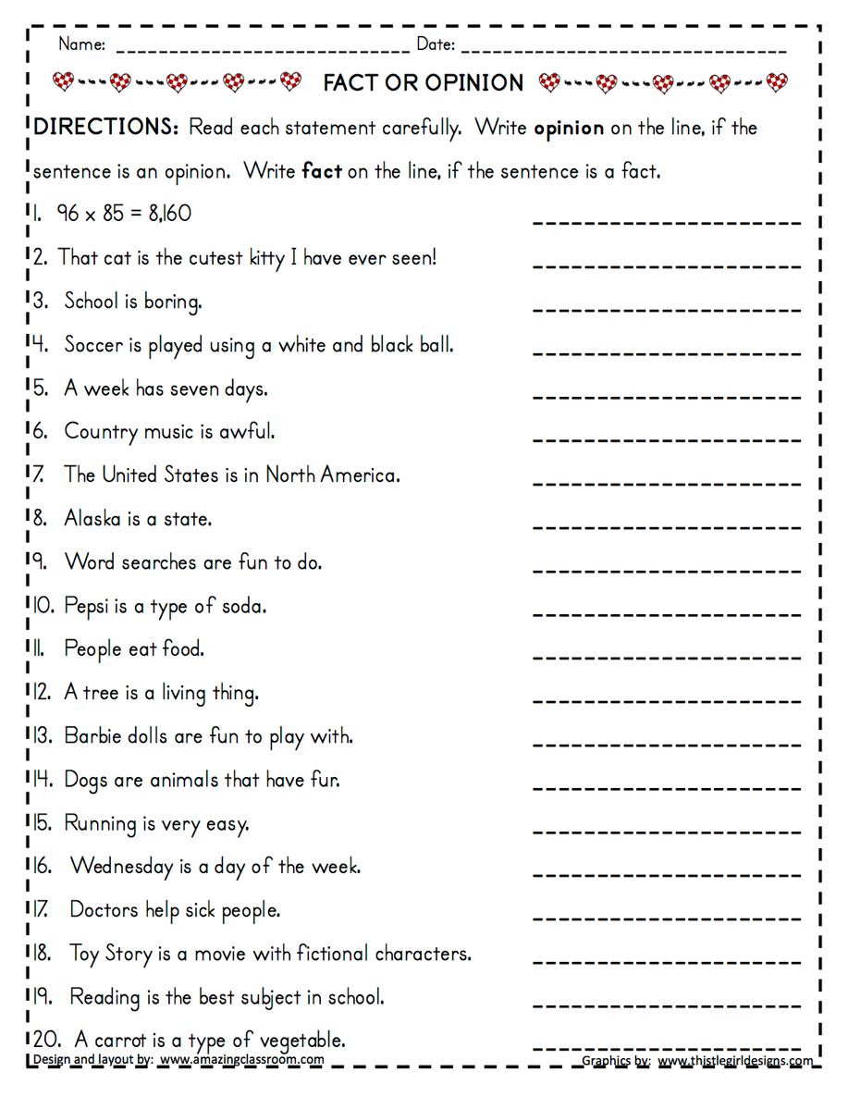

Answer key
