Molloy College
Division of Education

Katharine Black Dr. Sheehan
EDU 351-01 8 April 2018
Grade: 5th, Topic: What is Happiness? Content Area: Social Studies

INSTRUCTIONAL OBJECTIVES

After students are presented with the compelling questions, Does where you live in the Western Hemisphere determine your happiness? and Are Mexicans happier than Americans? saving the the story The Wise Woman and Her Secret read to them, students will engage effectively in a range of collaborative discussions with diverse partners building on others’ ideas and expressing their own clearly. Students will be assessed on their exit tickets that require three well expressed examples of “savoring” in their own lives and a personal definition what makes them happy.

NYS-CCLS / +NYS STANDARDS AND INDICATORS

Social Studies Standards

New York State Social Studies Standards
Key Idea:
5.4 GEOGRAPHY IN THE WESTERN HEMISPHERE: The diverse geography of the Western Hemisphere has influences human culture and settlement in distinct ways. Human communities in the Western Hemisphere have modified the physical environment.

Key Concept:
5.4b The Western Hemisphere can be divided into regions. Regions are areas that share common, identifiable characteristics such as physical, political, economic, or cultural features. Regions within the Western Hemisphere include, North America (Canada and the United States), Mesoamerican (Mexico and Central America), Caribbean, and South America.

Indicator: This will be evident when students realize the key to people finding happiness is in savoring the things that are around them.).

National Social Studies Standards and Themes

I. Culture
Social studies programs should include experiences that provide for the study of culture and cultural diversity.
- explore and describe similarities and differences in the ways groups, societies, and cultures address similar human needs and concerns

- Indicator: This will be evident when students engage in a discussion explore and describe similarities and differences in the ways groups, societies, and cultures address similar human needs and concerns

NCSS C3 Inquiry Arc

Dimension 2: Students will analyze societal issues, trends, and events by applying concepts and tools from civics, economics, geography, and history. Look with lens and skills of the discipline

Dimension 3: Students will work toward conclusions about societal issues, trends, and events by collecting evidence and evaluating its usefulness in developing causal explanations.

Indicator: This will evident when students learn the key to happiness and predict differences in happiness.in the hemmsisphere.

Social Studies Practices: Habits of Mind

Gathering Information

Indicator: This will be evident when students gather information on what makes society happy and be asked questions that challenge opposing views.

English Language Arts Standards
NYS CCLS: SL.5.1
Domain: Speaking and Listening; Comprehension and Collaboration
Standard: Engage effectively in a range of collaborative discussions (one-on-one, in groups, and teacher-led) with diverse partners on grade 5 topics and texts, building on others’ ideas and expressing their own clearly.

Indicator: This will be evident when students follow along to the story worksheet and share their personal thoughts and questions with the class in a group discussion.

INSTRUCTIONAL RESOURCES

· SMARTBOARD
· PowerPoint slides: Compelling Questions/Personal Story/Academic Enrichment
· The Wise Woman and Her Secrets Book
· Story Worksheet
· Pens/Pencils
· Homework/EXIT TICKET

MOTIVATION
To engage students, the teacher will tell two differing stories on what makes us happy.

DEVELOPMENTAL PROCEDURES

- Students will be introduced to the compelling question: Does where you live determine your happiness? using a PowerPoint slide (#1). The teacher will explain that they will be getting information in five more lessons that will enable them to come to the conclusion if people in Mexico are happier than people in America. Teacher will explain that in order to make an informed decision we first need to talk about happiness and the secret to discovering it.

Has anyone ever been taught about the idea of happiness before? Or the secrets to achieving it? (2 minutes)

- Teacher will share a personal story in which he/she remembers a time of happiness. Teacher will use the PowerPoint slide’s (#2) visuals to aid to the storytelling.

Did both stories speak on the topic of happiness? Did the erasers cost the same as the American Girl Doll?
(3 minutes)

3. Teacher will explain that happiness comes in many shapes and forms. It does not necessarily have to be connected to the amount of money something is worth. The word itself, “Happiness” holds many definitions to many different people.
At the end of the lesson today, I will ask for some volunteers to share what happiness looks like to them.(1 minute)

- The teacher will inform students that they will listen to a read out loud on the short story The Wise Woman and Her Secrets. This is where students will discover the key to achieving happiness. The teacher will hand out the Story Worksheet and explain the directions to CHAMPS (slide 3)

Has anyone ever heard of this story before? Based on the cover what do you believe the “secret” is referring to?
(1 minute)
- Teacher will read story out loud for students. Teacher will stop at pages 3, 6, and 8 for each page has the answer for one of the three boxes. Teacher will ask comprehensive questions to support students during the story.

What do we notice from this scene? Do we see a change in any of the characters? Why are the reactions becoming more intense? What does savoring really mean? How does it relate to gratitude?
(15 minutes)
- Teacher will go over story worksheet with students. Teacher will ask students what the wise woman’s secret was. Students will have chance to exchange stories of a time they felt happiness through a class discussion. Students then will be given EXIT TICKETS to compleTE

Do you think many people in the hemisphere have the same understanding of happiness as you now have? What do you think the views on happiness for each region might be? Are they different?
(5 minutes)

INSTRUCTIONAL STRATEGIES (Learning Strategies*)

Activating Prior Knowledge
Indicator: This will be evident when students are able to recall memories of times when they felt the most happiest. Students will compare and contrast these memories with their peers and begin the discussion on their definition of true happiness.
Direct Instruction
Indicator: This will be evident when the teacher reads the book, The Wise Woman and Her Secrets, to the class while asking lower and higher thinking questions.

ADAPTATIONS (Exceptionality*)
- The student that struggles to stay focused with be seated near the teacher in the front of the room and be given silent, previously agreed upon signals, when needed.
- The student who wears glasses will sit near the board during instruction.

DIFFERENTIATION OF INSTRUCTION

Auditory Learners:
The Auditory Learners will be read the book, The Wise Woman and Her Secrets, out-loud and participate in a class discussion.

Visual Learners:
The Visual Learners will be able to visually look at the PowerPoint slides to see the compelling question and pictures from the personal story shared.

Kinesthetic Learners:
The Kinesthetic Learners will be able to move to the floor of the classroom when the read-out loud begins.

ASSESSMENT

· Teacher will assess students’ knowledge on the concept of “happiness”.
· Teacher will assess students understanding of happiness through comprehensive thinking strategies.
· Teacher will assess how students interact during the book discussion based on their Story Worksheet answers.
· Teacher will assess the EXIT TICKET at the end of the lesson.

INDEPENDENT PRACTICE

For homework, students will go home and have a discussion with their parents/guardians. They will discuss their definition of happiness and further said definition with examples. They will then write three reasons why they find happiness living in New York and explain if they could, would they move to anywhere else in the world and why.

FOLLOW-UP ACTIVITIES: DIRECT TEACHER INTERVENTION AND ACADEMIC ENRICHMENT

Direct Teacher Intervention
The student, under direct teacher intervention, will sit with the teacher and be given verbal scenarios of individuals finding happiness (ex. A man who just got back from a long jog in the sun gets offered an iced cold water from a stranger.)
Academic Enrichment
The higher achieving students will take happiness a step further and start to understand the differences of peoples’ happiness in the Western Hemisphere. This will be presented by a slide with a thinking question on happiness found by unlikely individuals. This student would have to answer the question, “Do you think the same could be said for those who live in America?” and explain their answer.

REFERENCES

Merriam, E.(1991). The Wise Woman and Her Secret. For Kids. New York.

Weedmark, David. “Twenty Surprising Facts About Happiness.” The Pursuit of Authenticity,
www.davidweedmark.com/facts-about-happiness/.

Assessment (Homework)

What is Happiness?

Name: __________________ Date: ______________

Directions: This assignment requires the assistance of a parent and/or guardian. You must ask this person how they would define “happiness.” Provide examples that further their explanation. For the second part of the assignment, list three reasons that make you happy living in New York State. If you had the option to live anywhere else in the world would you? Why?

What does your parent/guardian define as “happiness?”

List three ways you find “happiness” living in New York. Would you want to live anywhere else in the world? Why?

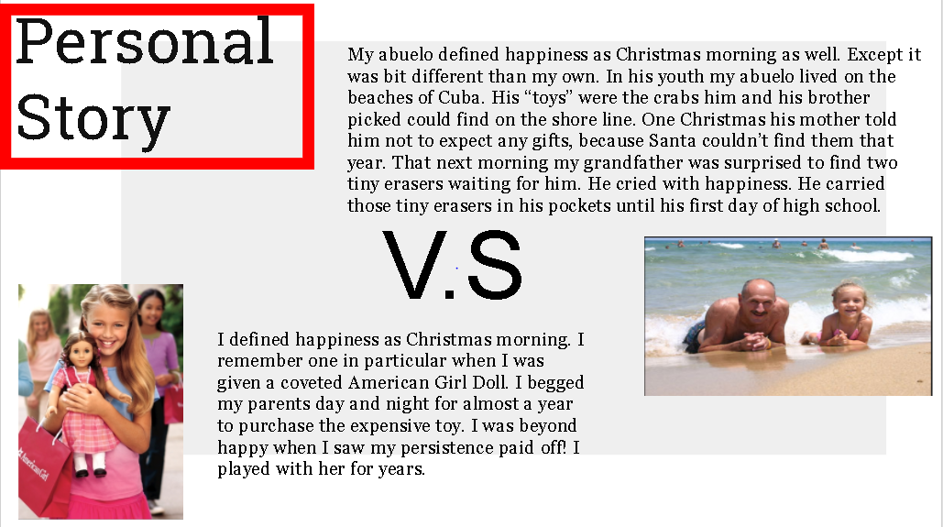

(PowerPoint of Personal Story: Slide #2)
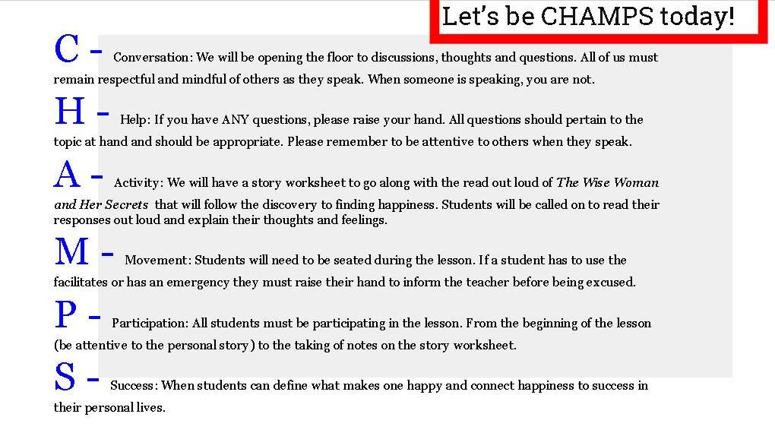(CHAMPS RULES: #3)

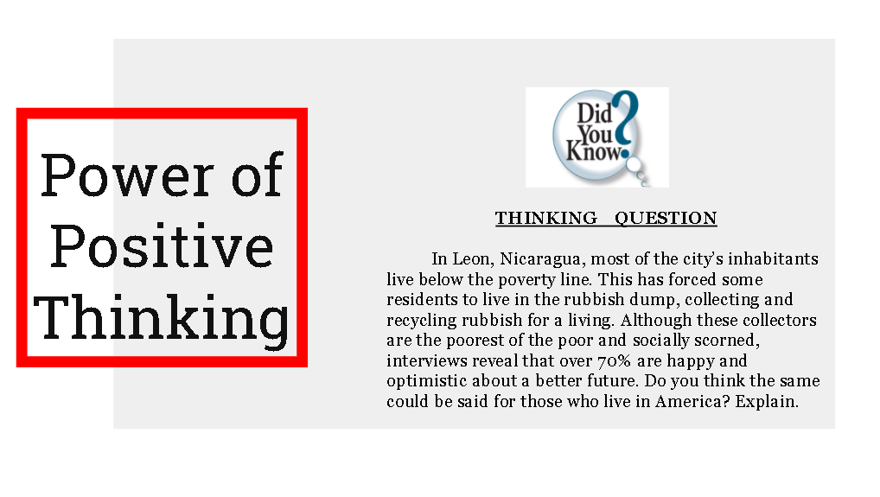

(PowerPoint for Enrichment: #4)

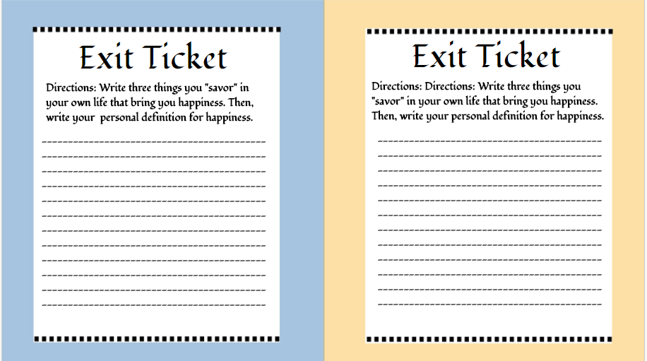

(Formative Assessment Piece)

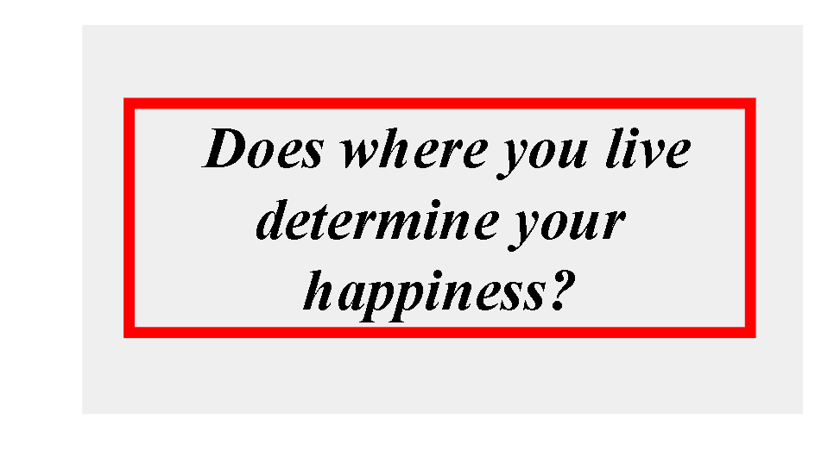(Compelling Question #1)

(Story Worksheet)
