5th Grade Mexico

Happiness in Mexico and America
This fifth grade Inquiry Design Model (IDM) curriculum allows students to explore the happiness of citizens in Mexico and citizens in America through critical analysis of the credibility of primary and secondary documents. Students will investigate these historical resources and undertake the compelling question, “Does Where You Live in the Western Hemisphere Determine Your Happiness?” By completing this IDM, students will not only begin to understand the severity of identifying credible and unreliable information that is presented to them, but how important these issues are pertaining to the world today.
Does Where You Live in the Western Hemisphere Determine Your Happiness?
Compelling Question: Staging the Question:
Students will engage in a lesson on The Wise Women and her Secret laying the foundation of the concept of happiness.

Standards and Practices:

5.4 GEOGRAPHY IN THE WESTERN HEMISPHERE: The diverse geography of the Western Hemisphere has influenced human culture and settlement in distinct ways. Human communities in the Western Hemisphere have modified the physical environment.
5.4c The physical environment influences human population distribution, land use, and other forms of economic activity.

5.5 COMPARATIVE CULTURES: The countries of the Western Hemisphere are diverse and the cultures of these countries are rich and varied. Due to their proximity to each other, the countries of the Western Hemisphere share some of the same concerns and issues. (Standards: 1, 2; Themes: ID, MOV, SOC)

5.5a The countries of the Western Hemisphere have varied characteristics and contributions that distinguish them from other countries.

5.5b. Countries in the Western Hemisphere face a variety of concerns and issues specific to the region.

1. Supporting Question:  What determines happiness? | Formative Task:  After reading the story, The Wise Woman and Her Secrets, and participating in a group discussion students will be able to discover the secret to happiness supporting their answer. | Sources:  Source A: The Wise Woman and Her Secrets  Source B: PowerPoint Presentation

2. Supporting Question:  How does the geography of life in Mexico affect life there? | Formative Task:  After students travel through a virtual bus tour of Mexico, students will write postcards to a friend back home in New York. Students will write in less than five sentences about one of the cities they traveled to in Mexico today and why they would be happy living there. | Sources:  Source A: PowerPoint presentation  Source B: Kids' Games, Animals, Photos, Stories, and More -- National Geographic Kids

3. Supporting Question:  How did Mexico come to be Mexico?  What historical events have shaped the country? | Formative Task:  After observing documents and completing the statement strategy activity, students will prove their understanding of the documents through their “History Alive: Act it Out” performance. | Sources:  Source A:  Statement Strategy Documents  Source B:  Students will be given a handout with directions

4. Supporting Question:  How do we know that what we have learned about Mexico is true? | Formative Task:  After observing four primary source documents based on Mexico’s history, students will use the SCIM-C method to determine if what we have learned about Mexico so far is valid. Students will conclude by writing a paragraph stating if the history we learned about yesterday is true or not. | Sources:  Source A: Thinking Like a Historian PowerPoint  Source B:  Four Primary Source Documents  Source C:  Is it Valid? handout

5. Supporting Question:  Are Mexicans happier than Americans? | Formative Task:  After solving a history mystery, students will create a written argument to support the claim, “Are Mexicans happier than Americans?” | Sources:  Source A:  History Mystery Envelopes  Source B:  PowerPoint Presentation  Source C:  Supporting Claim handout

6. Supporting Question:  In what ways is life in Mexico different than life in America? Do these differences indicate Americans are happier? | Formative Task:  After engaging in a practice Google Slides pre-writing exercise on the TDFC, students will complete a TDFC on their required DBQ on geography and happiness. | Sources:  Source A: Google Slides Presentation (Practice Yankee Essay)  Source B: TDFC Planning Sheet

Summative Performance Task

Extension: Students unable to write will make an Imovie including images that support their position on whether citizens of Mexico are happier than citizens of America.
Argument: Students will complete a DBQ essay answering the question: Does where you live in the Western Hemisphere determine your happiness?

Taking Informed Action

Students will create a flip grid response introducing themselves to students in Mexico. They will share pictures and a story in Spanish of what makes them happy.

GRADE: 5

Are people happier living in America or in Mexico?

Student Name_____________________
Date______________________________

Part III: This part consists of a document-based question. On this part, you will be provided with one version of the test based on your readiness to handle critical thinking challenges.

Document Based Question

Directions: The task below is based on documents 1 through 5-6. The task is designed to test your ability to work with documents. Examine each document and answer all questions beneath the document. Use the answers to the questions to help write your essay.

Background: The Western Hemisphere can be divided into regions. Regions within the Western Hemisphere include North America, Mesoamerica, The Caribbean, and South America. These regions may differ based on landscape, geographical features, climate, food, recreational activities, monuments, style of homes, and could have rural urban or suburban spaces within them. All of the differences between the four regions of the Western Hemisphere may or may not affect the happiness of the people living within those regions.

Task: Use the information from the documents and your knowledge of social studies, write an essay in which you:
Use the information from the documents and your knowledge of social studies, write an essay in which you:

● Discuss two factors that psychologists believe make people happy.
● Discuss life in Mexico compared to life in America.
● Evaluate whether the region where you live in this hemisphere determines your \ happiness.

In your essay remember to
● Write an opinion essay, arguing whether people live a happier life in Mexico or America
● Include an introduction, a body, and a conclusion
● Use information from at least four documents in your answer
● Include historical facts, relevant details, and reason in developing your ideas

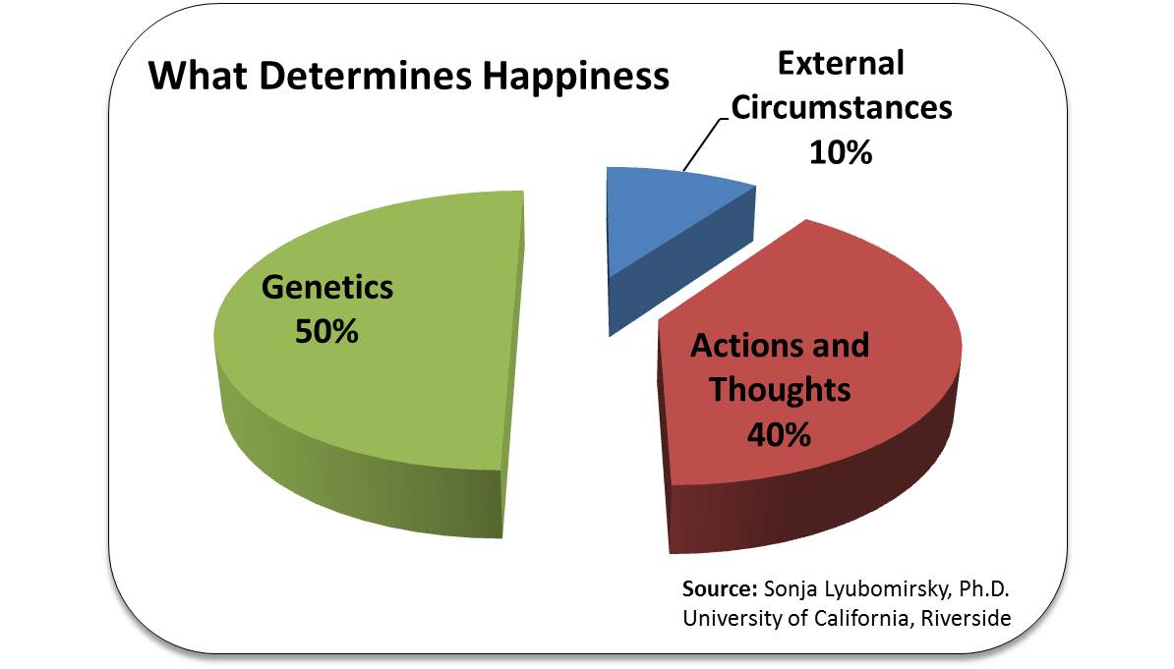
Document #1:
How you react to what happens to you in life
What happens to you in life
10%

1. According to the document, which section of the pie chart do psychologists believe contributes the least to our happiness?
______________________________________________________ [1]
2. Referring to the chart, what is responsible for 50% of our happiness?
_________________________________________________________ [1]
3. Referring to the chart, what does 40% of our happiness relate to? _________________________________________________________ [1]

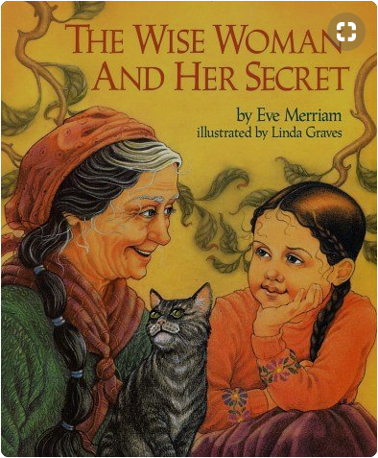
Document #2

Renowned for her wisdom, an old woman is sought out by people who come from far and wide, eager to discover the secret source of her insights. "You will have to discover it for yourself", she tells them, and so their search begins. But one little girl, who likes to wander and wonder, lag and linger, has already found the secret that eludes her elders".

1. Based on the document above, what does the wise woman say about finding happiness?
_________________________________________________________________________________________________________________________________________ [1]

2. According the above document, what two things does the wise woman say have led to Jenny’s happiness?
________________________________________________________________________________________________________________________________________ [1]

3. Based on this definition of happiness, would having more money automatically make you a happier person? What would make you happier?
_________________________________________________________________________________________________________________________________________ [2]
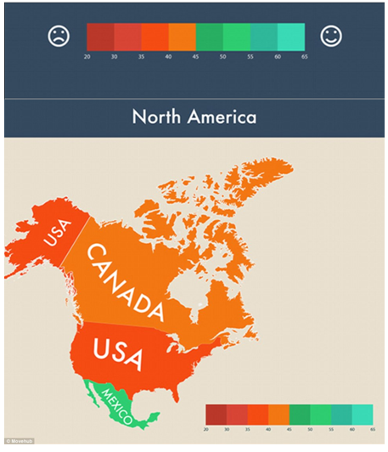
Document #3:

- Based on the document above, which country is happiest on the chart?
___________________________________________________________________ [1]
2. Do you think one test can determine the happiness of an entire country?
_______________________________________________________________________________________________________________________________________________________________________________________________________________ [2]

Document #4

“Violent crimes have been declining in the U.S. for over three decades, and have been increasing in Mexico during the same period. More Mexicans have been killed in drug wars than Americans killed in the Iraq and Afghanistan wars combined.”
-Glen Olives (2015) from the Mexican News

- According to the document, which country has higher crime rates?
___________________________________________________________________ [1]

2. How does this document compare to the information in document #3?
_______________________________________________________________________________________________________________________________________________________________________________________________________________[2]

3. How do you think the crime rate affects the happiness of citizens in a region?
______________________________________________________________________________________________________________________________________________________________________________________________________________________________________________________________________________________[2]

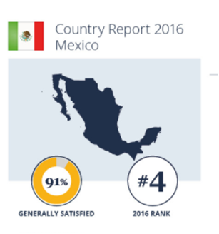

Document #5

- What percentage of people are generally satisfied with their life in Mexico?
___________________________________________________________________ [1]

2. Is this conclusive evidence that people in Mexico are happier than people in America?
________________________________________________________________________________________________________________________________________________________________________________________________________________[2]

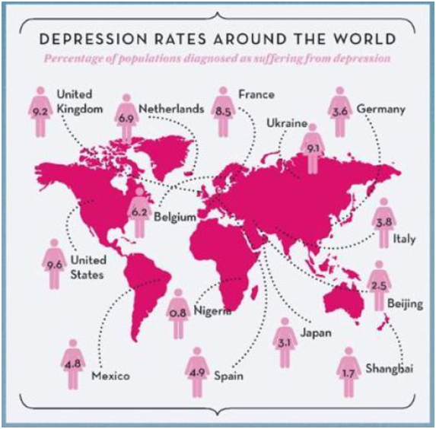
Document #6

- According to the document, how does the percentage of people suffering from depression in Mexico compare to those in the United States?
_______________________________________________________________________________________________________________________________________________________________________________________________________________[1]

- Why do you think more people in the United States, one of the richest countries in the world, has such a high rate of depression? (refer to document #1)
_______________________________________________________________________________________________________________________________________________________________________________________________________________[2]

Task: Use the information from the documents:

Directions: The task below is based on documents 1 through 5. The task is designed to test your ability to work with documents. Examine each document and answer all questions beneath the document. Use the answers to the questions to help write your essay.

Background: The Western Hemisphere can be divided into regions. Regions within the Western Hemisphere include North America, Mesoamerica, The Caribbean, and South America. These regions may differ based on landscape, geographical features, climate, food, recreational activities, monuments, style of homes, and could have rural urban or suburban spaces within them. All of the differences between the four regions of the Western Hemisphere may or may not affect the happiness of the people living within those regions.

Task: Use the information from the documents and your knowledge of social studies, write an essay in which you:
Use the information from the documents and your knowledge of social studies, write an essay in which you:

● Discuss two factors that psychologists believe make people happy.
● Discuss life in Mexico compared to life in America.
● Evaluate whether the region where you live in this hemisphere determines your \ happiness.

In your essay remember to
● Write an opinion essay, arguing whether people live a happier life in Mexico or America
● Include an introduction, a body, and a conclusion
● Use information from at least four documents in your answer
● Include historical facts, relevant details, and reason in developing your ideas

DBQ Scoring Rubric
(From the Revised Generic Scoring Rubric for Regents Examinations.)

Score of 5 | *Thoroughly develops all aspects of the task evenly & in depth | *Is more analytical than descriptive (applies, analyzes, evaluates, & creates information) | *Incorporates relevant information from at least the requested number of documents | *Incorporates substantial relevant outside information | *Richly supports the theme with many relevant facts, examples, & details | *Demonstrates a logical & clear plan of organization; includes and introduction & conclusion that are beyond a restatement of the theme
Score of 4 | *Develops all aspects of the task but may do so somewhat unevenly | *Is both descriptive & analytical (applies, analyzes, evaluates, and/or creates information) | *Incorporates relevant information for at least the requested number of documents | *Incorporates relevant outside information | *Supports the theme with relevant facts, examples, & details | *Demonstrates a satisfactory plan of organization; includes an introduction & a conclusion that are beyond a restatement of the theme
Score of 3 | *Develops all aspects of the task with little depth or develops most aspects of the task in some depth | *Is more descriptive than analytical (applies, may analyze and/or evaluate information) | *Incorporates relevant information from some documents | *Incorporates limited relevant outside information | *Includes some relevant facts, examples, & details; may include some minor inaccuracies | *Demonstrates a satisfactory plan of organization; includes an introduction & a conclusion that may be a restatement of the theme
Score of 2 | *Minimally develops all aspects of the task or develops some aspects of the task in depth | *Is primarily descriptive; may include faulty, weak, or isolated application or analysis | *Incorporates limited relevant information from the documents or consists primarily of relevant information copied from the documents | *Presents little or no relevant outside information | *Includes few relevant facts, examples, & details; may include some inaccuracies | *Demonstrates a general plan of organization; may lack focus; may contain digressions; may not clearly identify which aspect of the task is being addressed; may lack an introduction an/or an conclusion
Score of 1 | *Minimally develops some aspects of the task | *Is descriptive; may lack understanding, application, or analysis | *Makes vague, unclear references to the documents or consists primarily of relevant & irrelevant information copied from the documents | *Presents no relevant outside information | *Includes few relevant facts, examples, or details; may include inaccuracies | *May demonstrate a weakness in organization; may lack focus; may contain digressions; may not clearly identify which aspect of the task is being addressed; may lack an introduction and/or a conclusion
Score of 0 | *Fails to develop the task or may only refer to the theme in a general way; OR includes no relevant facts, examples or details; OR includes only the historical context and/or task as copied from the test booklet; OR includes only entire documents copied from the test booklet; OR is illegible: OR is a blank paper

